**EMERALD ROYAL INTERNATIONAL SCHOOL**

**MPAPE, ABUJA.**

**LESSON PLAN AND NOTE FOR WEEK 9 ENDING 30TH JUNE,2023.**

TERM : Third term.

WEEK : 9th

SUBJECT: Social Norms

TOPIC: Our environment.

SUB-TOPIC: Objects in our environment.

DATE: 27/6/2023

DURATION: 40 minutes

TIME: 10:40-11:20

PERIOD: 5th

CLASS: pre-nursery

NUMBER OF PUPILS: 11

AVERAGE AGE: 2

SEX: Mixed

SPECIFIC OBJECTIVES: By the end of the lesson, the pupils should be able to:-

1. Mention the objects at home.

2. Identify objects within the environment.

RATIONALE: For pupils to be conversant with their environment.

PREVIOUS KNOWLEDGE: Pupils have been taught the meaning of environment.

INSTRUCTIONAL MATERIAL:- pictures of pot, fan and chair.

REFERENCE: Smart start Civic education for nursery Schools book 1 by T.Y. Alabi and A. M. Solu.

LESSON DEVELOPMENT

|  |  |  |  |
| --- | --- | --- | --- |
| Stages/steps | Teacher's activities | Pupils' activities | Learning points |
| Introduction | Teacher introduces the lesson by singing a nursery rhyme for the pupils. | Pupils listen and sing the rhyme along with the teacher. | To arouse the interest of the pupils for the new lesson. |
| Presentation  Step 1 | Teacher leads the pupils to mention the object at home. | Pupils mention objects at home.   1. Television. 2. Chair 3. Table 4. Spoon 5. Plate 6. Clothes 7. Dog 8. Pot 9. Fan 10. Broom 11. Bed | To improve pupils speaking skills . |
| Step 2 | Teacher guides pupils to identify objects at home in the picture. | Pupils identify objects by naming and pointing at the pictures.   1. Fan..   2.pot.  3.bed  4.dog  5. Plate  6. Broom  7.chair. | To ensure active participation. |
| Summary | Teacher summarizes the lesson by mentioning objects at home.   1. plate. 2. Bed 3. Pot 4. Broom 5. Clothes 6. Table 7. Chair. | Pupils pay attention to the teacher and repeat after the her. | To ensure proper understanding of the lesson. |
| Evaluation | Teacher asks the pupils to:-   1. Mention objects at home.   2.Identify the objects at home . | Pupils answer the questions correctly. | To assess the level of pupils understanding of the lesson. |
| Conclusion | Teacher ends the lesson by singing rhymes for the pupils. | Pupils sing along with the teacher. | To consolidate the lesson. |
| Assignment | Teacher asks pupils to mention the objects in their house. | Pupils do the assignment at home . | To encourage learning at home. |

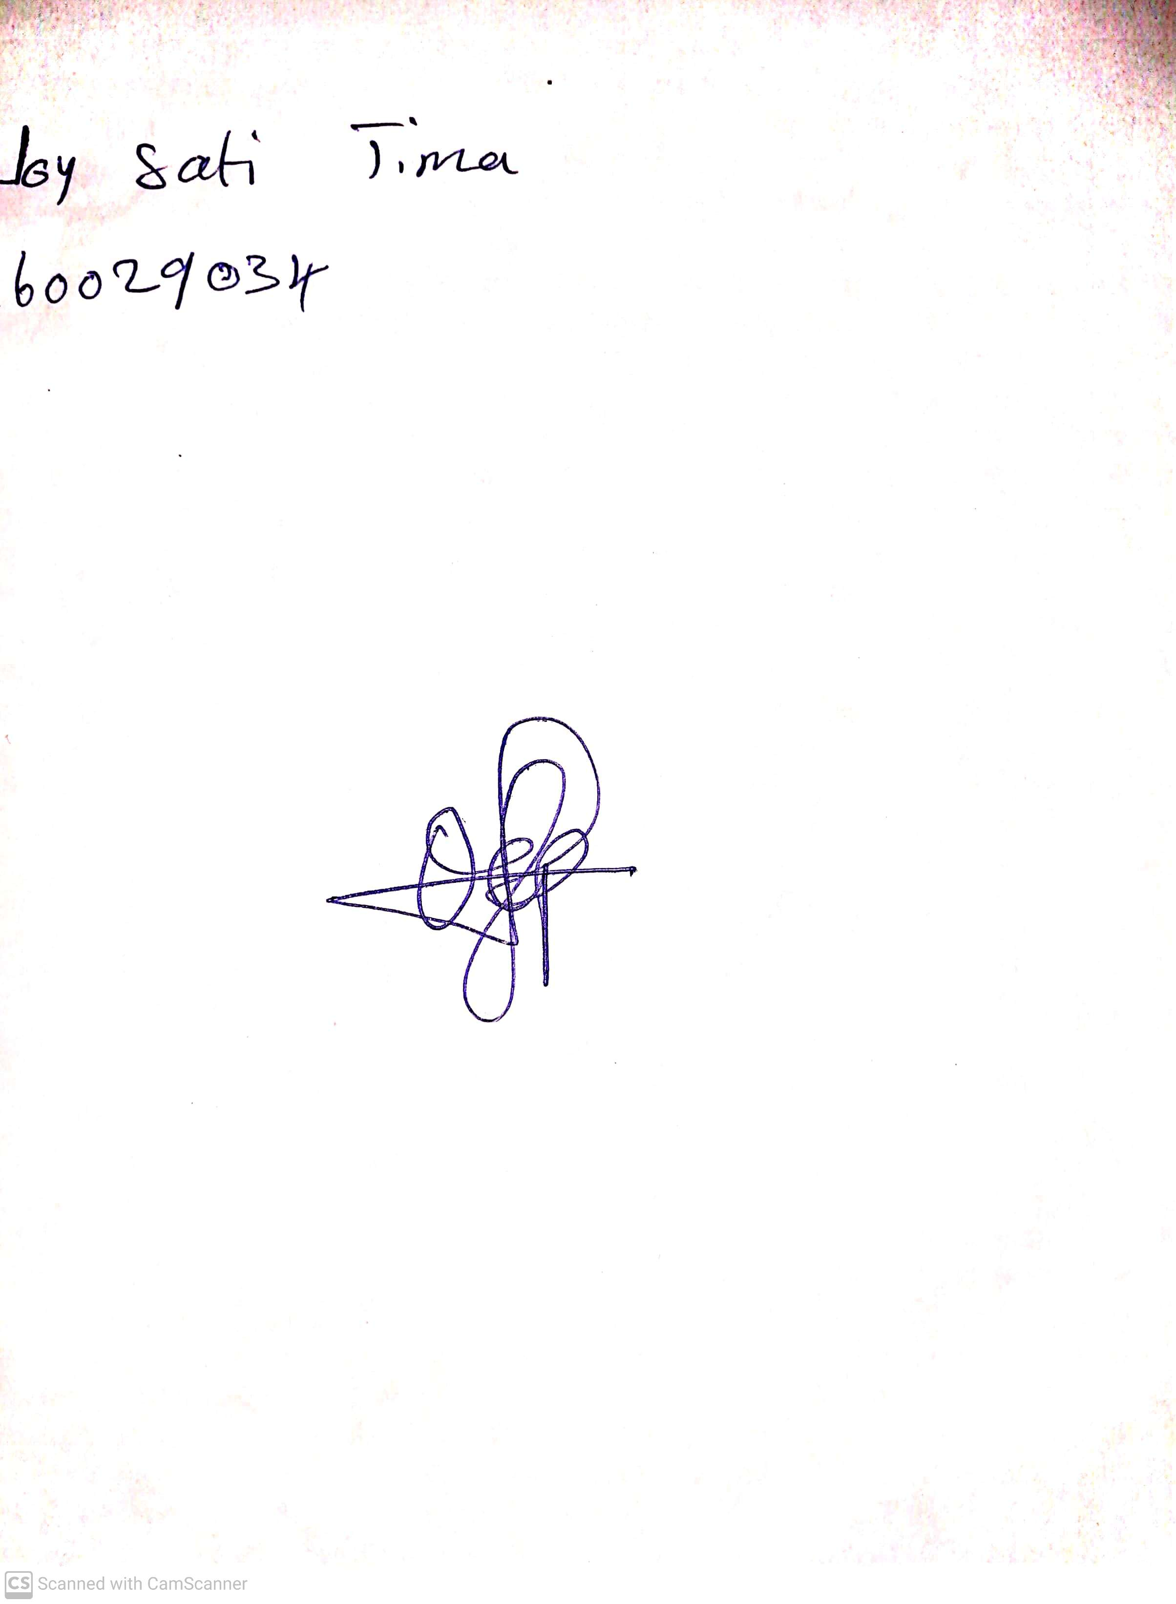

29th April, 2023

Perpetual Ojoma

Stream Head Nursery