LESSON PLAN AND NOTE 1 FOR WEEK 1 ENDING 12/01/2024

**Term 2nd term**

**Week 1st week**

**Date 9th January, 2024**

**Class Nursery One**

**Subject Letter Work**

**Topic Coping words with letter Aa**

**Sub-topic Naming three letter words with Aa**

**Period 6th period**

**Time 1:45pm**

**Duration 35 minutes**

**No in class 14**

**Average Age 3 years**

**Sex Mixed**

**Specific Objectives: By the end of the lesson, the pupils should be able to:**

**1. Name three letter words that start with Aa**

**2. Identify traced three letter words that start with Aa**

**Rationale: To make sure that the pupils mention and identify three**

**letter words**

**Previous Knowledge: The pupils have sound, identify and colour letters Vv - Zz**

**Instructional Resources: Chart, board, marker, exercise books,pencils.**

**Reference Materials: Online research , Chart, Board.**

**LESSSON PRESENTATION**

|  |  |  |  |
| --- | --- | --- | --- |
| **Steps** | **Teacher's Activities** | **Pupils' Activities** | **Learning Points** |
| **Introduction** | **The teacher introduces the topic ( coping words with letter Aa ) to the pupils.** | **The pupils listen to the teacher attentively** | **To arouse the interest of the pupils.** |
| **Step 1** | **The teacher starts by naming three letter words with Aa for the pupils to repeat after ÷ axe,and,arm,ape,ant,are.** | **The pupils repeat after the teacher the three letter words with Aa ÷ axe,and,arm,ape,ant,are.** | **It expands the pupils' knowledge about letter Aa.** |
| **Step 2** | **The teacher guides the pupils to identify traced three letter words with sound Aa ÷ and,ant, arm.** | **The pupils trace the three letter words with Aa as the teacher guides them.** | **It helps them progress while learning three letter words with Aa.** |
| **Summary** | **The teacher summarizes the lesson by sounding three letter words ÷ axe,are etc.** | **The pupils name three letter words with Aa ÷ axe,are etc.** | **For better understanding of the pupils.** |
| **Evaluation** | **Question:**  **Name (2) three letter words with letter a.**  **Copy and write the following three letter words below?**   |  |  | | --- | --- | | **ant** | **arm** | |  |  | | **ape** | **aim** | |  |  | | **The pupils answer the question accordingly** | **To ascertain the pupils' understanding of the lesson.** |
| **Conclusion** | **The teacher applauds the pupils for their activeness.** | **The pupils applauds themselves for their activeness** | **To make the pupils eager to learn more about letter Aa** |
| **Assignment** | **Question:**  **Name (2) three letter words with letter a.**  **Copy and write the following three letter words below?**   |  |  | | --- | --- | | **ant** | **arm** | |  |  | | **ape** | **aim** | |  |  | | **The pupils copy and do their homework at home.** | **To encourage learning while at home.** |

**LESSON PLAN AND NOTE 2 FOR WEEK 1 ENDING 12/01/2024**

**Term 2nd term**

**Week 1st week**

**Date 10th January, 2024**

**Class Nursery One**

**Subject Letter Work**

**Topic Coping words with letter Aa**

**Sub-topic Matching and Writing three letter words and objects with**

**letter Aa**

**Period 6th period**

**Time 1:55pm**

**Duration 35 minutes**

**No in class 14**

**Average Age 3 years**

**Sex Mixed**

**Specific Objectives: By the end of the lesson, the pupils should be able to:**

**1. Pick from a box a picture words with letter Aa and paste it**

**on a cardboard**

**2. Write three letter words with letter Aa**

**Rationale: To make the pupils match and write three letter words**

**Previous Knowledge: The pupils have identify and colour three letter words**

**Instructional Resources: Cardboard,exercise books,pencils.**

**Reference Materials: Online research ,cardboard.**

**LESSSON PRESENTATION**

|  |  |  |  |
| --- | --- | --- | --- |
| **Steps** | **Teacher's Activities** | **Pupils' Activities** | **Learning Points** |
| **Introduction** | **The teacher introduces the topic ( coping words with letter Aa ) to the pupils.** | **The pupils listen to the teacher attentively** | **To arouse the interest of the pupils.** |
| **Step 1** | **The teacher present a box with picture words and assists the pupils using gum to paste on the cardboard the pictures starting with Aa.** | **The pupils participate actively in picking and pasting on the cardboard the word pictures starting with Aa.** | **To practicalise the knowledge the pupils have about letter Aa.** |
| **Step 2** | **The teacher guides the pupils to write three letter words with Aa inside their notebooks.**  **a r m**  **a n t** | **The pupils write three letter words with Aa as the teacher guides them.** | **It helps them progress while learning about letter Aa** |
| **Summary** | **The teacher summaries the lesson by sounding random three letter words with Aa** | **The pupils have knowledge of three letter words with Aa** | **For better understanding of the pupils.** |
| **Evaluation** | **Question:**  **Write the three letter words with Aa**   |  | | --- | | **a r t** | |  | | **a n d** | |  |   **With a box of picture words ,pick the word with letter ‘a’ and paste it on the cardboard using a gum?** | **The pupils answer the question accordingly** | **To ascertain the pupils' understanding of the lesson.** |
| **Conclusion** | **The teacher applauds the pupils for their activeness.** | **The pupils applauds themselves for their activeness** | **To make the pupils eager to learn more about letter Aa** |
| **Assignment** | **Write the three letter word "a-r-m" below**  **________________**  **Write the three letter words with ‘a’**   |  | | --- | | **a r t** | |  | | **a n d** | |  | | **The pupils copy and do their homework at home.** | **To ensure learning while at home.** |

**LESSON PLAN AND NOTE 3 FOR WEEK 1 ENDING 12/01/2024**

**Term 2nd term**

**Week 1st week**

**Date 12th January, 2024**

**Class Nursery One**

**Subject Letter Work**

**Topic Coping words with letter Aa**

**Sub-topic Colouring three letter words and objects with letter Aa.**

**Period 6th period**

**Time 1:45pm**

**Duration 35 minutes**

**No in class 14**

**Average Age 3 years**

**Sex Mixed**

**Specific Objectives: By the end of the lesson, the pupils should be able to:**

**1. Identify three letter words and objects with letter Aa**

**2. Colour three letter words and objects with letter Aa**

**Rationale: To make the pupils identify and colour three letter words and objects.**

**Previous Knowledge: The pupils have name and identify traced three letter words**

**Instructional Resources: Chart, board, marker, exercise books,pencils.**

**Reference Materials: Online research , Chart, Board.**

**LESSSON PRESENTATION**

|  |  |  |  |
| --- | --- | --- | --- |
| **Steps** | **Teacher's Activities** | **Pupils' Activities** | **Learning Points** |
| **Introduction** | **The teacher introduces the topic ( coping words with letter Aa ) to the pupils.** | **The pupils listen to the teacher attentively** | **To arouse the interest of the pupils.** |
| **Step 1** | **The teacher draws objects that starts with three letter word ‘a’ for the pupils to identify axe arm** | **The pupils participate to identify objects that start with three letter word ‘a’.** | **To ensure the pupils understand while pointing** |
| **Step 2** | **The teacher draws and guides the pupils to colour objects starting with letter ‘a’** | **The pupils colour the objects that starts with letter ‘a’** | **To expand their knowledge of letter ‘a’** |
| **Summary** | **The teacher summaries the lesson by identifying other objects with letter ‘a’** | **The pupils have knowledge of identifying and Colouring objects with letter ‘a’** | **For better understanding of the pupils.** |
| **Evaluation** | **Question:**  **Identify the below object with ‘a’**    **Colour the objects with letter ‘a’** | **The pupils answer the question accordingly** | **To ascertain the pupils' understanding of the lesson.** |
| **Conclusion** | **The teacher applauds the pupils for their activeness.** | **The pupils applauds themselves for their activeness** | **To make the pupils eager to learn more about letter ‘a’** |
| **Assignment** | **Question:**  **Identify the below object with ‘a’**    **Colour the objects with letter ‘a’** | **The pupils copy and do their homework at home.** | **To encourage learning while at home.** |

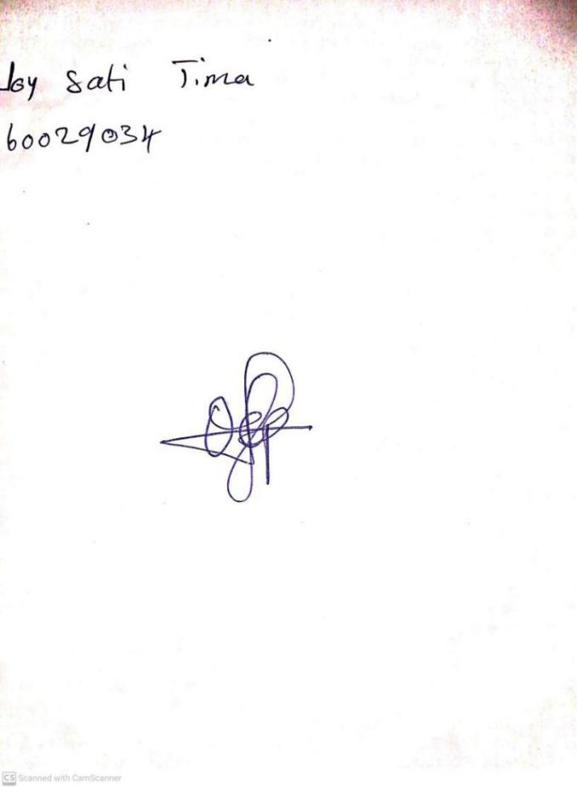

**5th January, 2024**

**Perpetual Ojoma Ocheja**

**Stream Head Nursery**