LESSON PLAN AND NOTE FOR WEEK 9 ENDING 10/11/2023

TERM: 1st

WEEK: 9th

DATE: 06/11/2023

CLASS: Nursery 2

SUBJECT: Nature studies

TOPIC: Food

SUB—TOPIC: Meaning and types of food

PERIOD: 4th

TIME: 10:40—11:20am

DURATION: 40 minutes

NUMBER IN CLASS: 14

AVERAGE AGE: 5 years

SEX: Mixed

LEARNING OBJECTIVES: By the end of the lesson, the pupils should be able to:

1. Define food.

2. Mention the types of food.

3. State the reason why we eat food.

RATIONALE: For pupils to know more about food.

PREVIOUS KNOWLEDGE: Pupils have been eating food.

INSTRUCTIONAL MATERIALS: A plate of cook food.

REFERENCE MATERIALS: Basic science and technology for Nursery schools book 3 by OPEMIPO DADA.

LESSON DEVELOPMENT

|  |  |  |  |
| --- | --- | --- | --- |
| Steps | Teacher's activities | Pupils' activities | Learning point |
| Introduction | Teacher introduces the lesson by reviewing the previous lesson. | Pupils pay attention to the teacher. | To prepare pupils minds for the lesson ahead. |
| Presentation  step 1 | Teacher defines food to pupils and then asks them to repeat after her. | Pupils listen to the teacher and repeat after her. | To improve pupils listening and speaking ability. |
| Step 2 | Teacher mentions the types of food to pupils and also asks them to repeat after her. | Pupils pay attention to the teacher and repeat her. | To enhance pupils participation in the class. |
| Step 3 | Teacher States the reasons why we eat food to pupils and also asks them to repeat after her. | Pupils listen very attentively to the teacher and repeat after her. | To improve pupils speaking ability. |
| Board summary | Teacher writes the whole note of lesson on the board for pupils to copy into their books. That is;  Food:  Food is anything we eat, drink or take into our body to give us energy and help us grow.  Examples of food eaten in our locality are:   1. Rice 2. Yam 3. Beans 4. Garri 5. Cocoyam 6. Plantain 7. Eggs 8. Meat 9. Palm oil 10. Vegetables 11. Potatoes 12. Noddle 13. Spaghetti 14. Fish 15. Milk etc.   Reasons why we eat food:   1. We eat food to make our body strong. 2. We eat food to keep our body healthy. 3. We eat food to help us grow. | Pupils copy the note into their exercise books. | For onward study. |
| Evaluation | Teacher evaluates the lesson by asking pupils the following questions;   1. What is food? 2. Mention the types of food in our locality. 3. State the reasons for eating food. | Pupils answer the questions asked by the teacher. | To assess pupils level of understanding. |
| Conclusion | Teacher concludes the lesson by marking pupils books. | Pupils submit their books for marking. | For endorsement. |
| Assignment | Answer the following question:  Mention 10 other types of food that you know. | Pupils do their assignment at home. | To encourage learning at home. |

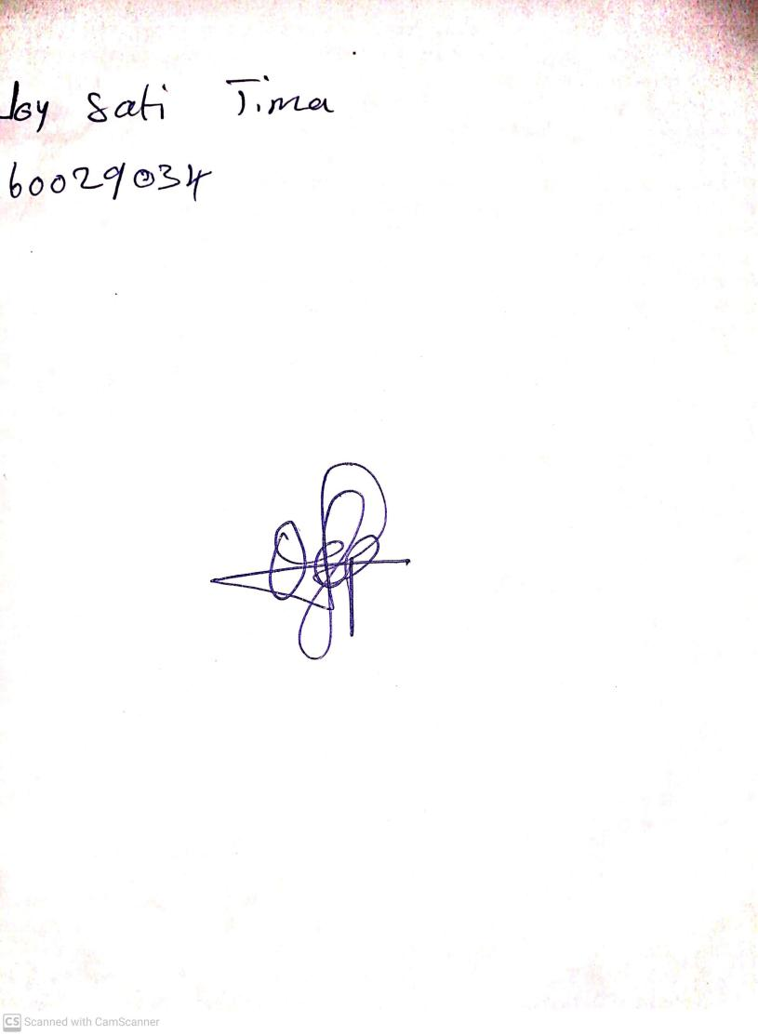

30TH October, 2023

Perpetual Ojoma Ocheja

Stream Head Nursery