**LESSON PLAN AND NOTE FOR WEEK 2 ENDING 12/05/2023**

**Term 3rd term**

**Week 2nd week**

**Date 12th May,2023**

**Class Nursery One**

**Subject Social Norms**

**Topic My School.**

**Sub-topic Places and activities fund in school.**

**Period 4th period**

**Time 10:40 am**

**Duration 35 minutes**

**No in class 18**

**Average Age 3 years**

**Sex Mixed**

**Specific Objectives: By the end of the lesson, the pupils**

**should be able to:**

1. **Define School**
2. **Mention the name of their school**

**Rationale: To ensure the pupils have vital**

**knowledge about their school.**

**Previous Knowledge: The pupils can identify and mention objects in the classroom.**

**Instructional Resources: School premises, Online research.**

**Reference Material: Smart Smart Civic Education by**

**ss A.M Solu & T.Y Alabi, nursery 2**

**LESSON PRESENTATION**

|  |  |  |  |
| --- | --- | --- | --- |
| **Steps** | **Teacher’s Activities** | **Pupils’ Activities** | **Learning Points** |
| **introduction** | **The teacher introduces the topic [my school] by singing the school anthem with the pupils.** | **The pupils participate actively in singing the school anthem with the teacher.** | **To arouse the pupils interest towards the lesson.** |
| **Step 1.** | **The teacher teaches the pupils meaning of school as “a place of learning” for them to repeat after.** | **The pupils repeat after the teacher the definition of school, as “a place of learning”.** | **For proper education.** |
| **Step 2.** | **The teacher guides the pupils to mention the name of their school: EMERALD ROYAL INTERNATIONAL SCHOOL.** | **The pupils mention the name of their school: EMERALD ROYAL INTERNATIONAL SCHOOL.** | **For better understanding.** |
| **Summary** | **The teacher summarizes the lesson by defining school as a “place of learning.** | **The pupils understand and learn the definition of school.** | **For onward study.** |
| **Evaluation** | **Question:**  **What is a school?**  **What is the name of your school?** | **The pupils answer the question correctly.** | **To ascertain the pupils’ understanding of the lesson.** |
| **Conclusion** | **The teacher summarizes, reacts and corrects the pupils.** | **The pupils gives answers to the teacher’s question.** | **To consolidate the lesson.** |
| **Assignment** | **Question:**  **What is the name of your school?** | **The pupils copy and do their homework at home.** | **To encourage learning while at home.** |

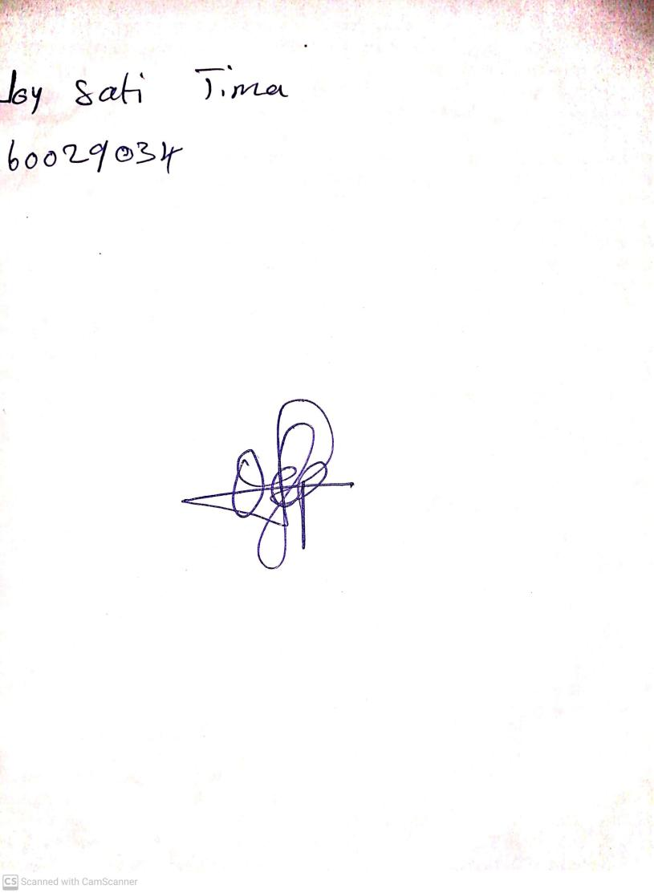

10th May, 2023

Perpetual Ojoma

Stream Head Nursery