**EMERALD ROYAL INTERNATIONAL SCHOOL**

**MPAPE, ABUJA.**

**LESSON PLAN AND NOTE FOR WEEK 7 PERIOD 1 ENDING 07/06/2024**

**TERM: 3RD**

**WEEK: 7TH**

**DATE: 03/06/2024**

**CLASS: NURSERY 2**

**SUBJECT: NUMBERWORK**

**TOPIC: NUMBERS IN WORDS 1-10 .**

**SUB-TOPIC: RECITING AND WRITING OF NUMBERS 1-5**

**PERIOD: 1ST**

**TIME: O8:50-09:30.**

**DURATION: 40 MINUTES.**

**NUMBER IN CLASS: 13**

**AVERAGE AGE: 5 YEARS.**

**SEX: MIXED.**

**SPECIFIC OBJECTIVES: BY THE END OF THE LESSON,THE PUPILS SHOULD BE**

**ABLE TO:**

1. **RECITE NUMBERS IN WORDS 1-5**
2. **IDENTIFY AND READ NUMBERS IN WORDS 1-5**

**RATIONALE: FOR PUPILS TO KNOW NUMBERS IN WORDS 1-5.**

**PREVIOU KNOWLEDGE: PUPILS HAVE LEARNT COUNTING OF NUMBERS 1- 50 IN PREVIOUS LESS0N.**

**INSTRUCTIONAL MATERIALS: A CHART OF NUMBERS IN WORDS 1-5 .**

**REFERENCE MATERIALS: THE NEW MASTERING MATHEMATICS FOR NURSERY SCHOOLSBOOK 3 BY HENRY.Z.IDOGUN.**

**LESSON DEVELOPMENT**

|  |  |  |  |
| --- | --- | --- | --- |
| **STAGES/STEPS** | **TEACHER’S ACTIVITIES** | **PUPILS’ ACTIVITIES** | **LEARNING POINTS** |
| **INTRODUCTION** | **Teacher introduces the lesson by reviewing the previous lesson.** | **Pupil listen to the teacher.** | **To arouse pupils interest for the lesson ahead.** |
| **PRESENTATION**  **STEP 1** | **Teacher recites numbers 1-5 and then asks pupils to repeat after her.** | **Pupils listen attentively to the teacher and repeat after her.** | **For proper understanding of the lesson .** |
| **STEP 2** | **Teacher writes numbers 1-5 in words on the board and then recite and also asks pupils to identify and repeat after her.** | **Pupils pay attention to the board and repeat after the teacher.** | **For better understanding of the lesson.** |
| **BOARD SUMMARY** | **Teacher summarizes the lesson by writing the whole note of lesson on the board for pupils to copy into their books. That is,**  **NUMBERS IN WORDS 1-5**  **One 1**  **Two 2**  **Three 3**  **Four 4**  **Five 5** | **Pupils copy the note into their exercise books.** | **For onward study.** |
| **EVALUATION** | **Teacher asks Pupils to identify and recite the number in words 1-5 on the board one after the other.** | **Pupils identify and recite the number in words 1-5 on the board one after another.** | **To assess pupils understanding of the lesson.** |
| **CONCLUSION** | **Teacher marks pupils books.** | **Pupils submit their books for marking.** | **For endorsement.** |
| **ASSIGNMENT** | **Identify, recite and rewrite numbers 6-10 words**  **Six 6**  **Seven 7**  **Eight 8**  **Nine 9**  **Ten 10** | **Pupils do their assignment at home.** | **To encourage learning at home.** |

**LESSON PLAN AND NOTE FOR WEEK 7 PERIOD 2 ENDING 07/06/2024**

**TERM: 3RD**

**WEEK: 7TH**

**DATE: 04/06/2024**

**CLASS: NURSERY 2**

**SUBJECT: NUMBER WORK**

**TOPIC: NUMBERS IN WORDS 1-10 .**

**SUB-TOPIC: IDENTIFY, RECITE AND WRITE NUMBERS IN WORDS 6-10**

**PERIOD: 2nd**

**TIME: O8:50-09:30.**

**DURATION: 40 MINUTES.**

**NUMBER IN CLASS: 13**

**AVERAGE AGE: 5 YEARS.**

**SEX: MIXED.**

**SPECIFIC OBJECTIVES: BY THE END OF THE LESSON,THE PUPILS SHOULD BE**

**ABLE TO:**

1. **RECITE NUMBERS IN WORDS 6-10**
2. **IDENTIFY AND READ NUMBERS IN WORDS 6-10**

**RATIONALE: FOR PUPILS TO KNOW NUMBERS IN WORDS 6-10 .**

**PREVIOU KNOWLEDGE: PUPILS HAVE LEARNT NUMBERS IN WORDS 1-5 IN PREVIOUS LESS0N.**

**INSTRUCTIONAL MATERIALS: A CHART OF NUMBERS IN WORDS 6-10 .**

**REFERENCE MATERIALS: THE NEW MASTERING MATHEMATICS FOR NURSERY SCHOOLSBOOK 3 BY HENRY.Z.IDOGUN.**

**LESSON DEVELOPMENT**

|  |  |  |  |
| --- | --- | --- | --- |
| **STAGES/STEPS** | **TEACHER’S ACTIVITIES** | **PUPILS’ ACTIVITIES** | **LEARNING POINTS** |
| **INTRODUCTION** | **Teacher introduces the lesson by asking pupils to all stand and recite numbers in words 1-5.** | **Pupil all stand and recite numbers in words 1-5** | **To prepare pupils minds for the lesson ahead.** |
| **PRESENTATION**  **STEP 1** | **Teacher presents the lesson by reciting numbers in words 6-10 and then asks pupils to repeat after.** | **Pupils pay attention to the teacher and the repeat after her.** | **For proper understanding of the lesson .** |
| **STEP 2** | **Teacher writes numbers in words 6-10 on the board and then read and also asks pupils to repeat after her.** | **Pupils pay attention to the teacher and repeat after her.** | **For better understanding of the lesson.** |
| **BOARD SUMMARY** | **Teacher summarizes the lesson by writing the whole note of lesson on the board for pupils to copy into their books.that is,**  **NUMERS IN WORDS 6-10**  **SIX 6**  **SEVEN 7**  **EIGHT 8**  **NINE 9**  **TEN 10** | **Pupils copy the note into their exercise books.** | **For onwardstudy.** |
| **EVALUATION** | **Teacher asks Pupils to all stand and recite number in words 6-10 on the board all together.** | **Pupils all stand and recite the numbers 6-10 in words on the board all together.** | **To create platform for slow learners.** |
| **CONCLUSION** | **Teacher marks pupils books.** | **Pupils submit their books for marking.** | **For endorsement.** |
| **ASSIGNMENT** | **Identify, recite and write numbers in words 1-10.** | **Pupils do their assignment at home.** | **To encourage learning at home.** |

**LESSON PLAN AND NOTE FOR WEEK 7 PERIOD 3 ENDING 07/06/2024**

**TERM: 3RD**

**WEEK: 7TH**

**DATE: 07/06/2024**

**CLASS: NURSERY 2**

**SUBJECT: NUMBER WORK**

**TOPIC: NUMBERS IN WORDS 1-10 .**

**SUB-TOPIC: IDENTIFY,READ AND WRITE NUMBER IN WORDS 1-10**

**PERIOD: 3RD**

**TIME: 08:10- 08:50am**

**DURATION: 40 MINUTES.**

**NUMBER IN CLASS: 13**

**AVERAGE AGE: 5 YEARS.**

**SEX: MIXED.**

**SPECIFIC OBJECTIVES: BY THE END OF THE LESSON,THE PUPILS SHOULD BE**

**ABLE TO:**

**1.READ NUMBERS IN WORDS 1-10 ORALLY**

**2.WRITE NUMBERS IN WORDS 1-10**

**RATIONALE: FOR PUPILS TO BE COVERSANT WITH NUMBERS IN**

**WORDS 1-10.**

**PREVIOU KNOWLEDGE: PUPILS HAVE LEARNT NUMBERS IN WORDS 1-10**

**INSTRUCTIONAL MATERIALS: NUMBER CHART IN WORDS 1-10 .**

**REFERENCE MATERIALS: THE NEW MASTERING MATHEMATICS FOR NURSERY**

**SCHOOLS BOOK 3 BY J.M OMOGBAI.**

**LESSON DEVELOPMENT**

|  |  |  |  |
| --- | --- | --- | --- |
| **STAGES/STEPS** | **TEACHER’S ACTIVITIES** | **PUPILS’ ACTIVITIES** | **LEARNING POINTS** |
| **INTRODUCTION** | **Teacher introduces the lesson by singing nursery numbers number rhymes .That**  **1 little,2little,3little fingers**  **4little, 5little,6little figers………..** | **Pupils sing the rhymes along with the teacher.** | **To arouse pupils interest for the lesson ahead.** |
| **PRESENTATION**  **STEP 1** | **Teacher presents the lesson by writing numbers in words 1-10 on the board and then recites and then asks pupils to repeat after her.** | **Pupils listen to the teacher and repeat after her.** | **For proper understanding of the lesson .** |
| **STEP 2** | **Teacher guides pupils to recite numbers in words 1-10 often and often.** | **Pupils recite numbers 1-10 in words often and often.** | **For better understanding of the lesson.** |
| **BOARD SUMMARY** | **Teacher summarizes the lesson by preparing pupils books for them to copy the note on the board.ie,**  **NUMBERS IN WORDS 1-10**  **One 1**  **Two 2**  **Three 3**  **Four 4**  **Five 5**  **Six 6**  **Seven 7**  **Eight 8**  **Nine 9**  **Ten 10** | **Pupils copy the note into their exercise books.** | **For onwardstudy.** |
| **EVALUATION** | **Teacher evaluates the lesson by asking pupils to all stand and recite numbers in words 1-10 on the board all together.** | **Pupils all stand and recite numbers 1-10 in words on the board all together.** | **To create platform for slow learners.** |
| **CONCLUSION** | **Teacher concludes the lesson by marking pupils notes .** | **Pupils submit their books for marking.** | **For endorsement.** |
| **ASSIGNMENT** | **Practice and write numbers in words 1-15** | **Pupils do their assignment at home.** | **To encourage learning at home.** |

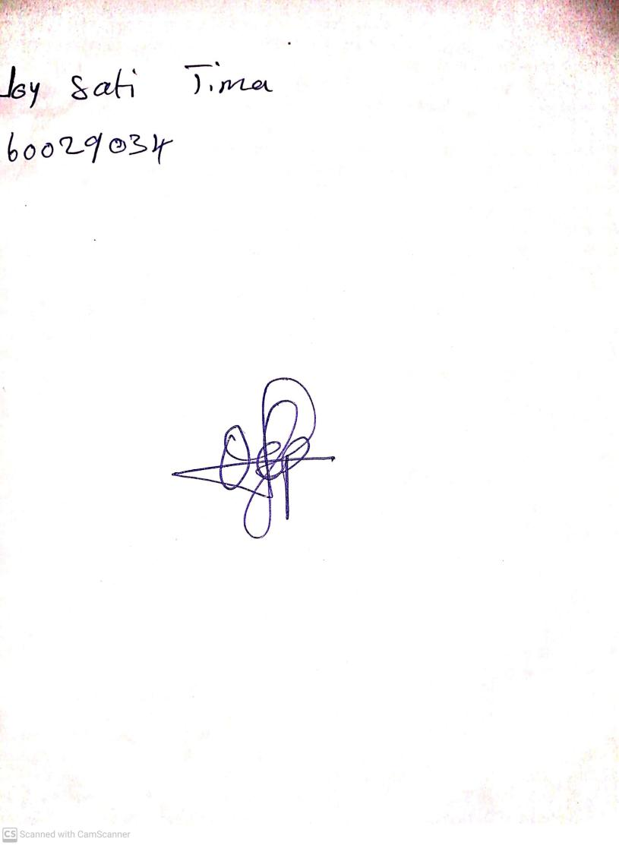

**31ST May, 2024**

**Perpetual Ojoma Ocheja**

**Stream Head Nursery**