EMERALD ROYAL INTERNATIONAL SCHOOL

MPAPE, ABUJA.

LESSON PLAN/ NOTE FOR WEEK 4 ENDING 2nd FEBRUARY,2024.

SUBJECT: Social Norms

TOPIC: My school

SUB-TOPIC: Meaning of school and name of my school.

DATE: 2nd FEBRUARY,2024.

DURATION: 40minutes

TIME: 08:10 -08:50

PERIOD: 1st

CLASS: Pre-nursery

NUMBER OF PUPILS: 17

AVERAGE AGE: 2years

SEX: Mixed

SPECIFIC OBJECTIVES: By the end of the lesson, the pupils should be able to:-

1. Define a school
2. Say the name of their school

RATIONALE: For pupils to have knowledge about their school.

PREVIOUS KNOWLEDGE: Pupils have practice to say their gender in the previous lesson.

INSTRUCTIONAL MATERIALS: The school buildings.

REFERENCE,: Smart start Civic education for nursery Schools book 1 by T.Y.Alabi and A.M.Solu.

LESSON DEVELOPMENT

|  |  |  |  |
| --- | --- | --- | --- |
| Stages/ Steps | Teacher's activities | Pupils' activities | Learning points |
| Introduction | Teacher introduces the lesson by taking the pupils round the premises and shows the pupils the school buildings. Teacher also tells the pupils that the building is a school. | Pupils follow the teacher round the buildings and also listen to the teacher as he/she calls the building a school. | To arouse the interest of the pupils and to get them ready for the lesson proper. |
| Presentation  Step 1 | Teacher defines school to the pupils as:- "A school is a place where people go to learn." Teacher asks the pupils to repeat after him/her. | Pupils listen as the teacher is defining a school and repeat after the teacher. | To ensure pupils can define a school. |
| Step 2 | Teacher tells the pupils the name of their school ie ."The name of my school is Emerald Royal International School Mpape, Abuja. Then the teacher asks the pupils to repeat after him/her. | Pupils listen attentively to the teacher and repeat after the teacher to say the name of their school repeatedly. | To ensure pupils are able to say the name of their school and to improve their speaking ability. |
| Summary | Teacher summarizes the lesson by teaching the pupils to say the meaning of school and the name of their school often. | Pupils say the meaning of school and name of their school. | To enhance pupils speaking ability. |
| Evaluation | Teacher asks the pupils the following questions:-   1. What is a school? 2. What is the name of your school? | Pupils response to the teacher's questions | To ascertain the level of pupils ability to define school . |
| Conclusion | Teacher concludes the lesson by singing a nursery rhymes for the pupils. | Pupils sing the rhyme along with the teacher's | To improve pupils speaking ability. |
| Assignment | Teacher encourages the pupils to practice the name of their school at home. | Pupils do the assignment at home. | To ensure learning takes place at home. |

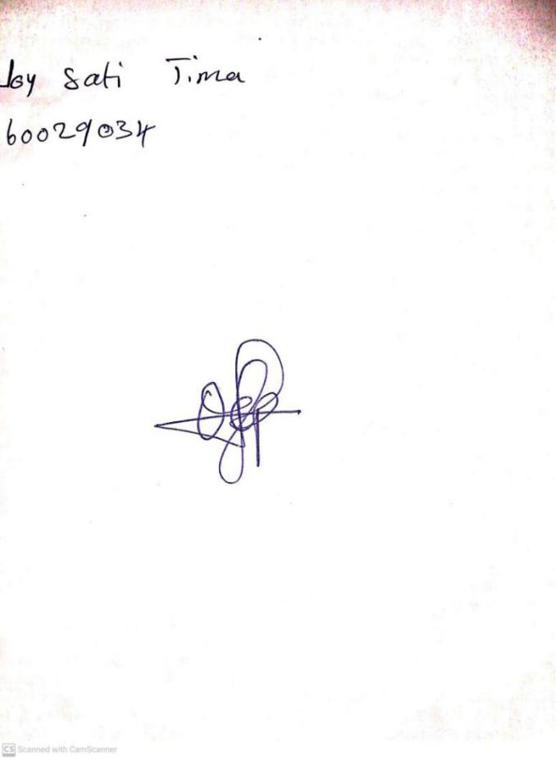

**26TH JANUARY, 2024**

**Perpetual Ojoma Ocheja**

**Stream Head Nursery**