**LESSON PLAN/ NOTE FOR WEEK 9 ENDING 30/06/2023.**

**Term:** 3rd

**Week**: 9

**Date:** 28/06/2023.

**Class**: SS 1

**Subject:** Civic Education

**Topic**: Respect for Constituted Authority.

**Sub-Topic:** Types of Constituted Authority (Government Constituted Authority and functions).

**Period**: 5th

**Time:** 11:10-11:50

**Duration**: 40 Minutes

**Number in class**: 8 students

**Average Age:** 14 Years

**Sex**: mixed

**Specific objectives**: By the end of the lesson, the students should be able to:

(1) Define Government Constituted Authority.

(11) State the functions of Government Constituted Authority.

**Rationale**: For the students to be able to respect government constituted leaders such as the president, Governors, chairman, ministers etc.

**Previous knowledge**: The students have seen government leaders such as president, Governors chairman ministers etc.

**Instructional material:** A chart showing the president of Nigeria, senators, governors and police.

**Reference material:** Gbenga Babalola (2017) Essential civic Education for senior secondary schools.

**LESSON DEVELOPMENT**

|  |  |  |  |
| --- | --- | --- | --- |
| **Stages/Steps** | **Teacher's Activities** | **Students' Activities** | **Learning points** |
| **Introduction** | Review the previous lesson. | Participate actively in the class discussion | To arouse the students interest to learn. |
| **Step 1** | Defines Government Constituted Authority as: Government Constituted Authority are government or political leaders who have constitutional backing to rule the people. | Listen carefully to the teacher | For better understanding of the lesson. |
| **Step 11** | Guides the students to state the functions of government constituted authority. | Respond to the class activity | To encourage critical thinking. |
| **Board summary** | Summarizes the lesson as:  **Government Constituted Authority.**  Government Constituted Authority are leaders of government or political office holders, Who have the constitutional backing to rule the people. These groups are vested with the political power and authority to rule the people, provide basic amenities, preserve and protect their rights and maintain security of the people. This group also makes laws, rules and regulations to ensure the peaceful and harmonious existence of the people.  They are the president, ministers, state governors, Chief justice, Senate president etc.  **Functions of Government Constituted Authority**.  (1) They maintain law, peace and order.  (2) They provide basic amenities (waters, electricity, health care) for the people.  (3) They promote national unity.  (4) They protect the citizens against internal and external attacks.  (5) They make laws and execute them.  (6) They guarantee equality of citizens and treat all citizens fairly  (7) They respect the dignity of individuals. | Copy and submit the note book for marking. | For future reference. |
| **Evaluation** | Evaluates the students as:  (1) Define Government Constituted Authority.  (2) state 5 functions of Government Constituted Authority. | Respond to the questions | Ascertaining the attainment of the stated objectives. |
| **Conclusion** | Rounds up the lesson by marking and correcting students work. | Check and do their correction. | Consolidation of the lesson. |
| **Assignment** | Gives home work as:  (1) Mention and explain 5 roles and duties of constituted authority. | Respond by doing the home work at home. | To ensure continuity of learning. |

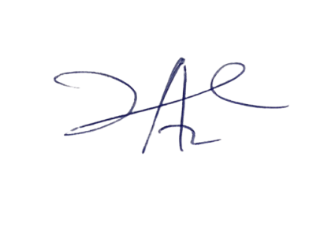

2/6/2023

Principal Head Instuctor