**EMERALD ROYAL INTERNATIONAL SCHOOL**

**MPAPE, ABUJA.**

**LESSON PLAN AND NOTE FOR WEEK 3 PERIOD 1 ENDING 29/09/2023**

TERM: FIRST

WEEK: 3RD

DATE: 25/09/2023

CLASS: NURSERY 2

SUBJECT: NUMBERWORK

TOPIC: EVEN AND ODD NUMBERS .

SUB-TOPIC: MEANING AND EXAMPLES OF EVEN NUMBERS

PERIOD: 1ST

TIME: O8:50-09:30.

DURATION: 40 MINUTES.

NUMBER IN CLASS: 14

AVERAGE AGE: 5 YEARS.

SEX: MIXED.

SPECIFIC OBJECTIVES: BY THE END OF THE LESSON,THE PUPILS SHOULD BE ABLE TO:

1. SAY THE MEANING OF EVEN NUMBERS
2. MENTION EXAMPLES OF EVEN NUMBERS

RATIONALE: FOR PUPILS TO KNOW THE MEANING AND EXAMPLES OF EVEN NUMBERS

PREVIOU KNOWLEDGE: PUPILS HAVE LEARNT COUNTING OF NUMBERS 21- 25 IN PREVIOUS LESS0N.

INSTRUCTIONAL MATERIALS: A CHART OF NUMBERS ON EVEN NUMBERS.

REFERENCE MATERIALS: THE NEW MASTERING MATHEMATICS FOR NURSERY SCHOOLS BOOK 3 BY HENRY.Z.IDOGUN.

**LESSON DEVELOPMENT**

|  |  |  |  |
| --- | --- | --- | --- |
| STAGES/STEPS | TEACHER’S ACTIVITIES | PUPILS’ ACTIVITIES | LEARNING POINTS |
| INTRODUCTION | Teacher introduces the lesson by reviewing the previous lesson. | Pupil listen to the teacher. | To arouse pupils interest for the lesson ahead. |
| PRESENTATION  STEP 1 | Teacher explains the meaning of even numbers and then asks pupils to repeat after her. | Pupils listen attentively to the teacher and repeat after her. | For proper understanding of the lesson . |
| STEP 2 | Teacher mentions the examples of even numbers and also asks pupils to repeat after her. | Pupils pay attention to the teacher and repeat after her. | For better understanding of the lesson. |
| BOARD SUMMARY | Teacher summarizes the lesson by writing the whole note of lesson on the board for pupils to copy into their books.that is,  EVEN NUMBERS  Even numbers are the numbers that can be divided by two without a remainder.  Examples:  2, 4, 6, 8, 10, 12, 14, 16, 18, 20 etc. | Pupils copy the note into their exercise books. | For onward study. |
| EVALUATION | Teacher evaluates the lesson by asking pupils the following question.   1. What are even numbers? 2. Mention the examples of even numbers. | Pupils answer the question asked by the teacher. | To assess pupils understanding of the lesson. |
| CONCLUSION | Teacher concludeds the lesson by marking pupils books. | Pupils submit their books for marking. | For endorsement. |
| ASSIGNMENT | Identify and circle all the even numbers bellow.  1 2 3 4 5 6 7 8 9 10 11 12 13 14 15 16 17 18 19 20 | Pupils do their assignment at home. | To encourage learning at home. |

**LESSON PLAN AND NOTE FOR WEEK 3 PERIOD 2 ENDING 29/09/2023**

TERM: FIRST

WEEK: 3RD

DATE: 26/09/2023

CLASS: NURSERY 2

SUBJECT: NUMBER WORK

TOPIC: EVEN AND ODD NUMBERS .

SUB-TOPIC: MEANING AND EXAMPLES OF ODD NUMBERS

PERIOD: 2nd

TIME: O8:50-09:30.

DURATION: 40 MINUTES.

NUMBER IN CLASS: 14

AVERAGE AGE: 5 YEARS.

SEX: MIXED.

SPECIFIC OBJECTIVES: BY THE END OF THE LESSON,THE PUPILS SHOULD BE ABLE TO:

1. EXPLAIN THE MEANING OF ODD NUMBERS
2. MENTION THE EXAMPLES OF ODD NUMBERS

RATIONALE: FOR PUPILS TO KNOW THE MEANING AND EXAMPLES OF ODD NUMBERS.

PREVIOU KNOWLEDGE: PUPILS HAVE LEARNT THE MEANING AND EXAMPLES OF EVEN NUMBERS IN PREVIOUS LESS0N.

INSTRUCTIONAL MATERIALS: A CHART OF ODD NUMBERS .

REFERENCE MATERIALS: THE NEW MASTERING MATHEMATICS FOR NURSERY SCHOOLS BOOK 3 BY HENRY.Z.IDOGUN.

**LESSON DEVELOPMENT**

|  |  |  |  |
| --- | --- | --- | --- |
| STAGES/STEPS | TEACHER’S ACTIVITIES | PUPILS’ ACTIVITIES | LEARNING POINTS |
| INTRODUCTION | Teacher introduces the lesson by asking pupils to all stand and explain the meaning of even numbers and the examples. | Pupils all stand and explain the meaning of even numbers and examples. | To prepare pupils minds for the lesson ahead. |
| PRESENTATION  STEP 1 | Teacher presents the lesson by explaining the meaning of odd numbers to pupils and then asks them to repeat after. | Pupils pay attention to the teacher and the repeat after her. | For proper understanding of the lesson . |
| STEP 2 | Teacher guides pupils to mention the examples of odd numbers. | Pupils pay attention to the teacher and attempt the examples of odd numbers. As;  1, 3, 5, 7 etc. | For better understanding of the lesson. |
| BOARD SUMMARY | Teacher summarizes the lesson by writing the whole note of lesson on the board for pupils to copy into their books.that is,  ODD NUMBERS  Odd numbers are the numbers that cannot be divided by two.  Examples;  1, 3, 5, 7, 9, 11, 13, 15, 17, 19, 21, 23, 25, 27, 29, etc. | Pupils copy the note into their exercise books. | For onwardstudy. |
| EVALUATION | Teacher asks Pupils the following questions;   1. what are odd numbers? 2. Mention the examples of odd numbers. | Pupils answer the questions asked by the teacher. | To assess pupils level of understanding of the lesson. |
| CONCLUSION | Teacher marks pupils books. | Pupils submit their books for marking. | For endorsement. |
| ASSIGNMENT | Write only the odd numbers from 1-50. | Pupils do their assignment at home. | To encourage learning at home. |

**LESSON PLAN AND NOTE FOR WEEK 3 PERIOD 3 ENDING 29/09/2023**

TERM: FIRST

WEEK: 3RD

DATE: 29/09/2023

CLASS: NURSERY 2

SUBJECT: NUMBER WORK

TOPIC: EVEN AND ODD NUMBERS .

SUB-TOPIC: FINDING THE MISSING EVEN AND ODD NUMBERS

PERIOD: 3RD

TIME: 08:10- 08:50am

DURATION: 40 MINUTES.

NUMBER IN CLASS: 14

AVERAGE AGE: 5 YEARS.

SEX: MIXED.

SPECIFIC OBJECTIVES: BY THE END OF THE LESSON,THE PUPILS SHOULD BE ABLE TO:

1. CIRCLE EVEN NUMBERS
2. FILL IN MISSING ODD NUMBERS

RATIONALE: FOR PUPILS TO BE COVERSANT WITH EVEN AND ODD NUMBERS

PREVIOU KNOWLEDGE: PUPILS HAVE LEARNT THE MEANING AND EXAMPLES OF EVEN AND ODD NUMBERS IN PREVIOUS LESSON

INSTRUCTIONAL MATERIALS: NUMBER CHART ON EVEN AND ODD NUMBERS

REFERENCE MATERIALS: THE NEW MASTERING MATHEMATICS FOR NURSERY SCHOOLS BOOK 3 BY J.M OMOGBAI.

**LESSON DEVELOPMENT**

|  |  |  |  |
| --- | --- | --- | --- |
| STAGES/STEPS | TEACHER’S ACTIVITIES | PUPILS’ ACTIVITIES | LEARNING POINTS |
| INTRODUCTION | Teacher introduces the lesson by asking pupils questions based on the previous lessons as;   1. What are even numbers? 2. Mention the examples of even numbers 3. Define odd numbers. 4. State the examples of odd numbers. | Pupils answer the questions asked by the teacher. | To arouse pupils interest for the lesson ahead. |
| PRESENTATION  STEP 1 | Teacher presents the lesson by writing numbers on the board for pupils to identify and circle all the even numbers one after another. That is;  Identify and cycle all the even numbers from 1-30  1 2 3 4 5 6 7 8 9 10 11 12 13 14 15 16 17 18 19 20 21 22 23 24 25 26 27 28 29 30 | Pupils identify and circle all the even numbers on the board  . | For proper understanding of the lesson . |
| STEP 2 | Teacher writes numbers on the board for pupils to fill in the missing odd numbers. As;  __ 2 __ 4 __ 6__ 8 __ 10 __ 12 __ 14 __ 16__ 18 __ 20 __ 22 __24 __ 26__ 28 __ 30 | Pupils pay attention to the board and fill in the missing odd numbers as;  1 2 3 4 5 6 7 8 9 10 11 12 13 14 15 16 17 18 19 20 21 22 23 24 25 26 27 28 29 30 | For better understanding of the lesson. |
| BOARD SUMMARY | Teacher summarizes the lesson by going through the lesson on the board over again | Pupils listen attentively to the teacher. | To create platform for slow learners. |
| EVALUATION | Teacher evaluates the lesson by asking pupils to all stand,   1. Mention the even numbers from 1-30 2. List all the odd numbers from 1-30 | Pupils all stand and answer the questions asked by the teacher. | To enhance pupils learning ability. |
| CONCLUSION | Teacher concludes the lesson by singing nursery number rhymes | Pupils sing the rhymes along with the teacher. | To make learning fun |
| ASSIGNMENT | Underline all the even numbers and circle all the odd numbers bellow.  1 2 3 4 5 6 7 8 9 10 11 12 13 14 15 16 17 18 19 20 21 22 23 24 25 26 27 28 29 30 31 32 33 34 35 36 37 38 39 40 41 42 43 44 45 46 47 48 49 50. | Pupils do their assignment at home. | To encourage learning at home. |

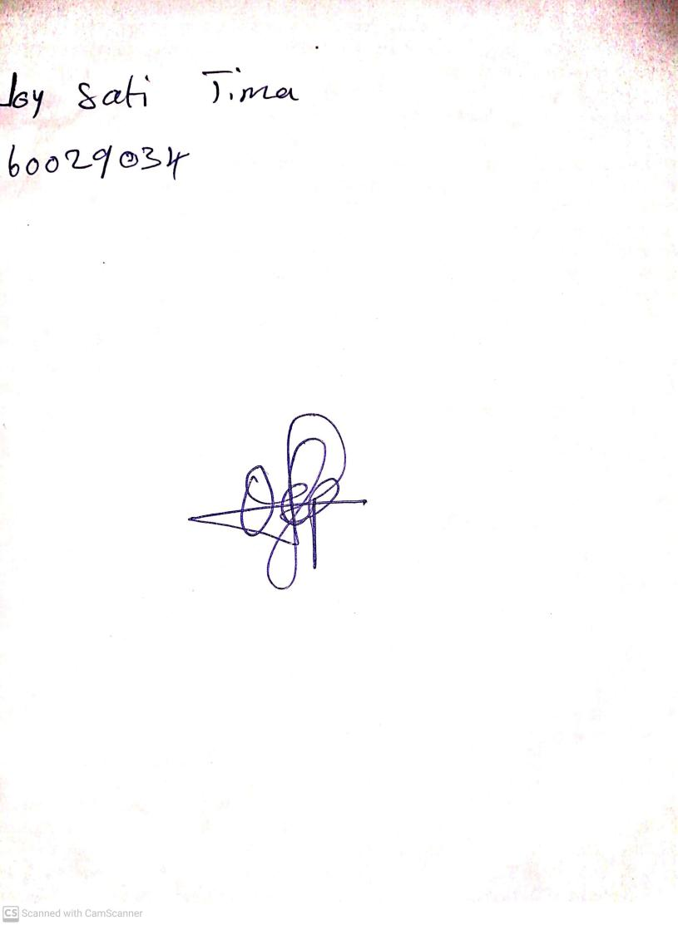

18th September, 2023

Perpetual Ojoma Ocheja

Stream Head Nursery