**EMERALD ROYAL INTERNATIONAL SCHOOL**

**MPAPE, ABUJA.**

**LESSON PLAN AND NOTE FOR WEEK 8 PERIOD 1 ENDING 08/11/2023**

TERM: FIRST

WEEK: 8TH

DATE: 04/11/2023

CLASS: NURSERY 2

SUBJECT: NUMBER WORK

TOPIC: ROMAN NUMERALS i - x .

SUB-TOPIC: NUMBERS IN ROMAN NUMERALS 1-5

PERIOD: 1ST.

TIME: O8:50-09:30.

DURATION: 40 MINUTES.

NUMBER IN CLASS: 14

AVERAGE AGE: 5 YEARS.

SEX: MIXED.

SPECIFIC OBJECTIVES: BY THE END OF THE LESSON,THE PUPILS SHOULD BE ABLE TO:

1. RECITE NUMBERS IN ROMAN NUMERALS i-v.
2. IDENTIFY NUMBERS IN ROMAN NUMERALS i - v.

RATIONALE: FOR PUPILS TO KNOW NUMBERS IN ROMANCE NUMERALS I - v

PREVIOU KNOWLEDGE: PUPILS HAVE LEARNT VARIOUS SHAPES IN PREVIOUS LESSON.

INSTRUCTIONAL MATERIALS: A CHART OF NUMBERS IN ROMAN NUMERALS 1-5.

REFERENCE MATERIALS: THE NEW MASTERING MATHEMATICS FOR NURSERY SCHOOLS BOOK 3 BY HENRY.Z.IDOGUN.

**LESSON DEVELOPMENT**

|  |  |  |  |
| --- | --- | --- | --- |
| STAGES/STEPS | TEACHER’S ACTIVITIES | PUPILS’ ACTIVITIES | LEARNING POINTS |
| INTRODUCTION | Teacher introduces the lesson by singing a number rhyme for the pupils. | Pupils sing the rhyme along with the teacher. | To arouse pupils interest in the lesson. |
| PRESENTATION  STEP 1 | Teacher recites numbers in roman numerals 1-5 and then asks pupils to repeat after her. | Pupils pay attention to the teacher and repeat after her. | To enhance pupils speakingability . |
| STEP 2 | Teacher writes numbers in roman numerals 1-5 on the board and then identify and asks pupils to repeat after her. As;  i - 1  ii -2  iii -3  iv - 4  V -5 | Pupils identify the numbers in roman numerals 1-5 on the board after the teacher. | For better understanding of the lesson. |
| BOARD SUMMARY | Teacher summarizes the lesson by preparing pupils books for them to copy the note on the board into their exercise books. | Pupils copy the note into their books. As;  NUMBERS IN ROMAN NUMERALS i - v.  i - 1  ii - 2  iii - 3  iv - 4  V - 5 | To build pupils writing skills. |
| EVALUATION | Teacher asks Pupils to   1. Recite numbers in roman numerals i–v on the board. 2. Read numbers in roman numerals i–v one after another. | Pupils read the numbers in roman numerals on the board one after another. | To assess pupis level of understanding. |
| CONCLUSION | Teacher ends the lesson by marking pupils books. | Pupils submit their booksfor marking. | For endorcement. |
| ASSIGNMENT (HOME WORK) | Identify and match the letter with numbers in roman numerals 1-5  iii 4  i 3  V 1  ii 5  iv 2 | Pupils do their assignment at home. | To encourage learning at home. |

**LESSON PLAN AND NOTE FOR WEEK 8 PERIOD 2 ENDING 08/11/2023**

TERM: FIRST

WEEK: 8TH

DATE: 05/11/2023

CLASS: NURSERY 2

SUBJECT: NUMBER WORK

TOPIC: ROMAN NUMERALS i - x .

SUB-TOPIC: ROMAN NUMERALS vi - x

PERIOD: 2ND.

TIME: O8:50-09:30.

DURATION: 40 MINUTES.

NUMBER IN CLASS: 14

AVERAGE AGE: 5 YEARS.

SEX: MIXED.

SPECIFIC OBJECTIVES: BY THE END OF THE LESSON,THE PUPILS SHOULD BE ABLE TO:

1.RECITE NUMBERS IN ROMAN NUMERALS VI -X

2. IDENTIFY NUMBERS IN ROMAN NUMERALS VI -X

RATIONALE: FOR PUPILS TO KNOW NUMBERS 6-10 IN ROMAN NUMERALS

PREVIOU KNOWLEDGE: PUPILS HAVE LEARNT NUMBERS IN ROMAN NUMERALS 1-5 IN PREVIOUS LESSON

INSTRUCTIONAL MATERIALS: CHART OF NUMBERS IN ROMAN NUMERALS 6-10.

REFERENCE MATERIALS: THE NEW MASTERING MATHEMATICS FOR NURSERY SCHOOLS BOOK 3 BY HENRY.Z.IDOGUN.

**LESSON DEVELOPMENT**

|  |  |  |  |
| --- | --- | --- | --- |
| STAGES/STEPS | TEACHER’S ACTIVITIES | PUPILS’ ACTIVITIES | LEARNING POINTS |
| INTRODUCTION | Teacher introduces the lesson by reviewing the previous lesson. | Pupil listen to the teacher. | To arouse pupils interest for the lesson ahead. |
| PRESENTATION  STEP 1 | Teacher recites numbers in roman numerals vi-x and then asks pupils to repeat after her. | Pupils recite numbers in roman numerals vi-x after the teacher. | For proper understanding of the lesson . |
| STEP 2 | Teacher then writes numbers in roman numerals vi-x on the board for pupils to identify after her. as,  NUMBERS IN ROMAN NUMERALS VI-X  Vi - 6  Vii - 7  Viii - 8  Ix - 9  X - 10 | Pupils identify the numbers in roman numerals vi-x on the board after the teacher. | For better understanding of the lesson. |
| BOARD SUMMARY | Teacher summarizes the lesson by going through the lesson on the board over and over again and then prepares pupils books for them to copy. | Pupils pay attention to the teacher as she summarizes the lesson and then copy their note. | For onward study |
| EVALUATION | Teacher asks Pupils to all stand and   1. sing numbers in roman numerals vi-x from the board. 2. Recite numbers in Roman numerals vi–x off hand. | Pupils stand and sing numbers in roman numerals vi-x all together. | To assess pupils understanding of the lesson. |
| CONCLUSION | Teacher marks pupils books. | Pupils submit their books for marking. | For endorsement. |
| ASSIGNMENT | Recite and write numbers in roman numerals vi-x. | Pupils do their assignment at home. | To encourage learning at home. |

**LESSON PLAN AND NOTE FOR WEEK 8 PERIOD 3 ENDING 08/11/2023**

TERM: FIRST

WEEK: 8TH

DATE: 08/11/2023

CLASS: NURSERY 2

SUBJECT: NUMBER WORK

TOPIC: ROMAN NUMERALS I-X .

SUB-TOPIC: NUMBERS IN ROMAN NUMERALS I-X

PERIOD: 3RD.

TIME: O8:1O- 08:50.

DURATION: 40 MINUTES.

NUMBER IN CLASS: 14

AVERAGE AGE: 5 YEARS.

SEX: MIXED.

SPECIFIC OBJECTIVES: BY THE END OF THE LESSON,THE PUPILS SHOULD BE ABLE TO:

1. RECITE NUMBERS IN ROMAN NUMERALS I-X
2. WRITE NUMBERS IN ROMAN NUMERALS I-X

RATIONALE: FOR PUPILS TO BE ABLE TO RECITEAND WRITE NUMBERS IN ROMAN NUMERALS I-X ON THEIR OWN

PREVIOU KNOWLEDGE: PUPILS HAVE LEARNT NUMBERS IN ROMAN NUMERALS VI-X IN PREVIOUS LESSON.

INSTRUCTIONAL MATERIALS: A CHART OF NUMBERS IN ROMAN NUMERALS I-X

REFERENCE MATERIALS: THE NEW MASTERING MATHEMATICS FOR NURSERY SCHOOLS BOOK 3 BY HENRY.Z.IDOGUN.

**LESSON DEVELOPMENT**

|  |  |  |  |
| --- | --- | --- | --- |
| STAGES/STEPS | TEACHER’S ACTIVITIES | PUPILS’ ACTIVITIES | LEARNING POINTS |
| INTRODUCTION | Teacher introduces the lesson by reviewing the previous lesson. | Pupil listen to the teacher. | To arouse pupils interest for the lesson ahead. |
| PRESENTATION  STEP 1 | Teacher recites numbers in roman numerals I-x and then asks pupils to repeat after her. | Pupils pay attention and recite numbers in roman numerals I-x after the teacher. | For proper understanding of the lesson . |
| STEP 2 | Teacher prepares pupils books for them to recite and write numbers in roman numerals I-x from their head. | Pupils recite and write numbers in roman numerals I-x on their own. | To test pupils ability of the topic treated so far. |
| BOARD SUMMARY | Teacher summarizes the lesson by writing the whole note of lesson on the board for pupils to copy. As;  NUMBERS IN ROMAN NUMERALS I-X  i - 1  ii - 2  iii - 3  iv - 4  V - 5  Vi - 6  Vii - 7  Viii - 8  Ix - 9  X - 10 | Pupils copy the note into their exercise books. | For onward study. |
| EVALUATION | Teacher asks pupils to:   1. Recite numbers in roman numerals i–x on the board. 2. Back the board and sing numbers in roman numerals i–x off hand. | Pupils recite numbers in roman numerals I-x . | To crate platform for slow learners. |
| CONCLUSION | Teacher marks pupils books. | Pupils submit their books for marking. | For endorsement. |
| ASSIGNMENT | Identify,sing and re-write numbers in roman numerals I-xx  I - 1  ----------------  Ii -2  ----------------  Iii -3  -----------------  Iv - 4  -----------------  V -5  -----------------  Vi -6  -----------------  Vii -7  -----------------  Viii -8  ----------------  Ix -9  ----------------  X -10  ----------------  Xi - 11  ----------------  Xii -12  ----------------  Xiii -13  ----------------  Xiv - 14  ----------------  Xv - 15  ---------------  Xvi - 16  -----------------  Xvii - 17  -----------------  Xviii - 18  -----------------  Xix - 19  -----------------  Xx - 20  ----------------- | Pupils do their assignment at home. | To encourage learning at home. |

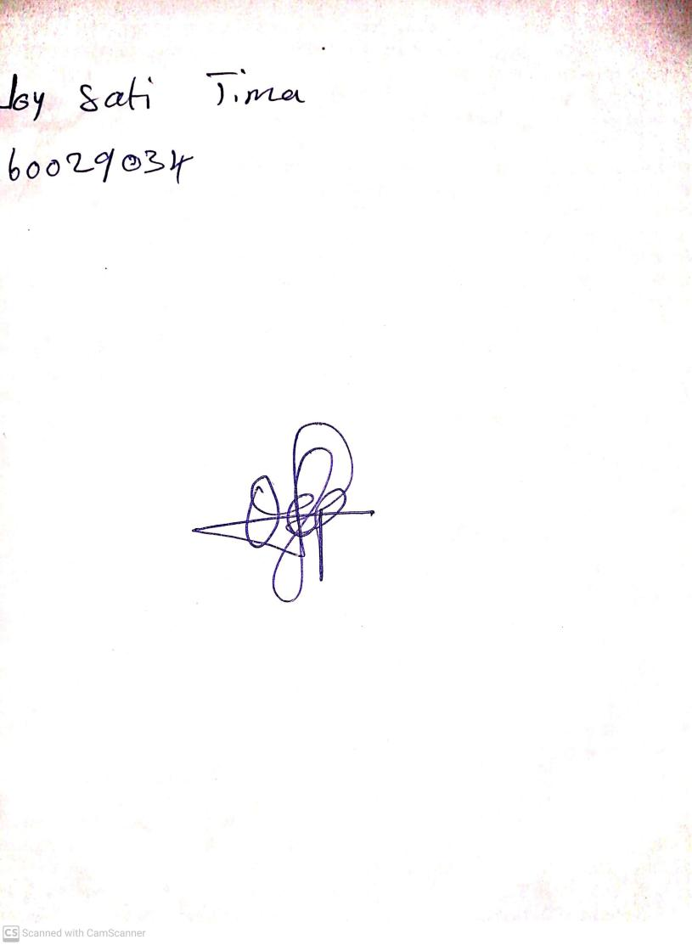

18th September, 2023

Perpetual Ojoma Ocheja

Stream Head Nursery