EMERALD ROYAL INTERNATIONAL SCHOOL MPAPE, ABUJA

LESSON PLAN AND NOTE FOR WEEK 9 PERIOD 1 ENDING 10/11/2023

TERM: FIRST

WEEK: 9TH

DATE: 06/11/2023

CLASS: NURSERY 2

SUBJECT: LETTER WORK

TOPIC: THREE LETTER WORDS ACROSS THE FIVE VOWELS

SUB-TOPIC: THREE LETTER WORDS WITH VOWEL “a” AND “e”

PERIOD: 3RD

TIME: 09: 30-10: 10 am

DURATION: 40 MINUTES

NUMBER IN CLASS: 16

AVERAGE AGE: 4

SEX: MIXED

SPECIFIC OBJECTIVES: BY THE END OF THE LESSON, THE PUPILS SHOULD BE ABLE

TO:

1.IDENTIFY THREE LETTER WORDS WITH VOWEL “a” AND “e”

2.SPELL AND PRONOUNCE THREE LETTER WORDS WITH

VOWEL “a” AND “e”

RATIONALE: FOR PUPILS TO BE ABLE TO SPELL AND PRONOUNCE WORDS WITH VOWERL “a” AND “e”

PREVIOUS KNOWLEDGE: PUPILS HAVE LEARNT THREE LETTER WORDS ENDING “ub” IN PREVIOUS LESSON.

INSTRUCTIONAL MATERIALS: A CHART OF THREE LETTER WORDS WITH VOWEL “a” AND “e”.

REFERENCE MATERIALS: TOP STAR MY CHOICE OF ENGLISH LANGUAGE STAGE 3 BY J.F OMOTAYO.

LESSON DEVELOPMENT

|  |  |  |  |
| --- | --- | --- | --- |
| STAGES/STEPS | TEACHER’S ACTIVITIES | PUPILS’ ACTIVITIES | LEARNING POINT |
| INTODUCTION | Teacher introduces the lesson by reviewing the previous lesson. | Pupils listen attentively to the teacher. | To arouse pupils interest for the lesson ahead. |
| PRESENTATION  STEP 1 | Teacher writes the three letter words with vowel “a” and “e” on the board and identify, and then asks them to repeat after her. | Pupils pay attention to the teacher and repeat after her. | For proper understanding. |
| STEP 2 | Teacher spells and pronounce the three letter words with vowel “a” and “e” on the board to pupils and also asks them to repeat after her. | Pupils listen very attentively to the teacher and repeat after her. | For better understanding of the lesson. |
| BOARD SUMMARY | Teacher summarizes the lesson by writing the whole note of lesson on the board for pupils to copy into their books. That is;  Three letter words with vowel “a” and “e”are:     |  |  |  | | --- | --- | --- | | S/N | “a” as in; | “e” as in; | | 1 | cat | leg | | 2 | fat | pen | | 3 | pat | egg | | 4 | map | get | | 5 | bad | met | | 6 | dad | ten | | 7 | rat | peg | | 8 | tag | net | | 9 | cap | men | | 10 | hat | beg | | 11 | sat | hen | | 12 | bat | bed | | 13 | fan | set | | 14 | mat | end | | 15 | Bag etc. | Fed etc. | | Pupils copy the note on the board into their exercise books. | For onward study. |
| EVALUATION | Teacher evaluates the lesson by asking the following questions:   1. identify three letter words with vowel “a” and “e” on the board. 2. Spell and pronounce the three letter words with vowel “a”. 3. Spell and pronounce the three letter words with vowel “e”. | Pupils answer the questions asked by the teacher. | To asses pupils level of understanding of the lesson. |
| CONCLUSION | Teacher concludes the lesson by marking pupils books. | Pupils submit their books for marking. | For endorsement. |
| ASSIGNMENT | Sound and write 10 three letter words with vowel “I” and 10 three letter words with vowel “o”. | Pupils do their assignment at home. | To encourage learning at home.s |

LESSON PLAN AND NOTE FOR WEEK 9 PERIOD 2 ENDING 10/11/2023

TERM: FIRST

WEEK: 9TH

DATE: 09/11/2023

CLASS: NURSERY 2

SUBJECT: LETTER WORK

TOPIC: THREE LETTER WORDS ACROSS THE FIVE VOWELS.

SUB-TOPIC: THREE LETTER WORDS ACROSS VOWEL “i” AND “o” .

PERIOD: 2ND

TIME: 08: 50-09: 30 am

DURATION: 40 MINUTES

NUMBER IN CLASS: 16

AVERAGE AGE: 4

SEX: MIXED

SPECIFIC OBJECTIVES: BY THE END OF THE LESSON, THE PUPILS SHOULD BE ABLE

TO:

1. IDENTIFY THREE LETTER WORDS ACROSS VOWEL “i” AND

“o”.

1. SPELL AND PRONOUNCE THREE LETTER WORDS

ACROSS VOWEL “i” AND “o”.

RATIONALE: FOR PUPILS TO BE ABLE TO SPELL AND PRONOUNCE WORDS

WITH VOWEL “i” AND “o”.

PREVIOUS KNOWLEDGE: PUPILS HAVE LEARNT THREE LETTER WORDS WITH VOWEL “a”AND “e” IN PREVIOUS LESSON.

INSTRUCTIONAL MATERIALS: A CHART OF THREE LETTER WORDS WITH VOWEL “i” AND “o”.

REFERENCE MATERIALS: TOP STAR MY CHOICE OF ENGLISH LANGUAGE STAGE 3 BY J.F OMOTAYO.

LESSON DEVELOPMENT

|  |  |  |  |
| --- | --- | --- | --- |
| STAGES/STEPS | TEACHER’S ACTIVITIES | PUPILS’ ACTIVITIES | LEARNING POINT |
| INTODUCTION | Teacher introduces the lesson by reviewing the previous lesson. | Pupils listen attentively to the teacher. | To arouse pupils interest for the lesson ahead. |
| PRESENTATION  STEP 1 | Teacher writes three letter words across vowel “i” and “o” on the board, identify and then asks pupils to repeat after her. | Pupils pay attention to the teacher and repeat after her. | For proper understanding. |
| STEP 2 | Teacher spells and pronounce the three letter words with vowel “i” and “o” to pupils and also asks them to repeat after her. | Pupils listen very attentively to the teacher and repeat after her. | For better understanding of the lesson. |
| BOARD SUMMARY | Teacher summarizes the lesson by writing the whole note of lesson on the board for pupils to copy into their books. That is;  Three letter words across vowel “i” and “o” are:   |  |  |  | | --- | --- | --- | | S/N1 | “i” as in; | “o” as in; | | 1 | fin | not | | 2 | big | pot | | 3 | lip | dog | | 4 | ink | top | | 5 | pig | hop | | 6 | lid | cot | | 7 | rib | god | | 8 | pin | toy | | 9 | sit | rod | | 10 | bin | got | | 11 | nib | pop | | 12 | bib | rob | | 13 | dig | lot | | 14 | him | boy | | 15 | Hit etc. | joy | | Pupils copy the note into their exercise books. | For onward study. |
| EVALUATION | Teacher evaluates the lesson by asking the following questions:   1. Identify three letter words across vowel “i” and “o” on the board. 2. Spell and pronounce the three letter words across vowel “i” and “o” on the board one after the other. | Pupils answer the questions asked by the teacher. | To asses pupils level of understanding of the lesson. |
| CONCLUSION | Teacher concludes the lesson by marking pupils books. | Pupils submit their books for marking. | For endorsement. |
| ASSIGNMENT | Identify, write and pronounce the following three letter words across vowel “i” and “o”.   1. i - n - k = 2. L- i - p = 3. R - i - b = 4. P - i - n = 5. S - i - t = 6. B - o - y = 7. T - o - y = 8. T - o - p = 9. G - o - d = 10. P - o - t = | Pupils do their assignment at home. | To encourage learning at home.s |

LESSON PLAN AND NOTE FOR WEEK 9 PERIOD 3 ENDING 10/11/2023

TERM: FIRST

WEEK: 9TH

DATE: 10/11/2023

CLASS: NURSERY 2

SUBJECT: LETTER WORK

TOPIC: THREE LETTER WORDS ACROSS THE FIVE VOWELS .

SUB-TOPIC: THREE LETTER WORDS WITH VOWEL “u”.

PERIOD: 3RD

TIME: 09: 30-10: 10 am

DURATION: 40 MINUTES

NUMBER IN CLASS: 16

AVERAGE AGE: 4

SEX: MIXED

SPECIFIC OBJECTIVES: BY THE END OF THE LESSON, THE PUPILS SHOULD BE ABLE

TO:

1.STATE THREE LETTER WORDS WITH VOWEL “u”

2.SPELL AND PRONOUNCE THREE LETTER WORDS ACROSS

VOWEL “u”.

RATIONALE: FOR PUPILS TO BE ABLE TO SPELL AND PRONOUNCE WORDS WITH VOWEL “u”.

PREVIOUS KNOWLEDGE: PUPILS HAVE LEARNT THREE LETTER WORDS ACROSS VOWEL “i” AND “o” IN PREVIOUS LESSON.

INSTRUCTIONAL MATERIALS: A CHART OF THREE LETTER WORDS WITH VOWEL “u” .

REFERENCE MATERIALS: TOP STAR MY CHOICE OF ENGLISH LANGUAGE STAGE 3 BY J.F OMOTAYO.

LESSON DEVELOPMENT

|  |  |  |  |
| --- | --- | --- | --- |
| STAGES/STEPS | TEACHER’S ACTIVITIES | PUPILS’ ACTIVITIES | LEARNING POINT |
| INTODUCTION | Teacher introduces the lesson by reviewing the previous lesson. | Pupils listen attentively to the teacher. | To arouse pupils interest for the lesson ahead. |
| PRESENTATION  STEP 1 | Teacher states the three letter words with vowel “u” to pupils and then asks them to repeat after her. | Pupils pay attention to the teacher and repeat after her. | For proper understanding. |
| STEP 2 | Teacher spells and pronounce the three letter words with vowel “u” to pupils and also asks them to repeat after her. | Pupils listen very attentively to the teacher and repeat after her. | For better understanding of the lesson. |
| BOARD SUMMARY | Teacher summarizes the lesson by writing the whole note of lesson on the board for pupils to copy into their books. That is;  Three letter words across vowel “u” are:  “u” as in;   1. Rub 2. Nub 3. Sub 4. Cub 5. Hub 6. Tub 7. Bub 8. Dub 9. Fub 10. Gub 11. Pub 12. Bus 13. Hut 14. Cup 15. Jug 16. Sun 17. Run 18. Hug 19. Mug 20. But etc. | Pupils copy the note on the board into their exercise books. | For onward study. |
| EVALUATION | Teacher evaluates the lesson by asking the following questions:   1. State the three letter words with vowel “u”.   2.Spell and pronounce the three letter words with vowel “u”. | Pupils answer the questions asked by the teacher. | To asses pupils level of understanding of the lesson. |
| CONCLUSION | Teacher concludes the lesson by marking pupils books. | Pupils submit their books for marking. | For endorsement. |
| ASSIGNMENT | Answer the following words:   1. What are rhyming words? 2. List 5 examples of rhyming words . | Pupils do their assignment at home. | To encourage learning at home.s |

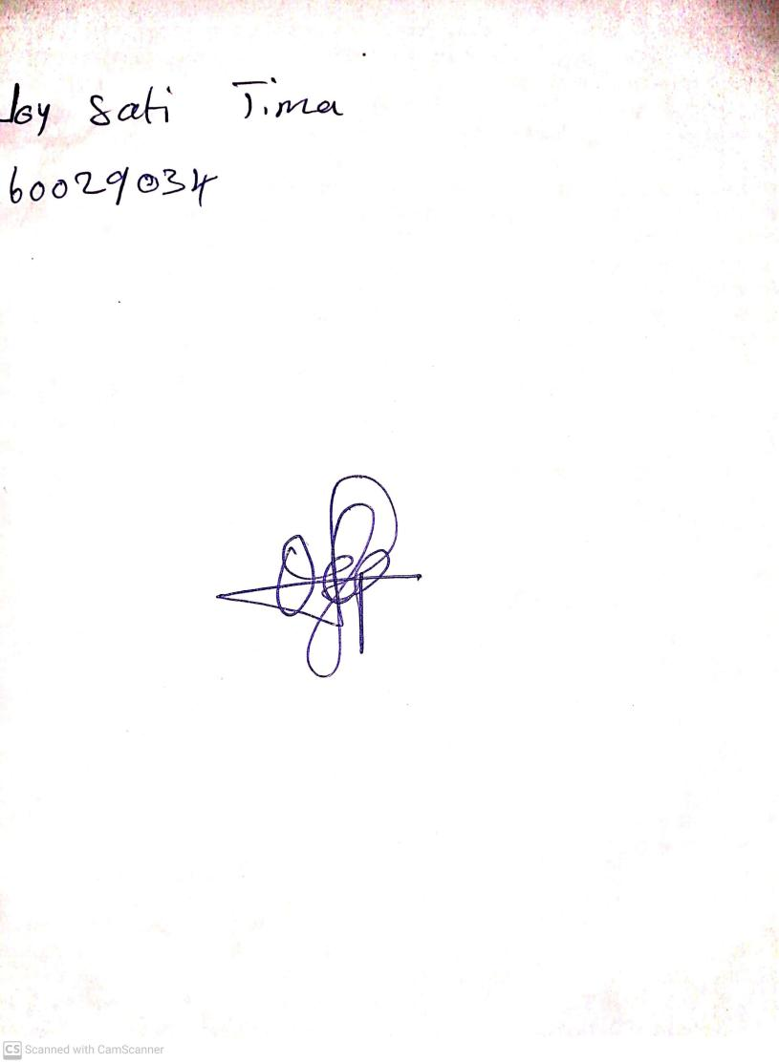

4TH November, 2023

Perpetual Ojoma Ocheja

Stream Head Nursery