**EMERALD ROYAL INTERNATIONAL SCHOOL, MPAPE ABUJA**

**LESSON PLAN AND NOTE FOR WEEK 4 ENDING FRIDAY, 6TH OCTOBER, 2023**

**TERM:** FIRST TERM

**WEEK:** WEEK 4

**SUBJECT:** ENGLISH LANGUAGE (SPEECH)

**TOPIC:** GREETINGS

**SUB-TOPIC:** SIMPLE GREETING AND RESPONSES

**DATE:** WEDNESDAY, 4TH OCTOBER, 2023

**TIME:** 02:00 – 02:20PM

**DURATION:** 30 MINUTES

**PERIOD:** 9TH

**CLASS:** NURSERY 3

**NUMBER IN CLASS:** ELEVEN

**AVERAGE AGE:** FIVE

**SEX:** MIXED

**LEARNING OBJECTIVES:** By the end of the lesson, the pupils should be able to:

1. Define greeting.
2. Practice the habit of greeting.

**RATIONALE:** For pupils to learn how to greet and respond to greeting.

**PREVIOUS KNOWLEGDE:** pupils have learnt animals and their sounds.

**INSTRUCTIONAL MATERIALS:**

1. Individual pupils
2. Textbook: Nigeria Primary English book 1 by B. Someye, D Dallas etal 2000

**REFERENCE MATERIALS:**

1. Nigeria Primary English book 1 by B. Someye, D Dallas etal 2000

**LESSON DEVELOPMENT**

|  |  |  |  |
| --- | --- | --- | --- |
| **STAGES/STEPS** | **TEACHER’S ACTIVITIES** | **PUPILS’ ACTIVITIES** | **LEARNING POINTS** |
| **INTRODUCTION** | Call pupils to the front of the classroom and pair them. | Move to the front of the classroom and stand with their partners. | Arousing pupils’ interest |
| **PRESENTATION**  **STEP 1** | Teaches pupils the meaning of greeting.  **Meaning of greeting**  Greeting is showing regard and honour for someone especially those that are older than us ( our elders). | Listens attentively. | For proper understanding. |
| **STEP 2** | Leads pupils to demonstrate greetings and responses in the classroom.  Pupils: Good morning, Miss Joy.  Miss Joy: Good morning, pupils.  How are you doing?  Pupils: Fine thank you, ma. | Demonstrate and learn how to greet and respond to greeting | For better understanding. |
| **SUMMARY** | Summarizes the lesson by emphasizing on the main concept and writes note on the board. | Listen and copy their notes | For onward study |
| **EVALUATION** | Ask pupils to:  1. Define greeting.  3. Demonstrate the act of greeting and response among themselves. | Respond to the teacher’s questions. | Based on stated objectives, and to test the pupils understanding of the lesson |
| **CONCLUSION** | Summarizes, correct and mark pupils’ notebooks. | Write the note on the board and submit their notebooks for marking | Clarifying the concept. |
| **HOME-WORK** | 1. Write down a dialogue section on greeting and response between you and your mummy. 2. Nigeria Primary English book 1 page 25 | Return home with task. | Extending lesson home. |

**LESSON PLAN AND NOTE FOR WEEK 3 ENDING FRIDAY, 6TH OCTOBER, 2023**

**TERM:** FIRST TERM

**WEEK:** WEEK 4

**SUBJECT:** ENGLISH LANGUAGE (GRAMMAR)

**TOPIC:** PUNCTUATION MARKS

**SUB-TOPIC:** PUNCTUATION: COMMA

**DATE:** MONDAY, 2ND OCTOBER, 2023

**TIME:** 01:20 – 02:00PM

**DURATION:** 40 MINUTES

**PERIOD:** 9TH

**CLASS:** NURSERY 3

**NUMBER IN CLASS:** ELEVEN

**AVERAGE AGE:** FIVE

**SEX:** MIXED

**LEARNING OBJECTIVES:** By the end of the lesson, the pupils should be able to:

1. Define a comma.
2. State the use of a comma.

**RATIONALE:** For pupils to know how to use the comma.

**PREVIOUS KNOWLEGDE:** pupils have learnt how to use the question mark.

**INSTRUCTIONAL MATERIALS:**

1. Textbook: Nigeria Primary English book 1 by B. Someye, D Dallas etal 2000

**REFERENCE MATERIALS:**

1. Nigeria Primary English book 1 by B. Someye, D Dallas etal 2000

**LESSON DEVELOPMENT**

|  |  |  |  |
| --- | --- | --- | --- |
| **STAGES/STEPS** | **TEACHER’S ACTIVITIES** | **PUPILS’ ACTIVITIES** | **LEARNING POINTS** |
| **INTRODUCTION** | Preview previous knowledge | Respond to the teacher | Arouse the pupils’ interest. |
| **PRESENTATION**  **STEP 1** | Teaches and explain the meaning of a comma.  **Meaning of a comma**  A comma is a punctuation mark that is used to separate two or more items in a sentence. | Listen attentively and learn. | For proper understanding. |
| **STEP 2** | Teaches and explain the use of a comma.  **Use of a comma**  A comma is used to separate two or more items in a sentence and between adjectives.  Examples.   1. The colours of the Nigerian flag are green, white, and green. 2. She bought onions, oranges, fish, and oil to prepare soup. 3. We saw a happy, lively woman. 4. She gave him a lovely, big gift. | Listen carefully and learn. | For better understanding. |
| **SUMMARY** | Summarizes the lesson by emphasizing on the main concept and writes note on the board. | Listen and copy their notes | For onward study |
| **EVALUATION** | Asks pupils to:  1. Define a comma.  2. write down three (3) sentences and indicate a comma. | Respond to the teacher’s question | To test the pupils’ understanding of the lesson. |
| **CONCLUSION** | Summarizes, correct and mark pupils’ notebooks. | Write the note on the board and submit their notebooks for marking | To consolidate the lesson. |
| **HOME-WORK** | Form five (5) sentences and indicate a comma. | Copy and return home with task. | Extending lesson home. |

**LESSON PLAN AND NOTE FOR WEEK 4 ENDING FRIDAY, 6TH OCTOBER, 2023**

**TERM:** FIRST TERM

**WEEK:** WEEK 4

**SUBJECT:** ENGLISH LANGUAGE (COMPREHENSION)

**TOPIC:** READING

**SUB-TOPIC:** MY FATHER’S FARM

**DATE:** THURSDAY, 5TH OCTOBER, 2023

**TIME:** 09:25AM – 09:55AM

**DURATION:** 30 MINUTES

**PERIOD:** 3RD

**CLASS:** NURSERY 3

**NUMBER IN CLASS:** ELEVEN

**AVERAGE AGE:** FIVE

**SEX:** MIXED

**LEARNING OBJECTIVES:** By the end of the lesson, the pupils should be able to:

1. Concentrate fully in reading.
2. Pronounce difficult words.
3. Answer the questions bellow the passage.

**RATIONALE:** For pupils to know how to read about ‘my father’s farm’.

**PREVIOUS KNOWLEGDE:** pupils have learnt how to read the passage ‘our house’.

**INSTRUCTIONAL MATERIALS:**

1. Textbook: Nigeria Primary English book 1 by B. Someye, D Dallas etal 2000

**REFERENCE MATERIALS:**

1. Nigeria Primary English book 1 by B. Someye, D Dallas etal 2000

**LESSON DEVELOPMENT**

|  |  |  |  |
| --- | --- | --- | --- |
| **STAGES/STEPS** | **TEACHER’S ACTIVITIES** | **PUPILS’ ACTIVITIES** | **LEARNING POINTS** |
| **INTRODUCTION** | Ask pupils to open their textbook to page 26. | Open their textbooks. | Arouse the pupils’ interest. |
| **PRESENTATION**  **STEP 1** | Teaches pupils how to read the passage ‘my father’s farm’.  We live in a village called Oloya. My father is a farmer. He became a farmer after his retirement from the civil service. My mother is a trader, but she sometimes helps my father on his farm.  In my father’s farm there are only food crops. They are yams, maize, cassava, oranges, cucumber, mangoes, vegetables, and potatoes. My father works hard on his farm every day. My father’s farm is very far from the the village. So he rides his bicycle to the farm every day.  My family uses a lot of the produce from the farm. However, my mother takes the excess produce to the market for sale. In this way, we are able to to have food at home, as well as some money to meet our other needs. | Spell numbers 1-10 in words. | For proper understanding |
| **STEP 2** | Leads pupils to pronounce difficult words from the passage.  **Words from the passage**  1. Village  2. Retirement  3. Trader  4. Bicycle  5. Money  6. Market  7. Vegetables  8. farm  9. Family  10. Produce | Spell and pronounce difficult words from the passage. | For better understanding. |
| **STEP 3** | Leads pupils to answer the questions from the passage.  1. Where do we live?  2. When did my father become a farmer  3. What kid of crops does he plant? | Answer the questions respectively.  1.We live in a village called Oloya..  2. My father became a farmer after his retirement fom the civil service.  3. He plant only food crops like yam, maize etc. | For examples understanding. |
| **SUMMARY** | Summarizes the lesson by emphasizing on the main concept and writes note on the board. | Listen and copy their notes | For onward study |
| **EVALUATION** | Ask pupils to:  1. Answer the questions under the passage. | Respond to the teacher’s question | To test the pupils understanding of the lesson. |
| **CONCLUSION** | Summarizes, correct and mark pupils’ notebooks. | Write the note on the board and submit their notebooks for marking | To consolidate the lesson. |
| **HOME-WORK** | Nigeria Primary English book 1 page 26, exercise 2 | Return home with task. | Extending the lesson home. |

**LESSON PLAN AND NOTE FOR WEEK 4 ENDING FRIDAY, 6TH OCTOBER, 2023**

**TERM:** FIRST TERM

**WEEK:** WEEK 4

**SUBJECT:** ENGLISH LANGUAGE (COMPOSITION)

**TOPIC:** LETTERS OF THE ALPHABET

**SUB-TOPIC:** CAPITAL AND SMALL LETTERS Ee-Hh

**DATE:** THURSDAY, 5TH OCTOBER, 2023

**TIME:** 11:10AM – 11:50AM

**DURATION:** 30 MINUTES

**PERIOD:** 5TH

**CLASS:** NURSERY 3

**NUMBER IN CLASS:** ELEVEN

**AVERAGE AGE:** FIVE

**SEX:** MIXED

**LEARNING OBJECTIVES:** By the end of the lesson, the pupils should be able to:

1. Identify capital and small letters Ee-Hh.
2. Read capital and small letters Ee-Hh.
3. Write capital and small letters Ee-Hh.

**RATIONALE:** For pupils to how to identify and write capital and small letters Ee-Hh.

**PREVIOUS KNOWLEGDE:** pupils have learnt how to write a cpmposition about their mother.

**INSTRUCTIONAL MATERIALS:**

1. Flash cards
2. Textbook

**REFERENCE MATERIALS:**

1. Nigeria Primary English book 2 by B. Someye, D Dallas etal 2000

**LESSON DEVELOPMENT**

|  |  |  |  |
| --- | --- | --- | --- |
| **STAGES/STEPS** | **TEACHER’S ACTIVITIES** | **PUPILS’ ACTIVITIES** | **LEARNING POINTS** |
| **INTRODUCTION** | Displays flash cards with letters of the alphabet on a flat surface. | Identify capital and small letters Ee-Hh. | Arouse pupils interest. |
| **PRESENTATION**  **STEP 1** | Leads pupils to identify capital and small letters Ee-Hh.  Ee Ff Gg  Hh | Identify capital and small letters Ee - Hh. | For proper understanding. |
| **STEP 2** | Leads pupils to read capital and small letter Ee-Hh  Ee Ff Gg  Hh | Read capital and small letters Ee - Hh. | For better understanding. |
| **STEP 3** | guides pupils to write capital and small letters Ee -Hh  Ee Ff Gg  Hh | Read capital and small letters Ee - Hh.. | For further understanding. |
| **SUMMARY** | Summarizes the lesson by emphasizing on the main concept and writes note on the board. | Listen and copy their notes | For onward study |
| **EVALUATION** | Asks pupils to:  1. Identify capital and small letters Ee - Hh..  2. Read capital and small letters Ee - Hh.  3. Write capital and small letters Ee - Hh. | Respond to the teachers questions. | To test the pupils understanding of the lesson. |
| **CONCLUSION** | Summarizes, correct and mark pupils’ notebooks. | Write the note on the board and submit their notebooks for marking | To consolidate the lesson. |
| **HOME-WORK** | Nigeria Primary English for schools book 1, page 28. | Returns home with task. | Extending lesson home. |

**LESSON PLAN AND NOTE FOR WEEK 4 ENDING FRIDAY, 6TH OCTOBER, 2023**

**TERM:** FIRST TERM

**WEEK:** WEEK 4

**SUBJECT:** ENGLISH LANGUAGE (PHONICS)

**TOPIC:** SOUND BANKS

**SUB-TOPIC:** WORDS WITH THE SOUND /Ʊ/ AND /u:/

**DATE:** TUESDAY, 3RD OCTOBER, 2023

**TIME:** 10:30AM – 11:10AM

**DURATION:** 30 MINUTES

**PERIOD:** 4TH

**CLASS:** NURSERY 3

**NUMBER IN CLASS:** ELEVEN

**AVERAGE AGE:** FIVE

**SEX:** MIXED

**LEARNING OBJECTIVES:** By the end of the lesson, the pupils should be able to:

1. Identify the sounds /Ʊ/ and /u:/
2. Pronounce the sounds / /Ʊ/ and /u:/
3. List words with the sounds /Ʊ/ and /u:/

**RATIONALE:** For pupils to learn how pronounce the sounds /Ʊ/ and /u:/ and identify words associated with the sounds.

**PREVIOUS KNOWLEGDE:** pupils have learnt how to pronounce the sounds /æ/ and /a:/ and identify words that is associated with the sounds.

**INSTRUCTIONAL MATERIALS:**

1. Flash cards.
2. Pictorial charts.

**REFERENCE MATERIALS:**

1. Nigeria Primary English book 2 by B. Someye, D Dallas etal 2000

**LESSON DEVELOPMENT**

|  |  |  |  |
| --- | --- | --- | --- |
| **STAGES/STEPS** | **TEACHER’S ACTIVITIES** | **PUPILS’ ACTIVITIES** | **LEARNING POINTS** |
| **INTRODUCTION** | Displays flash cards on a flat surface. | Respond to the teacher’s questions. | Arouse pupils interest. |
| **PRESENTATION**  **STEP 1** | Leads pupils to identify the sounds /Ʊ/ and /u:/ on a flash card.  **/Ʊ/ /u:/** | Identify the sounds. | For proper understanding. |
| **STEP 2** | Teaches pupils how to pronounce the sounds /Ʊ/ and /u:/  /Ʊ/ is a short vowel sound that can be pronounced with the back of the tongue raised to a mid-high position.  /u:/ is a long vowel sound. To pronounce the /u:/, you put your tongue high and at the back of your mouth and lightly push your lips together. | Pronounce the sounds as taught by the teacher. | For better understanding. |
| **STEP 3** | Teaches pupils words with the sounds /æ/ and /a:/  Words the the sound /Ʊ/   1. Pull 2. Put 3. Book 4. Look 5. Full 6. Woman   Words with the sound /u:/   1. School 2. Food 3. Fruit 4. New 5. Shoe 6. Use | Learn the words with the sounds /æ/ and /a:/ | For further understanding. |
| **SUMMARY** | Summarizes the lesson by emphasizing on the main concept and writes note on the board. | Listen and copy their notes | For onward study |
| **EVALUATION** | Asks pupils to:   1. Identify the sounds /Ʊ/ and /u:/ 2. Pronounce the sounds /Ʊ/ and /u:/ 3. List two words with each of the sounds /Ʊ/ and /u:/ | Respond to the teacher’s questions. | To test the pupils understanding of the lesson. |
| **CONCLUSION** | Summarizes, correct and mark pupils’ notebooks. | Write the note on the board and submit their notebooks for marking | To consolidate the lesson. |
| **HOME-WORK** | Nigeria Primary English for school book 1, page 23 | Return home with task. | Extending lesson home. |

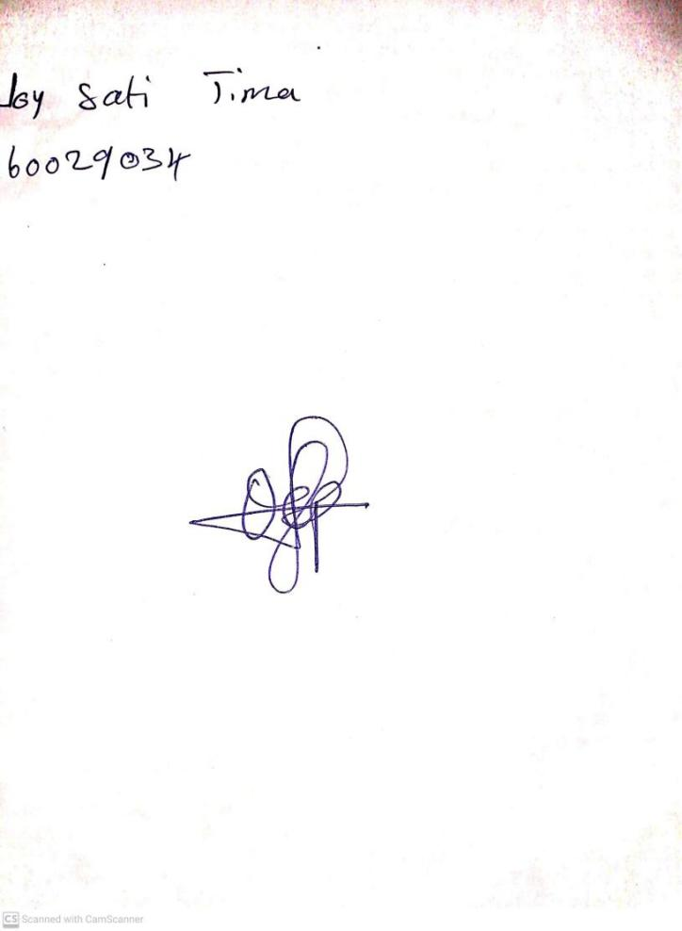

29TH September, 2023

Perpetual Ojoma Ocheja

Stream Head Nursery