**EMERALD ROYAL INTERNATIONAL SCHOOL, MPAPE ABUJA**

**LESSON PLAN AND NOTE FOR WEEK 4 ENDING FRIDAY, 2ND FEBRUARY, 2024**

**TERM:** FIRST TERM

**WEEK:** WEEK 4

**SUBJECT:** ENGLISH LANGUAGE (SPEECH)

**TOPIC:** RHYME

**SUB-TOPIC:** MEANING OF RHYME

**DATE:** WEDNESDAY, 31ST JANUARY, 2024

**TIME:** 02:00 – 02:20PM

**DURATION:** 30 MINUTES

**PERIOD:** 9TH

**CLASS:** NURSERY 3

**NUMBER IN CLASS:** TWELVE

**AVERAGE AGE:** FIVE

**SEX:** MIXED

**LEARNING OBJECTIVES:** By the end of the lesson, the pupils should be able to:

1. Define rhyme.
2. Sing the rhyme ‘Old Macdonald’.

**RATIONALE:** For pupils to learn the meaning of rhyme.

**PREVIOUS KNOWLEGDE:** pupils have learnt simple command.

**INSTRUCTIONAL MATERIALS:**

1. Individual pupils
2. Textbook: Nigeria Primary English book 1 by B. Someye, D Dallas etal 2000

**REFERENCE MATERIALS:**

1. Nigeria Primary English book 1 by B. Someye, D Dallas etal 2000

**LESSON DEVELOPMENT**

|  |  |  |  |
| --- | --- | --- | --- |
| **STAGES/STEPS** | **TEACHER’S ACTIVITIES** | **PUPILS’ ACTIVITIES** | **LEARNING POINTS** |
| **INTRODUCTION** | Review previous knowledge. | Respond to the teacher. | Arousing pupils’ interest |
| **PRESENTATION**  **STEP 1** | Teaches pupils the meaning of rhyme.  **Meaning of rhyme**  Rhymes is a repetition of similar sounds in two or more words. | Listens attentively. | For proper understanding. |
| **STEP 2** | Leads pupils to open their textbooks to page 115 and sing the poem ‘Old Macdonald’. | Sing the poem ‘Old Macdonald. | For better understanding. |
| **SUMMARY** | Summarizes the lesson by emphasizing on the main concept and writes note on the board. | Listen and copy their notes | For onward study |
| **EVALUATION** | Ask pupils to:  1. Define rhyme.  3. sing the poem ‘Old Macdonald’. | Respond to the teacher’s questions. | Based on stated objectives, and to test the pupils understanding of the lesson |
| **CONCLUSION** | Summarizes, correct and mark pupils’ notebooks. | Write the note on the board and submit their notebooks for marking | Clarifying the concept. |
| **HOME-WORK** | 1. Nigeria Primary English book 1 page 115 | Return home with task. | Extending lesson home. |

**LESSON PLAN AND NOTE FOR WEEK 4 ENDING FRIDAY, 2ND FEBRUARY, 2024**

**TERM:** FIRST TERM

**WEEK:** WEEK 4

**SUBJECT:** ENGLISH LANGUAGE (GRAMMAR)

**TOPIC:** CONTRACTIONS

**SUB-TOPIC:** MEANING OF CONTRACTIONS

**DATE:** MONDAY, 29TH JANUARY, 2024

**TIME:** 01:20 – 02:00PM

**DURATION:** 30 MINUTES

**PERIOD:** 8TH

**CLASS:** NURSERY 3

**NUMBER IN CLASS:** TWELVE

**AVERAGE AGE:** FIVE

**SEX:** MIXED

**LEARNING OBJECTIVES:** By the end of the lesson, the pupils should be able to:

1. Define contractions.
2. Examples of contracted words.

**RATIONALE:** For pupils to know the meaning of contractions and examples of contracted words.

**PREVIOUS KNOWLEGDE:** pupils have learnt about compound words.

**INSTRUCTIONAL MATERIALS:**

1. Textbook: Nigeria Primary English book 1 by B. Someye, D Dallas etal 2000

**REFERENCE MATERIALS:**

1. Nigeria Primary English book 1 by B. Someye, D Dallas etal 2000

**LESSON DEVELOPMENT**

|  |  |  |  |
| --- | --- | --- | --- |
| **STAGES/STEPS** | **TEACHER’S ACTIVITIES** | **PUPILS’ ACTIVITIES** | **LEARNING POINTS** |
| **INTRODUCTION** | Preview previous knowledge | Respond to the teacher | Arouse the pupils’ interest. |
| **PRESENTATION**  **STEP 1** | Teaches and explain the meaning of contraction.  **Meaning of contractions**  Contraction means words that are shortened and joined together with the use of an apostrophe (‘) to replace the letter or letters that have been removed. | Listen attentively and learn. | For proper understanding. |
| **STEP 2** | Teaches and give the examples of contracted words  **Examples of contracted words**   1. Have not = haven’t 2. Has not = hasn’t 3. Are not = aren’t 4. Is not = isn’t 5. Does not = doesn’t 6. Was not = wasn’t 7. I am =I’m | Listen carefully and learn. | For better understanding. |
| **SUMMARY** | Summarizes the lesson by emphasizing on the main concept and writes note on the board. | Listen and copy their notes | For onward study |
| **EVALUATION** | Asks pupils to:  1. Define contraction.  2. give the examples of contracted words. | Respond to the teacher’s question | To test the pupils’ understanding of the lesson. |
| **CONCLUSION** | Summarizes, correct and mark pupils’ notebooks. | Write the note on the board and submit their notebooks for marking | To consolidate the lesson. |
| **HOME-WORK** | 1. Nigeria Primary English, book 1 page 118, workbook page 27 | Copy and return home with task. | Extending lesson home. |

**LESSON PLAN AND NOTE FOR WEEK 4 ENDING FRIDAY, 2ND FEBRUARY, 2024**

**TERM:** FIRST TERM

**WEEK:** WEEK 4

**SUBJECT:** ENGLISH LANGUAGE (COMPREHENSION)

**TOPIC:** READING

**SUB-TOPIC:** THE MAN, THE BOY AND THE DONKEY

**DATE:** THURSDAY, 1ST AND FRIDAY, 2ND FEBRUARY, 2024

**TIME:** 09:25 – 10:55AM AND 11: 25 – 12PM

**DURATION:** 30 MINUTES

**PERIOD:** 3RD AND 6TH

**CLASS:** NURSERY 3

**NUMBER IN CLASS:** TWELVE

**AVERAGE AGE:** FIVE

**SEX:** MIXED

**LEARNING OBJECTIVES:** By the end of the lesson, the pupils should be able to:

1. Concentrate fully in reading.
2. Pronounce difficult words.
3. Answer the questions bellow the passage.

**RATIONALE:** For pupils to know how to read about ‘the boy, the boy and the donkey’.

**PREVIOUS KNOWLEGDE:** pupils have learnt how to read the passage ‘the pig and the tortoise’.

**INSTRUCTIONAL MATERIALS:**

1. Textbook: Nigeria Primary English book 1 by B. Someye, D Dallas etal 2000

**REFERENCE MATERIALS:**

1. Nigeria Primary English book 1 by B. Someye, D Dallas etal 2000

**LESSON DEVELOPMENT**

|  |  |  |  |
| --- | --- | --- | --- |
| **STAGES/STEPS** | **TEACHER’S ACTIVITIES** | **PUPILS’ ACTIVITIES** | **LEARNING POINTS** |
| **INTRODUCTION** | Ask pupils to open their textbook to page 116. | Open their textbooks. | Arouse the pupils’ interest. |
| **PRESENTATION**  **STEP 1** | Teaches pupils how to read the passage ‘the man, the boy and the donkey’.  A man and his son was once going with their donkey to the market. As they were walking along by the roadside, a countryman passed and said, ‘you fools, what is a donkey for, but to ride upon?’…. | Spell numbers 1-10 in words. | For proper understanding |
| **STEP 2** | Leads pupils to pronounce difficult words from the passage.  **Words from the passage**  1. Donkey  2. Roadside  3. Lazy  4. Bridge  5. Countryman  6. Young  7. Shame  8. Struggle  9. Laughed  10. Drowned | Spell and pronounce difficult words from the passage. | For better understanding. |
| **STEP 3** | Leads pupils to answer the questions from the passage.  1. Where were they going?  2. Who first sat on the donkey?  3. Who accused the man of being lazy? | Answer the questions respectively.  1.They were going to the market.  2. The son.  3. A woman. | For examples understanding. |
| **SUMMARY** | Summarizes the lesson by emphasizing on the main concept and writes note on the board. | Listen and copy their notes | For onward study |
| **EVALUATION** | Ask pupils to:  1. Answer the questions under the passage on page 117 of their text book. | Respond to the teacher’s question | To test the pupils understanding of the lesson. |
| **CONCLUSION** | Summarizes, correct and mark pupils’ notebooks. | Write the note on the board and submit their notebooks for marking | To consolidate the lesson. |
| **HOME-WORK** | Nigeria Primary English book 1 page 117, exercise 1 and 2 | Return home with task. | Extending the lesson home. |

**LESSON PLAN AND NOTE FOR WEEK 4 ENDING FRIDAY, 2ND FEBRUARY, 2024**

**TERM:** FIRST TERM

**WEEK:** WEEK 4

**SUBJECT:** ENGLISH LANGUAGE (COMPOSITION)

**TOPIC:** LETTERS OF THE ALPHABET

**SUB-TOPIC:** CAPITAL AND SMALL LETTERS Mm - Pp

**DATE:** THURSDAY, 1ST FEBRUARY, 2024

**TIME:** 11:10 – 11:50PM

**DURATION:** 40 MINUTES

**PERIOD:** 5TH

**CLASS:** NURSERY 3

**NUMBER IN CLASS:** TWELVE

**AVERAGE AGE:** FIVE

**SEX:** MIXED

**LEARNING OBJECTIVES:** By the end of the lesson, the pupils should be able to:

1. Identify capital and small letters Mm - Pp.
2. Read capital and small letters Mm - Pp.
3. Write capital and small letters Mm - Pp.

**RATIONALE:** For pupils to how to identify and write capital and small letters Mm - Pp.

**PREVIOUS KNOWLEGDE:** pupils have learnt how to form sentence from a given table

**INSTRUCTIONAL MATERIALS:**

1. Flash cards
2. Textbook

**REFERENCE MATERIALS:**

1. Nigeria Primary English book 1 by B. Someye, D Dallas etal 2000

**LESSON DEVELOPMENT**

|  |  |  |  |
| --- | --- | --- | --- |
| **STAGES/STEPS** | **TEACHER’S ACTIVITIES** | **PUPILS’ ACTIVITIES** | **LEARNING POINTS** |
| **INTRODUCTION** | Displays flash cards with letters of the alphabet on a flat surface. | Identify capital and small letters Mm - Pp. | Arouse pupils interest. |
| **PRESENTATION**  **STEP 1** | Leads pupils to identify capital and small letters Mm - Pp.  Mm Nn  Oo Pp | Identify capital and small letters Mm - Pp. | For proper understanding. |
| **STEP 2** | Leads pupils to read capital and small letter Mm - Pp  Mm Nn  Oo Pp | Read capital and small letters Mm - Pp | For better understanding. |
| **STEP 3** | guides pupils to write capital and small letters Mm - Pp  Mm Nn  Oo Pp | Read capital and small letters Mm - Pp | For further understanding. |
| **SUMMARY** | Summarizes the lesson by emphasizing on the main concept and writes note on the board. | Listen and copy their notes | For onward study |
| **EVALUATION** | Asks pupils to:  1. Identify capital and small letters Mm - Pp  2. Read capital and small letters Mm - Pp  3. Write capital and small letters Mm - Pp. | Respond to the teachers questions. | To test the pupils understanding of the lesson. |
| **CONCLUSION** | Summarizes, correct and mark pupils’ notebooks. | Write the note on the board and submit their notebooks for marking | To consolidate the lesson. |
| **HOME-WORK** | Nigeria Primary English for schools book 1, page 28. | Returns home with task. | Extending lesson home. |

**LESSON PLAN AND NOTE FOR WEEK 4 ENDING FRIDAY, 2ND FEBRUARY, 2024**

**TERM:** FIRST TERM

**WEEK:** WEEK 4

**SUBJECT:** ENGLISH LANGUAGE (PHONICS)

**TOPIC:** SOUND BANKS

**SUB-TOPIC:** WORDS WITH THE SOUND /ծ/

**DATE:** TUESDAY, 30TH FEBRUARY, 2024

**TIME:** 10:30 – 11:10AM

**DURATION:** 40 MINUTES

**PERIOD:** 4TH

**CLASS:** NURSERY 3

**NUMBER IN CLASS:** TWELVE

**AVERAGE AGE:** FIVE

**SEX:** MIXED

**LEARNING OBJECTIVES:** By the end of the lesson, the pupils should be able to:

1. Identify the sounds /ծ/
2. Pronounce the sounds /ծ/
3. List words with the sounds /ծ/

**RATIONALE:** For pupils to learn how pronounce the sounds /ծ/ and identify words associated with the sounds.

**PREVIOUS KNOWLEGDE:** pupils have learnt how to pronounce the sounds /θ/ and /a:/ and identify words that is associated with the sounds.

**INSTRUCTIONAL MATERIALS:**

1. Flash cards.
2. Pictorial charts.

**REFERENCE MATERIALS:**

1. Nigeria Primary English book 2 by B. Someye, D Dallas etal 2000

**LESSON DEVELOPMENT**

|  |  |  |  |
| --- | --- | --- | --- |
| **STAGES/STEPS** | **TEACHER’S ACTIVITIES** | **PUPILS’ ACTIVITIES** | **LEARNING POINTS** |
| **INTRODUCTION** | Displays flash cards on a flat surface. | Respond to the teacher’s questions. | Arouse pupils interest. |
| **PRESENTATION**  **STEP 1** | Leads pupils to identify the sounds /ծ/ on a flash card.  **/ծ/** | Identify the sounds. | For proper understanding. |
| **STEP 2** | Teaches pupils how to pronounce the sounds /ծ/  /ծ/ is a voiced ‘th’ sound | Pronounce the sounds as taught by the teacher. | For better understanding. |
| **STEP 3** | Teaches pupils words with the sounds /ծ/  **Words the the sound /ծ/**   1. them 2. then 3. those 4. that 5. mother 6. father 7. with 8. weather 9. these 10. the | Learn the words with the sounds /ծ/ | For further understanding. |
| **SUMMARY** | Summarizes the lesson by emphasizing on the main concept and writes note on the board. | Listen and copy their notes | For onward study |
| **EVALUATION** | Asks pupils to:   1. Identify the sounds /ծ/ 2. Pronounce the sounds /ծ/ 3. List two words with each of the sounds /ծ/ / | Respond to the teacher’s questions. | To test the pupils understanding of the lesson. |
| **CONCLUSION** | Summarizes, correct and mark pupils’ notebooks. | Write the note on the board and submit their notebooks for marking | To consolidate the lesson. |
| **HOME-WORK** | Nigeria Primary English for school workbook 1, page 27 | Return home with task. | Extending lesson home. |

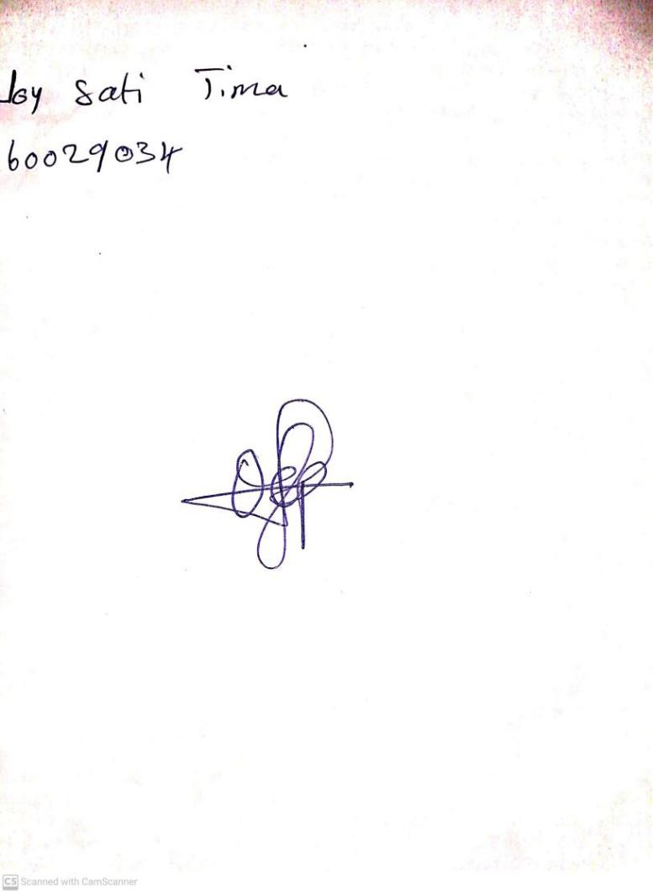

26TH January, 2024

Perpetual Ojoma Ocheja

Stream Head Nursery