**EMERALD ROYAL INTERNATIONAL SCHOOL MPAPE, ABUJA**

**LESSON PLAN AND NOTE FOR WEEK 1 PERIOD 1 ENDING 12/01/2024**

**TERM: Second**

**WEEK: 1**

**DATE: 08/01/2024**

**CLASS: Nursery 2**

**SUBJECT: Numeracy**

**TOPIC: Revision of first term work**

**SUB–TOPIC: Revision on numbers in Roman numerals I— X**

**PERIOD: 2nd**

**TIME: 08:50—09:30 am**

**DURATION: 40 minutes**

**NUMBER IN CLASS: 13**

**AVERAGE AGE: 5 years**

**SEX: mixed**

**SPECIFIC OBJECTIVES: By the end of the lesson, the pupils should be able to:**

**1: Recite Roman numerals I – x**

**2: write Roman numerals I –x**

**RATIONALE: For pupils to glance through the last topic for previous term.**

**PREVIOUS KNOWLEDGE: Pupil have learnt the topic in previous term.**

**INSTRUCTIONAL MATERIALS: A chart of Roman numerals I – x**

**REFERENCE MATERIALS: The new mastering mathematics for nursery schools book 3 by J.M OMOGBA**

**LESSON DEVELOPMENT**

|  |  |  |  |
| --- | --- | --- | --- |
| **Stages/ steps** | **Teacher’s activities** | **Pupils’ activities** | **Learning point** |
| **Introduction** | **Teacher introduces the lesson by singing number rhymes** | **Pupils sing the rhymes along with the teacher** | **To arouse pupils interest for the lesson ahead.** |
| **Presentation step 1** | **Teacher presents the lesson by writing numbers in Roman numerals on the board from I –X, read and asks pupils to repeat after him or her. That is;**  **Numbers in Roman numerals 1—10 are:**  **i — 1**  **ii — 2**  **iii — 3**  **iv — 4**  **v — 5**  **vi — 6**  **vii — 7**  **viii — 8**  **ix — 9**  **x — 10** | **Pupils listen attentively to the teacher and repeat after him or her.** | **To improve pupils listening and speaking ability.** |
| **Step 2** | **Teacher prepares pupils books for them to identify and write numbers in Roman numerals from the board into their books** | **Pupils write the numbers in roman numerals into their exercise books. That is :**  **NUMBERS IN ROMAN NUMERALS**  **i — 1**  **ii — 2**  **iii — 3**  **iv — 4**  **v — 5**  **vi — 6**  **vii — 7**  **viii — 8**  **ix — 9**  **x — 10** | **To enhance pupils writing ability.** |
| **Board summary** | **Teacher summarizes the lesson on the board by going through the lesson over again.** | **Pupils pay attention to the teacher.** | **To create platform for slow learners.** |
| **Evaluation** | **Teacher evaluates the lesson by asking pupils to recite the numbers in Roman numerals on the board one after the other.** | **Pupils recite the Roman numerals on the board one after another.** | **To assess pupils level of understanding.** |
| **Conclusion** | **Teacher concludes the lesson by marking pupils books.** | **Pupils submit their books on teachers table for marking.** | **For endorsement.** |
| **Assignment**  **(Home work).** | **Recite and write numbers in Roman numerals 11—20.** | **Pupils do their assignment at home.** | **To encourage learning at home.** |

**LESSON PLAN AND NOTE FOR WEEK 1 PERIOD 2 ENDING 12/01/2024**

**TERM: 2nd**

**WEEK: 1st**

**DATE: 09/01/2024**

**CLASS: Nursery 2**

**SUBJECT: Number work**

**TOPIC: Revision**

**SUB—TOPIC: Revision numbers in Roman numerals xi — xx**

**PERIOD: 2nd**

**TIME: 08:40 —09:30am**

**DURATION: 40 minutes**

**NUMBER IN CLASS: 13**

**AVERAGE AGE: 5 years**

**SEX: mixed**

**LEARNING OBJECTIVES: By the end of the lesson, the pupils should be able to:**

**1. Recite numbers in Roman numerals xi — xx**

**2. Write numbers in Roman numerals xi — xx**

**RATIONALE: For pupils to memorise on previous terms work.**

**PREVIOUS KNOWLEDGE: Pupils have learnt numbers in Roman numerals i — x in previous Lesson.**

**INSTRUCTIONAL MATERIALS: A chart of numbers in Roman numerals.**

**REFERENCE MATERIALS: The new mastering mathematics for Nursery schools book 3 by J.M OMOGBAI.**

**LESSON DEVELOPMENT**

|  |  |  |  |
| --- | --- | --- | --- |
| **Stages/steps** | **Teacher's activities** | **Pupils' activities** | **Learning point** |
| **Introduction** | **Teacher introduces the lesson by reciting numbers in Roman numerals i — x.** | **Pupils recite the numbers in Roman numerals i — x along with the teacher.** | **To prepare pupils minds for the lesson ahead.** |
| **Presentation step 1** | **Teacher writes numbers in Roman numerals xi — xx on the board,read and then asks Pupils to repeat after her. That is;**  **NUMBERS IN ROMAN NUMERALS XI — XX**  **xi — 11**  **xii — 12**  **xiii — 13**  **xiv — 14**  **xv — 15**  **xvi — 16**  **xvii — 17**  **xviii — 18**  **xix — 19**  **xx — 20** | **Pupils pay attention to the teacher and repeat after her.** | **For proper understanding.** |
| **Step 2** | **Teacher prepares pupils book for them to copy the note on the board into their exercise books.** | **Pupils copy the note on the board into their exercise books.** | **For better understanding.** |
| **Board summary** | **Teacher summarizes the lesson by reading the numbers in Roman numerals on the board over and over again.** | **Pupils listen to the teacher.** | **For onward study.** |
| **Evaluation** | **Teacher evaluates the lesson by asking pupils to recite numbers in Roman numerals one after the other.** | **Pupils go to the board one after the other and read.** | **To assess pupils reading ability.** |
| **Conclusion** | **Teacher marks pupils books.** | **Pupils submit their books for marking.** | **For endorsement.** |
| **Assignment** | **Sing and write numbers in Roman numerals i — xx.** | **Pupils do their assignment at home.** | **To encourage learning at home.** |

**LESSON PLAN AND NOTE FOR WEEK 1 PERIOD 3 ENDING 12/01/2024**

**TERM: 2nd**

**WEEK: 1**

**DATE: 12/01/2024**

**CLASS: Nursery 2**

**SUBJECT: Number work**

**TOPIC: Revision on multiplication table 2**

**SUB—TOPIC: Reciting and writing multiplication table 2**

**PERIOD: 1st**

**TIME: 08:10—08:50**

**DURATION: 40 minutes**

**NUMBER IN CLASS: 13**

**AVERAGE AGE: 5 years**

**SEX: Mixed**

**LEARNING OBJECTIVES: By the end of the lesson,the pupils should be able to:**

**1: Recite multiplication table 2**

**2: write multiplication table2**

**RATIONALE: For pupils to be conversant with multiplication table 2**

**PREVIOUS KNOWLEDGE: Pupils have learnt numbers in Roman numerals 1—20 in previous lesson.**

**INSTRUCTIONAL MATERIALS: A chart of multiplication table 2**

**REFERENCE MATERIALS: Pupils back cover page book.**

**LESSON DEVELOPMENT**

|  |  |  |  |
| --- | --- | --- | --- |
| **STEPS** | **TEACHER’S ACTIVITIES** | **PUPILS’ ACTIVITIES** | **LEARNING POINT** |
| **Introduction** | **Teacher introduces the lesson by asking pupils to recite numbers in Roman numerals 1—20** | **Pupils recite the numbers in roman numerals 1—20** | **To arouse pupils interest for the lesson ahead.** |
| **Presentation step 1** | **Teacher presents the lesson by reciting multiplication table 2 and asks pupils to repeat after him or her.** | **Pupils listen attentively and repeat after the teacher** | **To enhance pupils participation in class.** |
| **Step 2** | **Teacher writes multiplication table 2 on the board for pupils to identify. That is;**  **MULTIPLICATION TABLE 2**  **2 × 1= 2**  **2 × 2= 4**  **2 × 3= 6**  **2 × 4= 8**  **2 × 5= 10**  **2 × 6= 12**  **2 × 7= 14**  **2 × 8= 16**  **2 × 9= 18**  **2 × 10= 20**  **2 × 11= 22**  **2 × 12= 24** | **Pupils identify the table on the board** | **To improve pupils identification ability.** |
| **Board summary** | **Teacher summarizes the lesson by preparing pupils books for them to copy the note from the board** | **Pupils copy the note into their exercise books.** | **To improve pupils writing skills.** |
| **Evaluation** | **Teacher evaluates the lesson by asking pupils to recite the table on the board one after the other.** | **Pupils go to the board one after the other and recite the table.** | **To assess pupils reading ability.** |
| **Conclusion** | **Teacher concludes the lesson by marking pupils books** | **Pupils submit their books on teachers table for marking.** | **For endorsement** |
| **Assignment** | **Recite and write multiplication table 3** | **Pupils do their assignment at home .** | **To encourage learning at home** |

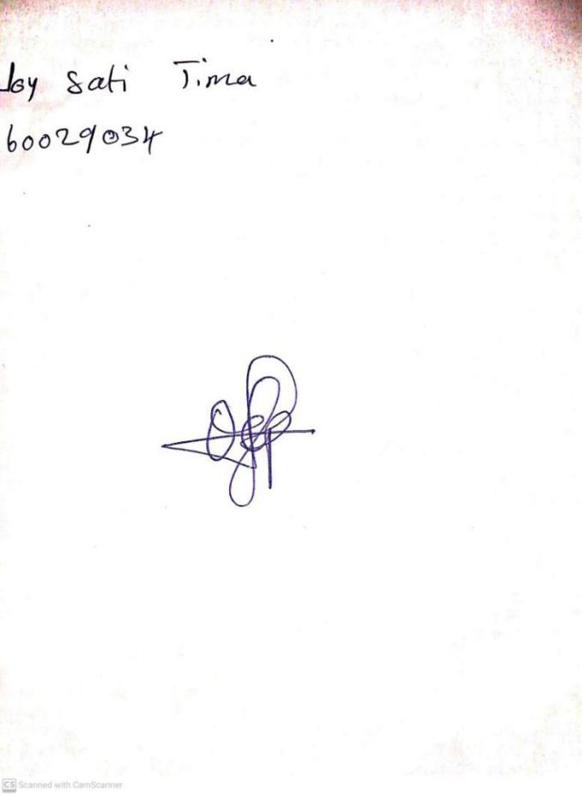

**10TH JANUARY, 2024**

**Perpetual Ojoma Ocheja**

**Stream Head Nursery**