**EMERALD ROYAL INTERNATIONAL SCHOOL, MPAPE ABUJA**

**LESSON PLAN AND NOTE FOR WEEK 2 ENDING FRIDAY, 22ND SEPTEMBER, 2023**

**TERM:** FIRST TERM

**WEEK:** WEEK 2

**SUBJECT:** SOCIAL STUDIES

**TOPIC:** FAMILY

**SUB-TOPIC:** MEANING OF FAMILY

**DATE:** TUESDAY, 19TH ANDWEDNESDAY, 20TH SEPTEMBER, 2023

**TIME:** 11:50 – 12:30PM AND 01:20 – 02:00PM

**DURATION:** 40 MINUTES

**PERIOD:** 6TH AND 8TH

**CLASS:** NURSERY 3

**NUMBER IN CLASS:** ELEVEN

**AVERAGE AGE:** FIVE

**SEX:** MIXED

**LEARNING OBJECTIVES:** By the end of the lesson, the pupils should be able to:

1. Explain the meaning of family
2. Identify the the members of a family.
3. State the duties of members of the family.

**RATIONALE:** for pupils to learn the meaning of social studies.

**PREVIOUS KNOWLEGDE:** pupils learnt the meaning and important of social studies.

**INSTRUCTIONAL MATERIALS:**

1. Charts

**REFERENCE MATERIALS:**

1. Social Studies for primary schools book 1 by Olufemi J. Olugasa, Olusola H. Bamidele, Felix K. Alonge, Julius O. Onwuka

**LESSON DEVELOPMENT**

|  |  |  |  |
| --- | --- | --- | --- |
| **STAGES/STEPS** | **TEACHER’S ACTIVITIES** | **PUPILS’ ACTIVITIES** | **LEARNING POINTS** |
| **INTRODUCTION** | Review previous knowledge | Respond to the teacher | To arouse the pupils’ interest. |
| **PRESENTATION**  **STEP 1** | Teaches and explain the meaning of family.  **Meaning of family**  The family is the basic unit of every society. Its is a group of people that are closely related by blood, marriage or adoption. | Listen attentively and learn. | Meaning of a family. |
| **STEP 2** | Teaches the pupils the members of a family.  **Members of the family**  A family consist of   1. Father 2. Mother 3. Children | Listen attentively and learn. | Members of a family. |
| **STEP 3** | Teaches pupils the duties of members of the family  **Duties of members f the family**   1. Father is the head of the family and he provide for the family 2. Mother takes care of the family. 3. Children help with house chores at home. | Listen attentively and learn. | Duties of members of the family. |
| **SUMMARY** | Summarises the lesson by emphasising on the main concept and writes note on the board | Listen and copy their notes | For onward study |
| **EVALUATION** | Asks pupils to:   1. Define family 2. Mention the members of a family 3. State the duties of members of a family. | Respond to the teacher’s question. | To test the pupils understanding on the lesson. |
| **CONCLUSION** | Summarizes, corrects and mark pupils’ notebooks | Submit their notebooks for marking. | Clarifying the concept. |
| **HOME WORK** | 1. Mention the names of members of your family | Cope and return with task. | Extending lesson home. |

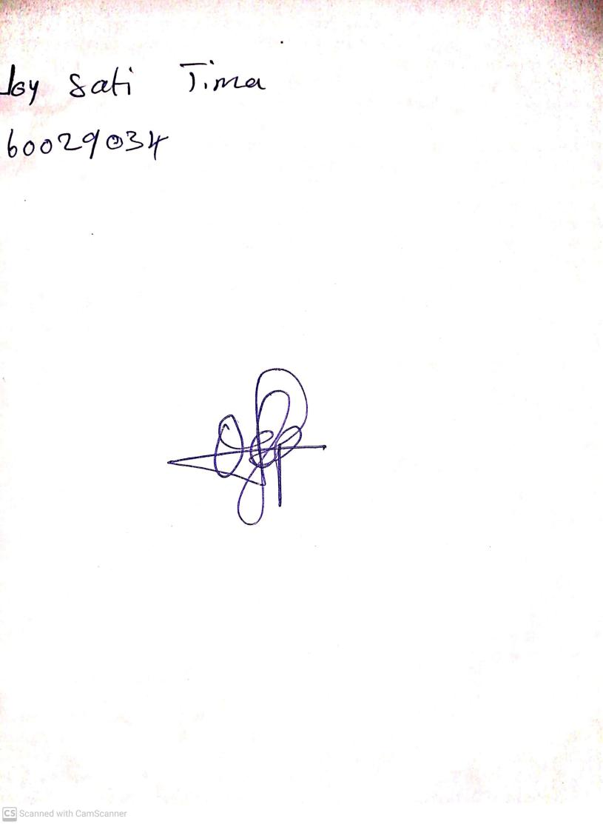

15TH September, 2023

Perpetual Ojoma Ocheja

Stream Head Nursery