**EMERALD ROYAL INTERNATIONAL SCHOOL MPAPE, ABUJA.**

**LESSON PLAN/ NOTE FOR WEEK 10 PERIOD 1 ENDING 28 /06/2024**

**TERM: 3rd**

**WEEK: 10th**

**DATE: 24/06/2024**

**CLASS: Nursery 2**

**SUBJECT: Number work**

**TOPIC: Simple subtraction(Numbers 1— 9)**

**SUB—TOPIC: Simple meaning of subtraction and its sign (—),examples**

**PERIOD: 1st**

**TIME: 08:50—09:30 am**

**DURATION: 40 minutes**

**NUMBER IN CLASS: 13**

**AVERAGE AGE: 5 years**

**SEX: Mixed**

**LEARNING OBJECTIVES: By the end of the lesson, the Pupils should be able to:**

**1. Explain the meaning of subtraction**

**2. Identify subtraction sign and examples**

**RATIONALE: For Pupils to know the meaning of subtraction.**

**PREVIOUS KNOWLEDGE: Pupils have learnt about addition in previous lesson.**

**INSTRUCTIONAL MATERIALS: pencils and bottles top**

**REFERENCE MATERIALS: Mastering Mathematics for Nursery schools book 3 by Henry Z.Idogun**

**LESSON DEVELOPMENT**

|  |  |  |  |
| --- | --- | --- | --- |
| **STAGES/ STEPS** | **TEACHER'S ACTIVITIES** | **PUPILS' ACTIVITIES** | **LEARNING POINT** |
| **Introduction** | **Teacher reviews the previous lesson.** | **Pupils listen attentively to the teacher.** | **To arouse pupils interest for the lesson.** |
| **Presentation step 1** | **Teacher explains the meaning of subtraction to pupils and then ask them to repeat after her.** | **Pupils listen to the teacher and repeat after her.** | **For proper understanding.** |
| **Step 2** | **Teacher writes the sign for subtraction and examples on the board for pupils to identify and also ask them to repeat after her.** | **Pupils pay attention to the teacher and repeat after her.** | **To enhance Pupils participation in class.** |
| **Board summary** | **Teacher summarizes the lesson by writing the whole note of lesson on the board for pupils to copy into their bookS as;**  **SUBTRACTIONS**  **Subtraction is simply the process of taking one quantity and removing part of it to work out what is left.**  **It is the opposite of addition, because we are reducing the value of the number rather than increasing it by adding more numbers.**  **Subtraction sign is (–)**  **Examples of subtraction**  **Question**  **Subtract the following numbers**  **1.8–5**  **2. 9–3**  **3. 7–1**  **4. 9–5**  **5. 7–2**  **6. 6–5**  **7. 8–3**  **8. 5–3**  **Solution:**  **1. 8–5= 3**  **00000000–00000=3**  **2. 9–3= 6**  **000000000–000=6**  **3. 7–1= 6**  **0000000–0 =6**  **4. 9–5= 4**  **000000000–00000=4**  **5. 7–2= 5**  **0000000–00=5**  **6. 6–5= 1**  **000000–00000=1**  **7. 8–3= 5**  **00000000–000=5**  **8. 5–3= 2**  **00000–000=2** | **Pupils copy the note into their exercise books.** | **For onward study.** |
| **Evaluation** | **Teacher evaluates the lesson by asking pupils the following questions;**  **1. What is the meaning of subtraction**  **2. What is the sign for subtraction?** | **Pupils answer the questions ask by the teacher.** | **To assess pupils level of understanding.** |
| **Conclusion** | **Teacher concludes the lesson by marking pupils books.** | **Pupils submit their books for marking.** | **For endorsement.** |
| **Assignment** | **Subtract the following:**  **1. 8–2=**  **2. 6–2=**  **3. 9–4=**  **4. 6–5=**  **5. 8–1=** | **Pupils do their assignment at home.** | **To encourage learning at home.** |

**LESSON PLAN/NOTE FOR WEEK 10 PERIOD 2 ENDING 28/06/2024**

**TERM: 3rd**

**WEEK: 10th**

**DATE: 25/06/2024**

**CLASS: Nursery 2**

**SUBJECT: Number work**

**TOPIC: Simple subtraction(Numbers 1–9)**

**SUB—TOPIC: Subtraction of numbers 1–5**

**PERIOD: 2nd**

**TIME: 08:50—09:30 am**

**DURATION: 40 minutes**

**NUMBER IN CLASS: 13**

**AVERAGE AGE: 5 years**

**SEX: Mixed**

**LEARNING OBJECTIVES: By the end of the lesson, the Pupils should be able to:**

**1. Identify numbers 1–5**

**2. Subtract numbers 1–5**

**RATIONALE: For Pupils to subtraction of numbers 1–5**

**PREVIOUS KNOWLEDGE: Pupils have learnt the meaning of subtraction and some examples.**

**INSTRUCTIONAL MATERIALS: Bottle tops and crayons..**

**REFERENCE MATERIALS: New General Mathematics for primary schools book 1. By J Aderohunmu etal.**

**LESSON DEVELOPMENT**

|  |  |  |  |
| --- | --- | --- | --- |
| **STAGES/ STEPS** | **TEACHER'S ACTIVITIES** | **PUPILS' ACTIVITIES** | **LEARNING POINT** |
| **Introduction** | **Teacher reviews the previous lesson.** | **Pupils listen attentively to the teacher.** | **To arouse pupils interest for the lesson.** |
| **Presentation step 1** | **Teacher writes number 1–5 on the board, count and then ask pupils to repeat after her.** | **Pupils listen to the teacher and repeat after her.** | **For proper understanding.** |
| **Step 2** | **Teacher guides pupils to solve some questions on the board.** | **Pupils solve the questions on the board .** | **To enhance Pupils participation in class.** |
| **Board summary** | **Teacher writes the whole note of lesson on the board for pupils to copy into their books. That is;**  **Subtraction of numbers 1–5**  **Subtract the following numbers**  **1. 4–2**  **2. 4–3**  **3. 5–4**  **4. 4–1**  **5. 2–1**  **Solution**  **1.4–2= 2**  **0000–00= 2**  **2. 4–3= 1**  **0000–000=1**  **3. 5–4= 1**  **00000–0000=1**  **4. 4–1= 3**  **0000–0=3**  **5. 2–1= 1**  **00–0= 1** | **Pupils copy the note into their exercise books.** | **For onward study.** |
| **Evaluation** | **Teacher evaluates the lesson by asking pupils to count their bottle tops to find out if the answer's are correct.** | **Pupils all count the bottle tops individually on their table.** | **To assess Pupils level of understanding.** |
| **Conclusion** | **Teacher concludes the lesson by marking pupils books.** | **Pupils submit their books for marking.** | **For endorsement.** |
| **Assignment** | **Subtract these numbers**   1. **5 — 3=_____** 2. **5 — 4=_____** 3. **4 — 4=_____** 4. **3 — 1=_____** 5. **4 — 1=_____** | **Pupils do their assignment at home.** | **To encourage learning at home.** |

**LESSON PLAN/NOTE FOR WEEK 10 PERIOD 3 ENDING 28/06/2024**

**TERM: 3rd**

**WEEK: 10th**

**DATE: 28/06/2024**

**CLASS: Nursery 2**

**SUBJECT: Number work**

**TOPIC: Simple subtraction (numbers 1–9)**

**SUB—TOPIC: Subtraction of numbers 6–9**

**PERIOD: 3rd**

**TIME: 08: 10–80 :50am**

**DURATION: 40 minutes**

**NUMBER IN CLASS: 13**

**AVERAGE AGE: 5 years**

**SEX: Mixed**

**LEARNING OBJECTIVES: By the end of the lesson, the Pupils should be able to:**

**1. Identify number 6–9**

**2. Solve simple Subtraction from 6–9**

**RATIONALE: For Pupils to learn more of subtractions**

**PREVIOUS KNOWLEDGE: Pupils have learnt Subtraction of numbers 6–9**

**INSTRUCTIONAL MATERIALS: Bottle tops**

**REFERENCE MATERIALS: The New Mastering Mathematics for Nursery schools book 3 by Henry Z.Idogun**

**LESSON DEVELOPMENT**

|  |  |  |  |
| --- | --- | --- | --- |
| **STAGES/ STEPS** | **TEACHER'S ACTIVITIES** | **PUPILS' ACTIVITIES** | **LEARNING POINT** |
| **Introduction** | **Teacher introduces the lesson by reviewing the previous lesson.** | **Pupils pay attention to the teacher.** | **To arouse pupils interest for the lesson.** |
| **Presentation step 1** | **Teacher writes numbers 6–9 on the board for pupils to identify. As**  **6 7 8 9** | **Pupils listen to the teacher and identify the numbers.** | **For proper understanding.** |
| **Step 2** | **Teacher guides pupils to solve the following questions;** | **Pupils take turns to solve the questions on the board.** | **To enhance Pupils participation in class.** |
| **Board summary** | **Teacher summarizes the lesson by writing note on the board for pupils to copy. That is;**  **Subtraction of numbers 6–9**  **Subtract the following:**   1. **6–0** 2. **7–3** 3. **7–4** 4. **9–9** 5. **8–6** 6. **9–6**   **Solution**  **1. 6–0= 6**  **000000–()=6**  **2. 7–3=4**  **0000000–000= 4**  **3. 7–4= 3**  **0000000–0000= 3**  **4. 9–9= 0**  **000000000–000000000= 0**  **5. 8–6= 2**  **00000000–000000= 2**  **6. 9–6= 3**  **000000000–000000= 3** | **Pupils copy the note into their exercise books.** | **For onward study.** |
| **Evaluation** | **Teacher evaluates the lesson by asking pupils the following questions orally;**  **Find the answer for the following:**  **1.9–8=**  **2. 8–3=**  **3. 9–2=**  **4. 8–6=**  **5. 7–4=** | **Pupils answer the questions ask by the teacher.** | **To assess Pupils level of understanding.** |
| **Conclusion** | **Teacher concludes the lesson by marking pupils books.** | **Pupils submit their books for marking.** | **For endorsement.** |
| **Assignment** | **Find the answer to for the following:** | **Pupils do their assignment at home.** | **To encourage learning at home.** |

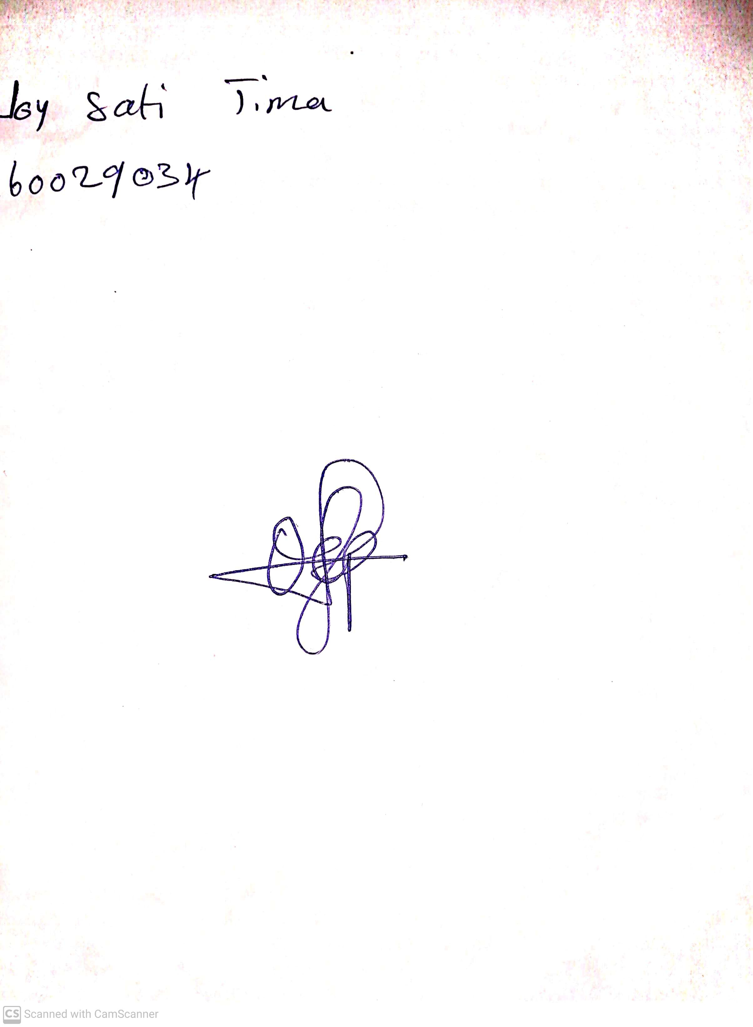

**21st June, 2024**

**Perpetual Ojoma Ocheja**

**Stream Head Nursery**