**EMERALD ROYAL INTERNATIONAL SCHOOL**

**MPAPE, ABUJA.**

**LESSON PLAN AND NOTE FOR WEEK 8 ENDING 3RD NOVEMBER,2023**

TERM : First term.

WEEK : 8

SUBJECT: Social Norms

TOPIC: Greetings.

SUB-TOPIC: Saying " welcome".

DATE: 1/9/2023

DURATION: 40 minutes

TIME: 10:40-11:20

PERIOD: 5th

CLASS: pre-nursery

NUMBER OF PUPILS: 10

AVERAGE AGE: 2

SEX: Mixed

SPECIFIC OBJECTIVES: By the end of the lesson, the pupils should be able to:-

1. Say welcome.

2. Know when to say "welcome."

RATIONALE: For pupils to know good ettiques and be respectful.

PREVIOUS KNOWLEDGE: Pupils have been given their parents hugs when they return back home.

INSTRUCTIONAL MATERIALS: picture book.

REFERENCE: Smart start Civic education for nursery Schools book 1 by T.Y. Alabi and A. M. Solu.

LESSON DEVELOPMENT

|  |  |  |  |
| --- | --- | --- | --- |
| Stages/steps | Teacher's activities | Pupils' activities | Learning points |
| Introduction | Teacher introduces the lesson by singing nursery rhymes for the pupils. | Pupils sing the rhymes along with the teacher. | To arouse the interest of the pupils. |
| Presentation  Step 1 | Teacher tells the pupils to repeat after the teacher to say"welcome". | Pupils say the " welcome" after the teacher repeatedly. | To improve better understanding. |
| Step 2 | Teacher explains to the pupils in simple term when to say " welcome " . Teacher tells the pupils to always say "welcome" when someone returns back from journey. Teacher also encourages the pupils to say "welcome "when someone tells them thank you. | Pupils pay attention to the teacher's explanation. Pupils also practice to say "welcome. " | For better understanding of the lesson. |
| Summary | Teacher summarizes the lesson by showing the pupils the picture of children saying welcome to their parents as they returns back from market. | Pupils pay attention to the teacher's explanation. | To ensure better understanding of the lesson. |
| Evaluation | Teacher asks the pupils :-   1. When do we say welcome? 2. Say welcome to their friends. | Pupils respond to the teacher's questions correctly. | To assess pupils level of understanding of the lesson. |
| Conclusion | Teacher ends the lesson by correcting the pupils who were not able to answer the questions. | Pupils take the corrections given to them by the teacher. | For onwards learning. |

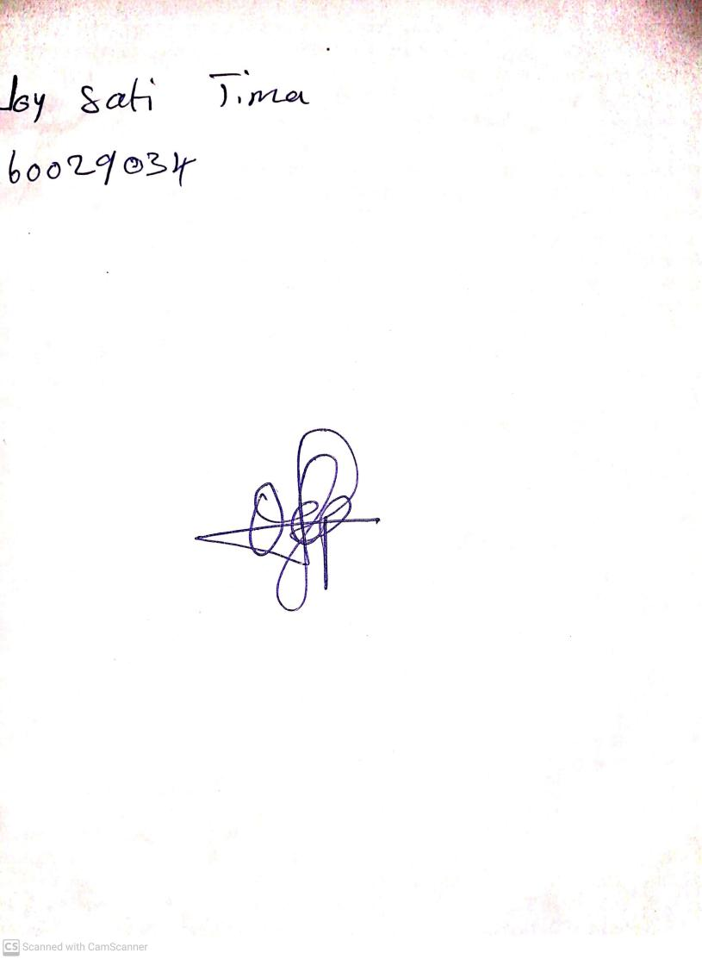

25th August, 2023

Perpetual Ojoma Ocheja

Stream Head Nursery