**EMERALD ROYAL INTERNATIONAL SCHOOL MPAPE, ABUJA**

**LESSON PLAN AND NOTE FOR WEEK 11 PERIOD 1 ENDING 22/11/2024**

**TERM: FIRST**

**WEEK: 11TH**

**DATE: 18/11/2024**

**CLASS: NURSERY 2**

**SUBJECT: LITERACY**

**TOPIC: FOUR LETTER WORDS.**

**SUB-TOPIC: MEANING AND EXAMPLES OF FOUR LETTER WORDS.**

**PERIOD: 3RD**

**TIME: 09: 30-10: 10 am**

**DURATION: 40 MINUTES**

**NUMBER IN CLASS: 16**

**AVERAGE AGE: 4**

**SEX: MIXED**

**SPECIFIC OBJECTIVES: BY THE END OF THE LESSON, THE PUPILS SHOULD BE ABLE**

**TO:**

1. **EXPLAIN THE MEANING OF FOUR LETTER WORDS.**
2. **MENTION SOME EXAMPLES OF FOUR LETTER WORDS.**

**RATIONALE: FOR PUPILS TO BE ABLE TO KNOW THE MEANING AND EXAMPLES OF FOUR LETTER WORDS.**

**PREVIOUS KNOWLEDGE: PUPILS HAVE LEARNT THREE LETTERS RHYMING WORDS IN PREVIOUS LESSON.**

**INSTRUCTIONAL MATERIALS: A CHART OF FOUR LETTEER WORDS.**

**REFERENCE MATERIALS: THE NEW MASTERING ENGLISH FOR NURSERY SCHOOLS BOOK 2 BY J.M OMOGBAI**

**TOP STAR MY CHOICE OF ENGLISH LANGUAGE STAGE 3 BY**

**J.F OMOTAYO.**

**LESSON DEVELOPMENT**

|  |  |  |  |
| --- | --- | --- | --- |
| **STAGES/STEPS** | **TEACHER’S ACTIVITIES** | **PUPILS’ ACTIVITIES** | **LEARNING POINT** |
| **INTODUCTION** | **Teacher introduces the lesson by reviewing the previous lesson.** | **Pupils listen attentively to the teacher.** | **To arouse pupils interest for the lesson ahead.** |
| **PRESENTATION STEP 1** | **Teacher explains the meaning of four letter words to pupils and then asks them to repeat after her.** | **Pupils pay attention to the teacher and repeat after her.** | **For proper understanding.** |
| **STEP 2** | **Teacher mention the examples of four letter words to pupils and also asks them to repeat after her.** | **Pupils listen very attentively to the teacher and repeat after her.** | **For better understanding of the lesson.** |
| **BOARD SUMMARY** | **Teacher summarizes the lesson by writing the whole note of lesson on the board for pupils to copy into their books. That is;**  **Four letter words**  **Four letter words are meaningful words that has only four letters of the alphabets.**  **Examples of four letters words are;**   1. **Book** 2. **Food** 3. **Wool** 4. **Wood** 5. **Leaf** 6. **Crab** 7. **Look** 8. **Comb** 9. **Desk** 10. **Moon etc.** | **Pupils copy the note on the board into their exercise books.** | **For onward study.** |
| **EVALUATION** | **Teacher evaluates the lesson by asking the following questions:**   1. **Explain the meaning of four letter words.** 2. **Mention the examples of four letter words.** | **Pupils answer the questions asked by the teacher.** | **To asses pupils level of understanding of the lesson.** |
| **CONCLUSION** | **Teacher concludes the lesson by marking pupils books.** | **Pupils submit their books for marking.** | **For endorsement.** |
| **ASSIGNMENT** | **Answer the following questions;**   1. **What are four letter words?** 2. **Mention 10 examples of four letter words.** | **Pupils do their assignment at home.** | **To encourage learning at home.** |

**LESSON PLAN AND NOTE FOR WEEK 11 PERIOD 2 ENDING 22/11/2024**

**TERM: FIRST**

**WEEK: 11TH**

**DATE: 19/11/2024**

**CLASS: NURSERY 2**

**SUBJECT: LITERACY**

**TOPIC: FOUR LETTER WORDS**

**SUB-TOPIC: FOUR PHONICS LETTER SOUNDS**

**PERIOD: 2ND**

**TIME: 08: 50-09: 30 am**

**DURATION: 40 MINUTES**

**NUMBER IN CLASS: 16**

**AVERAGE AGE: 4**

**SEX: MIXED**

**SPECIFIC OBJECTIVES: BY THE END OF THE LESSON, THE PUPILS SHOULD BE ABLE**

**TO:**

1. **IDENTIFY THE FIVE VOWEL LETTERS AMONGST OTHERS.**
2. **SOUND AND PRONOUNCE THE FOUR PHONICS LETTER**

**SOUNDS ON “a”, “e” ,AND “I”.**

**RATIONALE: FOR PUPILS TO KNOW HOW TO SOUND AND PRONOUNCE FOUR PHONICS LETTER SOUNDS .**

**PREVIOUS KNOWLEDGE: PUPILS HAVE LEARNT THE MEANING AND EXAMPLES OF FOUR LETTER WORDS IN PREVIOUS LESSON.**

**INSTRUCTIONAL MATERIALS: A CHART OF FOUR PHONICS LETTER WORDS.**

**REFERENCE MATERIALS: THE NEW MASTERING ENGLISH FOR NURSERY SCHOOLS BOOK 2 BY J. M OMOGBAI**

**TOP STAR MY CHOICE OF ENGLISH LANGUAGE STAGE 3 BY**

1. **F OMOTAYO.**

**LESSON DEVELOPMENT**

|  |  |  |  |
| --- | --- | --- | --- |
| **STAGES/STEPS** | **TEACHER’S ACTIVITIES** | **PUPILS’ ACTIVITIES** | **LEARNING POINT** |
| **INTODUCTION** | **Teacher introduces the lesson by reviewing the previous lesson.** | **Pupils listen attentively to the teacher.** | **To arouse pupils interest for the lesson ahead.** |
| **PRESENTATION STEP 1** | **Teacher writes the 26 letters of the alphabets on the board for pupils to identify the five vowel letters amongst others. That is;**  **a b c d e f g h i j k l m n o p q r s t u v w x y z.** | **Pupils pay attention to the teacher and identify the five vowel letters on the board. As;**  **a b c d e f g h i j k l m n o p q r s t u v w x y z.** | **For proper understanding.** |
| **STEP 2** | **Teacher sounds and pronounce the four phonics letter sounds with “a”, “e”,and “I” on the board , and then asks pupils to repeat after her.** | **Pupils listen very attentively to the teacher and repeat after her.** | **For better understanding of the lesson.** |
| **BOARD SUMMARY** | **Teacher summarizes the lesson by writing the whole note of lesson on the board for pupils to copy into their books. That is:**  **Four letter words on “a”, “e”, and “I” are:**   |  |  |  | | --- | --- | --- | | **“a” as in** | **“e” as in** | **“i” as in** | | **hand** | **help** | **milk** | | **sand** | **rent** | **sing** | | **bank** | **rest** | **ring** | | **band** | **next** | **pink** | | **crab** | **desk** | **swim** | | **clap** | **send** | **clip** | | **camp** | **sent** | **slip** | | **damp** | **went** | **grip** | | **fast** | **vest** | **king** | | **flag** | **pest** | **wing** | | **brag** | **best** | **gift** | | **gang** | **belt** | **trip** | | **bang** | **bend** | **list** | | **land** | **melt** | **limp** | | **lamb etc.** | **held etc.** | **mist etc.** | | **Pupils copy the note into their exercise books ..** | **For onward study.** |
| **EVALUATION** | **Teacher evaluates the lesson by asking the following questions one after the other;**   1. **Mention the five vowel letters.** 2. **Sound and pronounce four letter words with vowel “a”.** 3. **spell and pronounce four letter words with vowel “e”.** 4. **identify and pronounce four letter words with vowel “I”.** | **Pupils answer the questions asked by the teacher.** | **To asses pupils level of understanding of the lesson.** |
| **CONCLUSION** | **Teacher concludes the lesson by marking pupils books.** | **Pupils submit their books for marking.** | **For endorsement.** |
| **ASSIGNMENT** | **Fill in the missing vowel to complete the words**   1. **B--nk** 2. **C--mp** 3. **P--st** 4. **F--st** 5. **L--st** 6. **Cl--p** 7. **Cr--b** 8. **R--nt** 9. **G--ft** 10. **M--lk** | **Pupils do their assignment at home.** | **To encourage learning at home.** |

**LESSON PLAN AND NOTE FOR WEEK 11 PERIOD 3 ENDING 22/11/2024**

**TERM: FIRST**

**WEEK: 11TH**

**DATE: 22/11/2024**

**CLASS: NURSERY 2**

**SUBJECT: LITERACY**

**TOPIC: FOUR LETTER WORDS .**

**SUB-TOPIC: FOUR LETTER WORDS WITH VOWEL “o” AND “u”.**

**PERIOD: 3RD**

**TIME: 09: 30-10: 10 am**

**DURATION: 40 MINUTES**

**NUMBER IN CLASS: 16**

**AVERAGE AGE: 4**

**SEX: MIXED**

**SPECIFIC OBJECTIVES: BY THE END OF THE LESSON, THE PUPILS SHOULD BE ABLE**

**TO:**

1. **IDENTIFY FOUR LETTER WORDS WITH VOWEL “o” AND “u”**
2. **SPELL AND PRONOUNCE FOUR LETTER WORDS WITH**

**VOWEL “o” AND “u”.**

**RATIONALE: FOR PUPILS TO BE ABLE TO SPELL AND PRONOUNCE FOUR LETTER WORDS WITH VOWEL “o” AND “ u”.**

**PREVIOUS KNOWLEDGE: PUPILS HAVE LEARNT FOUR LETTER WORDS WITH VOWEL “a”, “e”, AND “I” IN PREVIOUS LESSON.**

**INSTRUCTIONAL MATERIALS: A CHART OF FOUR LETTER WORDS WITH VOWEL “0” AND “u” .**

**REFERENCE MATERIALS: THE NEW MASTERING ENGLISH FOR NURSERY SCHOOLS BOOK 2 BY J.M OMOGBAI.**

**TOP STAR MY CHOICE OF ENGLISH LANGUAGE STAGE 3 BY J.M OMOTAYO.**

**LESSON DEVELOPMENT**

|  |  |  |  |
| --- | --- | --- | --- |
| **STAGES/STEPS** | **TEACHER’S ACTIVITIES** | **PUPILS’ ACTIVITIES** | **LEARNING POINT** |
| **INTODUCTION** | **Teacher introduces the lesson by reviewing the previous lesson.** | **Pupils listen attentively to the teacher.** | **To arouse pupils interest for the lesson ahead.** |
| **PRESENTATION STEP 1** | **Teacher writes four letter words with vowel “o” and “u” on the board, identify and then asks pupils to repeat after her.** | **Pupils pay attention to the teacher and repeat after her.** | **For proper understanding.** |
| **STEP 2** | **Teacher spells and pronounce four letter words with vowel “o” and “u” to pupils and also asks them to repeat after her.** | **Pupils listen very attentively to the teacher and repeat after her.** | **For better understanding of the lesson.** |
| **BOARD SUMMARY** | **Teacher summarizes the lesson by writing the whole note of lesson on the board for pupils to copy into their books. That is;**  **Four letter words with vowel “o” and “u” are:**   |  |  | | --- | --- | | **“o” as in** | **“u” as in** | | **cost** | **drug** | | **crop** | **drum** | | **drop** | **dump** | | **frog** | **bump** | | **song** | **jump** | | **long** | **pump** | | **pond** | **dust** | | **soft** | **rust** | | **from** | **bust** | | **stop** | **plug** | | **spot** | **hunt** | | **gong** | **hung** | | **golf** | **lung** | | **fond** | **just** | | **lost** | **sulk** | | **plot** | **must** | | **blot** | **plum** | | **flop** | **lump** | | **trot** | **hump** | | **Romp etc.** | **Snub etc.** | | **Pupils copy the note on the board into their exercise books.** | **For onward study.** |
| **EVALUATION** | **Teacher evaluates the lesson by asking the following questions:**   1. **Identify four letter words with vowel “o” and “u”.** 2. **Spell and pronounce four letter words with vowel “o” and “u”.** | **Pupils answer the questions asked by the teacher.** | **To asses pupils level of understanding of the lesson.** |
| **CONCLUSION** | **Teacher concludes the lesson by marking pupils books.** | **Pupils submit their books for marking.** | **For endorsement.** |
| **ASSIGNMENT** | **Spell and pronounce the following four (4) letter words:**   1. **Tank** 2. **Lamp** 3. **List** 4. **Stop** 5. **Ring** 6. **From** 7. **Frog** 8. **Flag** 9. **Bank** 10. **Food** | **Pupils do their assignment at home.** | **To encourage learning at home.** |

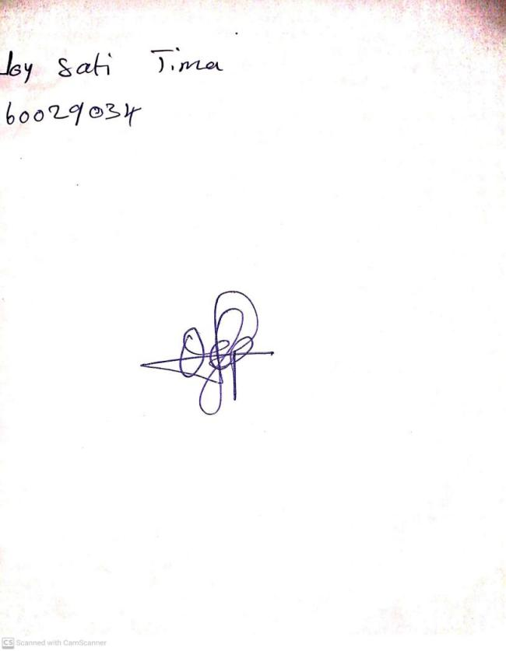

**15th November, 2024**

**Perpetual Ojoma Ocheja**

**Stream Head Nursery**