**EMERALD ROYAL INTERNATIONAL SCHOOL**

**MPAPE, ABUJA.**

**LESSON PLAN AND NOTE FOR WEEK 5 ENDING 11/10/2024**

**TERM: 1st**

**WEEK: 5th**

**DATE: 07/10/2024**

**CLASS: Nursery 2**

**SUBJECT: Nature studies**

**TOPIC: Body care for wounds.**

**SUB—TOPIC: Meaning of wounds and first aid treatment for wounds.**

**PERIOD: 4th**

**TIME: 10:40—11:20am**

**DURATION: 40 minutes**

**NUMBER IN CLASS: 14**

**AVERAGE AGE: 5 years**

**SEX: Mixed**

**LEARNING OBJECTIVES: By the end of the lesson, the pupils should be able to:**

**1. Define wound**

**2. State the first aid treatment for wounds**

**RATIONALE: For pupils to know the treatment for wounds.**

**PREVIOUS KNOWLEDGE: Pupils have learnt about cut in previous lesson.**

**INSTRUCTIONAL MATERIALS: cotton wool, water , bandage, jelly cream, and plaster.**

**REFERENCE MATERIALS: Basic science and technology for Nursery schools book 3 by OPEMIPO DADA.**

**LESSON DEVELOPMENT**

|  |  |  |  |
| --- | --- | --- | --- |
| **Steps** | **Teacher's activities** | **Pupils' activities** | **Learning point** |
| **Introduction** | **Teacher introduces the lesson by reviewing the previous lesson.** | **Pupils pay attention to the teacher.** | **To prepare pupils minds for the lesson ahead.** |
| **Presentation step 1** | **Teacher defines wound to pupils and then asks them to repeat after her.** | **Pupils listen to the teacher and repeat after her.** | **To improve pupils listening and speaking ability.** |
| **Step 2** | **Teacher States the first aid treatment for wound to pupils and also asks them to repeat after her.** | **Pupils pay attention to the teacher and repeat her.** | **To enhance pupils participation in the class.** |
| **Board summary** | **Teacher writes the whole note of lesson on the board for pupils to copy into their books. That is;**  **Wounds:**  **Wound is an injury to the body. It can be caused by a cut, a fall or a blow to the head.**  **First aid treatment for wounds are:**   1. **Wash your hands to avoid infection.** 2. **Stop the bleeding.** 3. **Clean the wound with the use of cotton wool.** 4. **Apply an antibiotic.** 5. **Cover the wound to avoid infections.** 6. **Get some rest after treatment to help the wound heal fast.** | **Pupils copy the note into their exercise books.** | **For onward study.** |
| **Evaluation** | **Teacher evaluates the lesson by asking pupils the following questions;**   1. **Define wound.** 2. **State the first aid treatment for wounds.** | **Pupils answer the questions asked by the teacher.** | **To assess pupils level of understanding.** |
| **Conclusion** | **Teacher concludes the lesson by marking pupils books.** | **Pupils submit their books for marking.** | **For endorsement.** |
| **Assignment** | 1. **What are living things?** 2. **Mention at least 4 examples of living things.** 3. **List the characteristics of living things.** | **Pupils do their assignment at home.** | **To encourage learning at home.** |

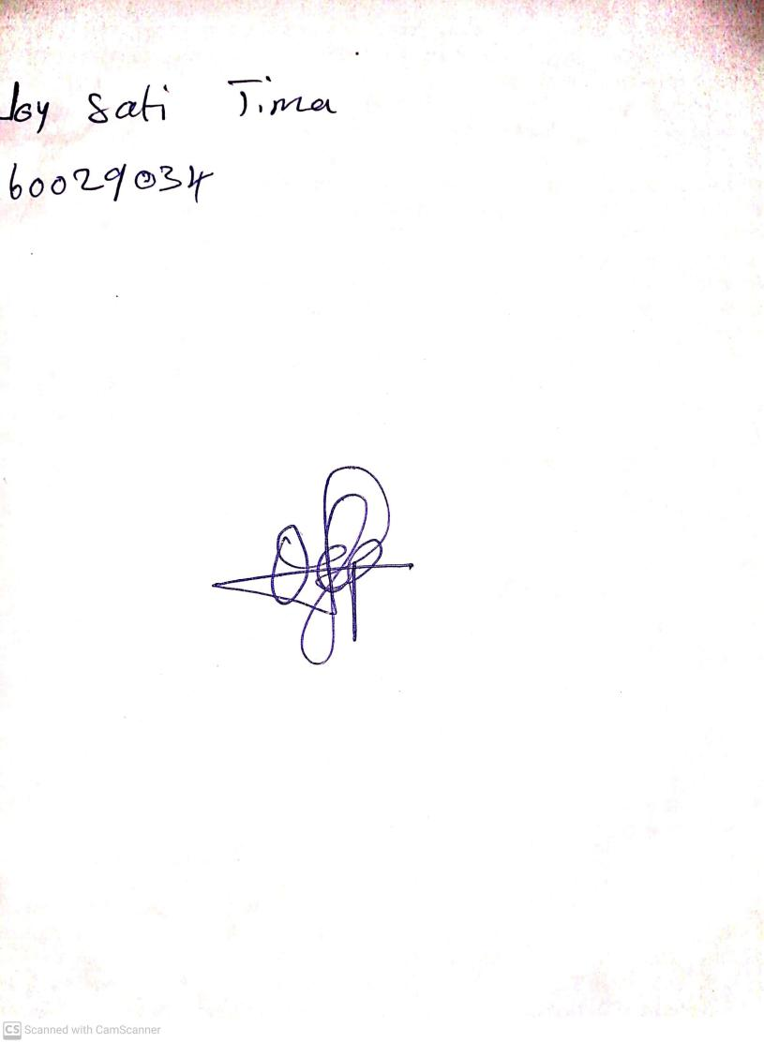

**4th October, 2024**

**Perpetual Ojoma Ocheja**

**Stream Head Nursery**