**Lesson Plan/Note for week 6 Ending on 17/2/2023.**

**Term:** 2nd

**Week**: 6

**Date:** 13/2/2023.

**Class:** SS 2

**Subject:** Economics.

**Topic:** Market structure

**Sub-Topic:** Price and quantity determination under perfect competition ( short-run and long-run equilibrium).

**Period:** second

**Time:** 8:50-9:30

**Duration:** 40 minutes

**Number in class:** 5 students

**Average Age:** 14 Years.

**Sex:** mixed.

**Specific objectives:** By the end of the lesson the students should be able to:

(1) Explain price and quantity determination under perfect competition (short-run equilibrium).

(11) Describe price and quantity determination under perfect competition (long-run equilibrium).

**Rationale:** To be able to determine the equilibrium price and quantity at the short and long-run equilibrium under perfect market.

**Previous knowledge:** The students have been buying goods in both lower and higher prices at different interval.

**Instructional Material:** A chart showing curves in both Short and long-run equilibrium

**Reference material:** Ande C E (2020) Essential Economics for senior Secondary schools.

**LESSON DEVELOPMENT**

|  |  |  |  |
| --- | --- | --- | --- |
| **Stages/steps** | **Teacher's Activities** | **Students' Activities** | **Learning points** |
| **Introduction** | Review the previous lesson | Participate actively in the class discussion. | To arouse the students’ interest to learn |
| **Step 1** | Guides the students to explain price and quantity determination under perfect competition (short-run equilibrium). | Respond to the class activity. | To encourage critical thinking ability. |
| **Step 11** | Leads the students to describe price and quantity determination under perfect competition in long-run equilibrium. | Describe price and quantity determination under perfect competition in long-run equilibrium and copy the Note. | To enhance their logical reasoning |
| **Board Summary** | Summarizes the lesson as:  **Price and quantity determination under** **perfect competition in short-run equilibrium.**  In a perfect market, also known as competitive or perfect competition, the buyers or sellers can not influence the prices of goods and services. This is because there are many buyers and sellers or firms in the market.  Price and quantity is determined by the interaction of the forces of demand and supply. Determination of equilibrium position of a firm under perfect competition both in the short-run is discussed below:  **(a) Equilibrium in the short run:** The equilibrium of a firm ina perfect competition is the most efficient operating levél for the firm, where it will not have the slightest intention of leaving the industry. Under perfect competition, the profit maximization of a firm is where marginal cost (MC) is equal to marginal revenue (MR). The average cost is ( AC) and the price of the commodity is P. This is demonstrated in figure A. I.e P=MC=MR.    In the short run, the marginal cost cuts the marginal revenue at K. The average cost curve is AC, the quantity of the commodity that has been sold is OQ. The shaded area of the rectangle (P1KLPO) represent the abnormal profit at the price POP1. Here, price or average revenue is higher than the average cost of production.  **(b) Equilibrium in the long run under perfect competition.**  In the equilibrium of a firm in a perfect competition, the abnormal profits are completely wiped off in the long run. In the long run, the firm is in equilibrium and makes normal profits. When the firm is in equilibrium, P=MC=MR=AC. The firm makes maximum profit at the point where marginal cost equal marginal revenue (MR). | Copy and submit the Note book for marking. | For future reference. |
| **Evaluation** | Evaluates the lesson as:  (1) Explain price and quantity determination under perfect competition in short-run and long run equilibrium. | Respond to the question | Ascertaining the attainment of the stated objectives. |
| **Conclusion** | Rounds up the lesson by marking and correcting students work. | Check and do their correction | Consolidation of the lesson. |
| **Assignment** | Gives home work as:   1. state 10 differences between perfect and monopolistic competition | Respond by doing the home work at home. | To ensure continuity of learning. |

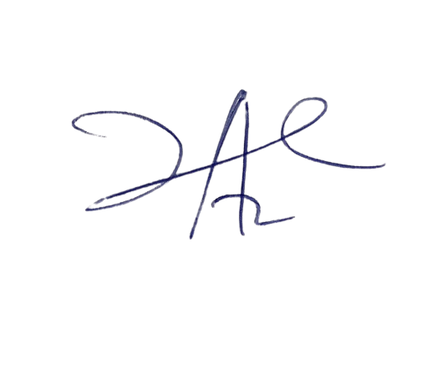

6/3/2023

Principal Head Instructor