**EMERALD ROYAL INTERNATIONAL SCHOOLMPAPE, ABUJA.**

**LESSON PLAN AND NOTE FOR WEEK 10 ENDING 28/06/2024**

**TERM: THIRD**

**WEEK: 10TH**

**DATE: 24/06/2024**

**CLASS: NURSERY 2**

**SUBJECT: NATURE STUDY**

**TOPIC: THINGS THAT HAVE NATURAL COLOURS .**

**SUB-TOPIC: MEANING OF NATURAL COLOURS AND EXAMPLES**

**PERIOD: 1ST PERIOD AFTER LONG BREAK**

**TIME: 10: 40- 11: 20am**

**DURATION: 40 MINUTES.**

**NUMBER IN CLASS: 13**

**AVERAGE AGE: 5 YEARS.**

**SEX: MIXED.**

**SPECIFIC OBJECTIVES: BY THE END OF THE LESSON,THE PUPILS SHOULD BE**

**ABLE TO:**

1. **EXPLAIN THE MEANING OF NATURAL COLOURS.**
2. **MENTION THE EXAMPLE OF THINGS THAT HAVE NATURAL COLOURS.**

**RATIONALE: FOR PUPILS TO KNOW THINGS THA HAVE NATURAL**

**COLOURS.**

**PREVIOU KNOWLEDGE: PUPILS HAVE BEEN SEEING THINGS WITH DIFFERENT**

**COLOURS OF OBJECTS.**

**INSTRUCTIONAL MATERIALS: EGG,GRASS AND CHARCOAL.**

**REFERENCE MATERIALS: BASIC SCIENCE AND TECHNOLOGY NURSERY SCHOOLS**

**BOOK 3 BY OPEMIPO DADA.**

**LESSON DEVELOPMENT**

|  |  |  |  |
| --- | --- | --- | --- |
| **STAGES/STEPS** | **TEACHER’S ACTIVITIES** | **PUPILS’ ACTIVITIES** | **LEARNING POINTS** |
| **INTRODUCTION** | **Teacher introduces the lesson by singing a nursery rhyme, red,red,red touch your head.**  **Blue,blue,blue tie your shoe….** | **Pupils sing the rhyme along with the teacher.** | **To prepare pupils minds for the lesson ahead..** |
| **PRESENTATION**  **STEP 1** | **Teacher explains the meaning of natural colour to pupils and then asks them to repeat after her.** | **Pupils listen attentively to the teacher and repeat after her.** | **For proper understanding .** |
| **STEP 2** | **Teacher mentions the example of things with natural colours to pupils and also asks them to repeat after her.** | **Pupils pay attention to the teacher and repeat after her.** | **For better understanding of the lesson.** |
| **BOARD SUMMARY** | **Teacher summarizes the lesson by writing the whole note of lesson on the board for pupils to copy into their books. Ie THINGS THAT HAVE NATURAL COLOURS.**  **NATURAL COLOURS: This means the colour of something or the appearance that it has.**  **Examples of things with natural colours are:**   1. **Blood** 2. **Sky** 3. **Milk** 4. **Charcoal** 5. **Fresh leaves** 6. **Grass** 7. **The tongue** 8. **Egg** 9. **Egg yolk**   **10 Cotton wool**  **11 Carrot etc.** | **Pupils copy the note into their exercise books.** | **For onward study.** |
| **EVALUATION** | **Teacher evaluates the lesson by asking the following questions;**   1. **What is natural colour?** 2. **Mention the things that has natural colours.** | **Pupils answer the questions ask by the teacher.** | **To assess pupils level of understanding.** |
| **CONCLUTION** | **Teacher concludes the lesson by marking pupils books.** | **Pupils submit their books for marking.** | **For endorsement.** |
| **ASSIGNMENT** | 1. **What is weather?** 2. **Mention the 3 types of weather..** | **Pupils do their assignment at home.** | **To encourage learning at home.** |

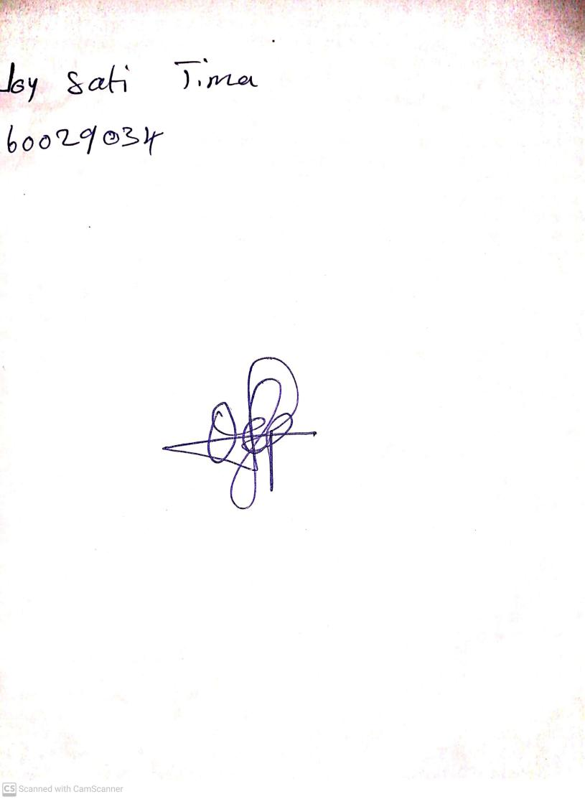

**14th June, 2024**

**Perpetual Ojoma Ocheja**

**Stream Head Nursery**