**LESSON PLAN/NOTE FOR WEEK 2 ENDING 12/05/2023**

**Term:** 3rd

**Week**: 2

**Date**: 8/05/2023

**Class**: ss 2

**Subject**: Economics

**Topic**: Elementary treatment of fiscal policy.

**Sub-Topics**: Direct and Indirect Taxation.

**Period**: second

**Time**: 8:50-9:30

**Duration**: 40 minutes.

**Number in class:** 5 students

**Average Age:** 14 years

**Sex**: mixed

**Specific objectives:** By the end of the lesson, the students should be able to:

1. Define taxation
2. Explain direct tax
3. Describe indirect tax.

**Rationale**: for the students to be able to differentiate between direct and indirect tax.

**Previous knowledge:** the students have seen people collecting taxes.

**Instructional material:** A chart showing revenue officers collecting taxes.

**Reference material:** cole Esan Ande (2020) Essential Economics for senior secondary schools.

**LESSON DEVELOPMEMT**

|  |  |  |  |
| --- | --- | --- | --- |
| **Stages/steps** | **Teacher’s Activities** | **Students’ Activities** | **Learning points** |
| **Introduction** | Review the previous lesson | Participate actively in the class discussion | To arouse the students interest to learn. |
| **Step 1** | Defines taxation as: taxation is a compulsory levy by the government. | Listen carefully to the teacher. | For better understanding of the lesson. |
| **Step 11** | Asks the students to explain direct tax | Explain direct tax as: Direct tax is impose directly on the income of the individuals. | To encourage critical thinking. |
| **Step 111** | Guides the students to describe indirect tax. | Respond to the class activity | To enhance their logical reasoning. |
| **Board summary** | Summarizes the lesson as:  **Taxation**  Taxation may be defined as the act or method of imposing a compulsory levy by the government or its agency on individuals and firms or on goods and services.  **Direct tax**  Direct tax as the name implies refers to the type of tax imposed directly on the income of individuals or organizations by the government or its agency. Such income include wages, salaries, profits, rents and interest.  **Types of direct tax**   1. Personal income tax 2. Company tax 3. Poll tax 4. Capital tax 5. Capital gains tax 6. Expenditure tax.   **Indirect tax**  Indirect tax refers to taxes which are imposed or levied on goods and services. The producers or sellers bear the initial burden of tax before shifting them to the final consumers in form of higher prices.  **Types of indirect tax**   1. customs duties and tariffs 2. Import duties 3. Export duties 4. Excise duties sales tax 5. Purchase tax 6. Value added tax. | Copy and submit the note book for marking. | For future reference. |
| **Evaluation** | Evaluates the lesson as:   1. Define taxation 2. Explain direct tax 3. Describe indirect tax. | Respond to the questions | Ascertaining the attainment of the stated objectives. |
| **Conclusion** | Rounds up the lesson by marking and correcting students work. | Check and do their correction. | Consolidation of the lesson. |
| **Assignment** | Gives home work as:   1. Mention and explain 5 advantages and disadvantages of direct and indirect tax | Respond by doing the home work at home | To ensure continuity of learning. |

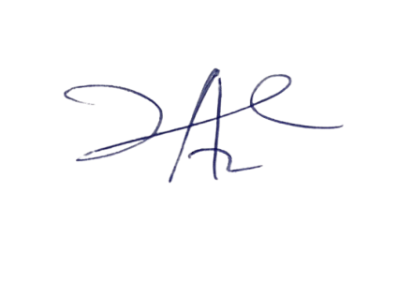

11/5/2023

Principal Head Instuctor