**EMERALD ROYAL INTERNATIONAL SCHOOL**

**MPAPE, ABUJA.**

**LESSON NOTE FOR WEEK 9 ENDING 30TH JUNE, 2023.**

TERM: 3rd

SUBJECT: Number Work

TOPIC: Counting numbers 1 - 45

SUB-TOPIC: Identification of numbers 1 - 20.

DATE: 25/06/2023.

DURATION: 40 minutes.

TIME: 08 : 50 - 09: 30.

PERIOD: 1st

CLASS: Pre-nursery

NUMBER OF PUPILS: 14

AVERAGE AGE: 2 years

SEX: Mixed.

SPECIFIC OBJECTIVES: By the end of the lesson, the pupils should be able to:-

1. Count numbers 1- 45
2. Identify numbers 1 - 20

RATIONALE: For pupils to be able to count numbers.

PREVIOUS KNOWLEDGE: Pupils have been counting numbers.

INSTRUCTIONAL MATERIALS: Number chart, flash cards, building blocks etc

REFERENCE MATERIALS: Mastering mathematics for nursery schools book 1 by Henry Idogun.

**LESSON DEVELOPMENT**

|  |  |  |  |
| --- | --- | --- | --- |
| STAGES/STEPS | TEACHER’S ACTIVITIES | PUPILS’ ACTIVITIES | LEARNING POINTS |
| INTRODUCTION | Teacher introduces the lesson by singing a number rhyme for the pupils. | Pupils sing the rhyme after the teacher. | To arouse pupils interest in the lesson. |
| PRESENTATION  STEP 1 | Teacher counts numbers 1 - 45 for the pupils to repeat after her. | Pupils count numbers 1 - 45 after the teacher. | For better understanding of the lesson . |
| STEP2 | Teacher guides each pupils to identify numbers 1 - 20 on flash cards. | Pupils point at the numbers I.e  1 2 3 4 5 6 7 8 9 10 11 12 13 14 15 16 17 18 19 20. | For proper understanding of the lesson. |
| SUMMARY | Teacher counts number 1-45 for the pupils. | Pupils point at the numbers and say the numbers. | For more understanding of the lesson. |
| EVALUATION | Teacher asks Pupils to count numbers 1 - 45 | Pupils count numbers 1 - 45. | To assess pupils understanding of the lesson. |
| CONCLUSION | Teacher sings a number rhyme for the pupils. | Pupils sing the rhyme along with the teacher. | To improve pupils speaking ability. |
| ASSIGNMENT (HOME WORK) | Count numbers 1 - 45 and circle numbers 1 - 20  1 2 3 4 5 6 7 8 9 10 1112 13 14 15 16 17 18 19 20 21 22 23 24 25 26 27 28 29 30 31 32 33 34 35 36 37 38 39 40 41 42 43 44 45. | Pupils do their assignment at home. | To encourage pupils to learn at home. |

**LESSON NOTE FOR WEEK 10 ENDING 30TH JUNE, 2023.**

TERM: 3rd

SUBJECT: Number Work

TOPIC: Counting numbers 1 - 45

SUB-TOPIC: Identification of numbers 21- 45

DATE: 27/06/2023.

DURATION: 40 minutes.

TIME: 10 : 40 - 11: 20.

PERIOD: 2nd

CLASS: Pre-nursery

NUMBER OF PUPILS: 14

AVERAGE AGE: 2 years

SEX: Mixed.

SPECIFIC OBJECTIVES: By the end of the lesson, the pupils should be able to:-

1Count numbers 1- 45

2 Identify numbers 21 - 45

RATIONALE: For pupils to be able to count numbers.

PREVIOUS KNOWLEDGE: Pupils have been counting numbers.

INSTRUCTIONAL MATERIALS: Number chart, flash cards, building blocks etc

REFERENCE MATERIALS: Mastering mathematics for nursery schools book 1 by Henry Idogun.

**LESSON DEVELOPMENT**

|  |  |  |  |
| --- | --- | --- | --- |
| STAGES/STEPS | TEACHER’S ACTIVITIES | PUPILS’ ACTIVITIES | LEARNING POINTS |
| INTRODUCTION | Teacher introduces the lesson by singing a number rhyme for the pupils. | Pupils sing the rhyme after the teacher. | To arouse pupils interest in the lesson. |
| PRESENTATION  STEP 1 | Teacher counts numbers 1 - 45 for the pupils to repeat after her. | Pupils count numbers 1 - 45 after the teacher. | For better understanding of the lesson . |
| STEP2 | Teacher guides each pupils to identify numbers 21 - 45 on flash cards. | Pupils point at the numbers I.e  21 22 23 24 25 26 27 28 29 3031 32 33 34 35 36 37 38 39 40 41 42 43 44 45. | For proper understanding of the lesson. |
| SUMMARY | Teacher identifies each number 21 - 45 for the pupils. | Pupils point at the numbers on the flash cards and say the numbers. | For more understanding of the lesson. |
| EVALUATION | Teacher asks Pupils to count numbers 1 - 45 | Pupils count numbers 1 - 45 | To assess pupils understanding of the lesson. |
| CONCLUSION | Teacher sings a number rhyme for the pupils. | Pupils sing the rhyme along with the teacher. | To improve pupils speaking ability. |
| ASSIGNMENT (HOME WORK) | Count numbers1 - 45 and circle numbers 21 - 45  1 2 3 4 5 6 7 8 9 10 1112 13 14 15 16 17 18 19 20 21 22 23 24 25 26 27 28 29 30 31 32 33 34 35 36 37 38 39 40 41 42 43 44 45. | Pupils do their assignment at home. | To encourage pupils to learn at home. |

**LESSON NOTE FOR WEEK 9 ENDING 30TH JUNE, 2023.**

TERM: 3rd

SUBJECT: Number Work

TOPIC: Counting numbers 1 - 45

SUB-TOPIC: Identification of common shapes

DATE: 28/06/2023.

DURATION: 40 minutes.

TIME: 08 : 50 - 09: 30.

PERIOD: 3rd

CLASS: Pre-nursery

NUMBER OF PUPILS: 14

AVERAGE AGE: 2 years

SEX: Mixed.

SPECIFIC OBJECTIVES: By the end of the lesson, the pupils should be able to:-

1. Count numbers 1- 45
2. Identify common shapes

RATIONALE: For pupils to be able to count numbers.

PREVIOUS KNOWLEDGE: Pupils have been counting numbers.

INSTRUCTIONAL MATERIALS: Chart of common shapes, building blocks etc

REFERENCE MATERIALS: Mastering mathematics for nursery schools book 1 by Henry Idogun.

**LESSON DEVELOPMENT**

|  |  |  |  |
| --- | --- | --- | --- |
| STAGES/STEPS | TEACHER’S ACTIVITIES | PUPILS’ ACTIVITIES | LEARNING POINTS |
| INTRODUCTION | Teacher introduces the lesson by singing a number rhyme for the pupils. | Pupils sing the rhyme after the teacher. | To arouse pupils interest in the lesson. |
| PRESENTATION  STEP 1 | Teacher counts numbers for the pupils to repeat after her. | Pupils count objects 1 - 45 after the teacher. | For better understanding of the lesson . |
| STEP2 | Teacher guides each pupils to identify common shapes. | Triangle  Circle  Square  Rectangle  Star  Heart | For proper understanding of the lesson. |
| SUMMARY | Teacher identifies the shapes for the pupils to repeat after her. | Pupils identify the shapes after the teacher. | For more understanding of the lesson. |
| EVALUATION | Teacher asks Pupils to identify the following shapes : triangle  Square  Heart  Rectangle. | Pupils point at the shapes and say their names. | To assess pupils understanding of the lesson. |
| CONCLUSION | Teacher sings a number rhyme for the pupils. | Pupils sing the rhyme along with the teacher. | To improve pupils speaking ability. |
| ASSIGNMENT (HOME WORK) | Colour these shapes: | Pupils do their assignment at home. | To encourage pupils to learn at home. |

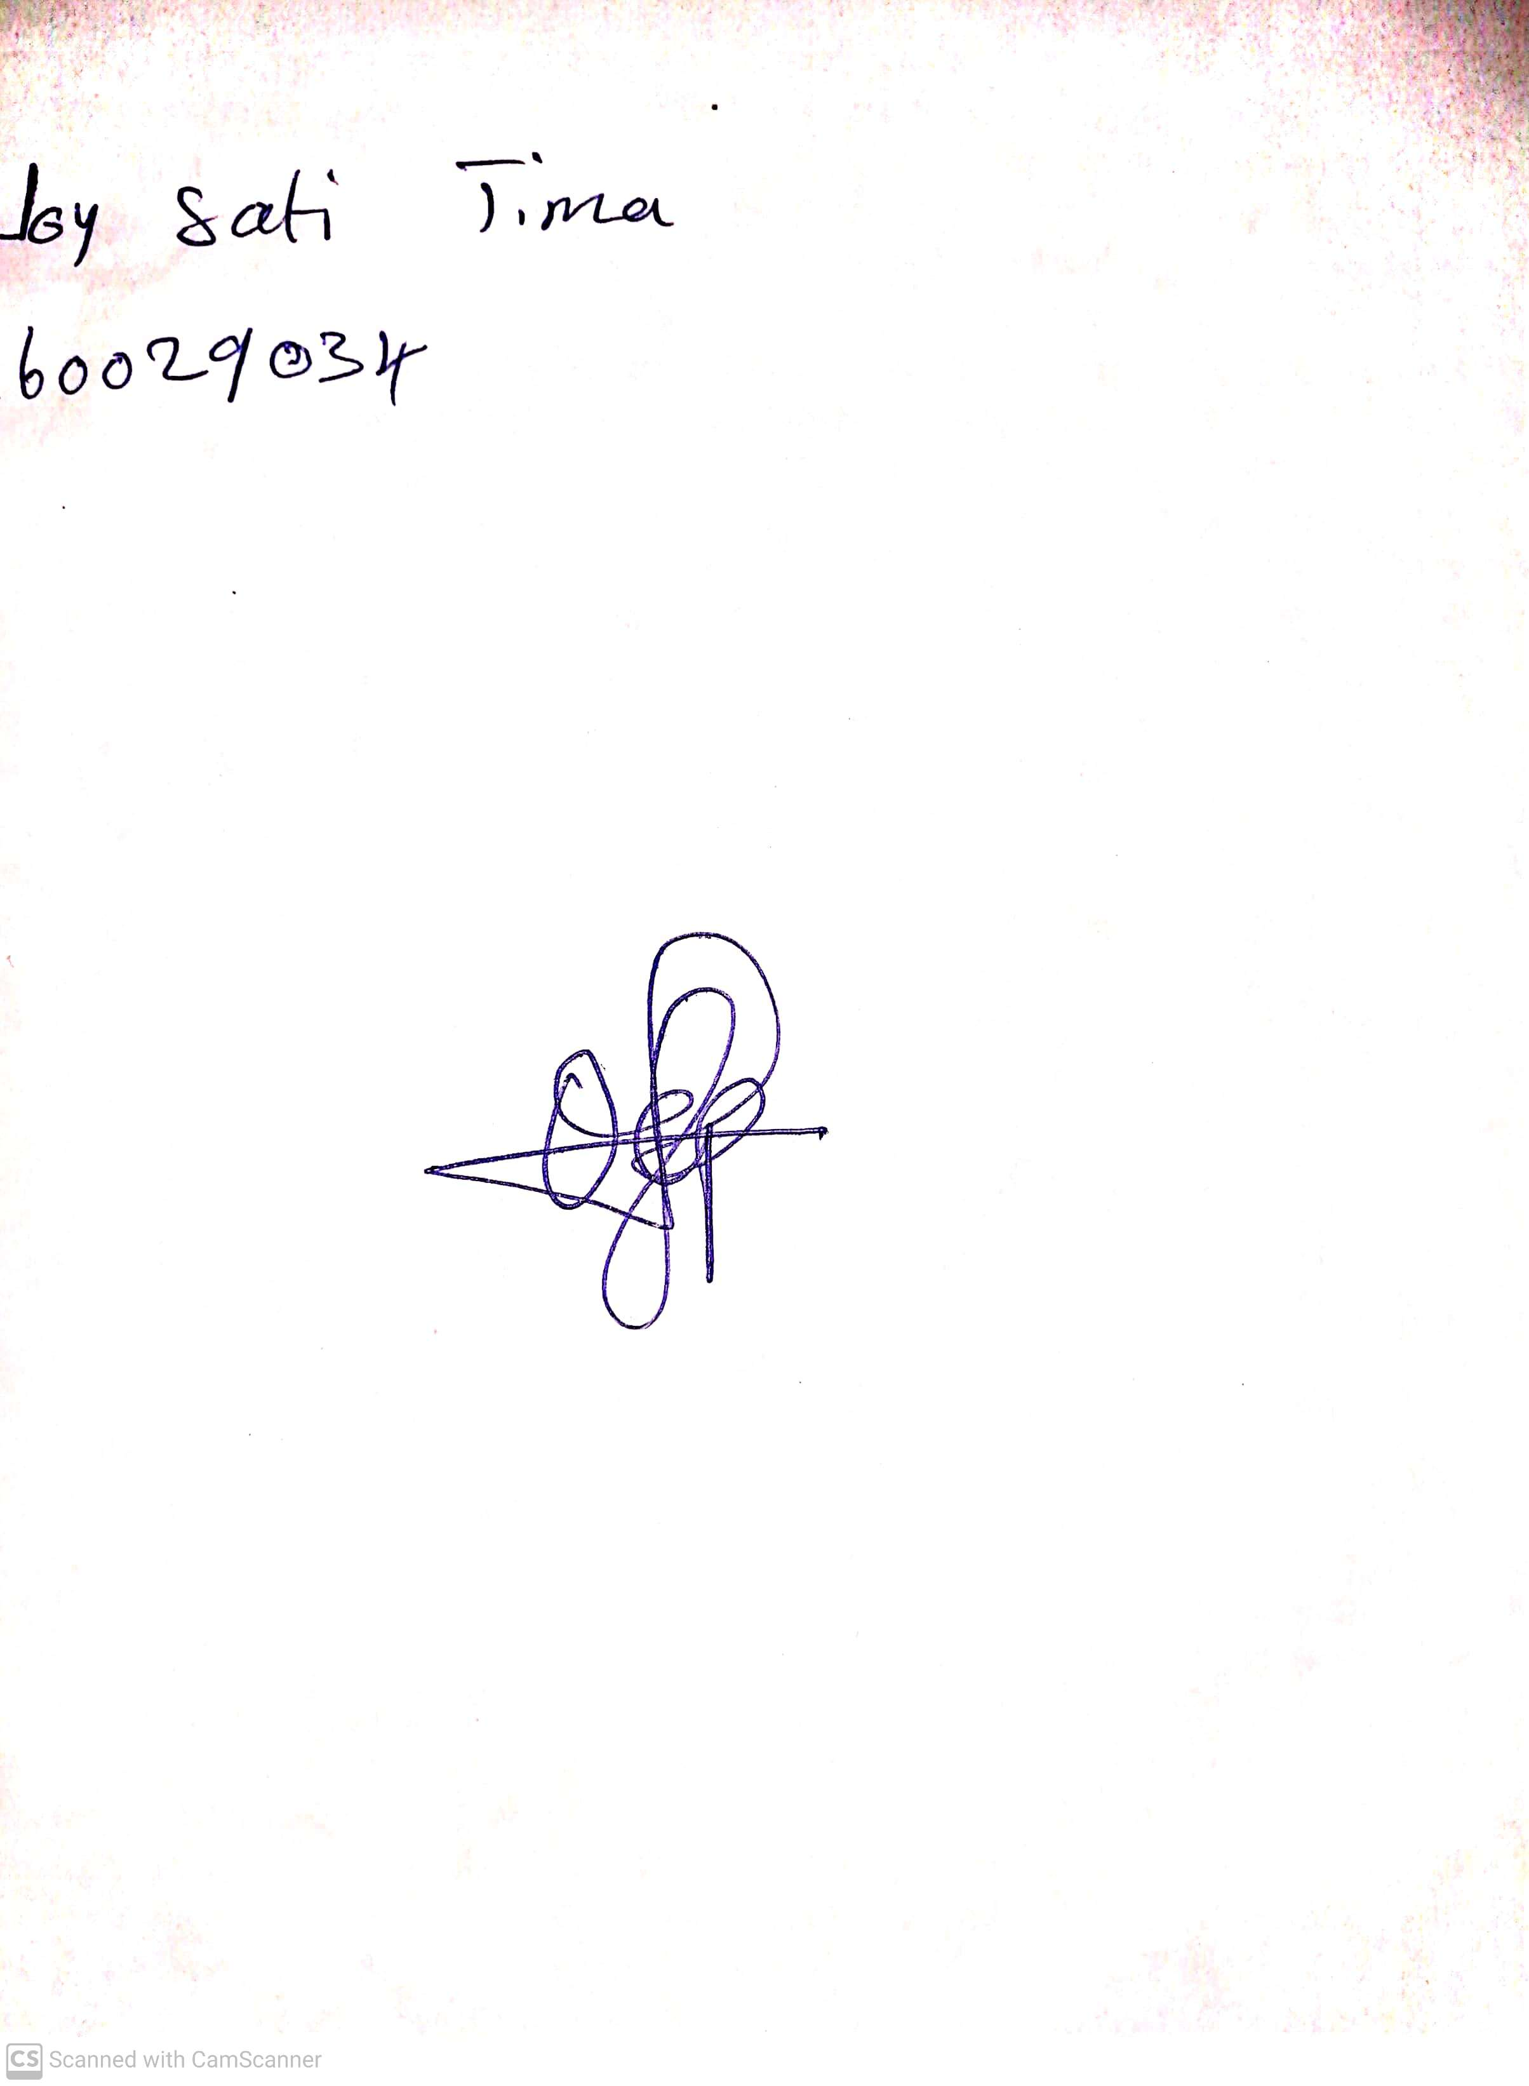

5th July, 2023

Perpetual Ojoma

Stream Head Nursery