**LESSON PLAN AND NOTE FOR WEEK 8 ENDING 23/6/2023**

**Term 3rd term**

**Week 8th week**

**Date 23rd June,2023**

**Class Nursery one**

**Subject Nature studies**

**Topic Sources and uses of water.**

**Sub-topic Naming sources and uses of water.**

**Period 2nd period**

**Time 9:05 am**

**Duration 35 minutes**

**No in class 18**

**Average Age 3 years**

**Sex Mixed.**

**Specific Objectives: By the end of the lesson, the pupils should know how to:**

1. **Name the sources of water.**
2. **Name the uses of water.**

**Rationale: To help the pupils know the sources and uses water.**

**Previous Knowledge: The pupils have knowledge of Animals and their homes.**

**Instructional Resources: Online Research,Sources of water chart.**

**Reference Materials: Online Research, Elementary Science by Showers Kiddies.**

**LESSON PRESENTATION**

|  |  |  |  |
| --- | --- | --- | --- |
| **Steps** | **Teacher’s Activities** | **Pupils’ Activities** | **Learning Points** |
| **Introduction** | **The teacher introduces the topic (sources and uses water ) by showing the pupils pictures of different kinds of water.** | **The pupils participates in seeing kinds of water.** | **To arouse the interest of the pupils.** |
| **Step 1** | **The teacher starts the lesson by teaching and mentioning for the pupils sources of water e.g**  **Well**  **Stream**  **Spring**  **River**  **Lakes**  **Sea**  **Oceans etc.** | **The pupils listen attentively to the teacher and repeats after the teacher sources of water.** | **For proper understanding.** |
| **Step 2** | **The teacher name the uses of water for the pupils**  **Water is used for drinking both man and animals.**  **Water is used for cooking**  **Water is used for bathing**  **Water is used for washing cloth etc.** | **The pupils repeats the uses of water along with their teacher.** | **For better understanding.** |
| **Summary** | **The teacher summarizes the lesson by defining water for the pupils as “ a clear liquid without color or taste that falls from sky”.** | **The pupils with define water with the teacher.** | **For onward study.** |
| **Evaluation** | **Question:**  **What is water?**  **Mention the sources of water you know?**  **Mention two uses of water?** | **The pupils answer the question correctly.** | **To ascertain the pupils’ understanding.** |
| **Conclusion** | **The teacher summarizes, reacts, and corrects the pupils.** | **The pupils gives answers to the teacher’s question.** | **To consolidate the lesson.** |
| **Assignment** | **Question:**  **Mention two each the sources and uses of water?** | **The pupils copy and do their homework at home.** | **To encourage learning while at home.** |

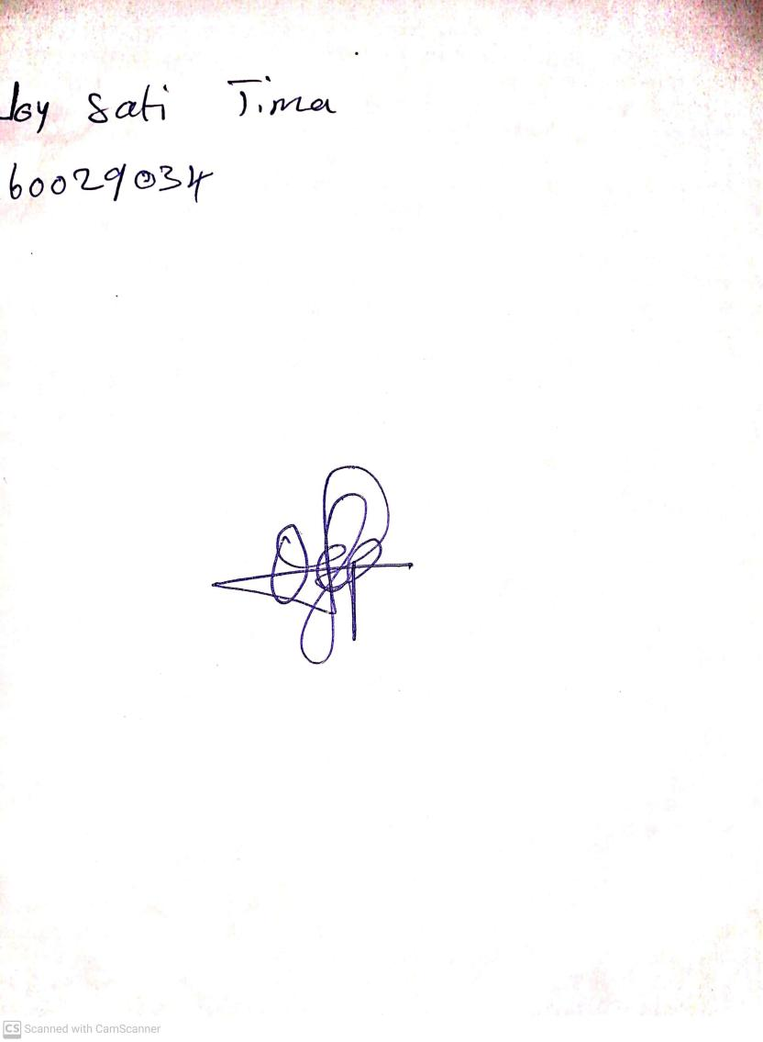

30th April, 2023

Perpetual Ojoma

Stream Head Nursery