**EMERALD ROYAL INTERNATIONAL SCHOOL MPAPE, ABUJA.**

**LESSONS PLAN AND NOTE FOR WEEK 7 ENDING 7TH JUNE, 2024**

**TERM: 3rd**

**WEEK: 7th**

**DATE: 03/06/2024**

**CLASS: Nursery 2**

**SUBJECT: Nature studies**

**TOPIC: Water–borne diseases**

**SUB—TOPIC: Meaning and examples of water —borne diseases.**

**PERIOD: 4th**

**TIME: 10:40—11:20am**

**DURATION: 40 minutes**

**NUMBER IN CLASS: 13**

**AVERAGE AGE: 5 years**

**SEX: Mixed**

**LEARNING OBJECTIVES: By the end of the lesson, the pupils should be able to:**

**1. Explain the meaning of water —borne diseases.**

**2. Mention the examples of water —borne diseases.**

**RATIONALE: For pupils to know the effects of drinking dirty water.**

**PREVIOUS KNOWLEDGE: Pupils have learnt about water storage in previous lesson.**

**INSTRUCTIONAL MATERIALS: Pictures of Pupils suffering from water borne diseases.**

**REFERENCE MATERIALS: Basic science and technology for Nursery schools book 3 by OPEMIPO DADA.**

**LESSON DEVELOPMENT**

|  |  |  |  |
| --- | --- | --- | --- |
| **Steps** | **Teacher's activities** | **Pupils' activities** | **Learning point** |
| **Introduction** | **Teacher introduces the lesson by reviewing the previous lesson.** | **Pupils pay attention to the teacher.** | **To prepare pupils minds for the lesson ahead.** |
| **Presentation step 1** | **Teacher explains the meaning of water—borne diseases to the pupils and asks them to repeat after her.** | **Pupils listen to the teacher and repeat after her.** | **For better understanding.** |
| **Step 2** | **Teacher mentions the examples of water—borne diseases and also asks Pupils to repeat after her.** | **Pupils pay attention to the teacher and repeat after the teacher.** | **For better understanding.** |
| **Board summary** | **Teacher writes the whole note of lesson on the board for pupils to copy. That is;**  **Meaning of water—borne diseases**  **Water—borne diseases are diseases that people get when they drink dirty water. People get water—borne diseases because dirty water contains germs that make people sick.**  **Examples of water—borne diseases**  **1. Cholera**  **2. Diarrhoea**  **3. Typhoid fever**  **4. Guinea–worm infection**  **5. Dysentery.** | **Pupils copy the note into their exercise books.** | **For onward study.** |
| **Evaluation** | **Teacher evaluates the lesson by asking pupils the following questions;**  **1. What is the meaning of water—borne diseases?**  **2. Mention the examples of water—borne diseases.** | **Pupils answer the questions ask by the teacher.** | **To assess pupils level of understanding.** |
| **Conclusion** | **Teacher concludes the lesson by marking pupils books.** | **Pupils submit their books for marking.** | **For endorsement.** |
| **Assignment** | **Activity 21 page 68. Basic science textbook.** | **Pupils do their assignment at home.** | **To encourage learning at home.** |

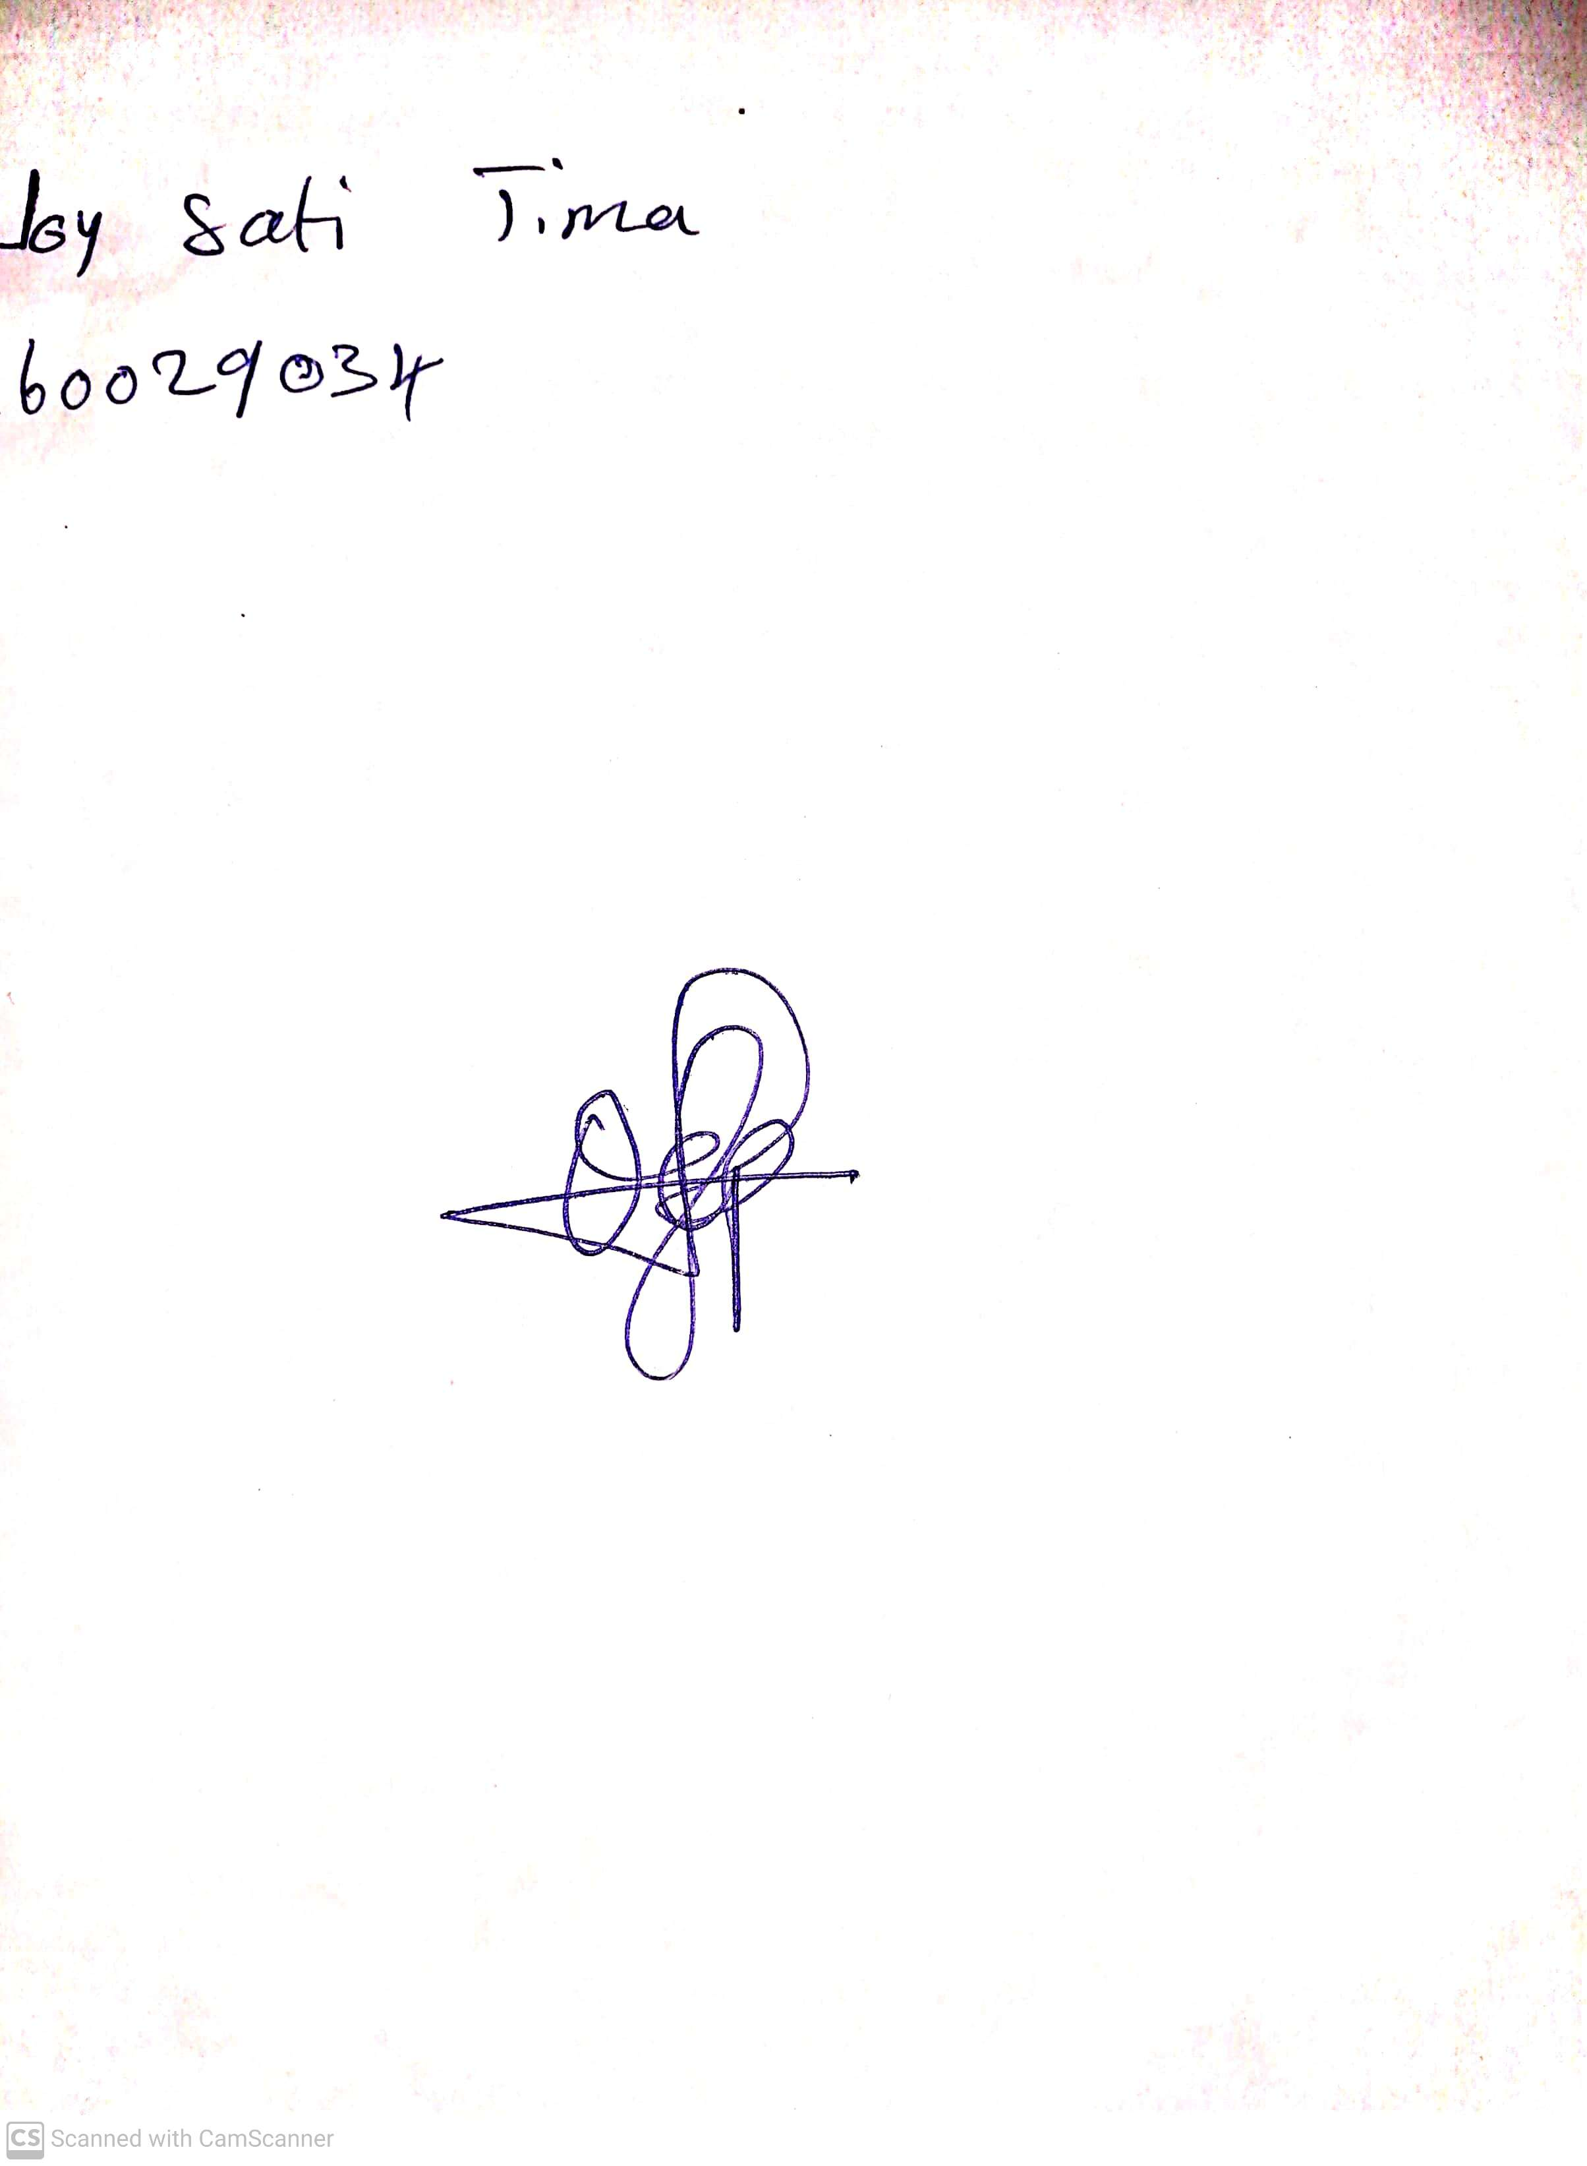

**17th May, 2024**

**Perpetual Ojoma Ocheja**

**Stream Head Nursery**