**EMERALD ROYAL INTERNATIONAL SCHOOL, MPAPE ABUJA**

**LESSON PLAN AND NOTE FOR WEEK 1 ENDING FRIDAY, 15TH SEPTEMBER, 2023**

**TERM:** FIRST TERM

**WEEK:** WEEK 1

**SUBJECT:** SOCIAL STUDIES

**TOPIC:** FUNDAMENTALS OF SOCIAL STUDIES

**SUB-TOPIC:** MEANING AND IMPORTANCE OF SOCIAL STUDIES

**DATE:** TUESDAY, 12TH ANDWEDNESDAY, 13TH SEPTEMBER, 2023

**TIME:** 11:50 – 12:30PM AND 01:20 – 02:00PM

**DURATION:** 40 MINUTES

**PERIOD:** 6TH AND 8TH

**CLASS:** NURSERY 3

**NUMBER IN CLASS:** ELEVEN

**AVERAGE AGE:** FIVE

**SEX:** MIXED

**LEARNING OBJECTIVES:** By the end of the lesson, the pupils should be able to:

1. Define social studies
2. State the importance of social studies

**RATIONALE:** for pupils to learn the meaning and importance of social studies

**PREVIOUS KNOWLEGDE:** pupils relate with family and friends

**INSTRUCTIONAL MATERIALS:**

1. charts.

**REFERENCE MATERIALS:**

1. Social Studies for primary schools book 1 by Olufemi J. Olugasa, Olusola H. Bamidele, Felix K. Alonge, Julius O. Onwuka

**LESSON DEVELOPMENT**

|  |  |  |  |
| --- | --- | --- | --- |
| **STAGES/STEPS** | **TEACHER’S ACTIVITIES** | **PUPILS’ ACTIVITIES** | **LEARNING POINTS** |
| **INTRODUCTION** | The teacher introduces the lesson by asking pupils to say how they relate with their family and friends | Respond to the teacher | To arouse the pupils’ interest. |
| **PRESENTATION**  **STEP 1** | Teachers and explain the meaning of social studies  **Meaning of social studies**  Social studies is a subject that studies social relationships and how the society functions. It focuses on the study of man and how his problem are solved in the environment. | Listen attentively and learn. | Meaning of social studies. |
| **STEP 2** | Teaches pupils the importance of social studies.  **Importance of social studies**   1. It helps us to know about our environment. 2. It helps us to do our work in school and at home well. 3. It informs us about the culture of our community. 4. It informs us of the things happening in other parts of the words. 5. It teaches respect for elders and other people in authority. | Listen attentively and learn. | Importance of social studies |
| **SUMMARY** | Summarises the lesson by emphasising on the main concept and writes note on the board | Listen and copy their notes | For onward study |
| **EVALUATION** | Asks pupils to:   1. Define social studies. 2. State the importance of social studies. | Respond to the teacher’s question. | To test the pupils understanding on the lesson. |
| **CONCLUSION** | Summarizes, corrects and mark pupils’ notebooks | Submit their notebooks for marking. | Clarifying the concept. |
| **HOME WORK** | 1. Apart from Nigeria, mention five other country you know. | Cope and return with task. | Extending lesson home. |

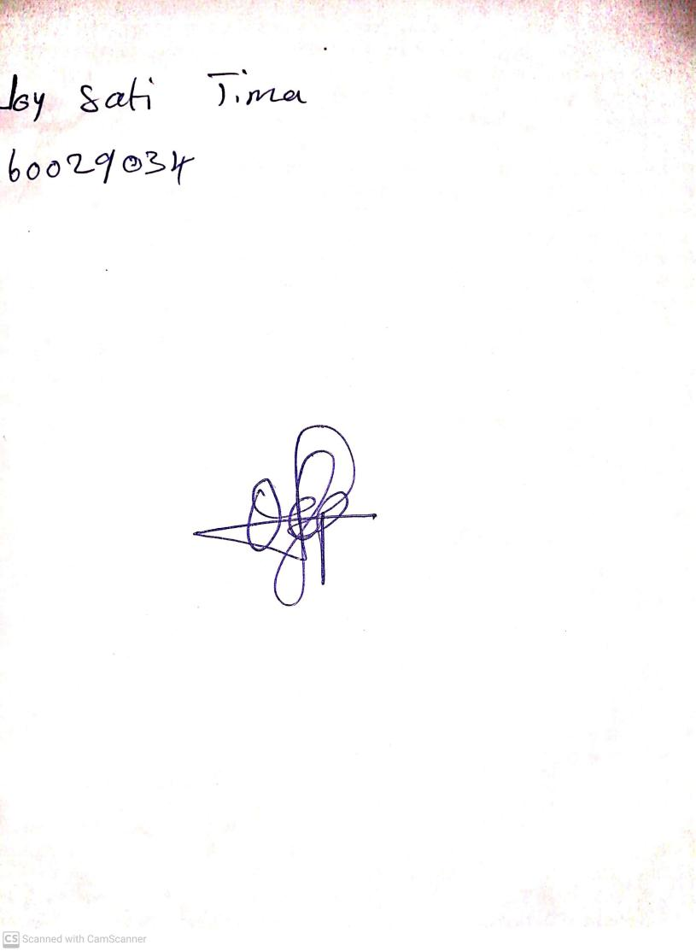

11TH September, 2023

Perpetual Ojoma Ocheja

Stream Head Nursery