LESSON PLAN FOR WEEK 6 ENDING 17TH FEBRUARY,2023

|  |  |
| --- | --- |
| TERM | 2ND |
| WEEK | 6 |
| DATE | 13TH -17TH February, 2023 |
| CLASS | SS 1 |
| SUBJECT | Government |
| TOPIC | Separation of Powers |
| SUB-TOPIC | Separation of Powers in the Presidential System of Government |
| PERIOD | 6th |
| TIME | 11:50-12:30 |
| DURATION | 40 Minutes |
| NO IN CLASS | 2 |
| AVERAGE AGE | 15years |
| SEX | Mixed |
| SPECIFIC OBJECTIVES | By the end of the lesson, scholars should be able to:  i.Outline the separation of powers in the presidential system of government.  ii.Highlight the separation of powers in the cabinet system of government. |
| RATIONALE | To acquaint the scholars with separation of powers some systems of government. |
| PREVIOUS KNOWLEDGE | The scholars can mention the merits and demerits of separation of powers. |
| INSTRUCTIONAL RESOURCES | Charts from textbook explaining the topic. |
| REFERENCE MATERIAL | Essential Government for Senior Secondary Schools.  Debbie C. Chris(2017) |

LESSON DEVELOPMENT

|  |  |  |  |
| --- | --- | --- | --- |
| STEPS | TEACHER’S ACTIVITIES | SCHOLARS’ ACTIVITIES | LEARNING POINTS |
| Introduction | The teacher introduces the lesson by asking the scholars to mention two merits of separation of powers. | The scholars mention them as:   1. Liberty 2. Checks and balances | To arouse scholar’s interest towards the topic. |
| Step 1 | The teacher outlines the separation of power in the presidential system of government. | The scholars listen carefully. | To ensure proper understanding of the topic. |
| Step 2 | The teacher outlines the separation of powers in the cabinet system of government. | The scholars ask questions on the topic. | To make room for logical reasoning on the topic. |
| Board summary | The teacher summarizes the lesson thus:  **Separation of Powers in the Presidential System of Government**  1.President/Heads of State don’t make laws: This is because they don’t sit in the legislature.  2.Pronounced Separation of Powers: There is clear separation of powers in a presidential system.  3.Dissolution of Parliament: The parliament cannot be dissolved by the president unless its tenure is complete.  4.Appointment of judges: The president appoint judges and they preside over judgment of the president and government officials.  5.Individual Responsibility: There is individual responsibilities of the cabinet members (ministers).  6.Impeachment: The President can only be removed through impeachment, if found guilty of a serious offence by the parliament.  **Separation of Powers in a Cabinet System of Government**  1.No clear or pronounced separation: Separation of power is not pronounced in this system.  2.Ministers sit in parliament: That is, members of the executive branch are equally involved in the legislative branch.  3.The cabinets presents policies: The cabinet decide on the policies which are to be put before parliament for discussion.  4.House of Lords: The House of Lords is also the final court of appeal for the U.K, Great Britain and Northern Ireland.  5.Vote of no Confidence: The parliament can pass a vote of no confidence and the entire cabinet is removed. This is a check on the powers of the cabinet.  6.Judicial review: The executive appoints the judges and they have power to preside over judgment on the conduct of government officials. | The scholars copy notes into their notebooks. | For future references. |
| Evaluation | The teacher evaluates the scholars thus:  i.Explain separation of powers in the Presidential system of government.  ii.Explain separation of powers in the cabinet system of government. | The scholars attempt the questions. | To ascertain their level of understanding of the lesson. |
| Conclusion | The teacher check scholars notes and make corrections. | The scholars take corrections made by the teacher. | For better understanding of the lesson. |
| Assignment | The teacher gives the scholars assignment:  Explain separation of powers in the unitary system of government. | The scholars copy their assignment to do it at home. | To encourage scholars to study and learn at home. |

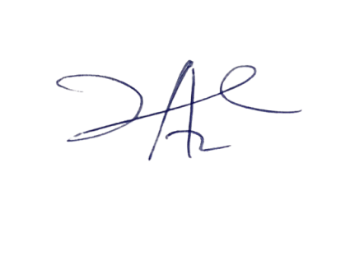

29/3/2023

Principal Head Instuctor