**EMERALD ROYAL INTERNATIONAL SCHOOL**

**MPAPE, ABUJA.**

**LESSON PLAN AND NOTE FOR WEEK 3 PERIOD 1 ENDING 27/09/2024**

**TERM: FIRST**

**WEEK: 3RD**

**DATE: 23/09/2024**

**CLASS: NURSERY 2**

**SUBJECT: NUMBERWORK**

**TOPIC: EVEN AND ODD NUMBERS .**

**SUB-TOPIC: MEANING AND EXAMPLES OF EVEN NUMBERS**

**PERIOD: 1ST**

**TIME: O8:50-09:30.**

**DURATION: 40 MINUTES.**

**NUMBER IN CLASS: 14**

**AVERAGE AGE: 5 YEARS.**

**SEX: MIXED.**

**SPECIFIC OBJECTIVES: BY THE END OF THE LESSON,THE PUPILS SHOULD BE ABLE TO:**

1. **SAY THE MEANING OF EVEN NUMBERS**
2. **MENTION EXAMPLES OF EVEN NUMBERS**

**RATIONALE: FOR PUPILS TO KNOW THE MEANING AND EXAMPLES OF EVEN NUMBERS**

**PREVIOU KNOWLEDGE: PUPILS HAVE LEARNT COUNTING OF NUMBERS 21- 25 IN PREVIOUS LESS0N.**

**INSTRUCTIONAL MATERIALS: A CHART OF NUMBERS ON EVEN NUMBERS.**

**REFERENCE MATERIALS: THE NEW MASTERING MATHEMATICS FOR NURSERY SCHOOLS BOOK 3 BY HENRY.Z.IDOGUN.**

**LESSON DEVELOPMENT**

|  |  |  |  |
| --- | --- | --- | --- |
| **STAGES/STEPS** | **TEACHER’S ACTIVITIES** | **PUPILS’ ACTIVITIES** | **LEARNING POINTS** |
| **INTRODUCTION** | **Teacher introduces the lesson by reviewing the previous lesson.** | **Pupil listen to the teacher.** | **To arouse pupils interest for the lesson ahead.** |
| **PRESENTATION**  **STEP 1** | **Teacher explains the meaning of even numbers and then asks pupils to repeat after her.** | **Pupils listen attentively to the teacher and repeat after her.** | **For proper understanding of the lesson .** |
| **STEP 2** | **Teacher mentions the examples of even numbers and also asks pupils to repeat after her.** | **Pupils pay attention to the teacher and repeat after her.** | **For better understanding of the lesson.** |
| **BOARD SUMMARY** | **Teacher summarizes the lesson by writing the whole note of lesson on the board for pupils to copy into their books.that is,**  **EVEN NUMBERS**  **Even numbers are the numbers that can be divided by two without a remainder.**  **Examples:**  **2, 4, 6, 8, 10, 12, 14, 16, 18, 20 etc.** | **Pupils copy the note into their exercise books.** | **For onward study.** |
| **EVALUATION** | **Teacher evaluates the lesson by asking pupils the following question.**   1. **What are even numbers?** 2. **Mention the examples of even numbers.** | **Pupils answer the question asked by the teacher.** | **To assess pupils understanding of the lesson.** |
| **CONCLUSION** | **Teacher concludes the lesson by marking pupils books.** | **Pupils submit their books for marking.** | **For endorsement.** |
| **ASSIGNMENT** | **Identify and circle all the even numbers bellow.**  **1 2 3 4 5 6 7 8 9 10 11 12 13 14 15 16 17 18 19 20** | **Pupils do their assignment at home.** | **To encourage learning at home.** |

**LESSON PLAN AND NOTE FOR WEEK 3 PERIOD 2 ENDING 27/09/2024**

**TERM: FIRST**

**WEEK: 3RD**

**DATE: 24/09/2024**

**CLASS: NURSERY 2**

**SUBJECT: NUMBER WORK**

**TOPIC: EVEN AND ODD NUMBERS .**

**SUB-TOPIC: MEANING AND EXAMPLES OF ODD NUMBERS**

**PERIOD: 2nd**

**TIME: O8:50-09:30.**

**DURATION: 40 MINUTES.**

**NUMBER IN CLASS: 14**

**AVERAGE AGE: 5 YEARS.**

**SEX: MIXED.**

**SPECIFIC OBJECTIVES: BY THE END OF THE LESSON,THE PUPILS SHOULD BE ABLE TO:**

1. **EXPLAIN THE MEANING OF ODD NUMBERS**
2. **MENTION THE EXAMPLES OF ODD NUMBERS**

**RATIONALE: FOR PUPILS TO KNOW THE MEANING AND EXAMPLES OF ODD NUMBERS.**

**PREVIOU KNOWLEDGE: PUPILS HAVE LEARNT THE MEANING AND EXAMPLES OF EVEN NUMBERS IN PREVIOUS LESS0N.**

**INSTRUCTIONAL MATERIALS: A CHART OF ODD NUMBERS .**

**REFERENCE MATERIALS: THE NEW MASTERING MATHEMATICS FOR NURSERY SCHOOLS BOOK 3 BY HENRY.Z.IDOGUN.**

**LESSON DEVELOPMENT**

|  |  |  |  |
| --- | --- | --- | --- |
| **STAGES/STEPS** | **TEACHER’S ACTIVITIES** | **PUPILS’ ACTIVITIES** | **LEARNING POINTS** |
| **INTRODUCTION** | **Teacher introduces the lesson by asking pupils to all stand and explain the meaning of even numbers and the examples.** | **Pupils all stand and explain the meaning of even numbers and examples.** | **To prepare pupils minds for the lesson ahead.** |
| **PRESENTATION**  **STEP 1** | **Teacher presents the lesson by explaining the meaning of odd numbers to pupils and then asks them to repeat after.** | **Pupils pay attention to the teacher and the repeat after her.** | **For proper understanding of the lesson .** |
| **STEP 2** | **Teacher guides pupils to mention the examples of odd numbers.** | **Pupils pay attention to the teacher and attempt the examples of odd numbers. As;**  **1, 3, 5, 7 etc.** | **For better understanding of the lesson.** |
| **BOARD SUMMARY** | **Teacher summarizes the lesson by writing the whole note of lesson on the board for pupils to copy into their books.that is,**  **ODD NUMBERS**  **Odd numbers are the numbers that cannot be divided by two.**  **Examples;**  **1, 3, 5, 7, 9, 11, 13, 15, 17, 19, 21, 23, 25, 27, 29, etc.** | **Pupils copy the note into their exercise books.** | **For onwardstudy.** |
| **EVALUATION** | **Teacher asks Pupils the following questions;**   1. **what are odd numbers?** 2. **Mention the examples of odd numbers.** | **Pupils answer the questions asked by the teacher.** | **To assess pupils level of understanding of the lesson.** |
| **CONCLUSION** | **Teacher marks pupils books.** | **Pupils submit their books for marking.** | **For endorsement.** |
| **ASSIGNMENT** | **Write only the odd numbers from 1-50.** | **Pupils do their assignment at home.** | **To encourage learning at home.** |

**LESSON PLAN AND NOTE FOR WEEK 3 PERIOD 3 ENDING 27/09/2024**

**TERM: FIRST**

**WEEK: 3RD**

**DATE: 27/09/2024**

**CLASS: NURSERY 2**

**SUBJECT: NUMBER WORK**

**TOPIC: EVEN AND ODD NUMBERS .**

**SUB-TOPIC: FINDING THE MISSING EVEN AND ODD NUMBERS**

**PERIOD: 3RD**

**TIME: 08:10- 08:50am**

**DURATION: 40 MINUTES.**

**NUMBER IN CLASS: 14**

**AVERAGE AGE: 5 YEARS.**

**SEX: MIXED.**

**SPECIFIC OBJECTIVES: BY THE END OF THE LESSON,THE PUPILS SHOULD BE ABLE TO:**

1. **CIRCLE EVEN NUMBERS**
2. **FILL IN MISSING ODD NUMBERS**

**RATIONALE: FOR PUPILS TO BE COVERSANT WITH EVEN AND ODD NUMBERS**

**PREVIOU KNOWLEDGE: PUPILS HAVE LEARNT THE MEANING AND EXAMPLES OF EVEN AND ODD NUMBERS IN PREVIOUS LESSON**

**INSTRUCTIONAL MATERIALS: NUMBER CHART ON EVEN AND ODD NUMBERS**

**REFERENCE MATERIALS: THE NEW MASTERING MATHEMATICS FOR NURSERY SCHOOLS BOOK 3 BY J.M OMOGBAI.**

**LESSON DEVELOPMENT**

|  |  |  |  |
| --- | --- | --- | --- |
| **STAGES/STEPS** | **TEACHER’S ACTIVITIES** | **PUPILS’ ACTIVITIES** | **LEARNING POINTS** |
| **INTRODUCTION** | **Teacher introduces the lesson by asking pupils questions based on the previous lessons as;**   1. **What are even numbers?** 2. **Mention the examples of even numbers** 3. **Define odd numbers.** 4. **State the examples of odd numbers.** | **Pupils answer the questions asked by the teacher.** | **To arouse pupils interest for the lesson ahead.** |
| **PRESENTATION**  **STEP 1** | **Teacher presents the lesson by writing numbers on the board for pupils to identify and circle all the even numbers one after another. That is;**  **Identify and cycle all the even numbers from 1-30**  **1 2 3 4 5 6 7 8 9 10 11 12 13 14 15 16 17 18 19 20 21 22 23 24 25 26 27 28 29 30** | **Pupils identify and circle all the even numbers on the board**  **.** | **For proper understanding of the lesson .** |
| **STEP 2** | **Teacher writes numbers on the board for pupils to fill in the missing odd numbers. As;**  **__ 2 __ 4 __ 6__ 8 __ 10 __ 12 __ 14 __ 16__ 18 __ 20 __ 22 __24 __ 26__ 28 __ 30** | **Pupils pay attention to the board and fill in the missing odd numbers as;**  **1 2 3 4 5 6 7 8 9 10 11 12 13 14 15 16 17 18 19 20 21 22 23 24 25 26 27 28 29 30** | **For better understanding of the lesson.** |
| **BOARD SUMMARY** | **Teacher summarizes the lesson by going through the lesson on the board over again** | **Pupils listen attentively to the teacher.** | **To create platform for slow learners.** |
| **EVALUATION** | **Teacher evaluates the lesson by asking pupils to all stand,**   1. **Mention the even numbers from 1-30** 2. **List all the odd numbers from 1-30** | **Pupils all stand and answer the questions asked by the teacher.** | **To enhance pupils learning ability.** |
| **CONCLUSION** | **Teacher concludes the lesson by singing nursery number rhymes** | **Pupils sing the rhymes along with the teacher.** | **To make learning fun** |
| **ASSIGNMENT** | **Underline all the even numbers and circle all the odd numbers bellow.**  **1 2 3 4 5 6 7 8 9 10 11 12 13 14 15 16 17 18 19 20 21 22 23 24 25 26 27 28 29 30 31 32 33 34 35 36 37 38 39 40 41 42 43 44 45 46 47 48 49 50.** | **Pupils do their assignment at home.** | **To encourage learning at home.** |

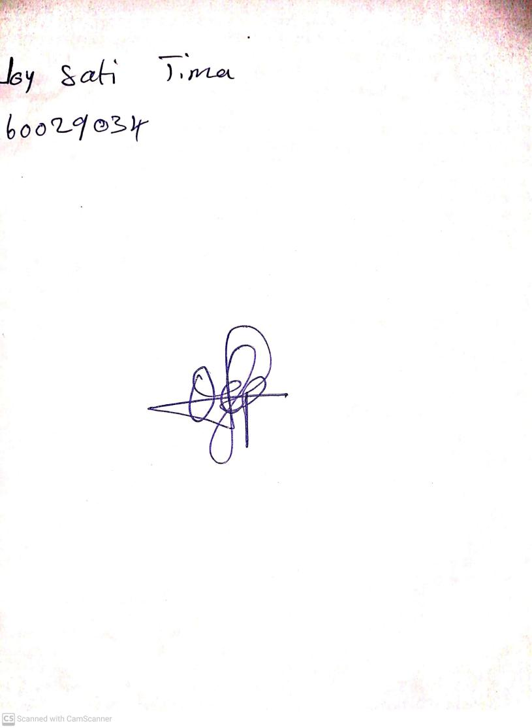

**13th September, 2024**

**Perpetual Ojoma Ocheja**

**Stream Head Nursery**