**EMERALD ROYAL INT’L SCHOOL**

**LESSON PLAN/NOTE FOR WEEK 6 ENDING: 9th JUNE, 2023**

|  |  |
| --- | --- |
| **Term** | 3rd |
| **Week** | 6 |
| **Date** | 09/06/2023 |
| **Class** | SSS 1 |
| **Subject** | Physics |
| **Topic** | Equilibrium of bodies in liquids |
| **Sub-topic** | floatation |
| **Period** | 3 |
| **Time** | 10:30-11:50 |
| **Duration** | 35minutes |
| **Number in class** | 8 |
| **Average age** | 13years |
| **Sex** | Mixed |
| **Specific objectives** | By the end of the lesson, the students should be able to:   1. Explain the principles of floatation 2. Solve simple exercises relating to the the application of floatation. |
| **Rationale** | To enable the students understand the concept of equilibrium of bodies in liquids |
| **Previous knowledge** | Students should have been taught on resultant forces |
| **Instructional aid** | One guide sheet for each student, science notebook and a science textbook. |
| **Reference** | * M.W. Anyakoha. New school physics for secondary schools. Africana first publishers PLC. page 155-169 * P.N. Okeke. Macmillan Senior Secondary Physics. Pearson. Page 89-99 |

**LESSON DEVELOPMENT**

|  |  |  |  |
| --- | --- | --- | --- |
| **STEPS** | **TEACHER’S ACTIVITIES** | **STUDENTS’ ACTIVITIES** | **LEARNING POINTS** |
| **Introduction** | The teacher introduces the lesson by explaining that when a piece of cork is pushed into water, the cork is seen to bob up when released due to the upthrust of the water on the cork.  As we have seen from Archimedes principle, when an object is partially immersed in a liquid, an upthrust equal to the weight of the liquid displaced acts upwards on the object. When the object is completely immersed in the liquid, the upthrust of the liquid on the object is now greater since more liquid would have now been displaced. If the upthrust equals the weight of the object before the object is completely immersed, then the object will not sink but will float in the liquid.  Because of upthrust, a swimmer floats in water, a balloon floats in air and ice cubes floats in water. When an object floats in a fluid, the weight of fluid displaced by the floating body is equal to the weight of the object. This is the principle of floatation. | The students listen attentively. | To give the students a proper understanding of equilibrium of forces in liquids. |
| **Step I** | *Principle of floatation*  The principle of floatation states that an object will float in a fluid (liquid or gas) when the upthrust exerted upon it by the fluid in which it floats equals the weight of the object. | The students engage in the practical application of the principle of floatation | To ensure proper understanding of the lesson. |
| **Step II** | *Example*  A piece of cork density 0.25 × 103 kgm-3 floats in a liquid of density 1.25 × 105 kgm-3, what fraction of the volume of the cork will be immersed?  *Solution*  Let the total volume of cork = V1 m3. let the volume of it submerged = V2 m3. Mass of cork = volume × density = 0.25 × 103V1 kg. When the cork floats, its weight equals the wight of the liquid displaced.  That is, 0.25 × 103V1 kg = 1.25 × 103V2kg  Therefore fraction of cork submerged is: $\frac{V2}{V1} = \frac{0.25 × {10}^{3}}{1.25 × {10}^{3}}$ = 0.2 | The students listen attentively to the teacher’s explanation. | To ensure that all the students are carried along. |
| **Summary** | The principle of floatation states that an object will float in a fluid (liquid or gas) when the upthrust exerted upon it by the fluid in which it floats equals the weight of the object. | The students listen attentively to the teacher’s explanation. | For reference purpose. |
| **Evaluation** | The teacher evaluates the students by giving the students the following class work.  State the principle of floatation and describe an experiment to verify the principle. | The students answer the question in their science notebook. | To ascertain the students level of understanding of the lesson. |
| **Conclusion** | The teacher makes correction of the classwork. | The students copy the correction in their exercise books. | For reference purpose |
| **Assignment**  **(Homework)** | The teacher gives the students the following assignment.  A metal block of density 9000 kgm-3 weighs 60 N in air. Find its weight when it is immersed in paraffin wax of density 800 kgm-3.. (take *g =* 10ms-2) | The students copy the questions into their exercise books and take home for solving. | To encourage logical thinking of the students at home. |

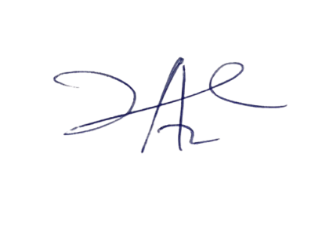

20/7/2023

Principal Head Instuctor