**LESSON PLAN FOR WEEK 3 ENDING 29/09/2023**

**Term 1st term**

**Week 3rd  week**

**Date 26th September,2023**

**Class Nursery One**

**Subject Nature studies**

**Topic Care of our surrounding.**

**Sub-topic Importance of caring for our**

**surrounding**

**Period 2nd period**

**Time 8:50 am**

**Duration 35 minutes**

**No in class 15**

**Average Age 3 years**

**Sex Mixed**

**Specific Objectives: By the end of the lesson, the pupils**

**should be able to:**

1. **Know the importance of caring for our surrounding clean**
2. **Mention the materials to keep our surrounding clean.**

**Rationale: To ensure the pupils have vital knowledge about keeping**

**their surrounding clean.**

**Previous Knowledge: The pupils can identify parts of their body.**

**Instructional Resources: Tools for caring for our surrounding chart.**

**Reference Material: Elementary science by Showers kiddies nursery 1**

**LESSON PRESENTATION**

|  |  |  |  |
| --- | --- | --- | --- |
| **Steps** | **Teacher’s Activities** | **Pupils’ Activities** | **Learning Points** |
| **Introduction** | **The teacher introduces the lesson by showing the pupils chart that contains the “tools for caring for our surrounding”.** | **The pupils listens attentively to identify tools for cleaning our surrounding.** | **To arose the pupils’ interest.** |
| **Step 1** | **The teacher explains the importance of cleaning our surrounding, because, “it prevents germs, and diseases that affects the health”, etc.** | **The pupils understands the importance of cleaning our surrounding.** | **For proper understanding.** |
| **Step 2** | **The teacher lists the materials/tools for keeping our surrounding clean which includes:**  **BROOM**  **MOP**  **IZAL**  **WATER**  **DETERGENT**  **RAKE**  **PARKER**  **HOE**  **CUTLASS**  **WASTE CAN etc.** | **The pupils mention with the teacher the tools for cleaning our surrounding.** | **For better understanding.** |
| **Summary** | **The teacher summarizes the lesson by showing the pupils some materials used for cleaning our surrounding.** | **The pupils can identify the materials for cleaning our surrounding.** | **For onward study.** |
| **Evaluation** | 1. **Why must we clean our surrounding?** 2. **Mention the two materials for cleaning our surrounding?** | **The pupils answer the question correctly.** | **To ascertain the pupils’ understanding.** |
| **Conclusion** | **The teacher summarizes, reacts, and corrects the pupils.** | **The pupils gives answer to the teacher’s questions** | **To consolidate the lesson.** |
| **Assignment** | 1. **What do we use to put our dirt?** 2. **What do we use to sweep the floor?** | **The pupils copy and do their homework at home.** | **To encourage learning while at home.** |

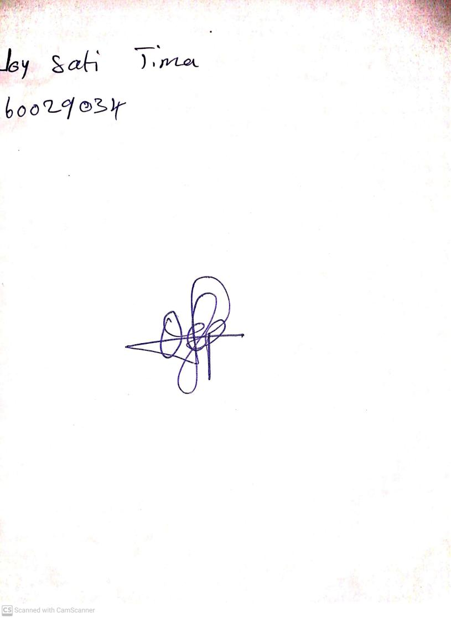

15th August, 2023

Perpetual Ojoma Ocheja

Stream Head Nursery