**EMERALD ROYAL INTERNATIONAL SCHOOL**

**MPAPE, ABUJA.**

**LESSON PLAN AND NOTE FOR WEEK 4 ENDING 17TH MAY,2024**

TERM : Third term.

WEEK : 4th

SUBJECT: Social Norms

TOPIC: My classroom

SUB-TOPIC: Classroom environment

DATE: 16/5/2024

DURATION: 40 minutes

TIME: 10:40-11:20

PERIOD: 4th

CLASS: pre-nursery

NUMBER OF PUPILS: 19

AVERAGE AGE: 2

SEX: Mixed

SPECIFIC OBJECTIVES: By the end of the lesson, the pupils should be able to:-

1. Define a classroom.

2. Say what they do in the class.

1. Mention the names of their class teacher .

RATIONALE: For pupils to be conversant with their classroom.

PREVIOUS KNOWLEDGE: Pupils have the in a classroom for quite some time and have been seeing different objects.

INSTRUCTIONAL MATERIALS: The classroom.

REFERENCE: Smart start Civic education for nursery Schools book 1 by T.Y. Alabi and A. M. Solu.

LESSON DEVELOPMENT

|  |  |  |  |
| --- | --- | --- | --- |
| Stages/steps | Teacher's activities | Pupils' activities | Learning points |
| Introduction | Teacher introduces the lesson by asking the pupils to look around | Pupils sing the rhymes along with the teacher. | To arouse the interest of the pupils for the new lesson. |
| Presentation  Step 1 | Teacher defines a classroom as thus:-  A classroom is a room in a school where classes are held.  Teacher asks the pupils to repeat after the teacher. | Pupils listen to the teacher and repeat after the teacher to define the classroom. | For proper understanding of the lesson. |
| Step 2 | Teacher explains to the pupils the things they do in the classroom and asks them to say it repeatedly. | Pupils repeat after the teacher to say the things they do in the classroom.   1. We write in the classroom. 2. We learn in the classroom. 3. We read in the classroom | To ensure active participation. |
| Step 3 | Teacher leads the pupils to mention the names of their class teachers. | Pupils mention the names of their class teachers as:-  " The names of my class teachers are Mrs Gloria and Miss Mercy. | To ensure better understanding of the lesson. |
| Summary | Teacher summarizes the lesson by going over the lesson again for more clarification. | Pupils listen and participate in the activities. | To ensure proper understanding of the lesson. |
| Evaluation | Teacher asks the pupils to:-   1. Define a classroom. 2. Mention what they do in the classroom. 3. Mention the names of their class teacher. | Pupils answer the questions correctly. | To assess the level of pupils understanding of the lesson. |
| Conclusion | Teacher ends the lesson by singing rhymes for the pupils. | Pupils sing along with the teacher. | To consolidate the lesson. |
| Assignment | Teacher encourages the pupils to practice the names of their teachers. | Pupils do the assignment at home . | To encourage learning at home. |

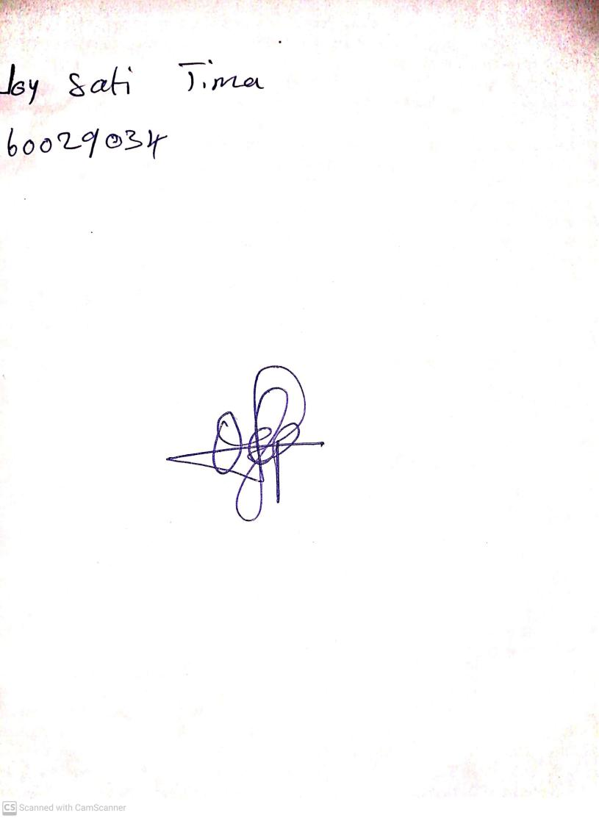

**10th May, 2024**

**Perpetual Ojoma Ocheja**

**Stream Head Nursery**