**LESSON PLAN AND NOTE FOR WEEK 4 ENDING 26/5/2023**

**Term 3rd term**

**Week 4th week**

**Date 26th May, 2023**

**Class Nursery One**

**Subject Nature studies**

**Topic Table Manners.**

**Sub-topic Explaining & Naming Good Table Manners.**

**Period 4th period**

**Time 10:40 am**

**Duration 35 minutes**

**No in class 18**

**Average Age 3 years**

**Sex Mixed**

**Specific Objectives: By the end of the lesson, the pupils should be able to:**

1. **Explain good table manners.**
2. **Mention good table manners.**

**Rationale: To teach & ensure the pupils to be well mannered in the dinning table.**

**Previous Knowledge: The pupils can mention the places around their school building.**

**Instructional Resources: Online research, Table manners chart.**

**Reference Material: Smart Smart Civic Education by A.M Solu & T.Y Alabi, nursery 2**

**LESSON PRESENTATION**

|  |  |  |  |
| --- | --- | --- | --- |
| **Steps** | **Teacher’s Activities** | **Pupils’ Activities** | **Learning Points** |
| **Introduction** | **The teacher introduces the lesson by showing the pupils the picture chart kinds of good table manners.** | **The pupils identify with the teacher.** | **To arouse the pupils’ interest.** |
| **Step 1** | **The teacher explains the meaning of Table Manner as “ the proper way of eating”** | **The pupils pay attention and repeats the definition of table manners with the teacher.** | **For proper understanding.** |
| **Step 2** | **The teacher guides and mention some kinds of good table manners to observe at the dining table which includes:**  **Wash your hands with soap & clean water before & after eating.**  **Do not talk while eating.**  **Take only small quantity of food into your mouth.**  **Do not rush your food while eating etc.** | **The pupils mention the kinds of good table manners along with the teacher.** | **For better understanding.** |
| **Summary** | **The teacher summarizes the lesson by explaining table manners to the pupils.** | **The pupils listen and understands the lesson.** | **For onward study.** |
| **Evaluation** | **Question:**  **What is Table Manners?**  **Mention two kinds of good table manners?.** | **The pupils answer the question correctly.** | **To ascertain the pupils’ understanding.** |
| **Conclusion** | **The teacher summarizes the lesson to the pupils.** | **The pupils gives answers to the teacher.** | **To consolidate the lesson.** |
| **Assignment** | **Question:**  **Mention one kind of table manner?.** | **The pupils copy and do their homework .** | **To encourage learning while at home.** |

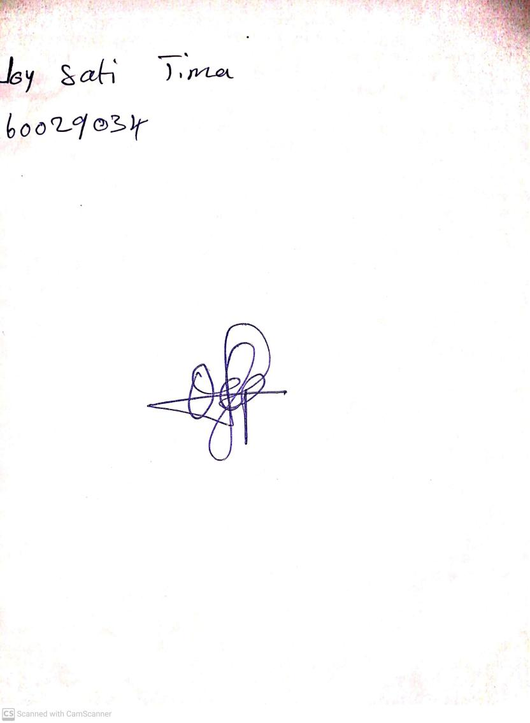

30th April, 2023

Perpetual Ojoma

Stream Head Nursery