EMERALD ROYAL INTERNATIONAL SCHOOL MPAPE, ABUJA.

LESSON PLAN/NOTE FOR WEEK 3 ENDING 26th JANUARY,2024.

SUBJECT: Nature studies

TOPIC: Difference domestic animals and wild animals.

SUB-TOPIC: Why domestic animals are friendly and wild animals are harmful.

DATE: 23rd- 26th January,2024 .

DURATION: 40 minutes

TIME: 09:30-10:10 and 09:30-10:10

PERIOD: 3rd period respectively.

CLASS : Pre-nursery

NUMBER IN CLASS: 17

AVERAGE AGE 2 years.

SEX: mixed

Specific objectives: By the end of the lesson , the pupils should be able to:-

1) Define domestic animals and wild animals.

2) State the difference between domestic animals and wild animals.

Rationale: For pupils to differentiate the types of animals we have.

Previous knowledge: Pupils have been taught the meaning of wild and domestic animals in the previous lesson.

Instructional materials:- chart.

Reference: Showers kiddies books Elementary science Nursery 1 by showers books.

LESSON DEVELOPMENT.

|  |  |  |  |
| --- | --- | --- | --- |
| Stages/steps | Teacher's activities | Pupils' activities | Learning points |
| Introduction | Teacher introduces the lesson by singing nursery rhymes for the pupils. | Pupils sing the rhymes along with the teacher. | To get the pupils ready for the lesson. |
| Presentation  Step 1 | Teacher defines again domestic animals and wild animals as:- "Domestic animals are those animals we keep at home while wild animals are those animals that lives in the forest". | Pupils listen to the teacher and repeat after the teacher to define domestic animals and wild animals. | To ensure pupils can define both domestic and wild animals. |
| Step 2 | Teacher state the difference between domestic animals and wild animals for the pupils to know.   1. Domestic animals stays at home while wild animals stays in the forest. 2. Domestic animals are friendly while wild animals are not friendly. 3. Domestic animals are being taking care of by human being while wild animals are find their own food. | Pupils listen attentively as the teacher is stating the difference between domestic animals and wild animals and they repeat after the teacher. | To ensure pupils can differentiate between domestic animals and wild animals. |
| Summary | Teacher summarises the lesson by going over the lesson for more understanding of the lesson. | Pupils pay attention to the teacher to understand the lesson. | For better understanding of the lesson. |
| Evaluation | Teacher evaluate the lesson by asking the pupils to:-  1) Define domestic animals.   1. The animals that lives in the forest are called_______________ | Pupils answer the teacher's questions correctly. | To ascertain the level of pupils understanding. |
| Conclusion | Teacher ends the lesson by playing a video clip on domestic animals and wild animals for the pupils to watch. | Pupils sit down and watch the video. | To improve pupils attention span. |
| Assignment | Teacher encourages the pupils to revise the difference between domestic animals and wild animals. | Pupils do the assignment at home | To ensure learning takes place at home. |

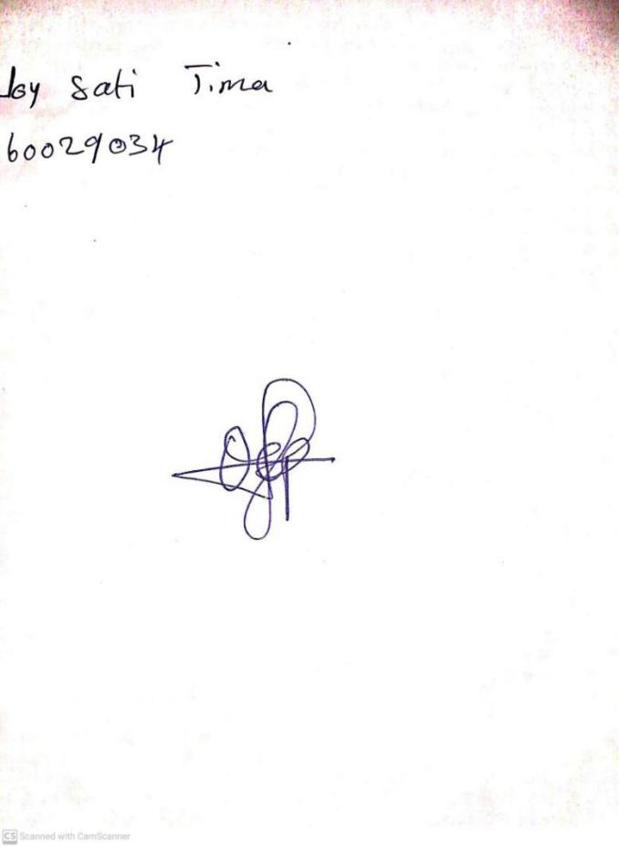

**19TH JANUARY, 2024**

**Perpetual Ojoma Ocheja**

**Stream Head Nursery**