**EMERALD ROYAL INTERNATIONAL SCHOOL**

**MPAPE, ABUJA.**

**LESSON PLAN AND NOTE FOR WEEK 6 PERIOD 1 ENDING 18/10/2024**

**TERM: FIRST**

**WEEK: 6TH**

**DATE: 14/10/2024**

**CLASS: NURSERY 2**

**SUBJECT: LITERACY**

**TOPIC: SIMPLE SENTENCES WITH THREE LETTER**

**WORDS.**

**SUB-TOPIC: MEANING AND EXAMPLES OF SENTENCES**

**PERIOD: 1ST**

**TIME: O8:50-09:30.**

**DURATION: 40 MINUTES.**

**NUMBER IN CLASS: 15**

**AVERAGE AGE: 4 YEARS.**

**SEX: MIXED.**

**SPECIFIC OBJECTIVES: BY THE END OF THE LESSON,THE PUPILS SHOULD BE**

**ABLE TO:**

**1. EXPLAIN THE MEANING AND OF SENTENCE**

**2. STATES EXAMPLES OF SIMPLE SENTENCES.**

**RATIONALE: FOR PUPILS TO KNOW HOW TO MAKE SIMPLE**

**SENTENCES.**

**PREVIOU KNOWLEDGE: PUPILS HAVE LEARNT THREE LETTER WORDS WITH VOWEL "I" IN PREVIOUS LESSON.**

**INSTRUCTIONAL MATERIALS: CHAIRS, TABLES, AND BOOKS.**

**REFERENCE MATERIALS: MASTERING ENGLISH FOR NURSERY 2 BY J. M OMOGBAI**

**LESSON DEVELOPMENT**

|  |  |  |  |
| --- | --- | --- | --- |
| **STAGES/STEPS** | **TEACHER’S ACTIVITIES** | **PUPILS’ ACTIVITIES** | **LEARNING POINTS** |
| **INTRODUCTION** | **Teacher introduces the lesson by keeping a ball under the table and then asks, children where is the ball?** | **Pupil listen to the teacher attentively and answer the question asked by the teacher.** | **To arouse pupils interest for the lesson ahead.** |
| **PRESENTATION**  **STEP 1** | **Teacher presents the lesson by explaining the meaning of sentence to pupils and then asks them to repeat after her.** | **Pupils pay attention and repeat after the teacher.** | **For proper understanding of the lesson .** |
| **STEP 2** | **Teacher states the examples of simple sentences to pupils and also asks them to repeat after her.** | **Pupils listen to the teacher and repeat after her.** | **For better understanding of the lesson.** |
| **BOARD SUMMARY** | **Teacher summarizes the lesson by writing the whole note of lesson on the board for pupils to copy into their books. That is,**  **Sentence:**  **A sentence is a set of words that is complete in itself.**  **Examples of sentences:**   1. **The book is on the table.** 2. **The ball is under the table.** 3. **This is a table.** 4. **I have one pencil** 5. **That is our teacher.** 6. **The book is mine etc.** | **Pupils copy the note into their exercise books.** | **For onward study.** |
| **EVALUATION** | **Teacher asks pupils the following questions:**   1. **What is a sentence?** 2. **State the examples of simple sentences.** | **Pupils answer the questions asked by the teacher.** | **To assess pupils level of understanding of the lesson so far.** |
| **CONCLUSION** | **Teacher marks pupils books.** | **Pupils submit their books for marking.** | **For endorsement.** |
| **ASSIGNMENT** | **Read the following two letter words simple sentences.**  **I go up.**  **Up I go.**  **Go on. Go up.**  **Go in or on.**  **I am up. Up I go.**  **I am on. On I go.**  **I go on . I go in.**  **If I go on. I go up.**  **He is to go up.**  **I am to go in.** | **Pupils do their assignment at home.** | **To encourage reading at home.** |

**LESSON PLAN AND NOTE FOR WEEK 6 PERIOD 2 ENDING 18/10/2024**

**TERM: FIRST**

**WEEK: 6TH**

**DATE: 15/10/2024**

**CLASS: NURSERY 2**

**SUBJECT: LITERACY**

**TOPIC: SIMPLE SENTENCES WITH THREE LETTER**

**WORDS.**

**SUB-TOPIC: SENTENCES WITH BED,MAN,CAT,DOG,HEN AND**

**WIG.**

**PERIOD: 2ND**

**TIME: O8:50-09:30.**

**DURATION: 40 MINUTES.**

**NUMBER IN CLASS: 15**

**AVERAGE AGE: 4 YEARS.**

**SEX: MIXED.**

**SPECIFIC OBJECTIVES: BY THE END OF THE LESSON,THE PUPILS SHOULD BE**

**ABLE TO:**

**1. IDENTIFY THREE LETTER WORDS ON THE BOARD.**

**2. MAKE SIMPLE SENTENCES WITH THE THREE LETTER**

**WORDS.**

**RATIONALE: FOR PUPILS TO LEARN READING WITH THREE LETTER**

**WORDS SENTENCES.**

**PREVIOU KNOWLEDGE: PUPILS HAVE LEARNT THE MEANING AND EXAMPLES OF SENTENCES IN PREVIOUS LESS0N.**

**INSTRUCTIONAL MATERIALS: PICTURE F A BED, CAT,DOG, WIG AND HEN.**

**REFERENCE MATERIALS: MASTERING ENGLISH FOR NURSERY SCHOOLS BOOK 2 BY J.M OMOGBAI.**

**LESSON DEVELOPMENT**

|  |  |  |  |
| --- | --- | --- | --- |
| **STAGES/STEPS** | **TEACHER’S ACTIVITIES** | **PUPILS’ ACTIVITIES** | **LEARNING POINTS** |
| **INTRODUCTION** | **Teacher introduces the lesson by reviewing the previous lesson.** | **Pupil listen attentively to the teacher.** | **To arouse pupils interest for the lesson ahead.** |
| **PRESENTATION**  **STEP 1** | **Teacher presents the lesson by writing three Letter words on the board, identify and then asks pupils to repeat after.** | **Pupils listen and repeat after the teacher.** | **For proper understanding of the lesson .** |
| **STEP 2** | **Teacher makes simple sentences with the three letter words on the board and also asks pupils to repeat after her.** | **Pupils pay attention and repeat after the teacher.** | **For better understanding of the lesson.** |
| **BOARD SUMMARY** | **Teacher summarizes the lesson by writing the whole note of lesson on the board for pupils to copy into their books.That is;**  **THREE LETTER WORDS ARE:**   1. **Boy** 2. **Hen** 3. **Dog** 4. **Cat** 5. **Man** 6. **Bed**   **SIMPLE SENTENCES WITH THREE LETTER WORDS ARE:**   1. **The boy has a wig.** 2. **The hen is big.** 3. **The dog is sad.** 4. **The cat is up.** 5. **The man can run.** 6. **I can sit on the bed.** | **Pupils copy the note into their exercise books.** | **For onward study.** |
| **EVALUATION** | **Teacher asks Pupils to:**   1. **Identify the three letter words on the board.** 2. **Read the simple sentences on the board one after another.** | **Pupils read the note on the board one after another.** | **To assess pupils understanding of the lesson.** |
| **CONCLUSION** | **Teacher marks pupils books.** | **Pupils submit their books for marking.** | **For endorsement.** |
| **ASSIGNMENT** | **Read the following sentence:**   1. **He has a gun.** 2. **My bad zip.** 3. **It is a wet mop.** 4. **Sam has a yam.** 5. **It is a big van.** 6. **The bag has a tag.** 7. **Ted fed his red hen.** | **Pupils do their assignment at home.** | **To encourage learning at home.** |

**LESSON PLAN AND NOTE FOR WEEK 6 PERIOD 3 ENDING 18/10/2024**

**TERM: FIRST**

**WEEK: 6TH**

**DATE: 18/10/2024**

**CLASS: NURSERY 2**

**SUBJECT: LITERACY**

**TOPIC: SIMPLE SENTENCES WITH THREE LETTER**

**WORDS.**

**SUB-TOPIC: SIMPLE SENTENCES WITH THREE LETTER**

**WORDS**

**PERIOD: 3RD**

**TIME: 08:10- 08:50am**

**DURATION: 40 MINUTES.**

**NUMBER IN CLASS: 16**

**AVERAGE AGE: 4 YEARS.**

**SEX: MIXED.**

**SPECIFIC OBJECTIVES: BY THE END OF THE LESSON,THE PUPILS SHOULD**

**BE ABLE TO:**

**1. READ THREE LETTER WORDS SENTENCES ON**

**THE BOARD.**

**2. IDENTIFY MISSING WORDS IN SENTENCES.**

**RATIONALE: FOR PUPILS TO KNOW HOW TO LEARN HOW TO READ.**

**PREVIOU KNOWLEDGE: PUPILS HAVE BEEN MAKING SIMPLE SENTENCES IN**

**DAILY BASES.**

**INSTRUCTIONAL MATERIALS: A CHART OF THREE LETTER WORDS SIMPLE**

**SENTENCES.**

**REFERENCE MATERIALS: MY CHOICE OF ENGLISH LANGUAGE STAGE 3 BY J.F**

**J.F.OMOTAYO AND A.B.OMOTAYO**

**LESSON DEVELOPMENT**

|  |  |  |  |
| --- | --- | --- | --- |
| **STAGES/STEPS** | **TEACHER’S ACTIVITIES** | **PUPILS’ ACTIVITIES** | **LEARNING POINTS** |
| **INTRODUCTION** | **Teacher introduces the lesson by reviewing the previous lesson.** | **Pupils pay attention to the teacher.** | **To arouse pupils interest for the lesson ahead.** |
| **PRESENTATION**  **STEP 1** | **Teacher presents the lesson by writing three letter words simple sentences on the board, read and then asks pupils to repeat after her.** | **Pupils listen to the teacher and repeat after her.** | **For proper understanding of the lesson .** |
| **STEP 2** | **Teacher guides pupils to identify missing words in the sentences on the board.** | **Pupils identify missing words on the board.** | **For better understanding of the lesson.** |
| **BOARD SUMMARY** | **Teacher summarizes the lesson by preparing pupils books for them to copy the note on the board.ie,**  **SIMPLE SENTENCES ON THREE LETTER WORDS**  **Three Letter words simple sentences are:**   1. **Sam has a cap.** 2. **Dan has a pen.** 3. **Dad pat a cat.** 4. **He has a pad.** 5. **A fat cat ran.** 6. **The cap is on his lap.** 7. **The bed is wet.** 8. **The cat is wet.** 9. **He set the cat on the bed.** 10. **He put the pet on the bed.**   **FILLING OF THE MISSING WORDS**   1. **The ___ has a _____.**  |  | | --- | | **bag,zip** |  1. **The ___ ___ the ball.**  |  | | --- | | **hit,bat** |  1. **The ___ is ___**  |  | | --- | | **Sun,up** |  1. **The ___ is on the ____**  |  | | --- | | **bed,box** |  1. **The ____ is in the ____**  |  | | --- | | **cat,car** | | **Pupils copy the note into their exercise books and also fill the missing letters as:**  **Three letter words simple sentences are:**   1. **Sam has a cap.** 2. **Dan has a pen.** 3. **Dad pat a cat.** 4. **He has a pad.** 5. **A fat cat ran.** 6. **The cap is on his lap.** 7. **The bed is wet.** 8. **The cat is wet.** 9. **He set the cat on the bed.** 10. **He put the pet on the bed.**   **Filling of the missing words**   1. **The bag has a zip.** 2. **The bat hit the ball.** 3. **The sun is up.** 4. **The box is on the bed.** 5. **The cat is in the car.** | **For onward study.** |
| **EVALUATION** | **Teacher evaluates the lesson by asking pupils the following questions:**   1. **Read the three letter words simple sentences on the board all together** 2. **Identify and read the three letter words simple sentences on the board one after the other..** | **Pupils all stand and read the note on the board all together and individually.** | **To create platform for slow learners.** |
| **CONCLUSION** | **Teacher concludes the lesson by marking pupils books.** | **Pupils submit their books for marking.** | **For endorsement.** |
| **ASSIGNMENT** | **Make simple sentences with the following words;**   1. **Hen** 2. **Cat** 3. **Cow** 4. **Dog** 5. **Bag** 6. **Fan** 7. **Mat** 8. **Sun** 9. **Pen** 10. **Mop**   **(Submit on Monday)** | **Pupils do their assignment at home.** | **To encourage learning at home.** |

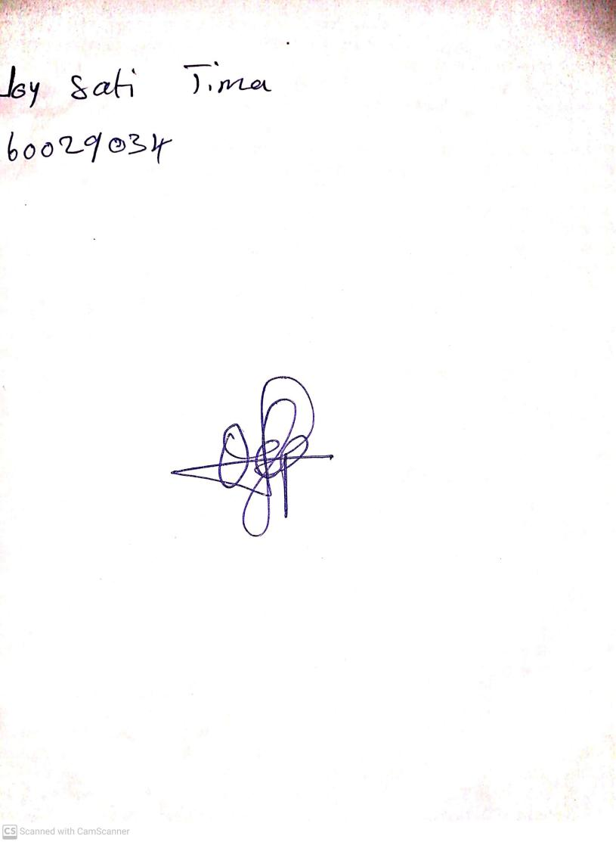

**11th October, 2024**

**Perpetual Ojoma Ocheja**

**Stream Head Nursery**