LESSON PLAN AND NOTE FOR WEEK 6 ENDING 09/06/2023

TERM: 3rd

WEEK: 6th

DATE: 05/06/2023

CLASS: Nursery 2

SUBJECT: Social norms

TOPIC: Love and care for orphaned and vulnerable children.

SUB—TOPIC: Meaning of orphaned and vulnerable children.

PERIOD: 2nd period after long break

TIME: 11:20—12: 00pm

DURATION: 40 minutes

NUMBER IN CLASS: 14

AVERAGE AGE: 5 years

SEX: Mixed

LEARNING OBJECTIVES: By the end of the lesson, the Pupils should be able to:

1. Explain the meaning of orphaned

2. Define vulnerable children

3. State the ways of caring for orphaned and vulnerable children.

RATIONALE: For pupils to learn how to giveaway.

PREVIOUS KNOWLEDGE: Pupils have learnt about children with special needs.

INSTRUCTIONAL MATERIALS: Pictures of orphaned and vulnerable children in the system.

REFERENCE MATERIALS: Google. com

LESSON DEVELOPMENT

|  |  |  |  |
| --- | --- | --- | --- |
| Steps | Teacher's activities | Pupils' activities | Learning point |
| Introduction | Teacher reviews the previous lesson. | Pupils pay attention to the teacher. | To prepare pupils minds for the lesson ahead. |
| Presentation step 1 | Teacher explains the meaning of orphaned to pupils and then asks them to repeat after her. | Pupils pay attention to the teacher and repeat after her. | For proper understanding. |
| Step 2 | Teacher defines the word vulnerable children to pupils and also asks them to repeat after her. | Pupils listen to the teacher and repeat after her. | For better understanding. |
| Step 3 | Teacher States the various ways in which we can care for the orphaned and the vulnerable children to pupils and also asks them to repeat after her. | Pupils listen attentively to the teacher and also repeat after her. | To enhance Pupils listening and speaking ability. |
| Board summary | Teacher summarizes the lesson by writing the whole note of lesson on the board for pupils to copy into their books. That is;  LOVE AND CARE FOR ORPHANED AND VULNERABLE CHILDRENCHILDREN  Orphaned children: simply means a child deprived by death of one or usually both parents. Or a child without a parent or guardian.  Vulnerable children: this is one who has been identified as being at greater risk of experiencing physical or emotional harm.  Ways of caring for orphaned and vulnerable children are:  1. Give them what they need, like food or clean water and clothes.  2. Support their education.  3. Provide them with a safe place to stay.  4. Sponsor them.  5. Educate them by giving them some courses.  6. Give away hi our children's old toys etc. | Pupils copy the note into their books. | For onward study. |
| Evaluation | Teacher evaluates the lesson by asking pupils the following questions:  1. Who are orphanes?  2. How do we care for orphaned children?  Define vulnerable children. | Pupils answer the questions asked by the teacher. | To assess pupils level of understanding. |
| Conclusion | Teacher concludes the lesson by marking pupils books. | Pupils submit their books for marking.. | For endorsement. |
| Assignment | Answer the following questions:  1. What is the meaning of HIV?  2. What is AID?  3. Mention 3 ways we can contact HIV/AIDS. | Pupils do their assignment at home. | To encourage learning at home. |

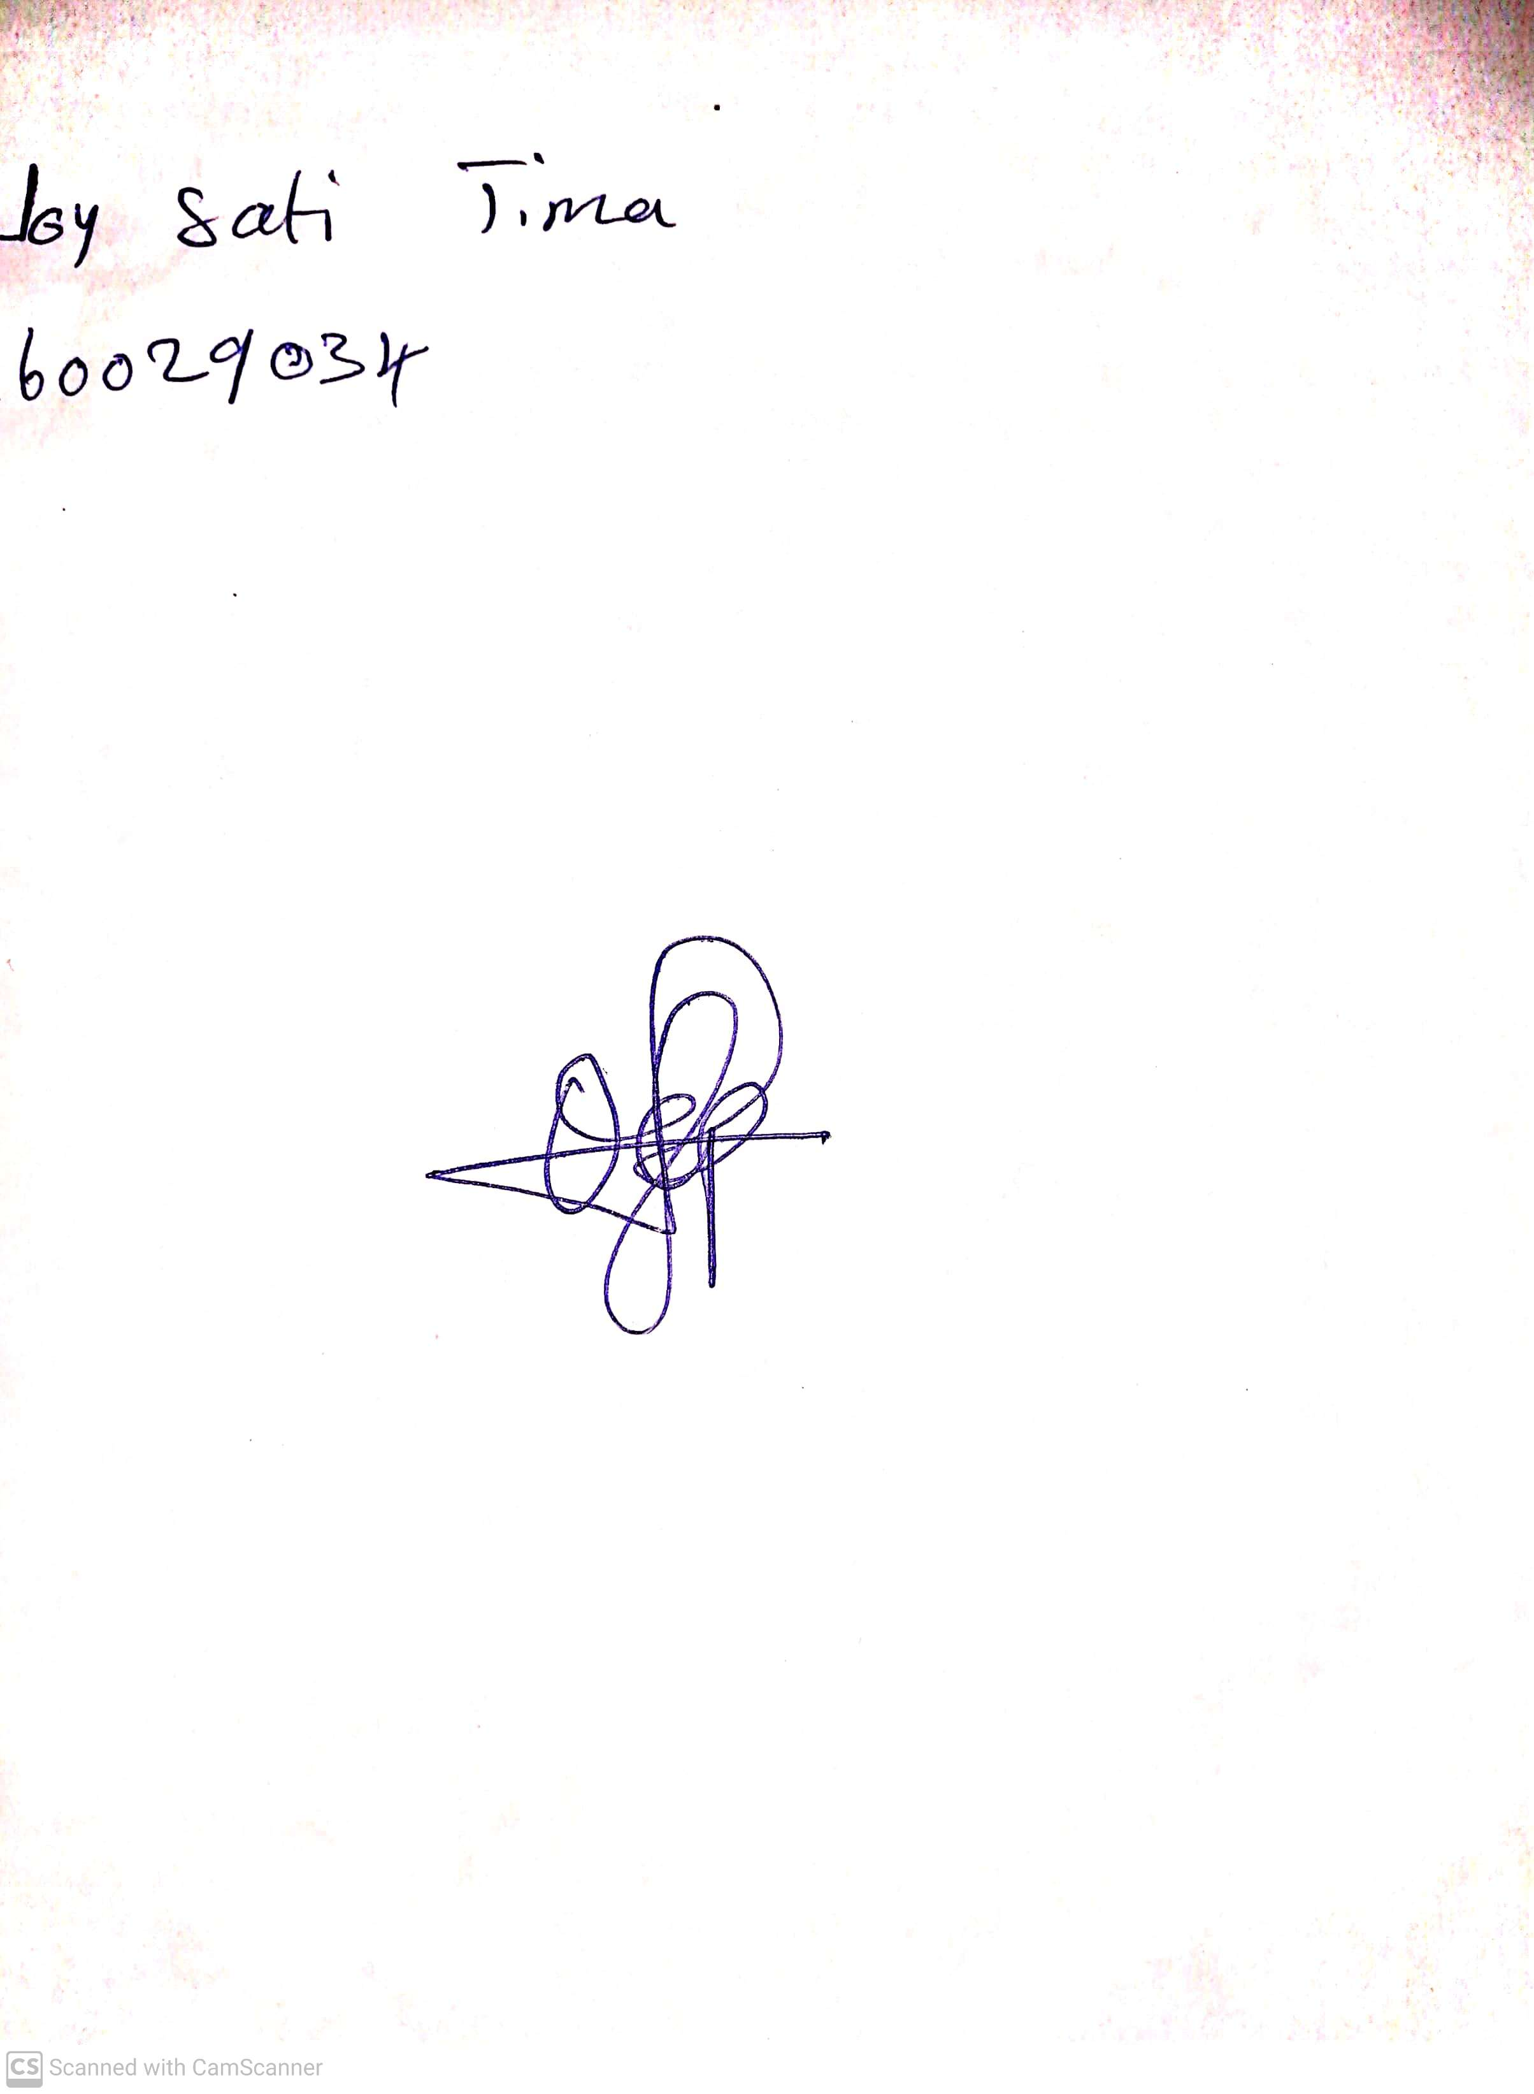

10th May, 2023

Perpetual Ojoma

Stream Head Nursery