**EMERALD ROYAL INTERNATIONAL SCHOOL**

**MPAPE, ABUJA**

**NATURE STUDY 3RD TERM SCHEME OF WORK NURSERY 1**

|  |  |
| --- | --- |
| **TOPICS** | **CONTENTS** |
| **Food** | **Explain food as “the healthy substances we eat that makes us grow and gives our body nutrients”.** |
| **Food** | **Explain sources of food from plants and animals.** |
| **Eating right** | **Explain balanced diet.** |
| **Table Manners** | **Explain table manners as “ the proper way of eating”**  **Demonstrate some examples of good table manners** |
| **Animals** | **Identify and lists different animals.** |
| **Animals and their young ones** | **Identify the names of their young ones**  **Goat=Kid**  **Lion=Cub etc.** |
| **Animals and their homes** | **Identify names of animals and their homes**  **Horse=Stable**  **Lion=Den**  **Dog=Kernel**  **Bird=Nest. Etc.** |
| **Uses and sources of drinking water** | **Name the sources of clean water.**  **Explain the uses of water.** |
| **Simple machines used in the home** | **Define simple machines used in the home**  **Examples of simple machines”**  **Bottle opener**  **Broom etc.** |
| **Simple machines used in the school** | **Define simple machines used in the school**  **Examples of simple machines used in the school:**  **Broom**  **Stapler**  **Sharpener etc.** |
| **Revision** |  |
| **Examination** |  |

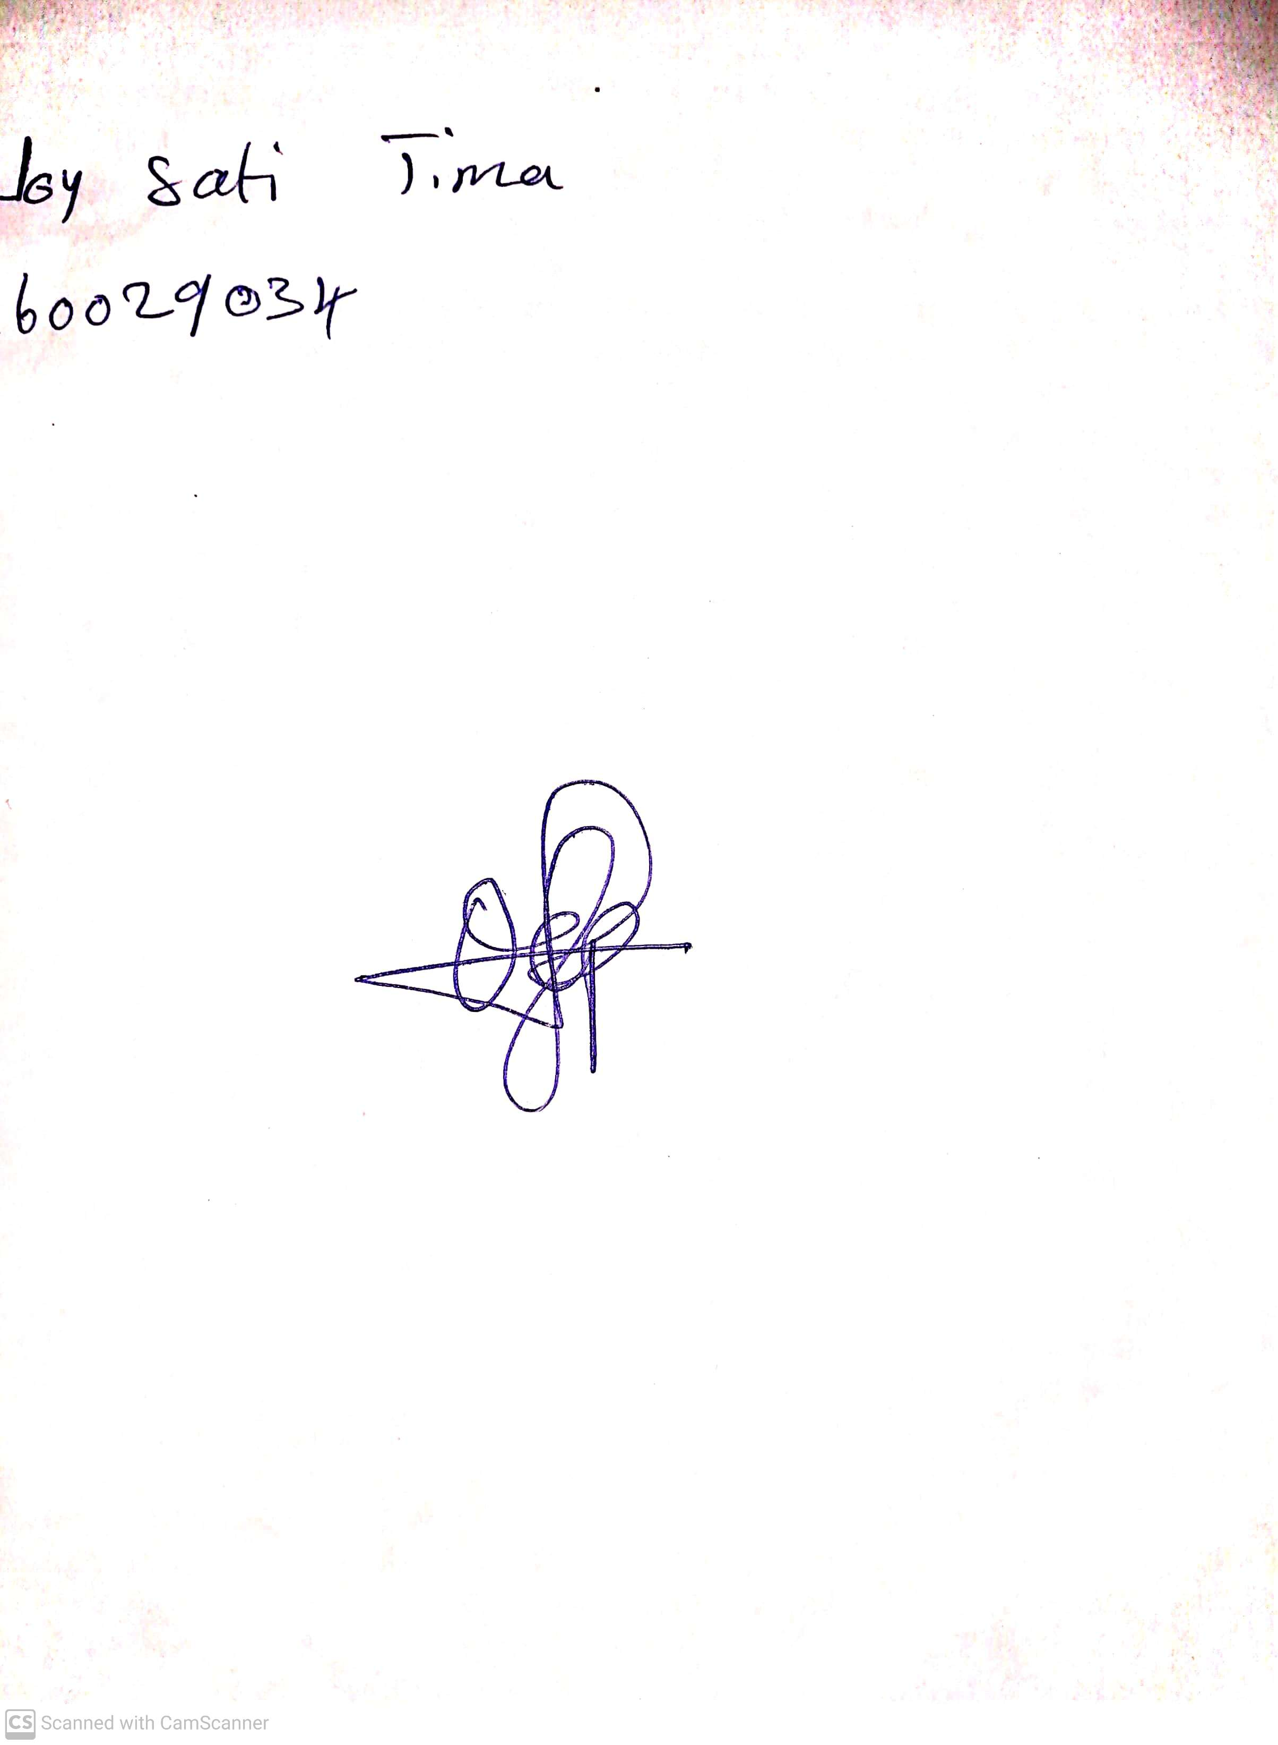

10th May, 2023

Perpetual Ojoma

Stream Head Nursery