**EMERALD ROYAL INTERNATIONAL SCHOOL, MPAPE ABUJA**

**LESSON PLAN AND NOTE FOR WEEK 5 ENDING FRIDAY, 9TH FEBRUARY, 2024**

**TERM:** FIRST TERM

**WEEK:** WEEK 5

**SUBJECT:** ENGLISH LANGUAGE (SPEECH)

**TOPIC:** RHYME

**SUB-TOPIC:** ‘RAIN, RAIN’

**DATE:** WEDNESDAY, 7TH FEBRUARY, 2024

**TIME:** 02:00 – 02:30PM

**DURATION:** 30 MINUTES

**PERIOD:** 9TH

**CLASS:** NURSERY 3

**NUMBER IN CLASS:** TWELVE

**AVERAGE AGE:** FIVE

**SEX:** MIXED

**LEARNING OBJECTIVES:** By the end of the lesson, the pupils should be able to

1. Define rhyme.
2. State the examples of rhyming words.
3. Read the rhyme ‘Rain, rain’.

**RATIONALE:** for pupils to know what rhyme is and to increase their reading skill accurately.

**PREVIOUS KNOWLEGDE:** pupils learnt to sing the rhyme ‘Old Macdonald’.

**INSTRUCTIONAL MATERIALS:**

1. Textbook- Nigeria Primary English book 1- fourth edition

**REFERENCE MATERIALS:**

1. Nigeria Primary English book 1 by B. Someye, D Dallas etal 2000

**LESSON DEVELOPMENT**

|  |  |  |  |
| --- | --- | --- | --- |
| **STAGES/STEPS** | **TEACHER’S ACTIVITIES** | **PUPILS’ ACTIVITIES** | **LEARNING POINTS** |
| **INTRODUCTION** | Review previous knowledge. | Answer the question. | Arouse the pupils interest. |
| **PRESENTATION**  **STEP 1** | Teaches pupils the meaning of rhyme.  **Meaning of rhyme**  A rhyme is a repetition of similar sounds in two or more words. Rhyming is particularly common in many types of poem, especially at the end of each stanza. | Learn attentively. | For proper understanding. |
| **STEP 2** | Teaches pupils examples of rhyme.  **Examples of rhyme**   1. Street feet 2. Roar door 3. Grey day 4. Through too 5. Sky eyes | Learn carefully. | For better understanding. |
| **STEP 3** | Leads pupils to read the rhyme ‘Rain, rain’.  Rain, rain  Fall on the street mud in the puddles cleaning my feet.  Thunder thunder rumbles and roar, close the windows and lock the door.  Clouds clouds black and grey, heavy with water to drop all day.  Sun sun  is breaking through, clouds are moving, the rain stop too.  Rainbow rainbow across the sky, see-through colours to tickle my eyes. | Read the rhyme after the teacher. | For further understanding. |
| **SUMMARY** | Summarizes the lesson by emphasizing on the main concept and writes note on the board. | Listen and copy their notes | For onward study |
| **EVALUATION** | Ask pupils to:   1. Define rhyme. 2. States the examples of rhyming words. 3. Read the rhyme ‘Rain, rain’. | Respond to the teacher’s questions. | To test the understanding of the pupils of the lesson |
| **CONCLUSION** | Summarizes, correct and mark pupils’ notebooks. | Write the note on the board and submit their notebooks for marking | Clarifying the concept. |
| **HOME-WORK** | Nigeria Primary English book 1 page 121. | Return home with task | Extending lesson home. |

**LESSON PLAN AND NOTE FOR WEEK 5 ENDING FRIDAY, 9TH FEBRUARY, 2024**

**TERM:** FIRST TERM

**WEEK:** WEEK 5

**SUBJECT:** ENGLISH LANGUAGE (GRAMMAR)

**TOPIC:** PUNCTUATION MARK

**SUB-TOPIC:** PUNCTUATION MARK (CAPITAL LETTERS)

**DATE:** MONDAY, 5TH FEBRUARY, 2024

**TIME:** 01:20 – 02:00PM

**DURATION:** 30 MINUTES

**PERIOD:** 8TH

**CLASS:** NURSERY 3

**NUMBER IN CLASS:** TWELVE

**AVERAGE AGE:** FIVE

**SEX:** MIXED

**LEARNING OBJECTIVES:** By the end of the lesson, the pupils should be able to

1. Define capital letter.
2. Give examples of the use of capital letters.
3. Indicate the uses of capital letters when writing a sentence.

**RATIONALE:** for pupils to know what capital letters is and be able to use it appropriately.

**PREVIOUS KNOWLEGDE:** pupils have learnt about contractions and its examples.

**INSTRUCTIONAL MATERIALS:**

1. Flash cards.
2. Nigeria Primary English book 1 by B. Someye, D Dallas etal 2000.

**REFERENCE MATERIALS:**

1. Nigeria Primary English book 1 by B. Someye, D Dallas etal 2000

**LESSON DEVELOPMENT**

|  |  |  |  |
| --- | --- | --- | --- |
| **STAGES/STEPS** | **TEACHER’S ACTIVITIES** | **PUPILS’ ACTIVITIES** | **LEARNING POINTS** |
| **INTRODUCTION** | Review previous knowledge. | Answer the teacher’s questions. | Arouse the pupils interest. |
| **PRESENTATION**  **STEP 1** | Teaches pupils the meaning of full stop.  **Meaning of capital letters**  Capital letters are the upper case letters in English studies.  Examples of capital letters  A B C D E F G H I J K L M N O P Q R S T U V W X Y Z | Give the meaning of a full stop. | For proper understanding. |
| **STEP 2** | Teaches pupils the use of capital letters  **Uses of capital letter**   1. Capital letter is used at the beginning of a sentence. 2. Capital letter is used as the initial when writing the name of a person which is a proper noun. 3. Capital letter is used as the initial when writing the name of a place which is a proper noun. E.g Abuja, Lagos etc. 4. Capital letter is used as the initial when writing the name of a country. E.g Nigeria, London, Ghana etc 5. Capital later is used when abbreviating. | Learn carefully. | For better understanding. |
| **STEP 3** | Guides pupils to Indicate the uses of capital letters in a sentence.   1. A lion is a wide animal. 2. My mother went to Lagos last weekend. 3. Have you been to London before? 4. I live in Nigeria. 5. The dog bit Sarah on her way home. | Indicate capital letters in the sentences. | For further understanding. |
| **SUMMARY** | Summarizes the lesson by emphasizing on the main concept and writes note on the board. | Listen and copy their notes | For onward study |
| **EVALUATION** | Ask pupils to:   1. Give the meaning of capital letter. 2. Write out capital letter A-Z. 3. Underline the words with capital letters in the sentences. 4. Mr. Kusa is a banker. 5. Abuja is a beautiful city. 6. My daddy is travelling to Ghana tomorrow. | Respond to the teacher’s questions. | To test the understanding of the pupils of the lesson |
| **CONCLUSION** | Summarizes, correct and mark pupils’ notebooks. | Write the note on the board and submit their notebooks for marking | Clarifying the concept. |
| **HOME-WORK** | Nigeria Primary English, book 1, page 123. | Return home with task | Extending lesson home. |

**LESSON PLAN AND NOTE FOR WEEK 5 ENDING 9TH FEBRUARY, 2024**

**TERM:** FIRST TERM

**WEEK:** WEEK 5

**SUBJECT:** ENGLISH LANGUAGE (COMPREHENSION)

**TOPIC:** COMPREHENSION

**SUB-TOPIC:** MR. KUSA THE BANKER

**DATE:** THURSDAY, 8TH AND FRIDAY, 9TH FEBRUARY, 2024

**TIME:** 09:25 – 10:55AM AND 11: 25 – 12PM

**DURATION:** 30 MINUTES

**PERIOD:** 3RD AND 6TH

**CLASS:** NURSERY 3

**NUMBER IN CLASS:** TWELVE

**AVERAGE AGE:** FIVE

**SEX:** MIXED

**LEARNING OBJECTIVES:** By the end of the lesson, the pupils should be able to:

1. Concentrate fully in reading.
2. Pronounce difficult words.
3. Answer the questions bellow the passage.

**RATIONALE:** to improve the reading skill of the pupils.

**PREVIOUS KNOWLEGDE:** pupils have read the passage ‘The man, the boy and the donkey’

**INSTRUCTIONAL MATERIALS:**

1. Nigeria Primary English book 1, fourth edition

**REFERENCE MATERIALS:**

1. Nigeria Primary English book 1 by B. Someye, D Dallas etal 2000

**LESSON DEVELOPMENT**

|  |  |  |  |
| --- | --- | --- | --- |
| **STAGES/STEPS** | **TEACHER’S ACTIVITIES** | **PUPILS’ ACTIVITIES** | **LEARNING POINTS** |
| **INTRODUCTION** | Ask pupils to bring out their textbooks and open to page 122. | Respond to the teacher instructions. | Arouse the pupils interest. |
| **PRESENTATION**  **STEP 1** | Lead pupils to read the passage ‘Mr. Kusa the banker’.  Mr. Kusa is a banker. He works in one of the banks in town. He is a very busy man. His office is very far from his house. He leaves home very early in the morning and comes back i9n the evening…… | Read the passage after the teacher. | For proper understanding. |
| **STEP 2** | Leads pupils to spell and pronounce difficult words in the passage.   1. Banker 2. Office 3. Morning 4. Movement 5. Watches 6. Clouds 7. Stars 8. Relax 9. Dinner 10. Newspaper 11. Folk 12. Interesting 13. Stories 14. Shower 15. Evening | Spell and pronounce difficult words in the passage. | For better understanding. |
| **STEP 3** | Ask pupils questions based on the passage.   1. Who is Mr. Kusa? 2. Where does he work? 3. When does he leave home for the office? | Answer the questions.   1. Mr. Kusa is a banker. 2. He works in the bank. 3. He leaves home for the office early in the morning. | For further understanding. |
| **SUMMARY** | Summarizes the lesson by emphasizing on the main concept and writes note on the board. | Listen and copy their notes | For onward study |
| **EVALUATION** | Ask pupils to:   1. Read the passage carefully. 2. Spell and pronounce the difficult word from the passage. | Respond to the teacher’s questions. | To test the understanding of the pupils of the lesson |
| **CONCLUSION** | Summarizes, correct and mark pupils’ notebooks. | Write the note on the board and submit their notebooks for marking | Clarifying the concept. |
| **HOME-WORK** | Nigeria Primary English book 1, page 122, exercise 1 and 2 | Return home with task | Extending lesson home. |

**LESSON PLAN AND NOTE FOR WEEK 5 ENDING FRIDAY, 9TH FEBRUARY, 2024**

**TERM:** FIRST TERM

**WEEK:** WEEK 5

**SUBJECT:** ENGLISH LANGUAGE (COMPOSITION)

**TOPIC:** COMPOSITION

**SUB-TOPIC:** MY FAMILY

**DATE:** THURSDAY, 8TH FEBRUARY, 2024

**TIME:** 11:10 – 11:50PM

**DURATION:** 40 MINUTES

**PERIOD:** 5TH

**CLASS:** NURSERY 3

**NUMBER IN CLASS:** TWELVE

**AVERAGE AGE:** FIVE

**SEX:** MIXED

**LEARNING OBJECTIVES:** By the end of the lesson, the pupils should be able to

1. Mention the members of their family.
2. Write a composition about my family.

**RATIONALE:** for pupils to know the members of their family and write a composition of their family.

**PREVIOUS KNOWLEGDE:** pupils have learnt to identify and write capital and small letters Mm-Pp

**INSTRUCTIONAL MATERIALS:**

1. Nigeria Primary English book 1 by B. Someye, D Dallas etal 2000
2. Charts of different kind of food.

**REFERENCE MATERIALS:**

1. Nigeria Primary English book 1 by B. Someye, D Dallas etal 2000

**LESSON DEVELOPMENT**

|  |  |  |  |
| --- | --- | --- | --- |
| **STAGES/STEPS** | **TEACHER’S ACTIVITIES** | **PUPILS’ ACTIVITIES** | **LEARNING POINTS** |
| **INTRODUCTION** | Ask pupils to mention the members of their family. | Mention their best food. | Arouse the pupils interest. |
| **PRESENTATION**  **STEP 1** | Teaches and guide pupils to mention the members of their family.  **Members of the family**  A family consist of:   1. Father 2. Mother and 3. Children | Learn attentively. | For proper understanding. |
| **STEP 2** | Guides pupils to write about their family.  **My family**   1. My family consist of four (4) people. 2. They are my father, my mother and my sister. 3. My father is a doctor in a government hospital. 4. My mother is a trader. 5. My sister is a clerk in an office. 6. I am a student. | Learn carefully. | For better understanding. |
| **SUMMARY** | Summarizes the lesson by emphasizing on the main concept and writes note on the board. | Listen and copy their notes | For onward study |
| **EVALUATION** | Ask pupils to:   1. Mention the members of their family. 2. Write about their family. | Respond to the teacher’s questions. | To test the understanding of the pupils of the lesson |
| **CONCLUSION** | Summarizes, correct and mark pupils’ notebooks. | Write the note on the board and submit their notebooks for marking | Clarifying the concept. |
| **HOME-WORK** | 1. Nigeria primary English book 1, page 124. | Return home with task | Extending lesson home. |

**LESSON PLAN AND NOTE FOR WEEK 5 ENDING FRIDAY, 9TH FEBRUARY, 2024**

**TERM:** FIRST TERM

**WEEK:** WEEK 5

**SUBJECT:** ENGLISH LANGUAGE (PHONICS)

**TOPIC:** SOUND BANK

**SUB-TOPIC:** WORDS WITH THE SOUNDS /ʧ/

**DATE:** TUESDAY, 6TH FEBRUARY, 2024

**TIME:** 10:30 – 11:10AM

**DURATION:** 40 MINUTES

**PERIOD:** 4TH

**CLASS:** NURSERY 3

**NUMBER IN CLASS:** ELEVEN

**AVERAGE AGE:** FIVE

**SEX:** MIXED

**LEARNING OBJECTIVES:** By the end of the lesson, the pupils should be able to

1. Identify the sounds /ʧ/
2. Pronounce the sounds /ʧ/
3. Mention words with the sounds /ʧ/.
4. **RATIONALE:** for pupils to identify and pronounce the sounds /ʧ/.

**PREVIOUS KNOWLEGDE:** pupils have learnt about the sounds /ծ/. **INSTRUCTIONAL MATERIALS:**

1. Flash cards.
2. Pictorial charts.
3. Text book

**REFERENCE MATERIALS:**

1. Nigeria Primary English book 1 by B. Someye, D Dallas etal 2000

**LESSON DEVELOPMENT**

|  |  |  |  |
| --- | --- | --- | --- |
| **STAGES/STEPS** | **TEACHER’S ACTIVITIES** | **PUPILS’ ACTIVITIES** | **LEARNING POINTS** |
| **INTRODUCTION** | 1. Display flash cards on a flat surface with words with the sounds /ʧ/ | Focus on the flash cards to identify words with the sounds /ʧ/. | Arouse the pupils interest. |
| **PRESENTATION**  **STEP 1** | Leads pupils to identify the sounds /ʧ/ on the flash cards and in the textbook.  **/ʧ/** | Learn attentively. | For proper understanding. |
| **STEP 2** | Teaches pupils word with the sounds /ʧ/.  /ʧ/   1. cheap 2. chicken 3. teach 4. watch 5. venture 6. vulture 7. patch 8. nature 9. match 10. lecture | Learn attentively. | For further understanding. |
| **SUMMARY** | Summarizes the lesson by emphasizing on the main concept and writes note on the board. | Listen and copy their notes | For onward study |
| **EVALUATION** | Ask pupils to:   1. Identify the sounds /ʧ/. 2. Pronounce the sounds /ʧ/. 3. Mention words with the sounds /ʧ/. | Respond to the teacher’s questions. | To test the understanding of the pupils of the lesson |
| **CONCLUSION** | Summarizes, correct and mark pupils’ notebooks. | Write the note on the board and submit their notebooks for marking | Clarifying the concept. |
| **HOME-WORK** | Nigeria Primary English work book 1, page 29. | Return home with task | Extending lesson home. |

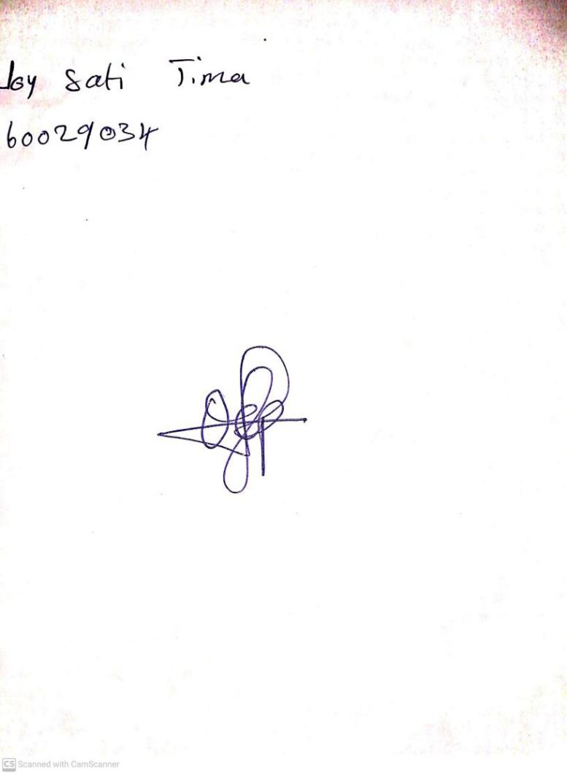

2ND FEBRUARY, 2024

Perpetual Ojoma Ocheja

Stream Head Nursery