**LESSON PLAN AND NOTE 1 FOR WEEK 5 ENDING 11/10/2024**

**Term 1st  term**

**Week 5th  week**

**Date 7th October,2024**

**Class Nursery one**

**Subject Letter work**

**Topic Matching letter Pp - Tt with picture words.**

**Sub-topic Matching letter Pp - Qq with picture words.**

**Period 2nd period**

**Time 8:50 am**

**Duration 35 minutes**

**No in class 15**

**Average Age 3 years**

**Sex Mixed**

**Specific Objectives: By the end of the lesson the pupils should be able to;**

1. **Match letter Pp - Qq with picture words.**
2. **Write letter Pp - Qq.**

**Rationale: To make sure the pupils match and write Pp - Qq.**

**Previous knowledge: The pupils can match letters Kk - Oo with picture words.**

**Instructional Resources: Chart, board, marker, exercise books, pencils.**

**Reference Materials: Online Research,chart,board.**

**LESSON PRESENTATION**

|  |  |  |  |
| --- | --- | --- | --- |
| **Steps** | **Teacher’s Activities** | **Pupils’ Activities** | **Learning points** |
| **Introduction** | **The teacher introduces the topic (Matching letter Pp - Tt with picture words) to the pupils.** | **The pupils listen attentively to the teacher.** | **To arouse the interest of the pupils.** |
| **Step 1** | **The teacher leads the pupils to to associate letter Pp - Qq with picture words.**  **Qq image of a pot**  **Pp image of a queen** | **The pupils associate pictures with words along with the teacher.**  **Qq image of a pot**  **Pp image of a queen** | **For proper understanding.** |
| **Step 2** | **The teacher guides the pupils to write capital and small letter Pp - Qq inside their notebooks.**   |  |  | | --- | --- | | **Pp** | **Pp** | |  |  | | **Qq** | **Qq** | |  |  | | **The pupils writes capital and smallletter Pp - Qq inside their notebooks.** | **For better understanding.** |
| **Summary** | **The teacher summarizes the lesson by sounding the capital and small letter Pp - Qq for the pupils.** | **The pupils sounds along with their teacher capital and small letter Pp - Qq.** | **For onward study.** |
| **Evaluation** | 1. **Associate letter Pp - Qq with picture words.**   **Qq image of a pot**  **Pp image of a queen**   1. **Write the capital and small letters below:**  |  |  | | --- | --- | | **Qq** | **Qq** | |  |  | | **The pupils answer the question correctly.** | **To ascertain the pupils’ understanding.** |
| **Conclusion** | **The teacher summarizes, reacts & corrects the pupils.** | **The pupils answer to the teacher’s questions.** | **To consolidate the lesson.** |
| **Assignment** | 1. **Write the capital and small letters below:**  |  |  | | --- | --- | | **Qq** | **Qq** | |  |  |  1. **Associate picture words to their letters below:**   **Qq image of a pot**  **Pp image of a queen** | **The pupils copy and do their homework at home.** | **To encourage learning while at home.** |

**LESSON PLAN AND NOTE 2 FOR WEEK 5 ENDING 11/10/2024**

**Term 1st  term**

**Week 5th  week**

**Date 9th October,2024**

**Class Nursery one**

**Subject Letter work**

**Topic Matching letter Pp - Tt with picture words.**

**Sub-topic Matching letter Rr - Ss with picture words.**

**Period 2nd period**

**Time 8:50 am**

**Duration 35 minutes**

**No in class 15**

**Average Age 3 years**

**Sex Mixed**

**Specific Objectives: By the end of the lesson the pupils should be able to;**

1. **Match letter Rr - Ss with picture words.**
2. **Write letter Rr - Ss.**

**Rationale: To make sure the pupils match and write Rr - Ss.**

**Previous knowledge: The pupils can match letters Pp - Qq with picture words.**

**Instructional Resources: Chart, board, marker, exercise books, pencils.**

**Reference Materials: Online Research,chart,board.**

**LESSON PRESENTATION**

|  |  |  |  |
| --- | --- | --- | --- |
| **Steps** | **Teacher’s Activities** | **Pupils’ Activities** | **Learning points** |
| **Introduction** | **The teacher introduces the topic (Matching letter Pp - Tt with picture words) to the pupils.** | **The pupils listen attentively to the teacher.** | **To arouse the interest of the pupils.** |
| **Step 1** | **The teacher leads the pupils to to associate letter Rr - Ss with picture words.**  **Ss image of a rat**  **Rr image of a snake** | **The pupils associate pictures with words letter Rr - Ss along with the teacher.**  **Ss image of a rat**  **Rr image of a snake** | **For proper understanding.** |
| **Step 2** | **The teacher guides the pupils to write capital and small letter Rr - Ss inside their notebooks.**   |  |  | | --- | --- | | **Rr** | **Rr** | |  |  | | **Ss** | **Ss** | |  |  | | **The pupils writes capital and smallletter Rr - Ss inside their notebooks.** | **For better understanding.** |
| **Summary** | **The teacher summarizes the lesson by sounding the capital and small letter Rr - Ss for the pupils.** | **The pupils sounds along with their teacher capital and small letter Rr - Ss.** | **For onward study.** |
| **Evaluation** | 1. **Associate letter Rr - Ss with picture words.**   **Ss image of a rat**  **Rr image of a snake**   1. **Write the capital and small letters below:**  |  |  | | --- | --- | | **Rr** | **Rr** | |  |  | | **The pupils answer the question correctly.** | **To ascertain the pupils’ understanding.** |
| **Conclusion** | **The teacher summarizes, reacts & corrects the pupils.** | **The pupils answer to the teacher’s questions.** | **To consolidate the lesson.** |
| **Assignment** | 1. **Write the capital and small letters below:**  |  |  | | --- | --- | | **Rr** | **Rr** | |  |  |  1. **Associate picture words to their letters below:**   **Ss image of a rat**  **Rr image of a snake** | **The pupils copy and do their homework at home.** | **To encourage learning while at home.** |

**LESSON PLAN AND NOTE 3 FOR WEEK 5 ENDING 11/10/2024**

**Term 1st  term**

**Week 5th  week**

**Date 11th October,2024**

**Class Nursery one**

**Subject Letter work**

**Topic Matching letter Pp - Tt with picture words.**

**Sub-topic Matching letter Pp - Tt with picture words.**

**Period 2nd period**

**Time 8:50 am**

**Duration 35 minutes**

**No in class 15**

**Average Age 3 years**

**Sex Mixed**

**Specific Objectives: By the end of the lesson the pupils should be able to;**

1. **Match letter Pp - Tt with picture words.**
2. **Write letter Pp - Tt .**

**Rationale: To make sure the pupils match and write Pp - Tt .**

**Previous knowledge: The pupils can match with picture words letters Rr - Ss.**

**Instructional Resources: Chart, board, marker, exercise books, pencils.**

**Reference Materials: Online Research,chart,board.**

**LESSON PRESENTATION**

|  |  |  |  |
| --- | --- | --- | --- |
| **Steps** | **Teacher’s Activities** | **Pupils’ Activities** | **Learning points** |
| **Introduction** | **The teacher introduces the topic (Matching letter Pp - Tt with picture words) to the pupils.** | **The pupils listen attentively to the teacher.** | **To arouse the interest of the pupils.** |
| **Step 1** | **The teacher leads the pupils to to associate letter Pp - Tt with picture words.**  **Tt image of a rat**  **Rr image of a snake**  **Ss image of a tap**  **Qq image of a pot**  **Pp image of a queen** | **The pupils associate pictures with words letters Pp - Tt along with the teacher.**  **Tt image of a rat**  **Rr image of a snake**  **Ss image of a tap**  **Qq image of a pot**  **Pp image of a queen** | **For proper understanding.** |
| **Step 2** | **The teacher guides the pupils to write capital and small letter Pp - Tt inside their notebooks.**   |  |  | | --- | --- | | **Pp** | **Pp** | |  |  | | **Qq** | **Qq** | |  |  | | **Rr** | **Rr** | |  |  | | **Ss** | **Ss** | |  |  | | **Tt** | **Tt** | |  |  | | **The pupils writes capital and smallletter Pp - Tt inside their notebooks.** | **For better understanding.** |
| **Summary** | **The teacher summarizes the lesson by sounding the capital and small letter Pp - Tt for the pupils.** | **The pupils sounds along with their teacher capital and small letter Pp - Tt.** | **For onward study.** |
| **Evaluation** | 1. **Associate letter Pp - Tt with picture words.**   **Tt image of a rat**  **Rr image of a snake**  **Ss image of a tap**  **Qq image of a pot**  **Pp image of a queen**   1. **Write the capital and small letters below:**  |  |  | | --- | --- | | **Qq** | **Qq** | |  |  | | **Rr** | **Rr** | |  |  | | **Tt** | **Tt** | |  |  | | **Ss** | **Ss** | |  |  | | **Pp** | **Pp** | |  |  | | **The pupils answer the question correctly.** | **To ascertain the pupils’ understanding.** |
| **Conclusion** | **The teacher summarizes, reacts & corrects the pupils.** | **The pupils answer to the teacher’s questions.** | **To consolidate the lesson.** |
| **Assignment** | 1. **Write the capital and small letters below:**  |  |  | | --- | --- | | **Qq** | **Qq** | |  |  | | **Rr** | **Rr** | |  |  | | **Tt** | **Tt** | |  |  | | **Ss** | **Ss** | |  |  | | **Pp** | **Pp** | |  |  |  1. **Associate picture words to their letters below:**   **Tt image of a rat**  **Rr image of a snake**  **Ss image of a tap**  **Qq image of a pot**  **Pp image of a queen** | **The pupils copy and do their homework at home.** | **To encourage learning while at home.** |

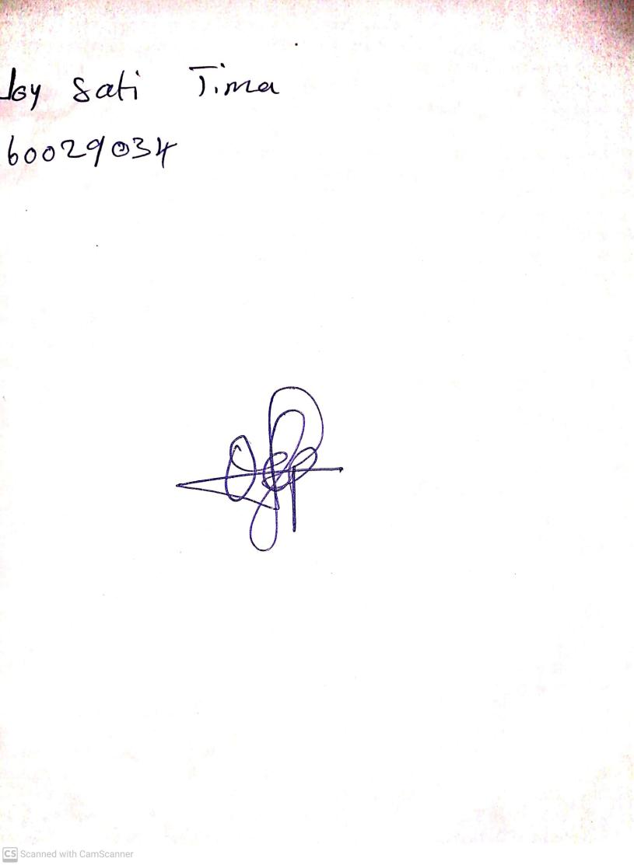

11th October, 2024

Perpetual Ojoma Ocheja

Stream Head Nursery