**EMERALD ROYAL INTERNATIONAL SCHOOL**

**MPAPE, ABUJA.**

**LESSON PLAN AND NOTE FOR WEEK 9 ENDING 10/11/2023**

TERM: FIRST

WEEK: 9TH

DATE: 06/11/2023

CLASS: NURSERY 2

SUBJECT: SOCIAL NORMS

TOPIC: PUBLIC PLACES .

SUB-TOPIC: MEANING AND EXAMPLES OF PUBLIC PLACES

PERIOD: 2ND PERIOD AFTER LONG BREAK

TIME: 11: 20- 12: 00PM

DURATION: 40 MINUTES.

NUMBER IN CLASS: 14

AVERAGE AGE: 5 YEARS.

SEX: MIXED.

SPECIFIC OBJECTIVES: BY THE END OF THE LESSON,THE PUPILS SHOULD BE ABLE TO:

1. EXPLAIN THE MEANING OF PUBLIC PLACES
2. MENTION THE EXAMPLES OF PUBLIC PLACES

RATIONALE: FOR PUPILS TO KNOW ABOUT PUBLIC PLACES.

PREVIOU KNOWLEDGE: PUPILS HAVE BEEN GOING OUT WITH THEIR PARENTS

INSTRUCTIONAL MATERIALS: PICTURES OF BANK,HOTEL,AND BAR IN TEACHERS PHONE.

REFERENCE MATERIALS: GOOGLE.COM

**LESSON DEVELOPMENT**

|  |  |  |  |
| --- | --- | --- | --- |
| STAGES/STEPS | TEACHER’S ACTIVITIES | PUPILS’ ACTIVITIES | LEARNING POINTS |
| INTRODUCTION | Teacher introduces the lesson by reviewing the previous lesson. | Pupils pay attention to the teacher. | To arouse pupils interest for the lesson ahead. |
| PRESENTATION  STEP 1 | Teacher explains the meaning of public places to pupils and then asks them to repeat after her. | Pupils listen attentively to the teacher and repeat after her. | For proper understanding . |
| STEP 2 | Teacher mentions the examples of public places to pupils and also asks them to repeat after her. | Pupils pay attention to the teacher and repeat after her. | For better understanding of the lesson. |
| BOARD SUMMARY | Teacher summarizes the lesson by writing the whole note of lesson on the board for pupils to copy into their books. That is;  Public places:  Public place is a location to which all of the public has access and is not a place exclusively used for a private gathering or any other personal purposes.  Examples of public placesare:   1. Banks 2. Bars 3. Hotels 4. Motels 5. Theaters and auditoriums 6. Convention centers 7. Hospitals | Pupils copy the note into their exercise books. | For onward study. |
| EVALUATION | Teacher evaluates the lesson by asking the following questions;   1. What is public place?. 2. Mention the examples of public places. | Pupils answer the questions asked by the teacher. | To assess pupils level of understanding. |
| CONCLUSION | Teacher concludes the lesson by marking pupils books. | Pupils submit their books for marking. | For endorsement. |
| ASSIGNMENT | 1. What is religions? 2. Mention the 3 main types of religion in Nigeria. 3. List 6 objects of worship by the three main types of religion in nigeria.. | Pupils do their assignment at home. | To encourage learning at home. |

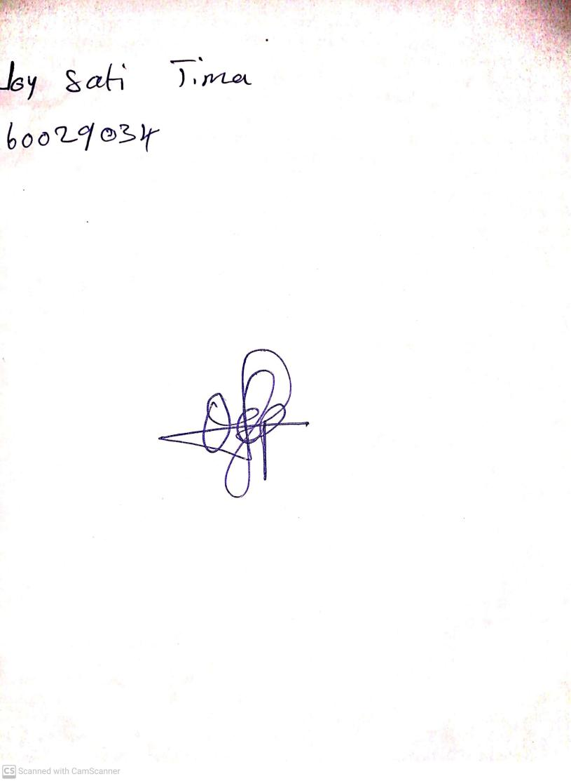

18th September, 2023

Perpetual Ojoma Ocheja

Stream Head Nursery