**EMERALD ROYAL INTERNATIONAL SCHOOL MPAPE, ABUJA**

**LESSON PLAN AND NOTE FOR WEEK 7 PERIOD 1 ENDING 07/06/2024**

**TERM: THIRD**

**WEEK: 7TH**

**DATE: 03/06/2024**

**CLASS: NURSERY 2**

**SUBJECT: LETTER WORK**

**TOPIC: VOWEL DIGRAPHS 5**

**SUB-TOPIC: WORDS WITH VOWEL DIGRAPHS “IE” AND “IGH”**

**PERIOD: 1ST PERIOD**

**TIME: 09: 30 - 10:10am**

**DURATION: 40 MINUTES.**

**NUMBER IN CLASS: 13**

**AVERAGE AGE: 5 YEARS.**

**SEX: MIXED.**

**SPECIFIC OBJECTIVES: BY THE END OF THE LESSON,THE PUPILS SHOULD BE**

**ABLE TO:**

**1. MENTION WORDS WITH VOWEL DIGRAPHS “IE”**

**AND "IGH"**

**2. PRONOUNCE WORDS WITH VOWEL DIGRAPHS**

**"IE" AND "IGH"**

**RATIONALE: FOR PUPILS TO KNOW WORDS ON VOWEL DIGRAPHS**

**"IE" AND "IGH"**

**PREVIOU KNOWLEDGE: PUPILS HAVE LEARNT ABOUT WORDS ON VOWEL**

**DIGRAPHS“OY” “AW” “OW” AND “OU”**

**INSTRUCTIONAL MATERIALS: A CHART OF WORDS ON VOWEL DIGRAPHS "IE" AND**

**"IGH"**

**REFERENCE MATERIALS: GOOGLE.COM .**

**LESSON DEVELOPMENT**

|  |  |  |  |
| --- | --- | --- | --- |
| **STAGES/STEPS** | **TEACHER’S ACTIVITIES** | **PUPILS’ ACTIVITIES** | **LEARNING POINTS** |
| **INTRODUCTION** | **Teacher reviews the previous lesson on vowel digraphs to pupils.** | **Pupil listen attentively to the teacher.** | **To prepare pupils minds for the lesson ahead.** |
| **PRESENTATION**  **STEP 1** | **Teacher mentions words on vowel digraphs “ie” “igh” to pupils and asks them to repeat after her.** | **Pupils listen attentively to the teacher and repeat after her.** | **For proper understanding .** |
| **STEP 2** | **Teacher writes the words on vowel digraph “ie” and “igh” on the board, spell and pronounce and also asks pupils to identify and repeat after her.** | **Pupils pay attention to the teacher and repeat after her.** | **For better understanding of the lesson.** |
| **BOARD SUMMARY** | **Teacher writes the whole not of lesson on the board for pupils to copy.ie,**  **VOWEL DIGRAPH “IE”**  **Examples of “ie” words are:**  **“ie” as in pie**  **“ie” as in tie**  **“ie” as in die**  **“ie” as in lie**  **"ie” as in cried**  **“ie” as in tried**  **“ie” as in tied**  **“ie” as in fried**  **“ie” as in dried**  **“ie” as in flies**  **“ie” as in fries etc**  **VOWEL DIGRAPHS “IGH” WORDS ARE:**  **“igh” as in light**  **“igh” as in fight**  **“igh” as in sight**  **“igh” as in bright**  **“igh” as in right**  **“igh” as in night**  **“igh” as in fright**  **“igh” as in tight**  **“igh” as in might**  **“igh” as in high**  **" igh" as in sigh**  **"igh" as in knight**  **" igh" as in delight**  **" igh" as in tonight**  **" igh" as in lightening etc.** | **Pupils copy the note into their exercise books.** | **For onward study.** |
| **EVALUATION** | **Teacher evaluates the lesson by asking pupils to go to the board one after the other and then**   1. **spell the words** 2. **pronounce the words.** | **Pupils listen to the teacher and read the note on the board one after another.** | **To assess pupils reading skills.** |
| **CONCLUTION** | **Teacher concludes the lesson by marking pupils books.** | **Pupils submit their books for marking.** | **For endorsement.** |
| **ASSIGNMENT** | **Spell and pronounce the following vowel digraphs words.**   |  |  | | --- | --- | | **"ie" words** | **"igh" words** | | **Pie** | **Light** | | **Tie** | **Fight** | | **Die** | **Sight** | | **Lie** | **Bright** | | **Cried** | **Right** | | **Tried** | **Night** | | **Fried** | **Fright** | | **Tied** | **Tight** | | **Dried** | **Might** | | **Flies** | **High** | | **Fries** | **Sigh** | | **Pupils do their assignment at home.** | **To encourage learning at home.** |

**LESSON PLAN AND NOTE FOR WEEK 7 PERIOD 2 ENDING 07/06/2024**

**TERM: THIRD**

**WEEK: 7TH**

**DATE: 04/06/2024**

**CLASS: NURSERY 2**

**SUBJECT: LETTER WORK**

**TOPIC: VOWEL DIGRAPHS 5**

**SUB-TOPIC: WORDS WITH VOWEL DIGRAPHS “Y”**

**PERIOD: 2ND PERIOD**

**TIME: 08: 50 - 09:30am**

**DURATION: 40 MINUTES.**

**NUMBER IN CLASS: 13**

**AVERAGE AGE: 5 YEARS.**

**SEX: MIXED.**

**SPECIFIC OBJECTIVES: BY THE END OF THE LESSON,THE PUPILS SHOULD BE**

**ABLE TO:**

**1. MENTION WORDS ON VOWEL DIGRAPHS “Y”**

**2. SPELL AND PRONOUNCE WORDS ON VOWEL**

**DIGRAPHS "Y"**

**RATIONALE: FOR PUPILS TO KNOW WORDS ON VOWEL DIGRAPH**

**"Y"**

**PREVIOU KNOWLEDGE: PUPILS HAVE LEARNT ABOUT WORDS ON VOWEL**

**DIGRAPHS“IE” AND “IGH” IN PREVIOUS LESSON**

**INSTRUCTIONAL MATERIALS: CHART OF WORDS ON VOWEL DIGRAPHS "Y"**

**REFERENCE MATERIALS: GOOGLE.COM**

**LESSON DEVELOPMENT**

|  |  |  |  |
| --- | --- | --- | --- |
| **STAGES/STEPS** | **TEACHER’S ACTIVITIES** | **PUPILS’ ACTIVITIES** | **LEARNING POINTS** |
| **INTRODUCTION** | **Teacher reviews the previous lesson on vowel digraphs "ie" and "igh" to pupils.** | **Pupil listen attentively to the teacher.** | **To prepare pupils minds for the lesson ahead.** |
| **PRESENTATION**  **STEP 1** | **Teacher mentions words on vowel digraphs “y” to pupils and asks them to repeat after her.** | **Pupils listen attentively to the teacher and repeat after her.** | **For proper understanding .** |
| **STEP 2** | **Teacher writes the words on vowel digraph “y” on the board, spell and pronounce and also asks pupils to identify and repeat after her.** | **Pupils pay attention to the teacher and repeat after her.** | **For better understanding of the lesson.** |
| **BOARD SUMMARY** | **Teacher writes the whole not of lesson on the board for pupils to copy.ie,**  **VOWEL DIGRAPH “Y” WORDS ARE:**  **“y” as in my**  **“y” as in cry**  **“y” as in by**  **“y” as in why**  **“y” as in sly**  **“y” as in fry**  **“y” as in dry**  **“y” as in fly**  **“y” as in shy**  **“y” as in cyclone**  **"y" as in cycle**  **"y" as in tycoon**  **"y" as in deny**  **"y" as in reply**  **" y" as in July**  **" y" as in apply**  **" y" as in rely**  **" y" as in comply etc.** | **Pupils copy the note into their exercise books.** | **For onward study.** |
| **EVALUATION** | **Teacher evaluates the lesson by asking pupils to all stand and then 1.spell words on vowel digraph "y"**   1. **pronounce the words on vowel digraph "y" on the board one after another.** | **Pupils listen to the teacher and read the note on the board one after another.** | **To assess pupils reading skills.** |
| **CONCLUTION** | **Teacher concludes the lesson by marking pupils books.** | **Pupils submit their books for marking.** | **For endorsement.** |
| **ASSIGNMENT** | **Spell and pronounce the following words.**  **1. Fry**  **2. Fly**  **3. July**  **4. Deny**  **5. Apply**  **6. Comply**  **7. Why**  **8. By**  **9. My**  **10. Shy** | **Pupils do their assignment at home.** | **To encourage learning at home.** |

**LESSON PLAN AND NOTE FOR WEEK 7 PERIOD 3 ENDING 07/06/2024**

**TERM: THIRD**

**WEEK: 7TH**

**DATE: 07/06/2024**

**CLASS: NURSERY 2**

**SUBJECT: LETTER WORK**

**TOPIC: VOWEL DIGRAPHS 5**

**SUB-TOPIC: WORDS ON VOWEL DIGRAPHS “EW”**

**PERIOD: 3RD PERIOD**

**TIME: 09: 30 - 10:10am**

**DURATION: 40 MINUTES.**

**NUMBER IN CLASS: 13**

**AVERAGE AGE: 5 YEARS.**

**SEX: MIXED.**

**SPECIFIC OBJECTIVES: BY THE END OF THE LESSON,THE PUPILS SHOULD BE ABLE**

**TO:**

**1. MENTION WORDS ON VOWEL DIGRAPHS “EW”**

**2. PRONOUNCE WORDS ON VOWEL DIGRAPHS "EW"**

**RATIONALE: FOR PUPILS TO KNOW WORDS ON VOWEL DIGRAPHS**

**" EW"**

**PREVIOU KNOWLEDGE: PUPILS HAVE LEARNT ABOUT WORDS ON VOWEL**

**DIGRAPHS “Y” IN PREVIOUS LESSON.**

**INSTRUCTIONAL MATERIALS: CHART OF WORDS ON VOWEL DIGRAPHS "EW"**

**REFERENCE MATERIALS: GOOGLE.COM .**

**LESSON DEVELOPMENT**

|  |  |  |  |
| --- | --- | --- | --- |
| **STAGES/STEPS** | **TEACHER’S ACTIVITIES** | **PUPILS’ ACTIVITIES** | **LEARNING POINTS** |
| **INTRODUCTION** | **Teacher reviews the previous lesson on vowel digraphs “y” to pupils.** | **Pupil listen attentively to the teacher.** | **To prepare pupils minds for the lesson ahead.** |
| **PRESENTATION**  **STEP 1** | **Teacher mentions words on vowel digraphs “ew” to pupils and asks them to repeat after her.** | **Pupils listen attentively to the teacher and repeat after her.** | **For proper understanding .** |
| **STEP 2** | **Teacher writes the words on vowel digraph “ew” on the board, spell and pronounce and also asks pupils to identify and repeat after her.** | **Pupils pay attention to the teacher and repeat after her.** | **For better understanding of the lesson.** |
| **BOARD SUMMARY** | **Teacher writes the whole not of lesson on the board for pupils to copy.ie,**  **VOWEL DIGRAPH “EW” WORDS ARE:**  **“ew” as in new**  **“ew” as in few**  **“ew” as in flew**  **“ew” as in brew**  **“ew” as in chew**  **“ew” as in crew**  **“ew” as in drew**  **“ew” as in knew**  **“ew”as in grew**  **“ew” as in threw**  **“ew” as in stew**  **“ew”as in blew**  **“ew” as in cashew**  **“ew” as in Andrew etc.** | **Pupils copy the note into their exercise books.** | **For onward study.** |
| **EVALUATION** | **Teacher evaluates the lesson by asking pupils to go to the board one after the other and then**   1. **spell the words on Vowel "ew"** 2. **pronounce the words on Vowel "ew" on the board one after the other .** | **Pupils read the note on the board one after another.** | **To assess pupils reading skills.** |
| **CONCLUTION** | **Teacher concludes the lesson by marking pupils books.** | **Pupils submit their books for marking.** | **For endorsement.** |
| **ASSIGNMENT** | **Fill in the missing words on the worksheet below.** | **Pupils do their assignment at home.** | **To encourage learning at home.** |

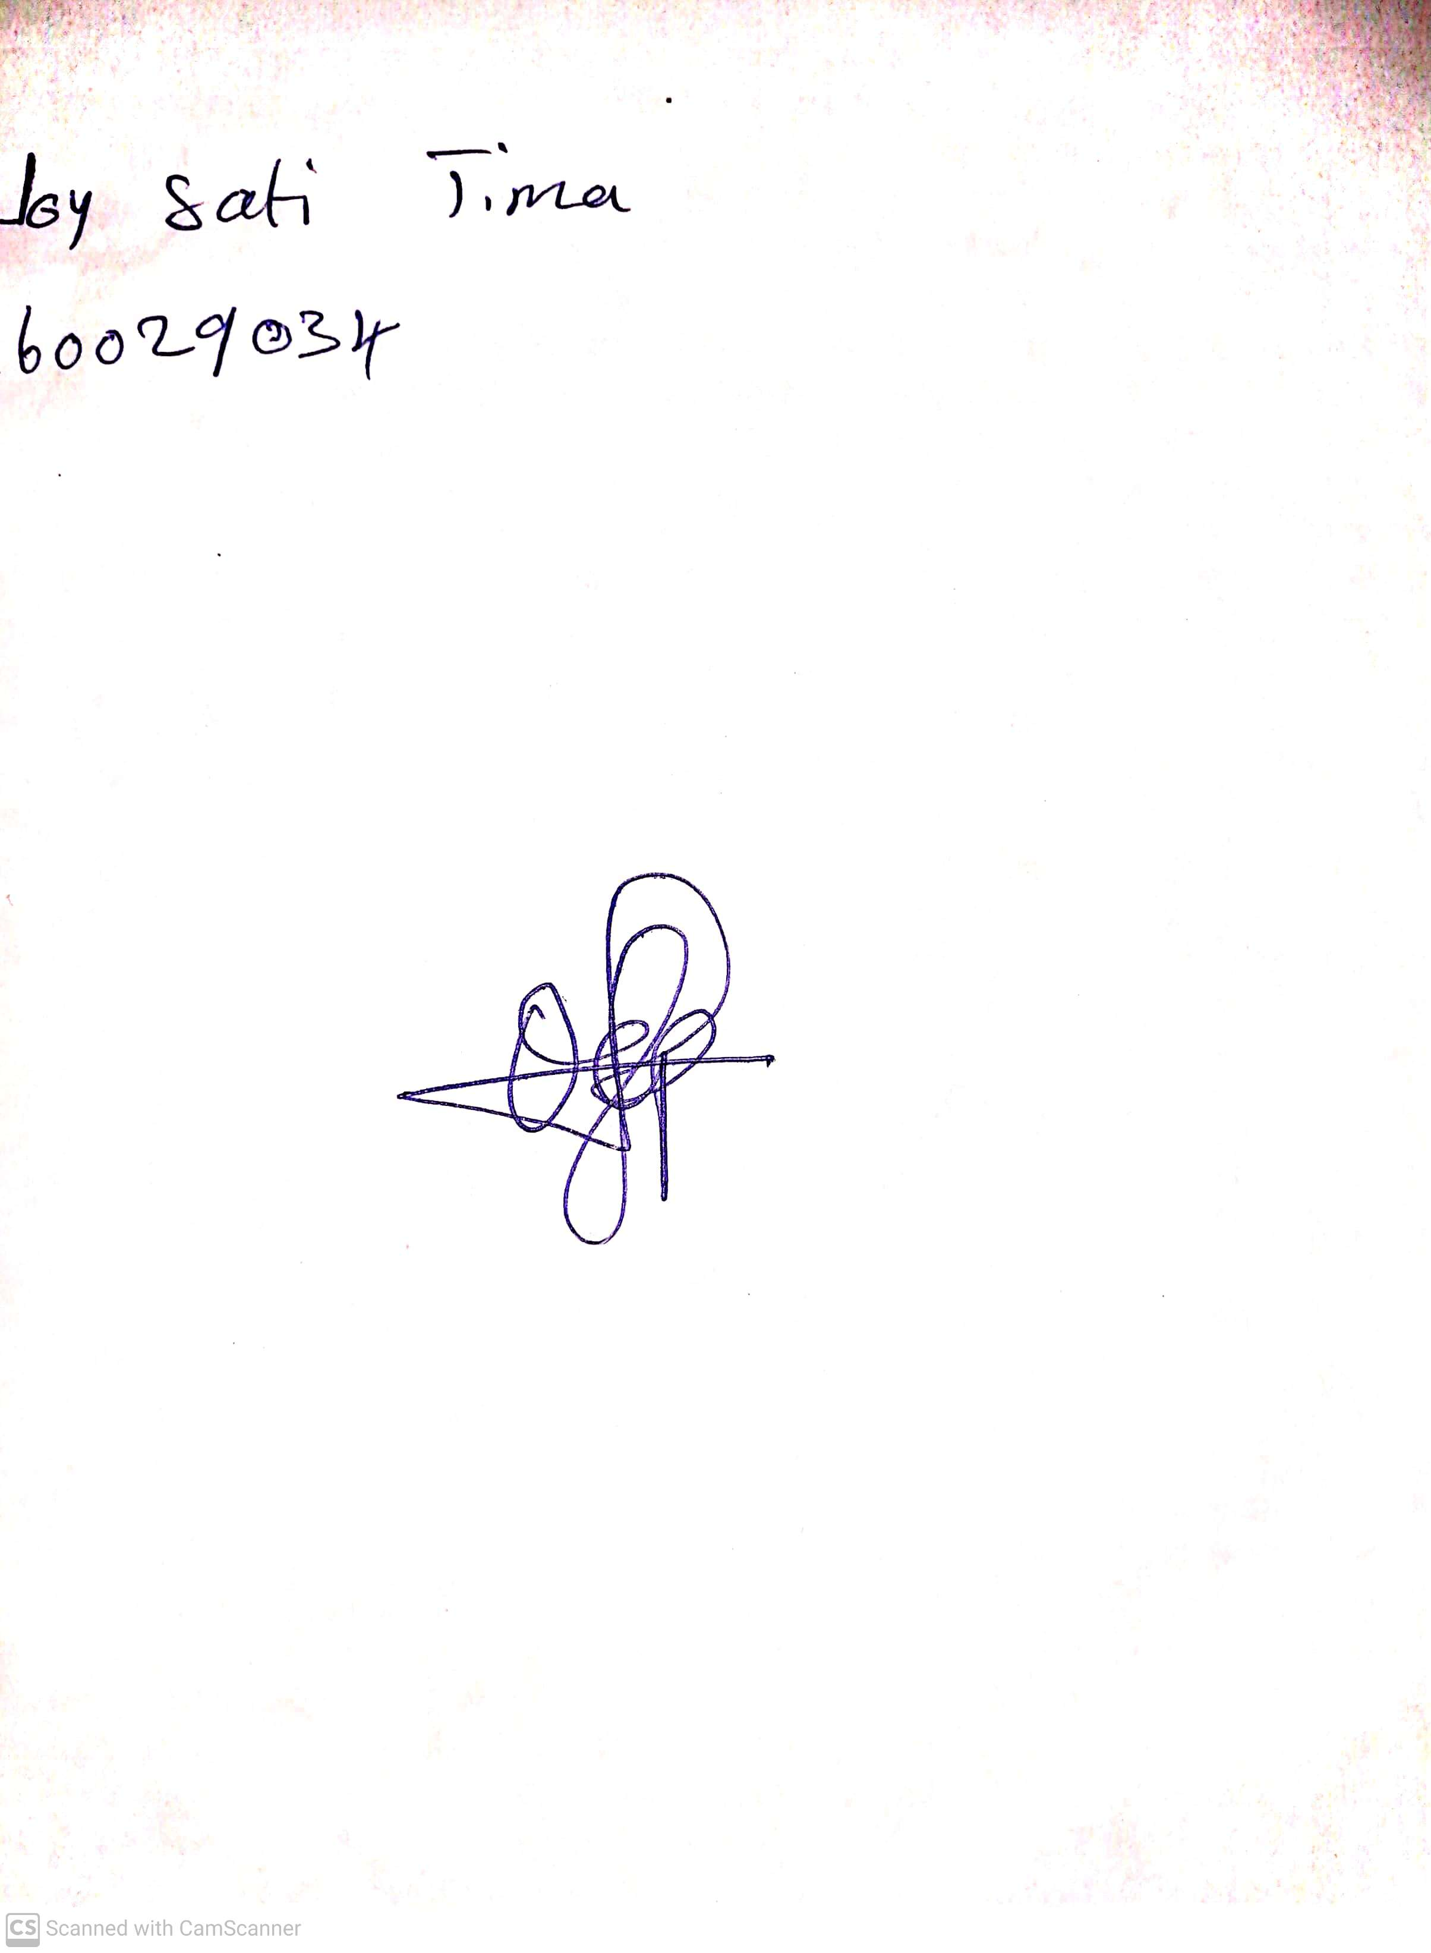

**31st May, 2024**

**Perpetual Ojoma Ocheja**

**Stream Head Nursery**