EMERALD ROYAL INTERNATIONAL SCHOOL MPAPE, ABUJA

LESSON PLAN AND NOTE FOR WEEK 7 PERIOD 1 ENDING 27/10/2023

TERM: FIRST

WEEK: 7TH

DATE: 26/10/2023

CLASS: NURSERY 2

SUBJECT: LETTER WORK

TOPIC: THREE LETTER WORDS WENDING IN “od” “og” “op” “ot”

“oy” “ol” .

SUB-TOPIC: THREE LETTER WORDS ENDING IN “od” and “og”

PERIOD: 3RD

TIME: 09: 30-10: 10 am

DURATION: 40 MINUTES

NUMBER IN CLASS: 16

AVERAGE AGE: 4

SEX: MIXED

SPECIFIC OBJECTIVES: BY THE END OF THE LESSON, THE PUPILS SHOULD BE ABLE

TO:

1.STATE THREE LETTER WORDS ENDING IN “od”AND “og”

2.SPELL AND PRONOUNCE THREE LETTER WORDS ENDING IN

“od” AND “og”

RATIONALE: FOR PUPILS TO BE ABLE TO SPELL AND PRONOUNCE WORDS THAT ENDS WITH “od” AND “og”.

PREVIOUS KNOWLEDGE: PUPILS HAVE LEARNT SIMPLE SENTENCES ON THREE LETTER WORDS IN PREVIOUS LESSON.

INSTRUCTIONAL MATERIALS: A CHART OF THREE LETTER WORDS ENDING IN “od” AND “og”.

REFERENCE MATERIALS: TOP STAR MY CHOICE OF ENGLISH LANGUAGE STAGE 3 BY J.F OMOTAYO.

LESSON DEVELOPMENT

|  |  |  |  |
| --- | --- | --- | --- |
| STAGES/STEPS | TEACHER’S ACTIVITIES | PUPILS’ ACTIVITIES | LEARNING POINT |
| INTODUCTION | Teacher introduces the lesson by reviewing the previous lesson. | Pupils listen attentively to the teacher. | To arouse pupils interest for the lesson ahead. |
| PRESENTATION  STEP 1 | Teacher states the three letter words ending with “od” and “og” to pupils and then asks them to repeat after her. | Pupils pay attention to the teacher and repeat after her. | For proper understanding. |
| STEP 2 | Teacher spells and pronounce the three letter words that ends with “od” and “og” to pupils and also asks them to repeat after her. | Pupils listen very attentively to the teacher and repeat after her. | For better understanding of the lesson. |
| BOARD SUMMARY | Teacher summarizes the lesson by writing the whole note of lesson on the board for pupils to copy into their books. That is;  Three letter words ending in “od” and “og” are:  “od” as in   1. God 2. Cod 3. Tod 4. Pod 5. Mod 6. Nod 7. Rod etc.   “og” as in   1. Jog 2. Cog 3. Dog 4. Mog 5. Log 6. Tog 7. Hog etc. | Pupils copy the note on the board into their exercise books. | For onward study. |
| EVALUATION | Teacher evaluates the lesson by asking the following questions:   1. State the three letter words that ends with “od” and “og”. 2. Spell and pronounce the three letter words that ends with “od”. 3. Spell and pronounce the three letter words that ends with “og”. | Pupils answer the questions asked by the teacher. | To asses pupils level of understanding of the lesson. |
| CONCLUSION | Teacher concludes the lesson by marking pupils books. | Pupils submit their books for marking. | For endorsement. |
| ASSIGNMENT | Identify, write and pronounce the following three letter words.   1. Top 2. Cop 3. Mop 4. Pop 5. Dop 6. Hop 7. Fop 8. Pot 9. Rot 10. Hot 11. Dot 12. Bot 13. Cot 14. Not 15. lot | Pupils do their assignment at home. | To encourage learning at home.s |

LESSON PLAN AND NOTE FOR WEEK 7 PERIOD 2 ENDING 27/10/2023

TERM: FIRST

WEEK: 7TH

DATE: 26/10/2023

CLASS: NURSERY 2

SUBJECT: LETTER WORK

TOPIC: THREE LETTER WORDS WENDING IN “od” “og” “op” “ot”

“oy” .

SUB-TOPIC: THREE LETTER WORDS ENDING IN “op” AND “ot” .

PERIOD: 2ND

TIME: 08: 50-09: 30 am

DURATION: 40 MINUTES

NUMBER IN CLASS: 16

AVERAGE AGE: 4

SEX: MIXED

SPECIFIC OBJECTIVES: BY THE END OF THE LESSON, THE PUPILS SHOULD BE ABLE

TO:

1.STATE THREE LETTER WORDS ENDING IN “op” AND “ot”

2.SPELL AND PRONOUNCE THREE LETTER WORDS ENDING IN

“op” AND “ot”

RATIONALE: FOR PUPILS TO BE ABLE TO SPELL AND PRONOUNCE WORDS THAT ENDS WITH “op” AND “ot”.

PREVIOUS KNOWLEDGE: PUPILS HAVE LEARNT THREE LETTER WORDS ENDING IN “od” AND “og” IN PREVIOUS LESSON.

INSTRUCTIONAL MATERIALS: A CHART OF THREE LETTER WORDS ENDING IN “op” AND ot” .

REFERENCE MATERIALS: TOP STAR MY CHOICE OF ENGLISH LANGUAGE STAGE 3 BY J.F OMOTAYO.

LESSON DEVELOPMENT

|  |  |  |  |
| --- | --- | --- | --- |
| STAGES/STEPS | TEACHER’S ACTIVITIES | PUPILS’ ACTIVITIES | LEARNING POINT |
| INTODUCTION | Teacher introduces the lesson by reviewing the previous lesson. | Pupils listen attentively to the teacher. | To arouse pupils interest for the lesson ahead. |
| PRESENTATION  STEP 1 | Teacher states the three letter words ending with “op” and “ot” to pupils and then asks them to repeat after her. | Pupils pay attention to the teacher and repeat after her. | For proper understanding. |
| STEP 2 | Teacher spells and pronounce the three letter words that ends with “op” and “ot” to pupils and also asks them to repeat after her. | Pupils listen very attentively to the teacher and repeat after her. | For better understanding of the lesson. |
| BOARD SUMMARY | Teacher summarizes the lesson by writing the whole note of lesson on the board for pupils to copy into their books. That is;  Three letter words ending in “op” and ot are:  “op” as in   1. Cop 2. Hop 3. Pop 4. Top 5. Mop 6. Dop 7. Fop 8. Lop 9. Nop 10. Oop 11. Rop 12. Gop 13. Bop 14. Sop etc   “0t” as in   1. Bot 2. Got 3. Oot 4. Tot 5. Mot 6. Pot 7. Rot 8. Hot 9. Dot 10. Cot 11. Not 12. Lot 13. Sot 14. Jot etc. | Pupils copy the note on the board into their exercise books. | For onward study. |
| EVALUATION | Teacher evaluates the lesson by asking the following questions:   1. State the three letter words that ends with “op” and “ot”. 2. Spell and pronounce the three letter words that ends with “op”. 3. Spell and pronounce the three letter words that ends with “ot”. | Pupils answer the questions asked by the teacher. | To asses pupils level of understanding of the lesson. |
| CONCLUSION | Teacher concludes the lesson by marking pupils books. | Pupils submit their books for marking. | For endorsement. |
| ASSIGNMENT | Identify, write and pronounce the following three letter words.   1. Bot 2. Got 3. Oot 4. Tot 5. Mot 6. Pot 7. Rot 8. Hot 9. Dot 10. Cot 11. Not 12. Lot 13. Sot 14. jot | Pupils do their assignment at home. | To encourage learning at home.s |

LESSON PLAN AND NOTE FOR WEEK 7 PERIOD 3 ENDING 27/10/2023

TERM: FIRST

WEEK: 7TH

DATE: 27/10/2023

CLASS: NURSERY 2

SUBJECT: LETTER WORK

TOPIC: THREE LETTER WORDS WENDING IN “od” “og” “op” “ot”

“oy” “ol” .

SUB-TOPIC: THREE LETTER WORDS ENDING IN “oy” and “ol” .

PERIOD: 3RD

TIME: 09: 30-10: 10 am

DURATION: 40 MINUTES

NUMBER IN CLASS: 16

AVERAGE AGE: 4

SEX: MIXED

SPECIFIC OBJECTIVES: BY THE END OF THE LESSON, THE PUPILS SHOULD BE ABLE

TO:

1.STATE THREE LETTER WORDS ENDING IN “oy” AND “ol”

2.SPELL AND PRONOUNCE THREE LETTER WORDS ENDING IN

“oy” AND “ol”

RATIONALE: FOR PUPILS TO BE ABLE TO SPELL AND PRONOUNCE WORDS THAT ENDS WITH “oy” AND “ol”.

PREVIOUS KNOWLEDGE: PUPILS HAVE LEARNT THREE LETTER WORDS ENDING IN “op” AND “ot” IN PREVIOUS LESSON.

INSTRUCTIONAL MATERIALS: A CHART OF THREE LETTER WORDS ENDING IN “oy” AND “ol” .

REFERENCE MATERIALS: TOP STAR MY CHOICE OF ENGLISH LANGUAGE STAGE 3 BY J.F OMOTAYO.

LESSON DEVELOPMENT

|  |  |  |  |
| --- | --- | --- | --- |
| STAGES/STEPS | TEACHER’S ACTIVITIES | PUPILS’ ACTIVITIES | LEARNING POINT |
| INTODUCTION | Teacher introduces the lesson by reviewing the previous lesson. | Pupils listen attentively to the teacher. | To arouse pupils interest for the lesson ahead. |
| PRESENTATION  STEP 1 | Teacher states the three letter words ending with “oy” and “ol” to pupils and then asks them to repeat after her. | Pupils pay attention to the teacher and repeat after her. | For proper understanding. |
| STEP 2 | Teacher spells and pronounce the three letter words that ends with “oy” and “ol” to pupils and also asks them to repeat after her. | Pupils listen very attentively to the teacher and repeat after her. | For better understanding of the lesson. |
| BOARD SUMMARY | Teacher summarizes the lesson by writing the whole note of lesson on the board for pupils to copy into their books. That is;  Three letter words ending in “oy” and “ol” are:  “oy” as in;   1. Boy 2. Coy 3. Joy 4. Toy 5. Roy 6. Moy 7. Soy 8. Doy 9. Goy 10. Foy 11. Hoy 12. Loy 13. Noy etc.   “ol” as in;   1. Pol 2. Col 3. Sol 4. Tol 5. Mol 6. Vol 7. Jol 8. Lol 9. Bol 10. Zol etc. | Pupils copy the note on the board into their exercise books. | For onward study. |
| EVALUATION | Teacher evaluates the lesson by asking the following questions:   1. State the three letter words that ends with “oy”.   2.Spell and pronounce the three letter words that ends with “ol”. | Pupils answer the questions asked by the teacher. | To asses pupils level of understanding of the lesson. |
| CONCLUSION | Teacher concludes the lesson by marking pupils books. | Pupils submit their books for marking. | For endorsement. |
| ASSIGNMENT | Read the following sentences:   1. Pat has a cat. 2. The cat is fat. Pat is sad. 3. Pat is sad at the cat. 4. Dan has a hat. 5. The hat is on the mat. 6. The cat sat on the mat. | Pupils do their assignment at home. | To encourage learning at home.s |

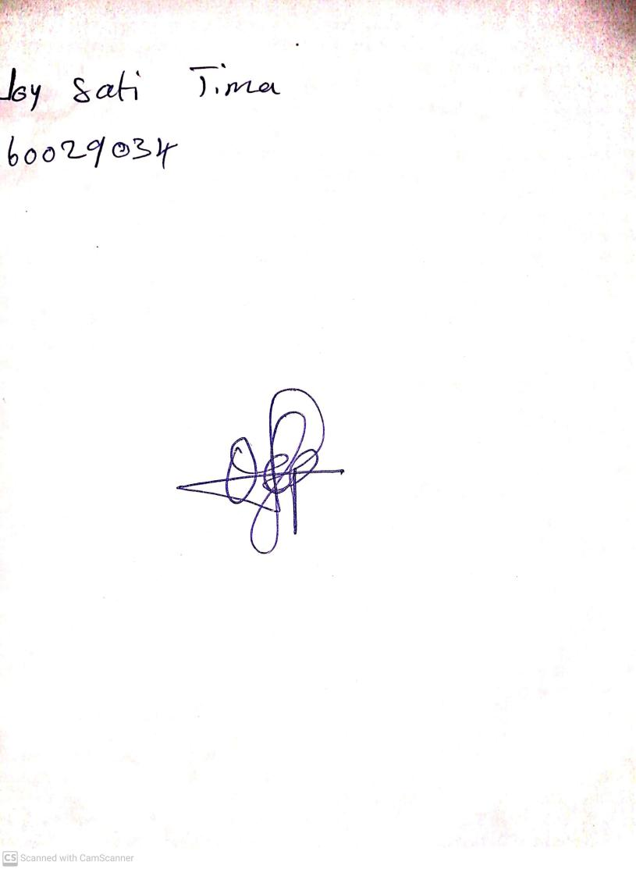

20TH October, 2023

Perpetual Ojoma Ocheja

Stream Head Nursery