**LESSON PLAN FOR WEEK 4 ENDING 6/10/2023**

**Term 1st term**

**Week 4th  week**

**Date 5th October,2023**

**Class Nursery One**

**Subject Nature studies**

**Topic Objects in the classroom.**

**Sub-topic Definition of objects in the classroom.**

**Period 2nd period**

**Time 8:50 am**

**Duration 35 minutes**

**No in class 15**

**Average Age 3 years**

**Sex Mixed**

**Specific Objectives: By the end of the lesson, the pupils should be able to:**

1. **Define the objects in the classroom.**
2. **Mention the objects found in the classroom.**

**Rationale: To ensure the pupils know the objects in the classroom.**

**Previous Knowledge: The pupils can identify tools for cleaning our**

**surrounding.**

**Instructional Resources: Objects in the classroom chart.**

**Reference Material: Elementary science by Showers kiddies nursery 1**

**LESSON PRESENTATION**

|  |  |  |  |
| --- | --- | --- | --- |
| **Steps** | **Teacher’s Activities** | **Pupils’ Activities** | **Learning Points** |
| **Introduction** | **The teacher introduces the lesson by showing the pupils chart that contains the “objects in the classroom”.** | **The pupils listens attentively to identify objects found in the classroom.** | **To arose the pupils’ interest.** |
| **Step 1** | **The teacher defines objects in the classroom as the “different kinds of school objects found in the classroom”.** | **The pupils defines with the teacher “objects in the classroom”.** | **For proper understanding.** |
| **Step 2** | **The teacher lists the objects found in the classroom which includes:**  **PENCILS**  **CRAYONS**  **SHARPENER**  **RAZOR**  **TABLE**  **CHAIRS**  **SHELVES**  **SCHOOL BAGS**  **LUNCH BAGS**  **BOARD**  **MARKER**  **BOOKS etc.** | **The pupils mention with the teacher the objects found in the classroom.** | **For better understanding.** |
| **Summary** | **The teacher summarizes the lesson by showing the pupils some objects found in the classroom.** | **The pupils can identify the objects found in the classroom.** | **For onward study.** |
| **Evaluation** | 1. **Define objects in the classroom?** 2. **Mention five objects you can find in a classroom?** | **The pupils answer the question correctly.** | **To ascertain the pupils’ understanding.** |
| **Conclusion** | **The teacher summarizes, reacts, and corrects the pupils.** | **The pupils gives answer to the teacher’s questions** | **To consolidate the lesson.** |
| **Assignment** | 1. **Objects in the classroom are those objects we can find in the __________?** 2. **Can we find a rake inside a classroom?** | **The pupils copy and do their homework at home.** | **To encourage learning while at home.** |

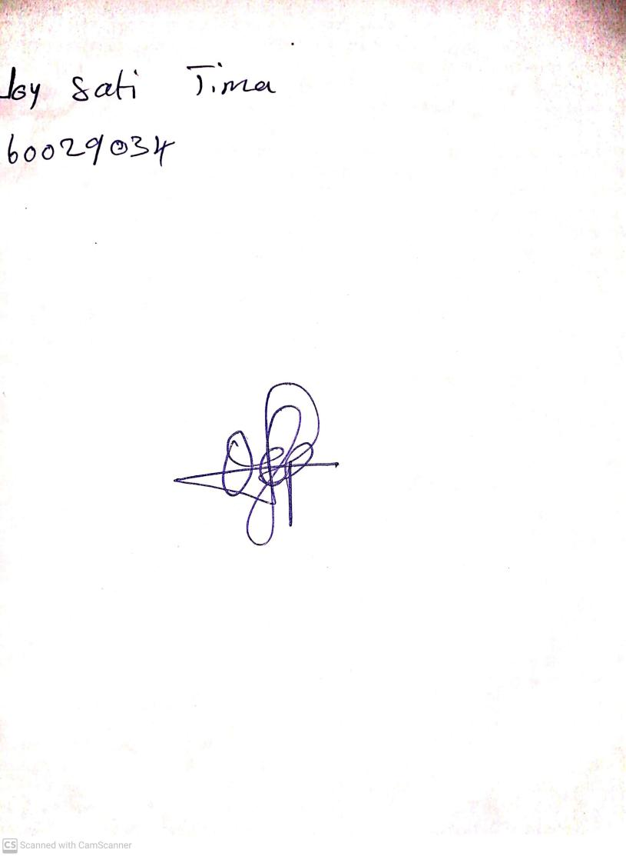

15th August, 2023

Perpetual Ojoma Ocheja

Stream Head Nursery