EMERALD ROYAL INTERNATIONAL SCHOOL

MPAPE, ABUJA.

LESSON PLAN AND NOTE 1 FOR WEEK 2 ENDING 22ND SEPTEMBER, 2023.

SUBJECT: Literacy

TOPIC: Alphabets.

SUB-TOPIC: Learning letters F and G.

DATE: 19/9/2023.

DURATION: 40 minutes.

TIME: 08:50--09:30.

PERIOD: 2nd

CLASS: Pre-nursery

NUMBER OF PUPILS: 11

AVERAGE AGE: 2 YEARS

SEX: Mixed.

SPECIFIC OBJECTIVES: By the end of the lesson, the pupils should be able to:-

1. Identify letters F and G
2. Colour letters F and G.

RATIONALE: For pupils to be able to identify letters F and G.

PREVIOUS KNOWLEDGE: Pupils may have been taught letters A-E.

INSTRUCTIONAL MATERIALS: Flash cards, chart.

REFERENCE:Mastering English for nursery schools book 1 by J.M.Omogbai.

**LESSON DEVELOPMENT**

|  |  |  |  |
| --- | --- | --- | --- |
| STAGES/STEPS | TEACHER’S ACTIVITIES | PUPILS’ ACTIVITIES | LEARNING POINTS |
| INTRODUCTION | Teacher introduces the lesson by singing ABC'S song for the pupils. | Pupils listen attentively to the teacher and try to emulate the teacher to sing. | To arouse the interest of the pupils for the lesson. |
| PRESENTATION  STEP 1 | Teacher shows the pupils two flash cards that has a letter on it respectively and says  "Letter F "  "Letter G".  The teacher asks the pupils to repeat after the teacher. | Pupils touch the flash cards that has a letter written on each of the cards and says.  " Letter F".  " Letter G".  Pupils also repeat after the teacher to identify letter F and G. | For better understanding of the lesson . |
| STEP2 | Teacher prepares the pupils books for them to colour letter F and G . | Pupils colour letter F and G inside their books.  F  G | To improve pupils psychomotive skills. |
| SUMMARY | Teacher summarizes the lesson by pointing at letter F and G on the chart for pupils to see and identify. | Pupils point at the two letters, letter F and on the chart and identify them. | For more understanding of the lesson. |
| EVALUATION | Teacher asks the pupils to   1. Identify letter F on a flash cards. 2. Touch letter G on a chart. | Pupils answer the teacher’s question. | To assess the level of pupils understanding of the lesson. |
| CONCLUSION | Teacher marks the pupils books and make corrections where necessary. | Pupils submit their books for marking and corrections . | For onwards study. |
| ASSIGNMENT | Teacher asks the pupils to colour letter F and G at home.  F    G | Pupils do their Home work at home. | To ensure learning takes place at home. |

EMERALD ROYAL INTERNATIONAL SCHOOL

MPAPE, ABUJA.

LESSON PLAN AND NOTE 2 FOR WEEK 2 ENDING 22ND SEPTEMBER, 2023.

SUBJECT: Literacy

TOPIC: Alphabets.

SUB-TOPIC: Learning letters H - J

DATE: 20/9/2023.

DURATION: 40 minutes.

TIME: 08:50--09:30.

PERIOD: 2nd

CLASS: Pre-nursery

NUMBER OF PUPILS: 11

AVERAGE AGE: 2 YEARS

SEX: Mixed.

SPECIFIC OBJECTIVES: By the end of the lesson, the pupils should be able to:-

1. Identify letters H-J and their sounds.
2. Match the letter correctly.

RATIONALE: For pupils to be able to identify letters.

PREVIOUS KNOWLEDGE: Pupils have been taught letters F and G in the previous period.

INSTRUCTIONAL MATERIALS: Flash cards, and chart.

REFERENCE:Mastering English for nursery schools book 1 by J.M.Omogbai.

LESSON DEVELOPMENT

|  |  |  |  |
| --- | --- | --- | --- |
| STAGES/STEPS | TEACHER’S ACTIVITIES | PUPILS’ ACTIVITIES | LEARNING POINTS |
| INTRODUCTION | Teacher introduces the lesson by reviewing the previous lesson on letter A -G as:-  Letter A sounds /a/.  Letter B sounds/b/  Letter C sounds /c/  Letter D sounds /d/........ | Pupils listen to their teacher as she sounds the letters. | To arouse the interest of the pupils for the lesson. |
| PRESENTATION  STEP 1 | Teacher shows the pupils letters H, I and J on the flash cards and asks them to say:-  " Letter H says/h/ /h/.  " Letter I says /h//h/.  " Letter J says /j//j/.  Teacher also sings the phonics song for letter H,I and J for the pupils. | Pupils point at the letters H, I and J on the flash cards and also say their sounds. Pupils also practice the phonics song for letter H, I and J along with the teacher. | For better understanding of the lesson. |
| STEP2 | Teacher prepares the pupils books and guides them to match letter H - J. | Pupils identify and match letter H - J as instructed by the teacher.  H J  I H  J I | To improve pupils psychomotive skills. |
| SUMMARY | Teacher summarizes the lesson by singing the phonics song for letter H, I, and J again for the pupils. | Pupils sing the phonics song along with the teacher. | For more understanding of the lesson. |
| EVALUATION | Teacher randomly places flash cards of letters and asks the pupils to identify letters H,I and J. | Pupils identify the letters correctly. | To assess the level of pupils understanding of the lesson. |
| CONCLUSION | Teacher marks the pupils books and make corrections where necessary. | Pupils submit their books for marking and corrections . | For onwards study. |
| ASSIGNMENT | Teacher asks the pupils to identify and match letters H-J.  H J  I H  J I | Pupils do their Home work at home. | To ensure learning takes place at home. |

LESSON PLAN AND NOTE 3 FOR WEEK 2 ENDING 22ND SEPTEMBER, 2023.

SUBJECT: Literacy

TOPIC: Alphabets

SUB-TOPIC: Identification and tracing of letters F-J .

DATE: 22/9/2023.

DURATION: 40 minutes.

TIME: 08:50--09:30.

PERIOD: 2nd

CLASS: Pre-nursery

NUMBER OF PUPILS: 11

AVERAGE AGE: 2 YEARS

SEX: Mixed.

SPECIFIC OBJECTIVES: By the end of the lesson, the pupils should be able to:-

1. Identify letters F-J on a chart.

2.Match letters F-J correctly.

RATIONALE: For pupils to be able to identify letters.

PREVIOUS KNOWLEDGE: Pupils have been taught letters H-J.

INSTRUCTIONAL MATERIALS: Flash cards and charts.

REFERENCE:Mastering English for nursery schools book 1 by J.M.Omogbai.

LESSON DEVELOPMENT

|  |  |  |  |
| --- | --- | --- | --- |
| STAGES/STEPS | TEACHER’S ACTIVITIES | PUPILS’ ACTIVITIES | LEARNING POINTS |
| INTRODUCTION | Teacher introduces the lesson by reviewing the last lesson on Alphabets. | Pupils listen as the teacher reviews the last lesson. | To arouse the interest of the pupils for the lesson proper. |
| PRESENTATION  STEP 1 | Teacher writes letters F - J on the chart for pupils to see, read and identify.  F G H I J | Pupils pay attention to the teacher as she is writing the letters on the Chart. Pupils read and identify the letters | For proper recognition of letters. |
| STEP2 | Teacher prepares the pupils books for them to trace letters F - J | Pupils trace the letters F-J and practice their sounds. | To improve pupils psychomotive skills. |
| SUMMARY | Teacher summarizes the lesson by singing an alphabetical rhymes for the pupils . | Pupils sing the song along with the teacher. | For more understanding of the lesson. |
| EVALUATION | Teacher calls out the pupils one after another to:-  1. identify letters F-J on a chart.  2. Trace letter F-J on their books. | Pupils answer the teacher’s questions. | To assess the level of pupils understanding of the lesson. |
| CONCLUSION | Teacher marks the pupils books and make corrections where necessary. | Pupils submit their books for marking and corrections . | For onwards study. |
| ASSIGNMENT | Teacher asks the pupils to match letters F-J correctly at home.  F J  G H  H I  I G  J F | Pupils do their Home work at home. | To ensure learning takes place at home. |

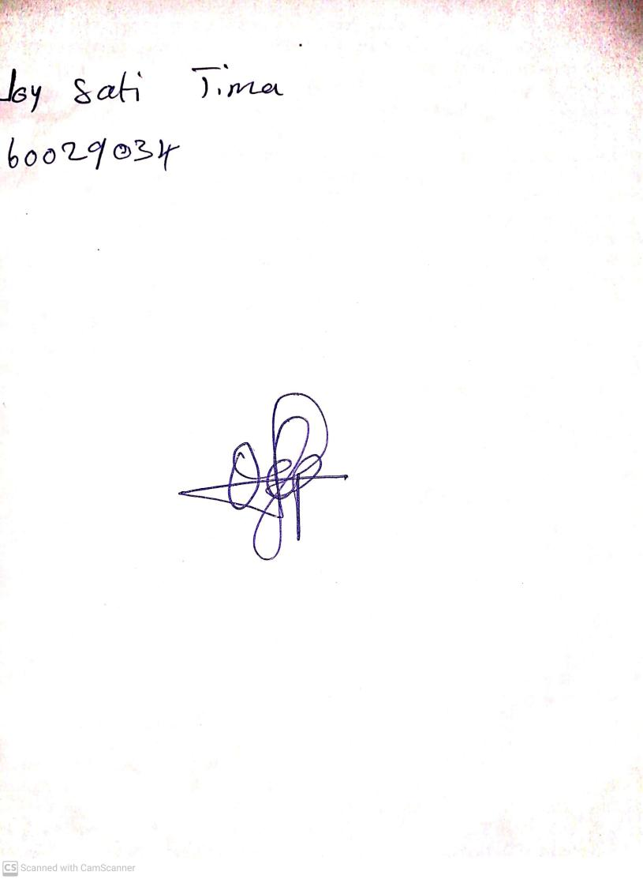

2ND OCTOBER, 2023

Perpetual Ojoma Ocheja

Stream Head Nursery