**EMERALD ROYAL INTERNATIONAL SCHOOL**

**MPAPE, ABUJA.**

**LESSON NOTE FOR WEEK 2 ENDING 3RD MAY, 2024.**

TERM; Second Term

SUBJECT: Number Work

TOPIC: Counting numbers 1 - 30.

SUB-TOPIC: Identification of numbers 1 - 30.

DATE: 30th April, 2024.

DURATION: 40 minutes.

TIME: 08:50--09:30.

PERIOD: 1st

CLASS: Pre-nursery

NUMBER OF PUPILS: 19

AVERAGE AGE: 2 years

SEX: Mixed.

SPECIFIC OBJECTIVES: By the end of the lesson, the pupils should be able to:-

1. Count Numbers 1-30
2. Identify numbers 1 - 30

RATIONALE: For pupils to be able to count numbers.

PREVIOUS KNOWLEDGE: Pupils have been counting numbers.

INSTRUCTIONAL MATERIALS: Number chart, flash cards, building blocks etc

REFERENCE MATERIALS: Mastering mathematics for nursery schools book 1 by Henry Idogun.

**LESSON DEVELOPMENT**

|  |  |  |  |
| --- | --- | --- | --- |
| STAGES/STEPS | TEACHER’S ACTIVITIES | PUPILS’ ACTIVITIES | LEARNING POINTS |
| INTRODUCTION | Teacher introduces the lesson by singing a number rhyme for the pupils. | Pupils sing the rhyme along with the teacher. | To arouse pupils interest in the lesson. |
| PRESENTATION  STEP 1 | Teacher counts numbers 1 - 30 for the pupils to repeat after her. | Pupils count numbers 1 - 30 after the teacher. I.e 1 2 3 4 5 6 7 8 9 10 11 12 13 14 15 16 17 18 19 20 21 22 23 24 25 26 27 28 29 30. | For better understanding of the lesson . |
| STEP 2 | Teacher guides pupils to identify numbers numbers 1 - 30. | Pupils point at the numbers 1 - 30. That is.  1 2 3 4 5 6 7 8 9 10 11 12 13 14 15 16 17 18 19 20 21 22 23 24 25 26 27 28 29 30. | For proper understanding of the lesson. |
| SUMMARY | Teacher identifies each number 1 - 30 for the pupils. | Pupils point at the numbers. | For more understanding of the lesson. |
| EVALUATION | Teacher asks Pupils to count numbers 1 - 30 | Pupils count numbers 1 - 30. | To assess pupils understanding of the lesson. |
| CONCLUSION | Teacher sings a number rhyme for the pupils. | Pupils sing the rhyme along with the teacher. | To improve pupils speaking ability. |
| ASSIGNMENT (HOME WORK) | Count and circle numbers 1 - 30  1 2 3 4 5 6 7 8 9 10 11 12 13 14 15 16 19 20 21 22 23 24 25 26 27 28 29 30. | Pupils do their assignment at home. | To encourage pupils to learn at home. |

**LESSON NOTE FOR WEEK 2 ENDING 3RD MAY, 2024.**

TERM; SECOND TERM

SUBJECT: Number Work

TOPIC: Counting numbers 1 - 30.

SUB-TOPIC: Matching numbers 1-4.

DATE: 1ST May, 2024

DURATION: 40 minutes.

TIME: 08:50--09:30.

PERIOD: 2nd

CLASS: Pre-nursery

NUMBER OF PUPILS: 19

AVERAGE AGE: 2 years

SEX: Mixed.

SPECIFIC OBJECTIVES: By the end of the lesson, the pupils should be able to:-

1. Count Numbers 1-30
2. Matching numbers 1 - 4

RATIONALE: For pupils to be able to count numbers.

PREVIOUS KNOWLEDGE: Pupils have been counting numbers.

INSTRUCTIONAL MATERIALS: Number chart, flash cards, building blocks etc

REFERENCE MATERIALS: Mastering mathematics for nursery schools book 1 by Henry Idogun.

**LESSON DEVELOPMENT**

|  |  |  |  |
| --- | --- | --- | --- |
| STAGES/STEPS | TEACHER’S ACTIVITIES | PUPILS’ ACTIVITIES | LEARNING POINTS |
| INTRODUCTION | Teacher introduces the lesson by singing a number rhyme for the pupils. | Pupils sing the rhyme along with the teacher. | To arouse pupils interest in the lesson. |
| PRESENTATION  STEP 1 | Teacher counts numbers 1 - 30 for the pupils to repeat after her. | Pupils count numbers 1 - 30 after the teacher. I.e 1 2 3 4 5 6 7 8 9 10 11 12 13 14 15 16 17 18 19 20 21 22 23 24 25 26 27 28 29 30. | For better understanding of the lesson . |
| STEP 2 | Teacher guides pupils to match numbers numbers 1 - 4. | Pupils match numbers 1 - 4. I.e  1 2  2 1  3 4  4 3 | For proper understanding of the lesson. |
| SUMMARY | Teacher identifies each number 1 - 30 for the pupils. | Pupils point at the numbers. | For more understanding of the lesson. |
| EVALUATION | Teacher asks Pupils to count numbers 1 - 30 | Pupils count numbers 1 - 30. | To assess pupils understanding of the lesson. |
| CONCLUSION | Teacher sings a number rhyme for the pupils. | Pupils sing the rhyme along with the teacher. | To improve pupils speaking ability. |
| ASSIGNMENT (HOME WORK) | Match these numbers  1 2  2 1  3 4  4 1 | Pupils do their assignment at home. | To encourage pupils to learn at home. |

**LESSON NOTE FOR WEEK 2 ENDING 3RD MAY, 2024**

TERM; Second Term

SUBJECT: Number Work

TOPIC: Counting numbers 1 - 30.

SUB-TOPIC: Identification of numbers 1 - 30.

DATE: 2nd May, 2024.

DURATION: 40 minutes.

TIME: 08:50--09:30.

PERIOD: 3rd

CLASS: Pre-nursery

NUMBER OF PUPILS: 11

AVERAGE AGE: 2 years

SEX: Mixed.

SPECIFIC OBJECTIVES: By the end of the lesson, the pupils should be able to:-

1.Count Numbers 1-30

2.Match numbers 1 - 4 with objects

RATIONALE: For pupils to be able to count numbers.

PREVIOUS KNOWLEDGE: Pupils have been counting numbers.

INSTRUCTIONAL MATERIALS: Number chart, flash cards, building blocks pencils, cups etc

REFERENCE MATERIALS: Mastering mathematics for nursery schools book 1 by Henry Idogun.

**LESSON DEVELOPMENT**

|  |  |  |  |
| --- | --- | --- | --- |
| STAGES/STEPS | TEACHER’S ACTIVITIES | PUPILS’ ACTIVITIES | LEARNING POINTS |
|  |  |  |  |
| PRESENTATION  STEP 1 | Teacher counts numbers 1 - 30 for the pupils to repeat after her. | Pupils count numbers 1 - 30 after the teacher. I.e 1 2 3 4 5 6 7 8 9 10 11 12 13 14 15 16 17 18 19 20 21 22 23 24 25 26 27 28 29 30. | For better understanding of the lesson . |
| STEP 2 | Teacher guides pupils to match numbers 1 - 4 with objects. | Pupils match numbers with objects That is.  1  2  3  4 | For proper understanding of the lesson. |
| SUMMARY | Teacher identifies each number 1 - 30 for the pupils. | Pupils point at the numbers. | For more understanding of the lesson. |
| EVALUATION | Teacher groups different objects on the table and asks Pupils to count the objects on the table. | Pupils count the objects on the table. | To assess pupils understanding of the lesson. |
| CONCLUSION | Teacher sings a number rhyme for the pupils. | Pupils sing the rhyme along with the teacher. | To improve pupils speaking ability. |
| ASSIGNMENT (HOME WORK) | Count these objects and circle them. | Pupils do their assignment at home. | To encourage pupils to learn at home. |

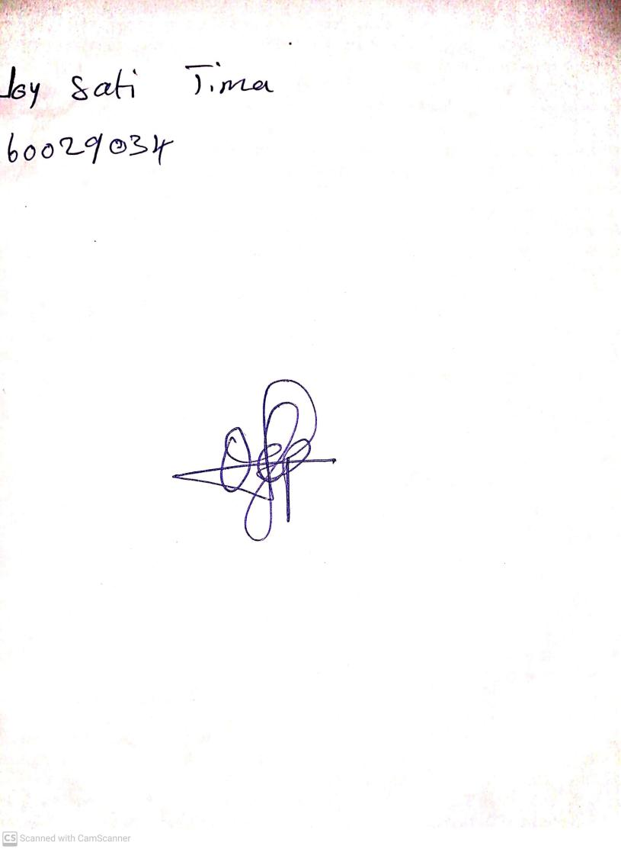

**26th April, 2024**

**Perpetual Ojoma Ocheja**

**Stream Head Nursery**