**EMERALD ROYAL INTERNATIONAL SCHOOL**

**MPAPE, ABUJA.**

**LESSON PLAN AND NOTE FOR WEEK 8 ENDING 03/11/2023**

TERM: FIRST

WEEK: 8TH

DATE: 30/10/2023

CLASS: NURSERY 2

SUBJECT: SOCIAL NORMS

TOPIC: HARMFUL TRADITIONAL PRACTICES .

SUB-TOPIC: MEANING AND EXAMPLES OF HARMFUL TRADITIONAL

PRACTICES.

PERIOD: 2ND PERIOD AFTER LONG BREAK

TIME: 11: 20- 12: 00PM

DURATION: 40 MINUTES.

NUMBER IN CLASS: 14

AVERAGE AGE: 5 YEARS.

SEX: MIXED.

SPECIFIC OBJECTIVES: BY THE END OF THE LESSON,THE PUPILS SHOULD BE ABLE TO:

1. EXPLAIN THE MEANING OF HARMFUL TRADITIONAL PRACTICES
2. MENTION THE EXAMPLES OF HARMFUL TRADITIONAL PRACTICES.

RATIONALE: FOR PUPILS TO KNOW ABOUTSOMEHARMFUL TRADITIONAL PRACTICES THAT ARE NOT REALLY RIGHT.

PREVIOU KNOWLEDGE: PUPILS HAVE BEEN SEING PEOPLE WITH FACIAL TRIBAL MARKS IN PREVIOUS LESSON.

INSTRUCTIONAL MATERIALS: PICTURES OF PEOPLE WITH TRIBAL MARKS IN TEACHERS PHONE.

REFERENCE MATERIALS: GOOGLE.COM

**LESSON DEVELOPMENT**

|  |  |  |  |
| --- | --- | --- | --- |
| STAGES/STEPS | TEACHER’S ACTIVITIES | PUPILS’ ACTIVITIES | LEARNING POINTS |
| INTRODUCTION | Teacher introduces the lesson by reviewing the previous lesson. | Pupils pay attention to the teacher. | To arouse pupils interest for the lesson ahead. |
| PRESENTATION  STEP 1 | Teacher explains the meaning of harmful traditional practices to pupils and then asks them to repeat after her. | Pupils listen attentively to the teacher and repeat after her. | For proper understanding . |
| STEP 2 | Teacher mentions the examples of harmful traditional practices to pupils and also asks them to repeat after her. | Pupils pay attention to the teacher and repeat after her. | For better understanding of the lesson. |
| BOARD SUMMARY | Teacher summarizes the lesson by writing the whole note of lesson on the board for pupils to copy into their books. That is;  Harmful traditional practices  These are forms of violence which have been committed primarily against women and girls in certain communities andsocieties for so long that they are considered, or presented by perpetrators, as part of accepted cultural practice.  Examples of harmful traditional practices are:   1. Forced or early marriage. 2. Female genital multilation or cutting. 3. Facial and tribal marks. 4. Ritual killings. 5. Maltreatment of widows. | Pupils copy the note into their exercise books. | For onward study. |
| EVALUATION | Teacher evaluates the lesson by asking the following questions;   1. What is harmful traditional practice?. 2. Mention the examples of harmful traditional practices. | Pupils answer the questions asked by the teacher. | To assess pupils level of understanding. |
| CONCLUSION | Teacher concludes the lesson by marking pupils books. | Pupils submit their books for marking. | For endorsement. |
| ASSIGNMENT | 1. What are public places? 2. Mention 10 wxamples of public places that you know. | Pupils do their assignment at home. | To encourage learning at home. |

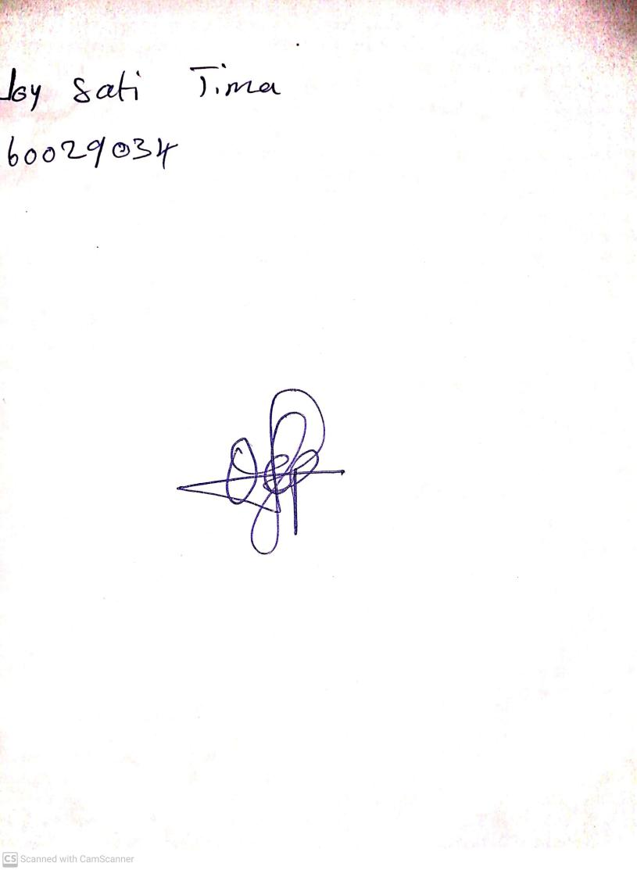

18th September, 2023

Perpetual Ojoma Ocheja

Stream Head Nursery