**EMERALD ROYAL INTERNATIONAL SCHOOL**

**MPAPE, ABUJA.**

**LESSON PLAN AND NOTE FOR WEEK 4 PERIOD 1 ENDING 17/05/2024**

**TERM: THIRD**

**WEEK: 4TH**

**DATE: 13/05/2024**

**CLASS: NURSERY 2**

**SUBJECT: LETTER WORK**

**TOPIC: VOWEL DIGRAPHS 3**

**SUB-TOPIC: WORDS WITH VOWEL DIGRAPHS “EA” AND “IE”**

**PERIOD: 1ST PERIOD**

**TIME: 09: 30 - 10:10am**

**DURATION: 40 MINUTES.**

**NUMBER IN CLASS: 13**

**AVERAGE AGE: 5 YEARS.**

**SEX: MIXED.**

**SPECIFIC OBJECTIVES: BY THE END OF THE LESSON,THE PUPILS SHOULD BE ABLE TO:**

**1. MENTION WORDS WITH VOWEL DIGRAPHS “EA”**

**AND "IE"**

**2. PRONOUNCE WORDS WITH VOWEL DIGRAPHS**

**"EA" AND "IE"**

**RATIONALE: FOR PUPILS TO KNOW WORDS WITH VOWEL DIGRAPHS“EA” AND “IE”**

**PREVIOU KNOWLEDGE: PUPILS HAVE LEARNT ABOUT WORDS ON VOWEL**

**DIGRAPHS“AI ” “AY” “OR” AND “AW"**

**INSTRUCTIONAL MATERIALS: A CHART OF WORDS ON VOWEL DIGRAPH "EA" AND "IE"**

**REFERENCE MATERIALS: GOOGLE.COM .**

**LESSON DEVELOPMENT**

|  |  |  |  |
| --- | --- | --- | --- |
| **STAGES/STEPS** | **TEACHER’S ACTIVITIES** | **PUPILS’ ACTIVITIES** | **LEARNING POINTS** |
| **INTRODUCTION** | **Teacher reviews the previous lesson on vowel digraphs to pupils.** | **Pupil listen attentively to the teacher.** | **To prepare pupils minds for the lesson ahead.** |
| **PRESENTATION**  **STEP 1** | **Teacher mentions words with vowel digraphs “ea” “ie” to pupils and asks them to repeat after her.** | **Pupils listen attentively to the teacher and repeat after her.** | **For proper understanding .** |
| **STEP 2** | **Teacher writes the words with vowel digraph “ea” and “ie” on the board, spell and pronounce and also asks pupils to identify and repeat after her.** | **Pupils pay attention to the teacher and repeat after her.** | **For better understanding of the lesson.** |
| **BOARD SUMMARY** | **Teacher writes the whole not of lesson on the board for pupils to copy.ie,**  **VOWEL DIGRAPH “EA”**  **Examples of “ea” words are:**  **“ea” as in leaf**  **“ea” as in bead**  **“ea” as in stream**  **“ea” as in swear**  **“ea” as in dream**  **“ea” as in cheat**  **“ea” as in steam**  **“ea” as in pear**  **“ea” as in break**  **“ea” as in wear**  **“ea” as in steak**  **“ea” as in great etc**  **VOWEL DIGRAPHS “IE” WORDS ARE:**  **“ie” as in pie**  **“ie” as in lie**  **“ie” as in tie**  **“ie” as in cried**  **“ie” as in die**  **“ie” as in tried**  **“ie” as in dried**  **“ie” as in fried**  **“ie” as in flies**  **“ie” as in tied etc.** | **Pupils copy the note into their exercise books.** | **For onward study.** |
| **EVALUATION** | **Teacher evaluates the lesson by asking pupils to go to the board one after the other and**   1. **spell the words.** 2. **pronounce the words.** | **Pupils listen to the teacher and read the note on the board one after another.** | **To assess pupils reading skills.** |
| **CONCLUTION** | **Teacher concludes the lesson by marking pupils books.** | **Pupils submit their books for marking.** | **For endorsement.** |
| **ASSIGNMENT** | **write 10 words with vowel digraphs “oa”** | **Pupils do their assignment at home.** | **To encourage learning at home.** |

**LESSON PLAN AND NOTE FOR WEEK 4 PERIOD 2 ENDING 17/05/2024**

**TERM: THIRD**

**WEEK: 4TH**

**DATE: 14/05/2024**

**CLASS: NURSERY 2**

**SUBJECT: LETTER WORK**

**TOPIC: VOWEL DIGRAPHS 3**

**SUB-TOPIC: WORDS WITH VOWEL DIGRAPHS “OA”**

**PERIOD: 2ND PERIOD**

**TIME: 08: 50 - 09:30am**

**DURATION: 40 MINUTES.**

**NUMBER IN CLASS: 13**

**AVERAGE AGE: 5 YEARS.**

**SEX: MIXED.**

**SPECIFIC OBJECTIVES: BY THE END OF THE LESSON,THE PUPILS SHOULD BE ABLE TO:**

**1. MENTION WORDS WITH VOWEL DIGRAPHS “OA”**

**2. PRONOUNCE WORDS WITH VOWEL DIGRAPHS "OA"**

**RATIONALE: FOR PUPILS TO KNOW WORDS WITH VOWEL DIGRAPHS“OA”**

**PREVIOU KNOWLEDGE: PUPILS HAVE LEARNT ABOUT WORDS WITH VOWEL**

**DIGRAPHS“EA” AND “IE” IN PREVIOUS LESSON.**

**INSTRUCTIONAL MATERIALS: A CHART OF WORDS ON VOWEL DIGRAPH "OA"**

**REFERENCE MATERIALS: GOOGLE.COM .**

**LESSON DEVELOPMENT**

|  |  |  |  |
| --- | --- | --- | --- |
| **STAGES/STEPS** | **TEACHER’S ACTIVITIES** | **PUPILS’ ACTIVITIES** | **LEARNING POINTS** |
| **INTRODUCTION** | **Teacher reviews the previous lesson on vowel digraphs to pupils.** | **Pupil listen attentively to the teacher.** | **To prepare pupils minds for the lesson ahead.** |
| **PRESENTATION**  **STEP 1** | **Teacher mentions words with vowel digraphs “oa” to pupils and asks them to repeat after her.** | **Pupils listen attentively to the teacher and repeat after her.** | **For proper understanding .** |
| **STEP 2** | **Teacher writes the words with vowel digraph “oa” on the board, spell and pronounce and also asks pupils to identify and repeat after her.** | **Pupils pay attention to the teacher and repeat after her.** | **For better understanding of the lesson.** |
| **BOARD SUMMARY** | **Teacher writes the whole not of lesson on the board for pupils to copy.ie,**  **VOWEL DIGRAPH “OA” WORDS ARE:**  **“oa” as in coat**  **“oa” as in boat**  **“oa” as in goat**  **“oa” as in float**  **“oa” as in roast**  **“oa” as in groan**  **“oa” as in coach**  **“oa” as in toad**  **“oa” as in soap**  **“oa” as in soak etc.** | **Pupils copy the note into their exercise books.** | **For onward study.** |
| **EVALUATION** | **Teacher evaluates the lesson by asking pupils to all stand and then spell and pronounce the words on the board one after another.** | **Pupils listen to the teacher and read the note on the board one after another.** | **To assess pupils reading skills.** |
| **CONCLUTION** | **Teacher concludes the lesson by marking pupils books.** | **Pupils submit their books for marking.** | **For endorsement.** |
| **ASSIGNMENT** | **Write 10 words with vowel digraphs “oi”** | **Pupils do their assignment at home.** | **To encourage learning at home.** |

**LESSON PLAN AND NOTE FOR WEEK 4 PERIOD 3 ENDING 17/05/2024**

**TERM: THIRD**

**WEEK: 4TH**

**DATE: 17/05/2024**

**CLASS: NURSERY 2**

**SUBJECT: LETTER WORK**

**TOPIC: VOWEL DIGRAPHS 3**

**SUB-TOPIC: WORDS WITH VOWEL DIGRAPHS “OI”**

**PERIOD: 3RD PERIOD**

**TIME: 09: 30 - 10:10am**

**DURATION: 40 MINUTES.**

**NUMBER IN CLASS: 13**

**AVERAGE AGE: 5 YEARS.**

**SEX: MIXED.**

**SPECIFIC OBJECTIVES: BY THE END OF THE LESSON,THE PUPILS SHOULD BE ABLE TO:**

**1. MENTION WORDS WITH VOWEL DIGRAPHS “OI”**

**2. PRONOUNCE WORDS WITH VOWEL DIGRAPHS "OI"**

**RATIONALE: FOR PUPILS TO KNOW WORDS WITH VOWEL DIGRAPHS “OI”**

**PREVIOU KNOWLEDGE: PUPILS HAVE LEARNT ABOUT WORDS WITH VOWEL**

**DIGRAPHS“OA” IN PREVIOUS LESSON.**

**INSTRUCTIONAL MATERIALS: CHART OF WORDS ON VOWEL DIGRAPH "OI"**

**REFERENCE MATERIALS: GOOGLE.COM .**

**LESSON DEVELOPMENT**

|  |  |  |  |
| --- | --- | --- | --- |
| **STAGES/STEPS** | **TEACHER’S ACTIVITIES** | **PUPILS’ ACTIVITIES** | **LEARNING POINTS** |
| **INTRODUCTION** | **Teacher reviews the previous lesson on vowel digraphs “oa” to pupils.** | **Pupil listen attentively to the teacher.** | **To prepare pupils minds for the lesson ahead.** |
| **PRESENTATION**  **STEP 1** | **Teacher mentions words with vowel digraphs “oi” to pupils and asks them to repeat after her.** | **Pupils listen attentively to the teacher and repeat after her.** | **For proper understanding .** |
| **STEP 2** | **Teacher writes the words with vowel digraph “oi” on the board, spell and pronounce and also asks pupils to identify and repeat after her.** | **Pupils pay attention to the teacher and repeat after her.** | **For better understanding of the lesson.** |
| **BOARD SUMMARY** | **Teacher writes the whole not of lesson on the board for pupils to copy.ie,**  **VOWEL DIGRAPH “OI” WORDS ARE:**  **“oi” as in oil**  **“oi” as in point**  **“oi” as in noise**  **“oi” as in hoist**  **“oi” as in adjoin**  **“oi” as in voice**  **“oi” as in choir**  **“oi” as in broil**  **“oi” as in loiter**  **“oi” as in doil**  **“oi” as in avoid**  **“oi”as in spoil**  **“oi” as in toilet**  **“oi” as in boiler etc.** | **Pupils copy the note into their exercise books.** | **For onward study.** |
| **EVALUATION** | **Teacher evaluates the lesson by**   1. **spell the words.** 2. **pronounce the words on the board one after the other.** | **Pupils read the note on the board one after another.** | **To assess pupils reading skills.** |
| **CONCLUTION** | **Teacher concludes the lesson by marking pupils books.** | **Pupils submit their books for marking.** | **For endorsement.** |
| **ASSIGNMENT** | 1. **Make 10 words with vowel digraphs “ea”** 2. **Write 1o words with vowel “ie”** 3. **List 5 words with vowel digraphs “oa” and 5 words with vowel digraphs “oi”.** | **Pupils do their assignment at home.** | **To encourage learning at home.** |

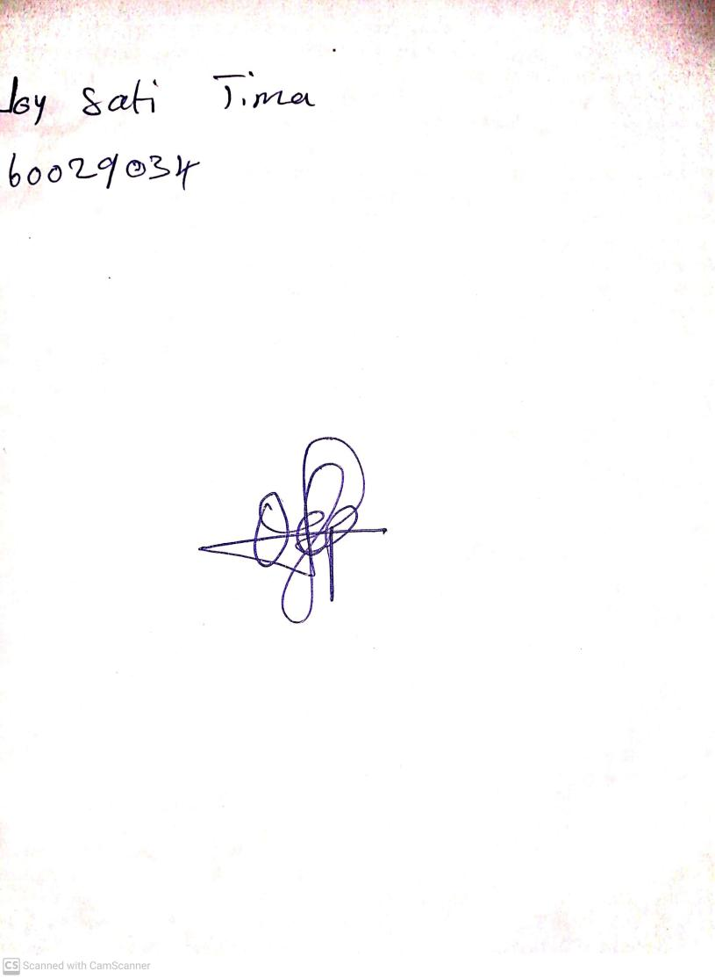

**10th May, 2024**

**Perpetual Ojoma Ocheja**

**Stream Head Nursery**