**LESSON PLAN FOR WEEK 2 ENDING 22/09/2023**

**Term 1st term**

**Week 2nd week**

**Date 20th September,2023**

**Class Nursery One**

**Subject Nature studies**

**Topic Care of our body.**

**Sub-topic Importance to care for our body.**

**Period 4th period**

**Time 10:40 am**

**Duration 35 minutes**

**No in class 15**

**Average Age 3 years**

**Sex Mixed**

**Specific Objectives: By the end of the lesson, the pupils**

**should be able to:**

1. **Know the importance of caring for our body.**
2. **Name tools for keeping our body clean.**
3. **Know ways of keeping our body clean.**

**Rationale: To ensure the pupils knows how clean our body.**

**Previous Knowledge: The pupils can identify the parts of the body.**

**Instructional Resources: Tools for keeping our body clean chart.**

**Reference Material: Elementary science by Showers kiddies nursery 1**

**LESSON PRESENTATION**

|  |  |  |  |
| --- | --- | --- | --- |
| **Steps** | **Teacher’s Activities** | **Pupils’ Activities** | **Learning Points** |
| **Introduction** | **The teacher introduces the lesson by showing the pupils the chart that contains the “tools for keeping our body clean”.** | **The pupils listens attentively to identify tools for keeping our body clean.** | **To arose the pupils’ interest.** |
| **Step 1** | **The teacher explains the importance of keeping our body clean everyday which include:**  **To prevent body odour.**  **To prevent tooth ache and tooth decay.**  **To prevent infection etc.** | **The pupils understands the importance of keeping our body clean”** | **For proper understanding.** |
| **Step 2** | **The teacher lists the materials for keeping our body clean that includes:**  **SPONGE**  **TOOHBRUSH**  **TOOTHPASTE**  **WATER**  **SOAP ETC** | **The pupils name the materials for keeping our body clean with their teacher.** | **For better understanding.** |
| **Step 3** | **The teacher mention ways the pupils can keep their body clean which includes:**  **Bathing everyday with water, soap, and water.**  **Brush our teeth and tongue with toothbrush, toothpaste and water. Etc** | **The pupils understands the ways in which they can keep their body clean.** | **For further understanding.** |
| **Summary** | **The teacher summarizes the lesson by rhyming the parts of the body for the pupils.** | **The pupils can identify and rhyme the parts of their body.** | **For onward study.** |
| **Evaluation** | 1. **Why must we keep our body clean?** 2. **Mention the materials for keeping our body clean?** 3. **How do we keep our teeth clean?** | **The pupils answer the question correctly.** | **To ascertain the pupils’ understanding.** |
| **Conclusion** | **The teacher summarizes, reacts, and corrects the pupils.** | **The pupils gives answer to the teacher’s questions** | **To consolidate the lesson.** |
| **Assignment** | 1. **Must we keep our body clean _____?** 2. **What do we use to bath?** 3. **What do we use to brush?.** | **The pupils copy and do their homework at home.** | **To encourage learning while at home.** |

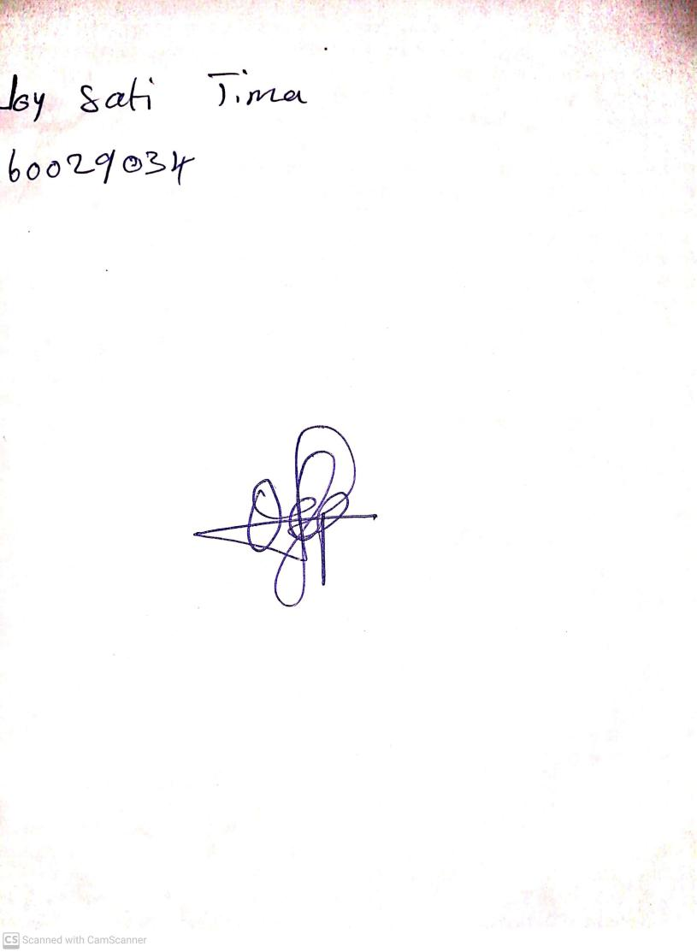

15th August, 2023

Perpetual Ojoma Ocheja

Stream Head Nursery