EMERALD ROYAL INTERNATIONAL SCHOOL

MPAPE, ABUJA.

LESSON PLAN AND NOTE FOR WEEK 10 ENDING 16TH NOVEMBER,2023

TERM: First term.

WEEK: Ten

SUBJECT: Nature studies.

TOPIC: Fruits

SUB-TOPIC: Definition and Identification of fruits.

DATE: 14/11/2023

DURATION: 40 minutes

TIME: 08:50-09:30

PERIOD: 3rd

CLASS: Pre-nursery

NUMBER OF PUPILS: 11

AVERAGE AGE: 2 years

SEX: Mixed

SPECIFIC OBJECTIVES: By the end of the lesson, the pupils should be able to:-

I Definitely fruits

2. Identify different fruits.

RATIONALE: For Pupils to identify some fruits

PREVIOUS KNOWLEDGE: Pupils have been eating fruits .

INSTRUCTIONAL MATERIALS: Chart and picture books.

REFERENCE: Showers kiddies books Elementary science book nursery 1 by Showers kiddies books.

LESSON DEVELOPMENT

|  |  |  |  |
| --- | --- | --- | --- |
| Stages/steps | Teacher's activities | Pupils' activities | Learning points |
| Introduction | Teacher introduces the lesson by singing a nursery rhymes such as:-  Paw-paw is a kind of fruits 2*  Sweet like sugar.  Yellow like fanta.  Every body likes paw-paw. | Pupils listen and sing the rhymes along with the teacher. | To arouse the interest of the pupils for the lesson ahead. |
| Presentation  Step 1 | Teacher define fruit to the pupils as:-  "Fruit is the part of a flowering plants that contains the seeds."  Then the teacher asks the pupils to repeat after her. | Pupils listen to the teacher and repeat after the teacher. | For better understanding of the lesson. |
| Step 2 | Teacher leads the pupils to identify some fruits on the chart. | Pupils pay attention to the teacher and identify the common fruits on the chart.  An apple.    A banana    An orange    Watermelon    Coconut | For better understanding of the lesson. |
| Summary | Teacher summarizes the lesson by going over the lesson again for better understanding of the lesson. | Pupils listen attentively to the teacher as she is going over the lesson again. | To ensure better understanding. |
| Evaluation | Teacher asks the Pupils to :-   1. Define fruit. 2. Identify the fruits on the chart. | Pupils answer the teacher's questions correctly. | To ascertain the level of pupils understanding of the lesson. |
| Conclusion | Teacher concludes the lesson by singing nursery rhymes that was sang at the introduction. | Pupils sing the rhymes along with the teacher . | For onwards learning. |
| Assignment | Teacher asks the pupils to colour the fruits in their text books. | Pupils do the assignment at home. | To encourage Learning at home. |

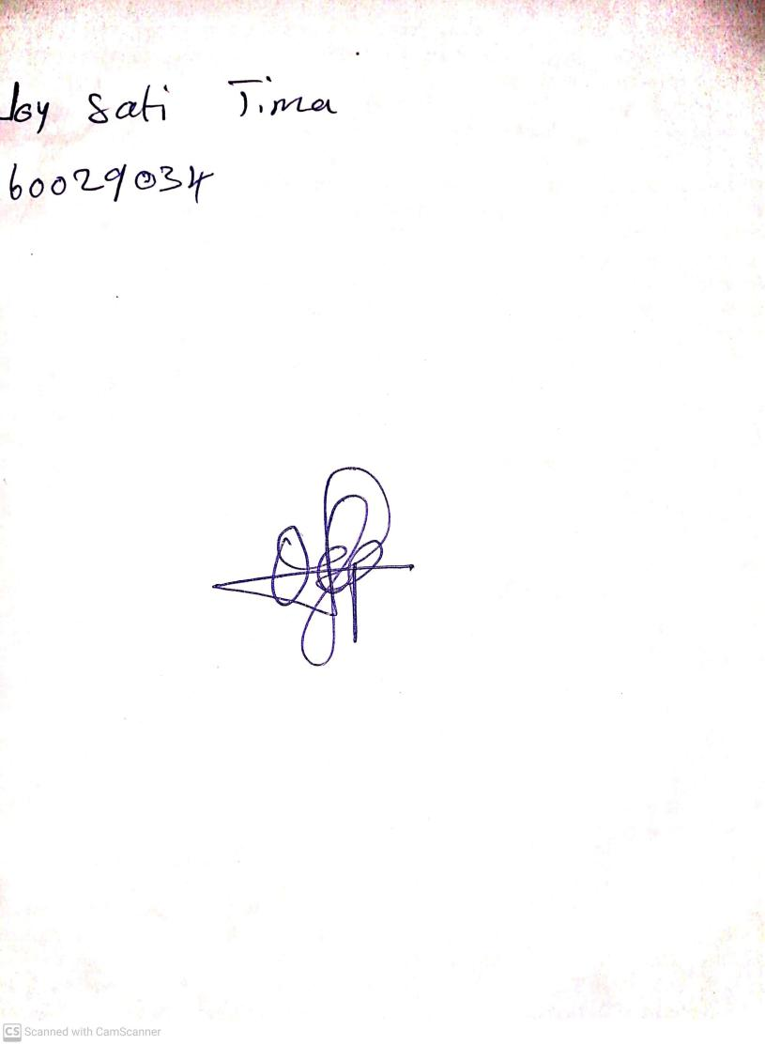

20th August, 2023

Perpetual Ojoma Ocheja

Stream Head Nursery