EMERALD ROYAL INTERNATIONAL SCHOOL

MPAPE, ABUJA.

LESSON PLAN AND NOTE FOR WEEK 7 ENDING 26TH OCTOBER,2023

TERM: First term.

WEEK: Seven

SUBJECT: Nature studies.

TOPIC: Plants.

SUB-TOPIC: Observing parts of a plant

DATE: 22/10/2023

DURATION: 40 minutes

TIME: 08:50-09:30

PERIOD: 3rd

CLASS: Pre-nursery

NUMBER OF PUPILS: 11

AVERAGE AGE: 2 years

SEX: Mixed

SPECIFIC OBJECTIVES: By the end of the lesson, the pupils should be able to:-

I Define a plant.

2. Identify and mention the parts of the plants.

RATIONALE: For Pupils to observe the parts of a plant .

PREVIOUS KNOWLEDGE: Pupils have been seeing plants or trees before.

INSTRUCTIONAL MATERIALS: Chart and real plant.

REFERENCE: Showers kiddies books Elementary science book nursery 1 by Showers kiddies books.

LESSON DEVELOPMENT

|  |  |  |  |
| --- | --- | --- | --- |
| Stages/steps | Teacher's activities | Pupils' activities | Learning points |
| Introduction | Teacher introduces the lesson by taking the pupils out of the classroom to look round. The teacher points at a tree and asks the pupils to say what they see on the tree 🌲 . | Pupils follow the teacher out of the classroom to look round. Pupils tell the teacher what they see on the tree as:-  leaves, flowers and fruits. | To arouse the interest of the pupils for the lesson ahead. |
| Presentation  Step 1 | Teacher defines plants to the pupils as:-  " Plants are living things that grows from the soil."  The teacher asks the pupils to repeat after her . | Pupils listen to the teacher and repeat after the teacher. | For better understanding of the lesson. |
| Step 2 | Teacher draws a plant for the pupils to identify and the teacher also mention the parts of the plant drawn.    Parts of plants are:-  Roots  Trunk  Branches  Leaves  Fruits. | Pupils watch the teacher as she is drawing a plant. They also mention the parts of a plant as:-   1. Roots 2. Trunk 3. Branches 4. Leaves 5. Fruits. | For better understanding of the lesson. |
| Summary | Teacher summarizes the lesson by defining plants again for the pupils understanding:-  " Plants are living things that grows from the soil."  Parts of a plant are:-   1. Roots 2. Trunk 3. Branches 4. Leaves 5. Fruits. | Pupils listen attentively to the teacher as she is going over the lesson again. | To ensure better understanding. |
| Evaluation | Teacher asks the Pupils to :-   1. Define plants. 2. Mention the parts of the plants. | Pupils answer the teacher's questions correctly. | To ascertain the level of pupils understanding of the lesson. |
| Conclusion | Teacher concludes the lesson by correcting pupils who was unable to identify. | Pupils take note of the corrections. | For onwards learning. |
| Assignment | Teacher asks the pupils to trace the parts of a plant in their text books. Elementary science page 25. | Pupils do the assignment at home. | To encourage Learning at home. |

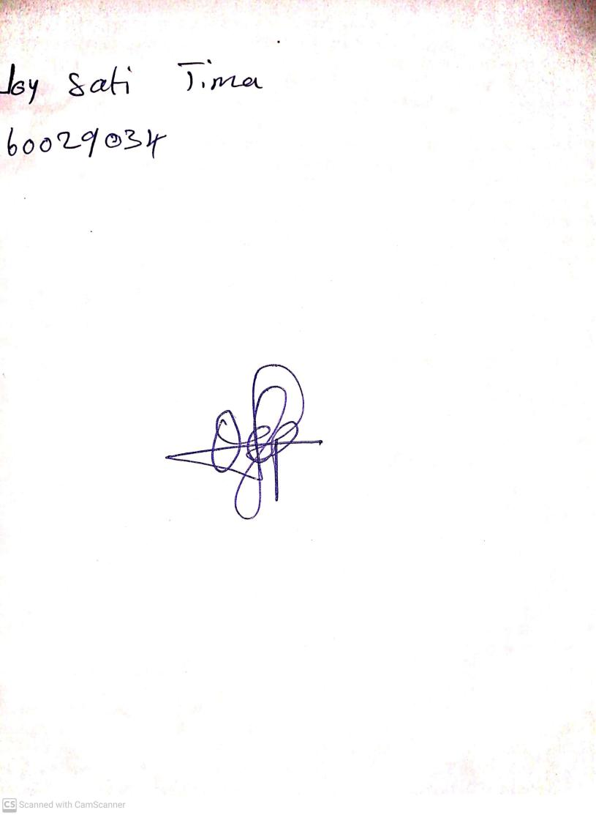

20th August, 2023

Perpetual Ojoma Ocheja

Stream Head Nursery