**EMERALD ROYAL INTERNATIONAL SCHOOL**

**MPAPE, ABUJA.**

**LESSON PLAN AND NOTE FOR WEEK 4 PERIOD 1 ENDING 04/10/2024**

**TERM: FIRST**

**WEEK: 4TH**

**DATE: 30/09/2024**

**CLASS: NURSERY 2**

**SUBJECT: LITERACY**

**TOPIC: THREE LETTER WORDS ENDING WITH "IN", "IP",**

**" IG" AND "IB".**

**SUB-TOPIC: THREE LETTER WORDS ENDING WITH "IN" , AND**

**" IP".**

**PERIOD: 1ST**

**TIME: O8:50-09:30.**

**DURATION: 40 MINUTES.**

**NUMBER IN CLASS: 17**

**AVERAGE AGE: 5 YEARS.**

**SEX: MIXED.**

**SPECIFIC OBJECTIVES: BY THE END OF THE LESSON,THE PUPILS SHOULD BE**

**ABLE TO:**

**1. IDENTIFY THREE LETTER WORDS ENDING WITH "IN"**

**AND " IP".**

**2. SPELL AND PRONOUNCE THREE LETTER WORDS**

**ENDING WITH "IN" AND "IP".**

**RATIONALE: FOR PUPILS TO BE ABLE TO SPELL AND PRONOUNCE**

**THERE LETTER WORDS ENDING WITH "IN" AND "IP".**

**PREVIOU KNOWLEDGE: PUPILS HAVE LEARNT THREE LETTER WORDS ENDING WITH "ET" AND " EG" IN PREVIOUS LESSON.**

**INSTRUCTIONAL MATERIALS: LIP AND PIN.**

**REFERENCE MATERIALS: MASTERING ENGLISH BOOK 2 BY J. M OMOGBAI**

**LESSON DEVELOPMENT**

|  |  |  |  |
| --- | --- | --- | --- |
| **STAGES/STEPS** | **TEACHER’S ACTIVITIES** | **PUPILS’ ACTIVITIES** | **LEARNING POINTS** |
| **INTRODUCTION** | **Teacher introduces the lesson by reviewing the previous lesson.** | **Pupil listen to the teacher attentively.** | **To arouse pupils interest for the lesson ahead.** |
| **PRESENTATION**  **STEP 1** | **Teacher presents the lesson by writing three letter words ending with "in" and "ip" on the board, identify and then asks pupils to repeat after her.** | **Pupils pay attention and repeat after the teacher.** | **For proper understanding of the lesson .** |
| **STEP 2** | **Teacher spells and pronounce the three letter words ending with "in" and "ip" on the board and also asks pupils to repeat after her.** | **Pupils spelled the three letter words on the board after the teacher.** | **For better understanding of the lesson.** |
| **BOARD SUMMARY** | **Teacher summarizes the lesson by writing the whole note of lesson on the board for pupils to copy into their books.that is,**  **THREE LETTER WORDS ENDING WITH "IN" AND "IP" ARE:**  **"in" as in;**   1. **Pin** 2. **Bin** 3. **Fin** 4. **Sin** 5. **Gin** 6. **Tin etc.**   **"ip" as in;**   1. **Dip** 2. **Hip** 3. **Kip** 4. **Lip** 5. **Rip** 6. **Sip** 7. **Tip** 8. **Yip** 9. **Zip etc.** | **Pupils copy the note into their exercise books.** | **For onward study.** |
| **EVALUATION** | **Teacher asks pupils to go to the board one after the other and read.** | **Pupils read the note on the board one after another.** | **To assess pupils level of understanding of the lesson so far.** |
| **CONCLUSION** | **Teacher marks pupils books.** | **Pupils submit their books for marking.** | **For endorsement.** |
| **ASSIGNMENT** | **Fill in the missing letters and pronounce.**   1. **G __ n** 2. **T __ n** 3. **Si__** 4. **Bi__** 5. **Zi__** 6. **T __ p** 7. **Di__** 8. **Hi__** 9. **Li __** 10. **R__ p** | **Pupils do their assignment at home.** | **To encourage learning at home.** |

**LESSON PLAN AND NOTE FOR WEEK 4 PERIOD 2 ENDING 04/10/2024**

**TERM: FIRST**

**WEEK: 4TH**

**DATE: 01/10/2024**

**CLASS: NURSERY 2**

**SUBJECT: LITERACY**

**TOPIC: THREE LETTER WORDS ENDING WITH "IN " ,"IP","IG",**

**"IB",**

**SUB-TOPIC: THREE LETTER WORDS ENDING WITH " IG"**

**PERIOD: 2ND**

**TIME: O8:50-09:30.**

**DURATION: 40 MINUTES.**

**NUMBER IN CLASS: 17**

**AVERAGE AGE: 5 YEARS.**

**SEX: MIXED.**

**SPECIFIC OBJECTIVES: BY THE END OF THE LESSON,THE PUPILS SHOULD BE**

**ABLE TO:**

**1. IDENTIFY THREE LETTER WORDS ENDING WITH "IG".**

**2. SPELL AND PRONOUNCE THREE LETTER WORDS**

**ENDING WITH "IG"**

**RATIONALE: FOR PUPILS TO BE ABLE TO READ WORDS THAT ENDS**

**WITH " IG"**

**PREVIOU KNOWLEDGE: PUPILS HAVE LEARNT THREE LETTER WORDS ENDING WITH "IN" AND "IP" IN PREVIOUS LESS0N.**

**INSTRUCTIONAL MATERIALS: A CHART OF THREE LETTER WORDS ENDING**

**WITH "IG"**

**REFERENCE MATERIALS: MASTERING ENGLISH 2 BY J. M OMOGBAI.**

**LESSON DEVELOPMENT**

|  |  |  |  |
| --- | --- | --- | --- |
| **STAGES/STEPS** | **TEACHER’S ACTIVITIES** | **PUPILS’ ACTIVITIES** | **LEARNING POINTS** |
| **INTRODUCTION** | **Teacher introduces the lesson by reviewing the previous lesson.** | **Pupil listen attentively to the teacher.** | **To arouse pupils interest for the lesson ahead.** |
| **PRESENTATION**  **STEP 1** | **Teacher presents the lesson by writing three Letter words ending with "ig" on the board, identify and then asks pupils to repeat after.** | **Pupils listen and repeat after the teacher.** | **For proper understanding of the lesson .** |
| **STEP 2** | **Teacher spells and pronounce the three letter words ending with "ig" on the board and also asks pupils to repeat after her.** | **Pupils pay attention and repeat after the teacher.** | **For better understanding of the lesson.** |
| **BOARD SUMMARY** | **Teacher summarizes the lesson by writing the whole note of lesson on the board for pupils to copy into their books.that is;**  **THREE LETTER WORDS ENDING WITH "IG" ARE:**  **"ig" as in;**   1. **Pig** 2. **Sig** 3. **Vig** 4. **Yig** 5. **Big** 6. **Rig** 7. **Tig** 8. **Wig** 9. **Zig** 10. **Dig** 11. **Gig** 12. **Mig** 13. **Fig etc.** | **Pupils copy the note into their exercise books.** | **For onward study.** |
| **EVALUATION** | **Teacher asks Pupils to read the three Letter words ending with "ig" on the board one after the other.** | **Pupils read the note on the board one after another.** | **To assess pupils understanding of the lesson.** |
| **CONCLUSION** | **Teacher marks pupils books.** | **Pupils submit their books for marking.** | **For endorsement.** |
| **ASSIGNMENT** | **Spell, pronounce and rewrite the following three Letter words ending with " ig" .**   1. **Gig ___** 2. **Mig ___** 3. **Pig ___** 4. **Vig ___** 5. **Sig ___** 6. **Yig ___** 7. **Big ___** 8. **Rig ___** 9. **Tig ___** 10. **Zig ___** | **Pupils do their assignment at home.** | **To encourage learning at home.** |

**LESSON PLAN AND NOTE FOR WEEK 4 PERIOD 3 ENDING 04/10/2024**

**TERM: FIRST**

**WEEK: 4TH**

**DATE: 02/10/2024**

**CLASS: NURSERY 2**

**SUBJECT: LITERACY**

**TOPIC: THREE LETTER WORDS ENDING WITH "IN", " IP",**

**"IG", " IB".**

**SUB-TOPIC: THREE LETTER WORDS ENDING WITH "IB"**

**PERIOD: 3RD**

**TIME: 08:10- 08:50am**

**DURATION: 40 MINUTES.**

**NUMBER IN CLASS: 17**

**AVERAGE AGE: 5 YEARS.**

**SEX: MIXED.**

**SPECIFIC OBJECTIVES: BY THE END OF THE LESSON,THE PUPILS SHOULD**

**BE ABLE TO:**

**1. IDENTIFY THREE LETTER WORDS ENDING WITH "IB"**

**2. SPELL AND PRONOUNCE THREE LETTER WORDS**

**ENDING WITH "IB"**

**RATIONALE: FOR PUPILS TO KNOW HOW TO PRONOUNCE WORDS**

**THAT ENDS WITH " IB".**

**PREVIOU KNOWLEDGE: PUPILS HAVE LEARNT ABOUT THREE LETTER WORDS ENDING WITH "IG" IN PREVIOUS LESS0N.**

**INSTRUCTIONAL MATERIALS: A CHART OF WORDS ENDING WITH "IB".**

**REFERENCE MATERIALS: MASTERING ENGLISH BOOK 2 BY J.M OMOGBAI.**

**LESSON DEVELOPMENT**

|  |  |  |  |
| --- | --- | --- | --- |
| **STAGES/STEPS** | **TEACHER’S ACTIVITIES** | **PUPILS’ ACTIVITIES** | **LEARNING POINTS** |
| **INTRODUCTION** | **Teacher introduces the lesson by reviewing the previous lesson.** | **Pupils pay attention to the teacher.** | **To arouse pupils interest for the lesson ahead.** |
| **PRESENTATION**  **STEP 1** | **Teacher presents the lesson by writing three letter words ending with "ib" on the board, identify and then asks pupils to repeat after her.** | **Pupils listen to the teacher and repeat after her.** | **For proper understanding of the lesson .** |
| **STEP 2** | **Teacher guides pupils to spell and pronounce the words ending with "ib" on the board.** | **Pupils spell and pronounced the words on the board.** | **For better understanding of the lesson.** |
| **BOARD SUMMARY** | **Teacher summarizes the lesson by preparing pupils books for them to copy the note on the board.ie,**  **Three Letter words ending with "ib" are:**  **"ib" as in;**   1. **Rib** 2. **Lib** 3. **Sib** 4. **Bib** 5. **Jib** 6. **Nib** 7. **Gib** 8. **Hib** 9. **Mib** 10. **Tib** 11. **Fib etc.** | **Pupils copy the note into their exercise books.** | **For onward study.** |
| **EVALUATION** | **Teacher evaluates the lesson by asking pupils to all stand and spell and pronounce three Letter words ending with "ib" on the board all together.** | **Pupils all stand and spelled and pronounced the words on the board.** | **To create platform for slow learners.** |
| **CONCLUSION** | **Teacher concludes the lesson by marking pupils books.** | **Pupils submit their books for marking.** | **For endorsement.** |
| **ASSIGNMENT** | **Fill in the missing letters and pronounce.**   1. **R___ b** 2. **F ___b** 3. **Li___** 4. **Si___** 5. **Ji ___** 6. **T___ b** 7. **Mi___** 8. **H___b** 9. **G ___ b** 10. **Ni___** | **Pupils do their assignment at home.** | **To encourage learning at home.** |

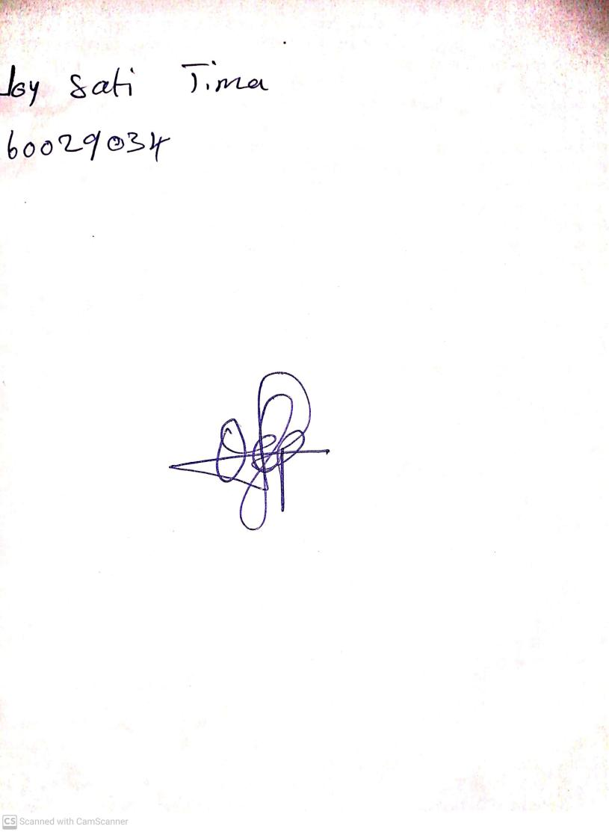

**27th September, 2024**

**Perpetual Ojoma Ocheja**

**Stream Head Nursery**