EMERALD ROYAL INTERNATIONAL SCHOOL

MPAPE, ABUJA.

LESSON PLAN AND NOTE 1 FOR WEEK 1 ENDING 26TH APRIL, 2024.

SUBJECT: Letter work

TOPIC: Match same letters Aa-Zz, identification of letters Aa-Zz(upper and lower

case).

SUB-TOPIC: identification of letters Aa-Zz.

DATE: 22/4/2024.

DURATION: 40 minutes.

TIME: 08:50--09:30.

PERIOD: 2nd

CLASS: Pre-nursery

NUMBER OF PUPILS: 11

AVERAGE AGE: 2 YEARS

SEX: Mixed.

SPECIFIC OBJECTIVES: By the end of the lesson, the pupils should be able to:-

1. Identify letter Aa-Ii
2. Match the upper case with the lower case.

RATIONALE: For pupils to know letters and their sounds.

PREVIOUS KNOWLEDGE: Pupils have been learning the lower case.

INSTRUCTIONAL MATERIALS: Flash cards, board, and phonics song.

REFERENCE:Mastering English for nursery schools book 1 by J.M.Omogbai.

LESSON DEVELOPMENT

|  |  |  |  |
| --- | --- | --- | --- |
| STAGES/STEPS | TEACHER’S ACTIVITIES | PUPILS’ ACTIVITIES | LEARNING POINTS |
| INTRODUCTION | Teacher introduces the lesson by singing a jolly phonics song for the pupils. | Pupils sing along with the teacher. | To arouse the interest of the pupils for the lesson. |
| PRESENTATION  STEP 1 | Teacher scattered the flash cards of upper and lower case of letters Aa-Ii on the table and asks the pupils identify the upper case and the lower case of each letters. | Pupils identify the upper and lower case of each letters on the table. | For better understanding of the lesson . |
| STEP2 | Teacher prepares the pupils books for them to match the upper case with lower case of letters Aa-Ii.  A g  B f  C e  D c  E b  F d  G a  H i  I h | Pupils match the upper case with the lower case.  A g  B f  C e  D c  E b  F d  G a  H i  I h . | To improve pupils locomotive skills. |
| SUMMARY | Teacher summarizes the lesson by going over the lesson again for more understanding | Pupils listen very attentively to the teacher | For more understanding of the lesson. |
| EVALUATION | Teacher calls out the pupils one after another to identify the upper and the lower case of letter Aa-iI. | Pupils answer the teacher’s questions. | To assess the level of pupils understanding of the lesson. |
| CONCLUSION | Teacher marks the pupils books and make corrections where necessary. | Pupils submit their books for marking and corrections . | For onwards study. |
| ASSIGNMENT | Read and match upper case and lower case of letter Aa-iI.    A g  B f  C e  D c  E b  F d  G a  H i  I h | Pupils do their Home work at home. | To ensure learning takes place at home. |

LESSON PLAN AND NOTE 2 FOR WEEK 1 ENDING 26TH APRIL, 2024.

SUBJECT: Letter work

TOPIC: Match same letter Aa-Zz, identification of letters Aa-Zz (upper and lower

cases).

SUB-TOPIC: Identification of letters Jj - Rr and matching letters.

DATE: 24/4/2024.

DURATION: 40 minutes.

TIME: 08:50--09:30.

PERIOD: 2nd

CLASS: Pre-nursery

NUMBER OF PUPILS: 11

AVERAGE AGE: 2 YEARS

SEX: Mixed.

SPECIFIC OBJECTIVES: By the end of the lesson, the pupils should be able to:-

1. Identify letter Jj-Rr.
2. Match the upper case with the lower case.

RATIONALE: For pupils to know letters and their sounds.

PREVIOUS KNOWLEDGE: Pupils have been learning the lower case.

INSTRUCTIONAL MATERIALS: Flash cards, board, and phonics song.

REFERENCE:Mastering English for nursery schools book 1 by J.M.Omogbai.

LESSON DEVELOPMENT

|  |  |  |  |
| --- | --- | --- | --- |
| STAGES/STEPS | TEACHER’S ACTIVITIES | PUPILS’ ACTIVITIES | LEARNING POINTS |
| INTRODUCTION | Teacher introduces the lesson by singing a jolly phonics song for the pupils. | Pupils sing along with the teacher. | To arouse the interest of the pupils for the lesson. |
| PRESENTATION  STEP 1 | Teacher scattered the flash cards of upper and lower case on the table and asks the pupils the upper case and the lower case of each letters. | Pupils identify the upper and lower case of each letters on the table. | For better understanding of the lesson . |
| STEP2 | Teacher prepares the pupils books for them to match the upper case with the lower case. .  J r  K q  L p  M o  N m  O l  P k  Q n  R j | Pupils match the upper case with the lower case.  J r  K q  L p  M o  N m  O l  P k  Q n  R j  . | To improve pupils locomotive skills. |
| SUMMARY | Teacher summarizes the lesson by going over the lesson again for more understanding | Pupils listen very attentively to the teacher | For more understanding of the lesson. |
| EVALUATION | Teacher calls out the pupils one after another to:- 1. identify the upper and the lower case of letter Jj-Rr   1. Match the upper letters with the lower case. | Pupils answer the teacher’s questions. | To assess the level of pupils understanding of the lesson. |
| CONCLUSION | Teacher marks the pupils books and make corrections where necessary. | Pupils submit their books for marking and corrections . | For onwards study. |
| ASSIGNMENT | Teacher asks the pupils to read and match upper case with the lower case in the text books. | Pupils do their Home work at home. | To ensure learning takes place at home. |

LESSON PLAN AND NOTE 3 FOR WEEK 1 ENDING 26TH APRIL, 2024.

SUBJECT: Letter work

TOPIC: Match same letter Aa -Zz, identification of letters Aa-Zz(upper case and

lower case)

SUB-TOPIC: identification of letters Ff - Jj and matching letters with the pictures.

DATE: 26/4/2024.

DURATION: 40 minutes.

TIME: 08:50--09:30.

PERIOD: 2nd

CLASS: Pre-nursery

NUMBER OF PUPILS: 11

AVERAGE AGE: 2 YEARS

SEX: Mixed.

SPECIFIC OBJECTIVES: By the end of the lesson, the pupils should be able to:-

1. Identify letter Ss - Zz.
2. Copy letter Ss-Zz..

RATIONALE: For pupils to know letters and their sounds.

PREVIOUS KNOWLEDGE: Pupils have been learning the lower case.

INSTRUCTIONAL MATERIALS: Flash cards, board, and phonics song.

REFERENCE:Mastering English for nursery schools book 1 by J.M.Omogbai.

LESSON DEVELOPMENT

|  |  |  |  |
| --- | --- | --- | --- |
| STAGES/STEPS | TEACHER’S ACTIVITIES | PUPILS’ ACTIVITIES | LEARNING POINTS |
| INTRODUCTION | Teacher introduces the lesson by singing a nursery rhyme for the pupils. | Puils sing along with the teacher. | To arouse the interest of the pupils for the lesson. |
| PRESENTATION  STEP 1 | Teacher writes the upper case and lower case of letter Ss-Zz on the board for pupils to identify. | Pupils points at the letters on the chalk board and identify them by reading them one after another. | For proper recognition of letters. |
| STEP2 | Teacher prepares the pupils books for them to copy letter Ss-Zz.  Ss Tt Uu Vv  Ww Xx Yy Zz | Pupils copy letters Ss-Zz in the books.  Ss Tt Uu Vv  Ww Xx Yy Zz. | To improve pupils locomotive skills. |
| SUMMARY | Teacher summarizes the lesson by asking the pupils to sing the phonics song for letters Ss-Zz with the teacher. | Pupils sing the phonics song for letters Ss-Zz with the teacher. | For more understanding of the lesson. |
| EVALUATION | Teacher calls out the pupils one after another to:-  1. identify the upper and lower case on the flash card.  2. Copy letters Ss-Zz. | Pupils answer the teacher’s questions. | To assess the level of pupils understanding of the lesson. |
| CONCLUSION | Teacher marks the pupils books and make corrections where necessary. | Pupils submit their books for marking and corrections . | For onwards study. |
| ASSIGNMENT | Read and match upper case with the lower case in the text books. | Pupils do their Home work at home. | To ensure learning takes place at home. |

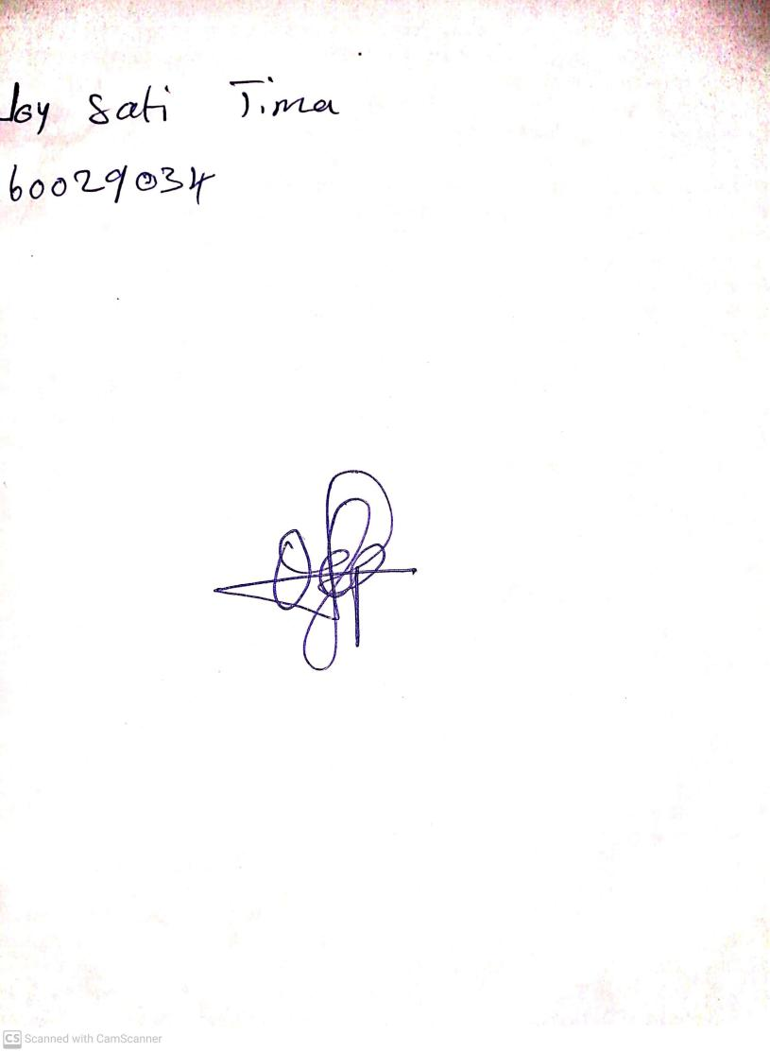

**19th April, 2024**

**Perpetual Ojoma Ocheja**

**Stream Head Nursery**